UNITED STATES

SECURITIES AND EXCHANGE COMMISSION

Washington, DC 20549-1004

___________________

FORM 8-K

___________________

CURRENT REPORT

Pursuant to Section 13 or 15(d) of

the Securities Exchange Act of 1934

Date of Report (Date of earliest event reported) April 30, 2019

___________________

GENERAL MOTORS COMPANY

(Exact name of registrant as specified in its charter)

___________________

DELAWARE | 001-34960 | 27-0756180
(State or other jurisdiction of | 001-34960 | (I.R.S. Employer
incorporation) | (Commission File Number) | Identification No.)
300 Renaissance Center, Detroit, Michigan |  | 48265-3000
(Address of principal executive offices) |  | (Zip Code)
 | (313) 667-1500
(Registrant's telephone number, including area code)

Not Applicable

(Former name or former address, if changed since last report)

__________________

Check the appropriate box below if the Form 8-K filing is intended to simultaneously satisfy the filing obligation of the registrant under any of the following provisions:

- Written communications pursuant to Rule 425 under the Securities Act (17 CFR 230.425)

- Soliciting material pursuant to Rule 14a-12 under the Exchange Act (17 CFR 240.14a-12)

- Pre-commencement communications pursuant to Rule 14d-2(b) under the Exchange Act (17 CFR 240.14d-2(b))

- Pre-commencement communications pursuant to Rule 13e-4(c) under the Exchange Act (17 CFR 240.13e-4(c))

Indicate by check mark whether the registrant is an emerging growth company as defined in Rule 405 of the Securities Act of 1933 (§230.405 of this chapter) or Rule 12b-2 of the Securities Exchange Act of 1934 (§240.12b-2 of this chapter). Emerging growth company ☐

If an emerging growth company, indicate by check mark if the registrant has elected not to use the extended transition period for complying with any new or revised financial accounting standards provided pursuant to Section 13(a) of the Exchange Act. ☐

ITEM 2.02 Results of Operations and Financial Condition

On April 30, 2019 General Motors Company (GM) issued a news release and supplemental materials on the subject of its 2019 first quarter earnings. The news release and supplemental materials are attached as Exhibit 99.1 and Exhibit 99.2.

Charts furnished to securities analysts in connection with GM's 2019 first quarter earnings release are available on GM's website at www.gm.com/investors/earnings-releases.html.

ITEM 9.01 Financial Statements and Exhibits

EXHIBIT

Exhibit |  | Description
Exhibit 99.1 |  | News Release Dated April 30, 2019
Exhibit 99.2 |  | Financial Highlights Dated April 30, 2019

SIGNATURE

Pursuant to the requirements of the Securities Exchange Act of 1934, the registrant has duly caused this report to be signed on its behalf by the undersigned hereunto duly authorized.

 | GENERAL MOTORS COMPANY (Registrant)
By: | /s/ CHRISTOPHER T. HATTO
Date: April 30, 2019
Date: April 30, 2019 | Christopher T. Hatto, Vice President, Controller and Chief Accounting Officer

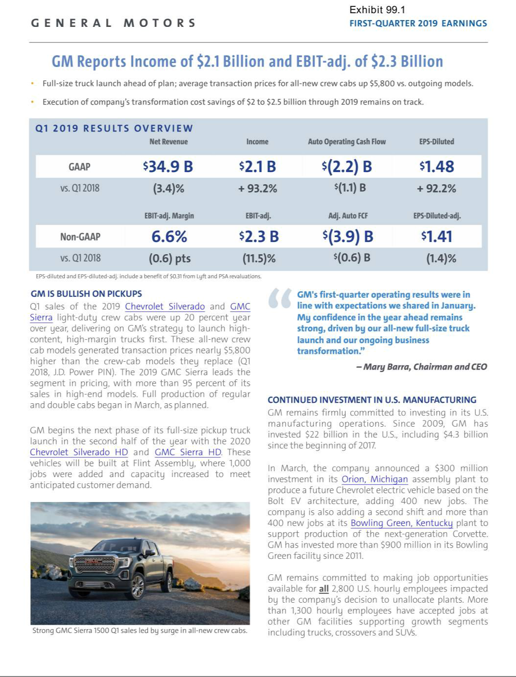

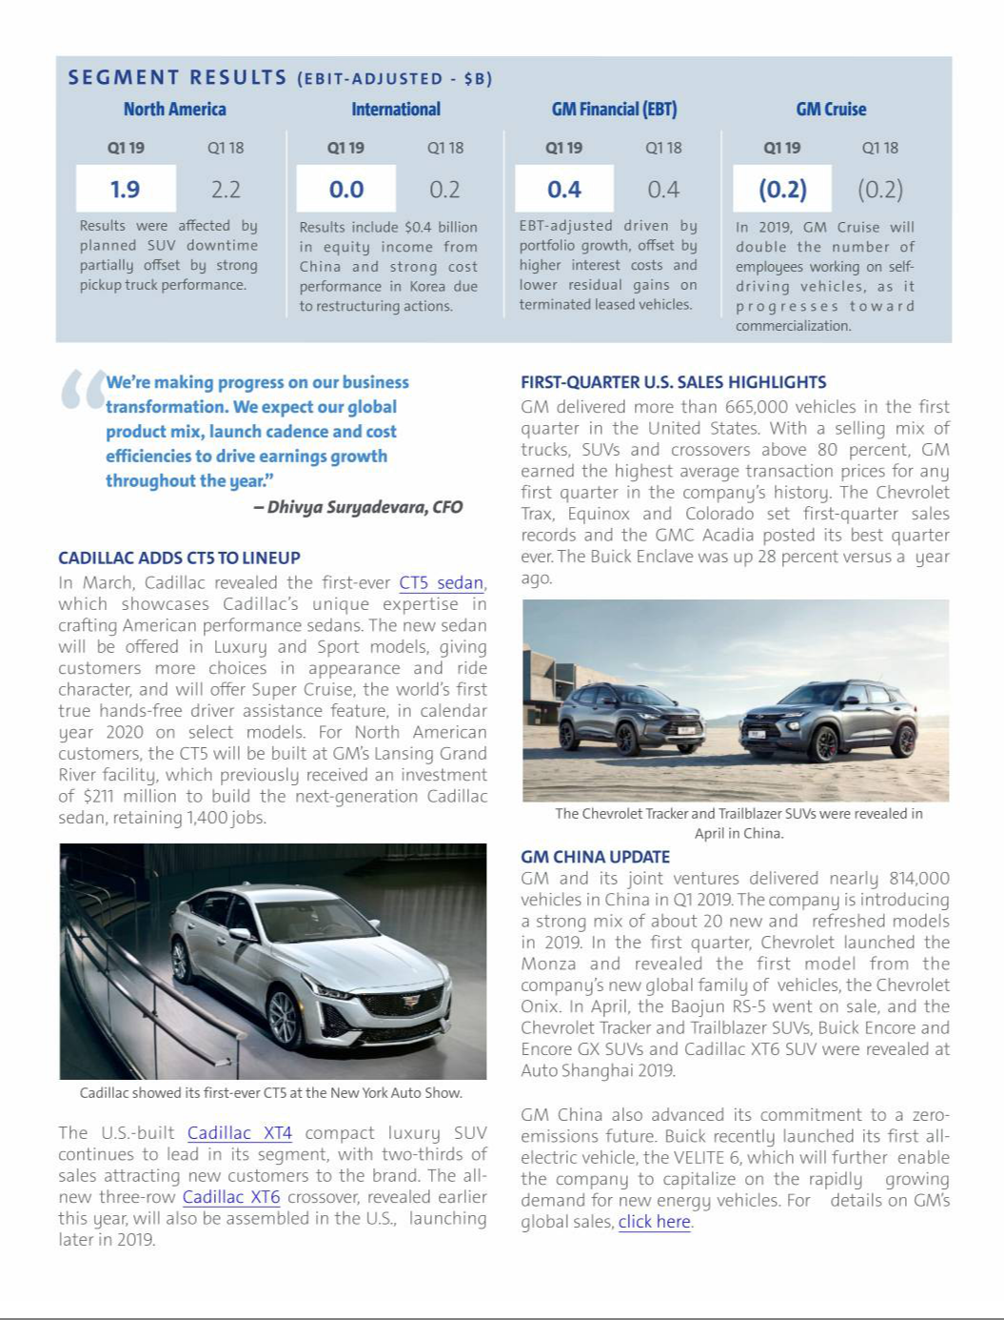

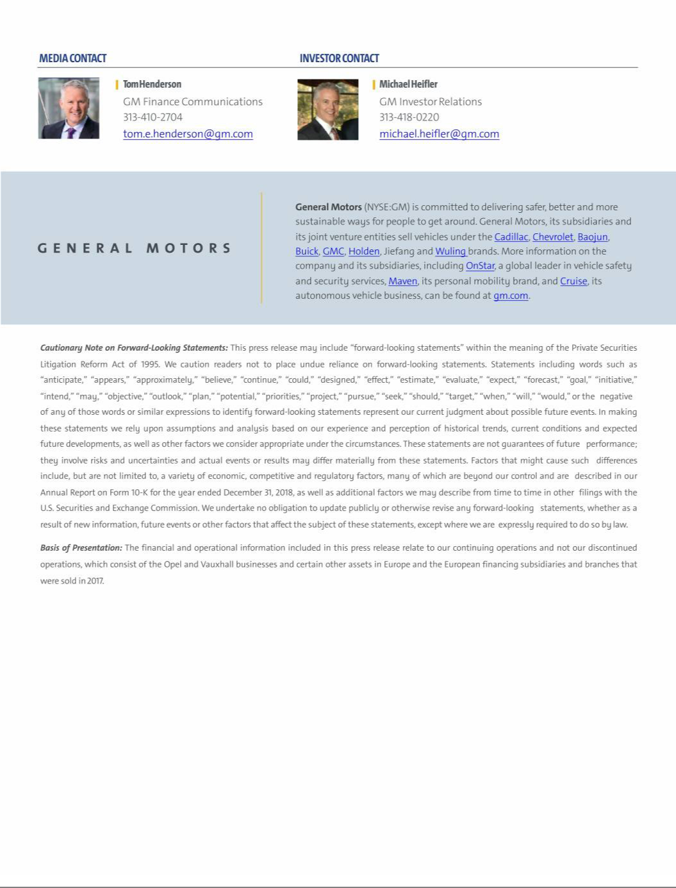

Exhibit 99.2

General Motors Company and Subsidiaries

Supplemental Material

(Unaudited)

Unless otherwise indicated, General Motors Company's (GM) non-GAAP measures are related to our continuing operations and not our discontinued operations. GM's non-GAAP measures include: earnings before interest and taxes (EBIT)-adjusted, presented net of noncontrolling interests; earnings before taxes (EBT)-adjusted for our GM Financial segment; earnings per share (EPS)-diluted-adjusted; effective tax rate-adjusted (ETR-adjusted); return on invested capital-adjusted (ROIC-adjusted) and adjusted automotive free cash flow. GM's calculation of these non-GAAP measures may not be comparable to similarly titled measures of other companies due to potential differences between companies in the method of calculation. As a result, the use of these non-GAAP measures has limitations and should not be considered superior to, in isolation from, or as a substitute for, related U.S. GAAP measures.

These non-GAAP measures allow management and investors to view operating trends, perform analytical comparisons and benchmark performance between periods and among geographic regions to understand operating performance without regard to items we do not consider a component of our core operating performance. Furthermore, these non-GAAP measures allow investors the opportunity to measure and monitor our performance against our externally communicated targets and evaluate the investment decisions being made by management to improve ROIC-adjusted. Management uses these measures in its financial, investment and operational decision-making processes, for internal reporting and as part of its forecasting and budgeting processes. Further, our Board of Directors uses certain of these and other measures as key metrics to determine management performance under our performance-based compensation plans. For these reasons we believe these non-GAAP measures are useful for our investors.

EBIT-adjusted EBIT-adjusted is presented net of noncontrolling interests and is used by management and can be used by investors to review our consolidated operating results because it excludes automotive interest income, automotive interest expense and income taxes as well as certain additional adjustments that are not considered part of our core operations. Examples of adjustments to EBIT include but are not limited to impairment charges on long-lived assets and other exit costs resulting from strategic shifts in our operations or discrete market and business conditions; costs arising from the ignition switch recall and related legal matters; and certain currency devaluations associated with hyperinflationary economies. For EBIT-adjusted and our other non-GAAP measures, once we have made an adjustment in the current period for an item, we will also adjust the related non-GAAP measure in any future periods in which there is an impact from the item. Our corresponding measure for our GM Financial segment is EBT-adjusted.

EPS-diluted-adjusted EPS-diluted-adjusted is used by management and can be used by investors to review our consolidated diluted EPS results on a consistent basis. EPS-diluted-adjusted is calculated as net income attributable to common stockholders-diluted less income (loss) from discontinued operations on an after-tax basis, adjustments noted above for EBIT-adjusted and certain income tax adjustments divided by weighted-average common shares outstanding-diluted. Examples of income tax adjustments include the establishment or reversal of significant deferred tax asset valuation allowances.

ETR-adjusted ETR-adjusted is used by management and can be used by investors to review the consolidated effective tax rate for our core operations on a consistent basis. ETR-adjusted is calculated as Income tax expense less the income tax related to the adjustments noted above for EBIT-adjusted and the income tax adjustments noted above for EPS-diluted-adjusted divided by Income before income taxes less adjustments.

ROIC-adjusted ROIC-adjusted is used by management and can be used by investors to review our investment and capital allocation decisions. We define ROIC-adjusted as EBIT-adjusted for the trailing four quarters divided by ROIC-adjusted average net assets, which is considered to be the average equity balances adjusted for average automotive debt and interest liabilities, exclusive of capital leases; average net pension and other postretirement benefits (OPEB) liabilities; and average automotive net income tax assets during the same period. Adjustments to the average equity balances exclude assets and liabilities classified as either assets held for sale or liabilities held for sale.

Adjusted automotive free cash flow Adjusted automotive free cash flow is used by management and can be used by investors to review the liquidity of our automotive operations and to measure and monitor our performance against our capital allocation program and evaluate our automotive liquidity against the substantial cash requirements of our automotive operations. We measure adjusted automotive free cash flow as automotive operating cash flow from continuing operations less capital expenditures adjusted for management actions. Management actions can include voluntary events such as discretionary contributions to employee benefit plans or nonrecurring specific events such as a closure of a facility that are considered special for EBIT-adjusted purposes.

1

General Motors Company and Subsidiaries

Supplemental Material

(Unaudited)

The following table reconciles segment profit (loss) to Net income attributable to stockholders under U.S. GAAP (dollars in millions):

 |  | Three Months Ended
 |  | March 31, 2019 |  |  | March 31, 2018
Operating segments
GM North America (GMNA) | $ | 1,896 |  | $ | 2,233
GM International (GMI) |  | 31 |  |  | 189
GM Cruise |  | (169) |  |  | (166)
General Motors Financial Company, Inc. (GM Financial)(a) |  | 359 |  |  | 443
Total operating segments |  | 2,117 |  |  | 2,699
Corporate and eliminations(b) |  | 193 |  |  | (89)
EBIT-adjusted |  | 2,310 |  |  | 2,610
Adjustments
Transformation activities(c) |  | (790) |  |  | —
GM Brazil indirect tax recoveries(d) |  | 857 |  |  | —
GMI restructuring(e) |  | — |  |  | (942)
Total adjustments |  | 67 |  |  | (942)
Automotive interest income |  | 98 |  |  | 64
Automotive interest expense |  | (181) |  |  | (150)
Income tax expense |  | (137) |  |  | (466)
Income from continuing operations(f) |  | 2,157 |  |  | 1,116
Loss from discontinued operations, net of tax(g) |  | — |  |  | 70
Net income attributable to stockholders | $ | 2,157 |  | $ | 1,046
__________
- GM Financial amounts represent earnings before income taxes-adjusted.

- GM's automotive operations' interest income and interest expense, Maven, legacy costs from the Opel and Vauxhall businesses and certain other assets in Europe (the Opel/Vauxhall Business), which are primarily pension costs, corporate expenditures and certain nonsegment-specific revenues and expenses are recorded centrally in Corporate.
- This adjustment was excluded because of a strategic decision to accelerate our transformation for the future to strengthen our core business, capitalize on the future of personal mobility and drive significant cost efficiencies. The adjustment primarily consists of accelerated depreciation.
- This adjustment was excluded because of the unique event associated with a decision rendered by the Superior Judicial Court of Brazil resulting in retrospective recoveries of indirect taxes.

- This adjustment was excluded because of a strategic decision to rationalize our core operations by exiting or significantly reducing our presence in various international markets to focus resources on opportunities expected to deliver higher returns. The adjustment primarily consists of asset impairments and employee separation costs in Korea.
- Net of Net loss attributable to noncontrolling interests.

- Represents the results of the Opel/Vauxhall Business and our European financing subsidiaries and branches (the Fincos, and together with the Opel/Vauxhall Business, the European Business).

2

General Motors Company and Subsidiaries

Supplemental Material

(Unaudited)

The following table reconciles Net income (loss) attributable to stockholders under U.S. GAAP to EBIT-adjusted (dollars in millions):

 |  |  |  |  |  |  |  |  |  |  |  | Three Months Ended
 |  |  | March 31, |  |  |  |  |  | December 31, |  |  |  |  |  | September 30, |  |  |  |  |  | June 30,
 |  |  | 2019 |  |  | 2018 |  |  | 2018 |  |  | 2017 |  |  | 2018 |  |  | 2017 |  |  | 2018 |  |  | 2017
 | Net income (loss) attributable to stockholders | $ | 2,157 |  | $ | 1,046 |  | $ | 2,044 |  | $ | (5,151) |  | $ | 2,534 |  | $ | (2,981) |  | $ | 2,390 |  | $ | 1,660
 | Loss from discontinued operations, net of tax |  | — |  |  | 70 |  |  | — |  |  | 277 |  |  | — |  |  | 3,096 |  |  | — |  |  | 770
 | Income tax expense (benefit) |  | 137 |  |  | 466 |  |  | (611) |  |  | 7,896 |  |  | 100 |  |  | 2,316 |  |  | 519 |  |  | 534
 | Automotive interest expense |  | 181 |  |  | 150 |  |  | 185 |  |  | 145 |  |  | 161 |  |  | 151 |  |  | 159 |  |  | 132
 | Automotive interest income |  | (98) |  |  | (64) |  |  | (117) |  |  | (82) |  |  | (82) |  |  | (59) |  |  | (72) |  |  | (68)
 | Adjustments
 | Transformation activities(a) |  | 790 |  |  | — |  |  | 1,327 |  |  | — |  |  | — |  |  | — |  |  | — |  |  | —
 | GM Brazil indirect tax recoveries(b) |  | (857) |  |  | — |  |  | — |  |  | — |  |  | — |  |  | — |  |  | — |  |  | —
 | GMI restructuring(c) |  | — |  |  | 942 |  |  | — |  |  | — |  |  | — |  |  | — |  |  | 196 |  |  | 540
 | Ignition switch recall and related legal matters(d) |  | — |  |  | — |  |  | — |  |  | — |  |  | 440 |  |  | — |  |  | — |  |  | 114
 | Total adjustments |  | (67) |  |  | 942 |  |  | 1,327 |  |  | — |  |  | 440 |  |  | — |  |  | 196 |  |  | 654
 | EBIT-adjusted | $ | 2,310 |  | $ | 2,610 |  | $ | 2,828 |  | $ | 3,085 |  | $ | 3,153 |  | $ | 2,523 |  | $ | 3,192 |  | $ | 3,682
________
- These adjustments were excluded because of a strategic decision to accelerate our transformation for the future to strengthen our core business, capitalize on the future of personal mobility and drive significant cost efficiencies. The adjustments primarily consist of accelerated depreciation in the three months ended March 31, 2019 and employee separation charges and accelerated depreciation in the three months ended December 31, 2018.

- This adjustment was excluded because of the unique event associated with a decision rendered by the Superior Judicial Court of Brazil resulting in retrospective recoveries of indirect taxes.

- These adjustments were excluded because of a strategic decision to rationalize our core operations by exiting or significantly reducing our presence in various international markets to focus resources on opportunities expected to deliver higher returns. The adjustments in the three months ended March 31, 2018 and June 30, 2018 primarily consist of asset impairments and employee separation costs in Korea. The adjustment in the three months ended June 30, 2017 primarily consists of asset impairments and other restructuring actions in India, South Africa and Venezuela.
- These adjustments were excluded because of the unique events associated with the ignition switch recall, which included various investigations, inquiries and complaints from constituents.

The following table reconciles diluted earnings per common share under U.S. GAAP to EPS-diluted-adjusted (dollars in millions):

 |  |  |  |  | Three Months Ended
 |  | March 31, 2019 |  |  |  |  |  | March 31, 2018
 |  | Amount |  |  | Per Share |  |  | Amount |  |  | Per Share
Diluted earnings per common share | $ | 2,119 |  | $ | 1.48 |  | $ | 1,032 |  | $ | 0.72
Diluted loss per common share – discontinued operations |  | — |  |  | — |  |  | 70 |  |  | 0.05
Adjustments(a) |  | (67) |  |  | (0.05) |  |  | 942 |  |  | 0.66
Tax effect on adjustment(b) |  | (32) |  |  | (0.02) |  |  | — |  |  | —
EPS-diluted-adjusted | $ | 2,020 |  | $ | 1.41 |  | $ | 2,044 |  | $ | 1.43
________
- Refer to the reconciliation of segment profit (loss) to Net income attributable to stockholders under U.S. GAAP for adjustment details.

- The tax effect of each adjustment is determined based on the tax laws and valuation allowance status of the jurisdiction to which the adjustment relates.

3

General Motors Company and Subsidiaries

Supplemental Material

(Unaudited)

The following table reconciles our effective tax rate under U.S. GAAP to ETR-adjusted (dollars in millions):

 |  |  |  |  |  |  | Three Months Ended
 |  |  |  |  | March 31, 2019 |  |  |  |  |  |  |  | March 31, 2018
 |  | Income before income |  |  | Income tax expense |  | Effective tax rate |  |  | Income before income |  |  | Income tax expense |  | Effective tax rate
 |  | taxes |  |  | Income tax expense |  | Effective tax rate |  |  | taxes |  |  | Income tax expense |  | Effective tax rate
Effective tax rate | $ | 2,282 |  | $ | 137 | 6.0% |  |  | $ | 1,576 |  | $ | 466 | 29.6%
Adjustments(a)(b) |  | (67) |  |  | 32 |  |  |  |  | 942 |  |  | —
ETR-adjusted | $ | 2,215 |  | $ | 169 | 7.6% |  |  | $ | 2,518 |  | $ | 466 | 18.5%
________
- Refer to the reconciliation of segment profit (loss) to Net income attributable to stockholders under U.S. GAAP for adjustment details.

- The tax effect of each adjustment is determined based on the tax laws and valuation allowance status of the jurisdiction to which the adjustment relates.

We define return on equity (ROE) as Net income (loss) attributable to stockholders for the trailing four quarters divided by average equity for the same period. Management uses average equity to provide comparable amounts in the calculation of ROE. The following table summarizes the calculation of ROE (dollars in billions):

 |  |  | Four Quarters Ended
 |  | March 31, 2019 |  |  |  | March 31, 2018
 | Net income (loss) attributable to stockholders | $ | 9.1 |  | $ | (5.4)
 | Average equity(a) | $ | 39.3 |  | $ | 39.3
 | ROE |  | 23.2% |  |  | (13.8)%
 | ________
- Includes equity of noncontrolling interests where the corresponding earnings (loss) are included in Net income (loss) attributable to stockholders.

The following table summarizes the calculation of ROIC-adjusted (dollars in billions):

 |  | Four Quarters Ended
 | March 31, 2019 |  |  | March 31, 2018
EBIT-adjusted(a) | $ | 11.5 |  | $ | 11.9
Average equity(b) | $ | 39.3 |  | $ | 39.3
Add: Average automotive debt and interest liabilities (excluding capital leases) |  | 14.4 |  |  | 12.7
Add: Average automotive net pension & OPEB liability |  | 17.5 |  |  | 20.6
Less: Average automotive and other net income tax asset |  | (22.9) |  |  | (26.9)
ROIC-adjusted average net assets | $ | 48.3 |  | $ | 45.7
ROIC-adjusted |  | 23.8% |  |  | 26.0%
________
- Refer to the reconciliation of Net income (loss) attributable to stockholders under U.S. GAAP to EBIT-adjusted.

- Includes equity of noncontrolling interests where the corresponding earnings (loss) are included in EBIT-adjusted.

4

General Motors Company and Subsidiaries

Supplemental Material

(Unaudited)

The following table reconciles Net automotive cash used in operating activities from continuing operations under U.S. GAAP to adjusted automotive free cash flow (dollars in millions):

 |  |  |  |  |  |  |  |  |  |  |  |  |  |  |  |  |  |  |  |  |  |  | Three Months Ended
 |  |  |  |  |  |  |  |  |  |  |  |  |  |  |  |  |  |  |  |  | March 31, 2019 |  |  |  | March 31, 2018
Net automotive cash used in operating activities |  |  |  |  |  |  |  |  |  |  |  |  |  |  |  |  |  |  |  |  | $ |  | (2,207) |  | $ |  |  | (1,063)
Less: Capital expenditures |  |  |  |  |  |  |  |  |  |  |  |  |  |  |  |  |  |  |  |  |  |  | (1,993) |  |  |  |  | (2,240)
Add: Transformation activities |  |  |  |  |  |  |  |  |  |  |  |  |  |  |  |  |  |  |  |  |  |  | 315 |  |  |  |  | —
Add: GMI restructuring |  |  |  |  |  |  |  |  |  |  |  |  |  |  |  |  |  |  |  |  |  |  | 9 |  |  |  |  | —
Adjusted automotive free cash flow |  |  |  |  |  |  |  |  |  |  |  |  |  |  |  |  |  |  |  |  | $ |  | (3,876) |  | $ |  |  | (3,303)
The following tables summarize key financial information by segment (dollars in millions):
 |  |  | GMNA |  |  | GMI |  |  | Corporate |  |  | Eliminations |  |  | Total |  |  | GM Cruise |  |  | GM |  | Reclassifications/Eliminations |  |  |  |  | Total
 |  |  | GMNA |  |  | GMI |  |  | Corporate |  |  | Eliminations |  |  | Automotive |  |  | GM Cruise |  |  | Financial |  |  |  |  |  |  | Total
Three Months Ended March 31, 2019
Net sales and revenue |  | $ | 27,365 |  | $ | 3,850 |  | $ | 46 |  |  |  |  | $ | 31,261 |  | $ | 25 |  | $ | 3,620 |  | $ |  | (28) |  | $ | 34,878
Expenditures for property |  | $ | 1,701 |  | $ | 292 |  | $ | — |  | $ | — |  | $ | 1,993 |  | $ | 4 |  | $ | 17 |  | $ |  | — |  | $ | 2,014
Depreciation and amortization |  | $ | 2,069 |  | $ | 127 |  | $ | 12 |  | $ | — |  | $ | 2,208 |  | $ | 2 |  | $ | 1,899 |  | $ |  | — |  | $ | 4,109
Impairment charges |  | $ | 7 |  | $ | — |  | $ | — |  | $ | — |  | $ | 7 |  | $ | — |  | $ | — |  | $ |  | — |  | $ | 7
Equity income(a) |  | $ | 2 |  | $ | 374 |  | $ | (7) |  | $ | — |  | $ | 369 |  | $ | — |  | $ | 45 |  | $ |  | — |  | $ | 414
 |  |  | GMNA |  |  | GMI |  |  | Corporate |  |  | Eliminations |  |  | Total |  |  | GM Cruise |  |  | GM |  | Eliminations |  |  |  |  | Total
 |  |  | GMNA |  |  | GMI |  |  | Corporate |  |  | Eliminations |  |  | Automotive |  |  | GM Cruise |  |  | Financial |  |  |  |  |  |  | Total
Three Months Ended March 31, 2018
Net sales and revenue |  | $ | 27,818 |  | $ | 4,848 |  | $ | 49 |  |  |  |  | $ | 32,715 |  | $ | — |  | $ | 3,411 |  | $ |  | (27) |  | $ | 36,099
Expenditures for property |  | $ | 2,064 |  | $ | 162 |  | $ | 14 |  | $ | — |  | $ | 2,240 |  | $ | 12 |  | $ | 20 |  | $ |  | — |  | $ | 2,272
Depreciation and amortization |  | $ | 1,109 |  | $ | 153 |  | $ | 11 |  | $ | — |  | $ | 1,273 |  | $ | 1 |  | $ | 1,823 |  | $ |  | — |  | $ | 3,097
Impairment charges |  | $ | 25 |  | $ | 459 |  | $ | — |  | $ | — |  | $ | 484 |  | $ | — |  | $ | — |  | $ |  | — |  | $ | 484
Equity income(a) |  | $ | 2 |  | $ | 594 |  | $ | — |  | $ | — |  | $ | 596 |  | $ | — |  | $ | 52 |  | $ |  | — |  | $ | 648
________
- Includes Automotive China equity income of $376 million and $597 million in the three months ended March 31, 2019 and 2018.

5

General Motors Company and Subsidiaries

Supplemental Material

(Unaudited)

Vehicle Sales

GM presents both wholesale and total vehicle sales data to assist in the analysis of our revenue and our market share. Cuba, Iran, North Korea, Sudan and Syria are subject to broad economic sanctions. Accordingly these countries are excluded from industry sales data and the corresponding calculation of GM's market share.

Wholesale vehicle sales data consists of sales to GM's dealers and distributors as well as sales to the U.S. Government, and excludes vehicles sold by our joint ventures. Wholesale vehicle sales data correlates to GM's revenue recognized from the sale of vehicles, which is the largest component of Automotive net sales and revenue. In the three months ended March 31, 2019, 34.0% of our wholesale vehicle sales volume was generated outside the U.S. The following table summarizes wholesale vehicle sales by automotive segment (vehicles in thousands):

Three Months Ended

 | March 31, 2019 |  |  | March 31, 2018
GMNA |  | 859 |  | 893
GMI |  | 236 |  | 266
Total |  | 1,095 |  | 1,159

6

General Motors Company and Subsidiaries

Supplemental Material

(Unaudited)

Total vehicle sales data represents: (1) retail sales (i.e., sales to consumers who purchase new vehicles from dealers or distributors); (2) fleet sales, such as sales to large and small businesses, governments, and daily rental car companies; and (3) vehicles used by dealers in their businesses, including courtesy transportation vehicles. Total vehicle sales data includes all sales by joint ventures on a total vehicle basis, not based on our percentage ownership interest in the joint venture. Certain joint venture agreements in China allow for the contractual right to report vehicle sales of non-GM trademarked vehicles by those joint ventures, which are included in the total vehicle sales we report for China. While total vehicle sales data does not correlate directly to the revenue GM recognizes during a particular period, we believe it is indicative of the underlying demand for GM vehicles. Total vehicle sales data represents management's good faith estimate based on sales reported by GM's dealers, distributors, and joint ventures, commercially available data sources such as registration and insurance data, and internal estimates and forecasts when other data is not available.

The following table summarizes total vehicle sales by geographic region (vehicles in thousands):

Three Months Ended

 | March 31, 2019 |  |  | March 31, 2018
United States
Chevrolet – Cars |  | 100 |  | 121
Chevrolet – Trucks |  | 197 |  | 223
Chevrolet – Crossovers |  | 155 |  | 147
Cadillac |  | 36 |  | 37
Buick |  | 52 |  | 57
GMC |  | 126 |  | 131
Total United States |  | 666 |  | 716
Canada, Mexico and Other |  | 109 |  | 111
Total North America |  | 775 |  | 827
Asia/Pacific, Middle East and Africa
Chevrolet |  | 221 |  | 217
Wuling |  | 266 |  | 289
Buick |  | 225 |  | 272
Baojun |  | 169 |  | 244
Cadillac |  | 46 |  | 57
Other |  | 20 |  | 22
Total Asia/Pacific, Middle East and Africa |  | 947 |  | 1,101
South America(a) |  | 156 |  | 168
Total in GM markets |  | 1,878 |  | 2,096
Total Europe |  | 1 |  | 1
Total Worldwide |  | 1,879 |  | 2,097
_______
(a) Primarily Chevrolet.
7

General Motors Company and Subsidiaries

Supplemental Material

(Unaudited)

The vehicle sales at GM's China joint ventures presented in the following table are included in the preceding vehicle sales table (vehicles in thousands):

 |  | Three Months Ended
 |  | March 31, 2019 |  |  |  | March 31, 2018
SAIC General Motors Sales Co., Ltd. |  | 382 |  |  |  | 457
SAIC GM Wuling Automobile Co., Ltd. and FAW-GM Light Duty Commercial Vehicle Co., Ltd. |  | 432 |  |  |  | 529
 |  | Three Months Ended
 |  | March 31, 2019 |  |  |  | March 31, 2018
Market Share
United States – Cars |  | 9.4% |  |  |  | 10.9%
United States – Trucks(a) |  | 28.0% |  |  |  | 31.9%
United States – Crossovers(a) |  | 14.5% |  |  |  | 14.1%
Total United States |  | 16.1% |  |  |  | 17.0%
Total North America |  | 15.6% |  |  |  | 16.3%
Total Asia/Pacific, Middle East and Africa |  | 8.0% |  |  |  | 9.0%
Total South America |  | 15.5% |  |  |  | 15.5%
Total GM Market |  | 10.6% |  |  |  | 11.4%
Total Worldwide |  | 8.3% |  |  |  | 8.9%
United States fleet sales as a percentage of retail vehicle sales |  | 25.0% |  |  |  | 23.0%
North America capacity two shift utilization |  | 100.7% |  |  |  | 99.0%
________
- Certain industry vehicles have been reclassified between these vehicle segments. GM vehicles were not impacted by this change. The prior period has been recast to reflect the changes.

8

General Motors Company and Subsidiaries

Combining Income Statement Information

(In millions) (Unaudited)

 |  | Three Months Ended March 31, 2019 |  |  |  |  | Three Months Ended March 31, 2018
Automotive | GM Cruise | GM Financial | Reclassifications/Eliminations | Combined |  | Automotive | GM Cruise | GM Financial | Eliminations | Combined
Net sales and revenue

Automotive | $
GM Financial
Total net sales and revenue

Costs and expenses

Automotive and other cost of sales

GM Financial interest, operating and other expenses

Automotive and other selling, general and administrative expense

Total costs and expenses

Operating income (loss)

Automotive interest expense

Interest income and other non-operating income, net

Equity income
Income (loss) before income taxes | $
Income tax expense
Income from continuing operations

Loss from discontinued operations, net of tax Net income

Net loss attributable to noncontrolling interests

Net income attributable to stockholders

Net income attributable to common stockholders

31,261 | $ | 25 |  | $ | — |  | $ | (25) |  | $ | 31,261 | $ |  | 32,715 |  | $ | — |  | $ | — |  | $ | (24) |  | $ | 32,691
— |  | — |  |  | 3,620 |  |  | (3) |  |  | 3,617 |  |  | — |  |  | — |  |  | 3,411 |  |  | (3) |  |  | 3,408
31,261 |  | 25 |  |  | 3,620 |  |  | (28) |  |  | 34,878 |  |  | 32,715 |  |  | — |  |  | 3,411 |  |  | (27) |  |  | 36,099
28,035 |  | 195 |  |  | — |  |  | (1) |  |  | 28,229 |  |  | 30,061 |  |  | 148 |  |  | — |  |  | (25) |  |  | 30,184
— |  | — |  |  | 3,306 |  |  | — |  |  | 3,306 |  |  | — |  |  | — |  |  | 3,020 |  |  | (6) |  |  | 3,014
2,080 |  | 19 |  |  | — |  |  | — |  |  | 2,099 |  |  | 2,354 |  |  | 18 |  |  | — |  |  | — |  |  | 2,372
30,115 |  | 214 |  |  | 3,306 |  |  | (1) |  |  | 33,634 |  |  | 32,415 |  |  | 166 |  |  | 3,020 |  |  | (31) |  |  | 35,570
1,146 |  | (189) |  |  | 314 |  |  | (27) |  |  | 1,244 |  |  | 300 |  |  | (166) |  |  | 391 |  |  | 4 |  |  | 529
184 |  | — |  |  | — |  |  | (3) |  |  | 181 |  |  | 152 |  |  | — |  |  | — |  |  | (2) |  |  | 150
768 |  | 24 |  |  | — |  |  | 13 |  |  | 805 |  |  | 549 |  |  | — |  |  | — |  |  | — |  |  | 549
369 |  | — |  |  | 45 |  |  | — |  |  | 414 |  |  | 596 |  |  | — |  |  | 52 |  |  | — |  |  | 648
2,099 | $ | (165) |  | $ | 359 |  | $ | (11) |  |  | 2,282 | $ |  | 1,293 |  | $ | (166) |  | $ | 443 |  | $ | 6 |  |  | 1,576
 |  |  |  |  |  |  |  |  |  |  | 137 |  |  |  |  |  |  |  |  |  |  |  |  |  |  | 466
 |  |  |  |  |  |  |  |  |  |  | 2,145 |  |  |  |  |  |  |  |  |  |  |  |  |  |  | 1,110
 |  |  |  |  |  |  |  |  |  |  | — |  |  |  |  |  |  |  |  |  |  |  |  |  |  | 70
 |  |  |  |  |  |  |  |  |  |  | 2,145 |  |  |  |  |  |  |  |  |  |  |  |  |  |  | 1,040
 |  |  |  |  |  |  |  |  |  |  | 12 |  |  |  |  |  |  |  |  |  |  |  |  |  |  | 6
 |  |  |  |  |  |  |  |  |  | $ | 2,157 |  |  |  |  |  |  |  |  |  |  |  |  |  | $ | 1,046
 |  |  |  |  |  |  |  |  |  | $ | 2,119 |  |  |  |  |  |  |  |  |  |  |  |  |  | $ | 1,032
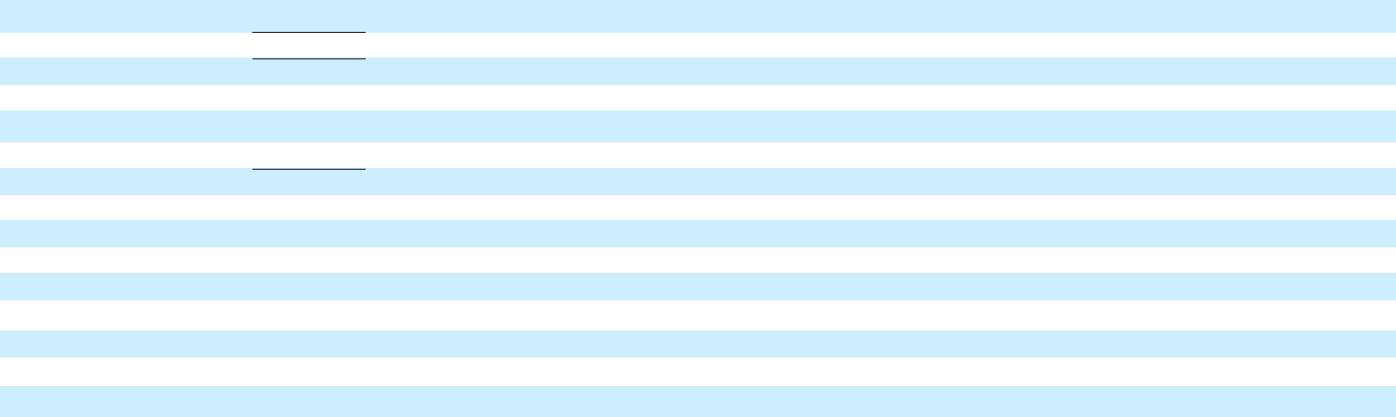

9

General Motors Company and Subsidiaries

Basic and Diluted Earnings per Share

(Unaudited)

The following table summarizes basic and diluted earnings (loss) per share (in millions, except per share amounts):

 |  | Three Months Ended
 |  | March 31, 2019 |  |  | March 31, 2018
Basic earnings per share
Income from continuing operations(a) | $ | 2,157 |  | $ | 1,116
Less: cumulative dividends on subsidiary preferred stock |  | (38) |  |  | (14)
Income from continuing operations attributable to common stockholders |  | 2,119 |  |  | 1,102
Loss from discontinued operations, net of tax |  | — |  |  | 70
Net income attributable to common stockholders | $ | 2,119 |  | $ | 1,032
Weighted-average common shares outstanding |  | 1,417 |  |  | 1,408
Basic earnings per common share – continuing operations | $ | 1.50 |  | $ | 0.78
Basic loss per common share – discontinued operations | $ | — |  | $ | 0.05
Basic earnings per common share | $ | 1.50 |  | $ | 0.73
Diluted earnings per share
Income from continuing operations attributable to common stockholders – diluted(a) | $ | 2,119 |  | $ | 1,102
Loss from discontinued operations, net of tax – diluted | $ | — |  | $ | 70
Net income attributable to common stockholders – diluted | $ | 2,119 |  | $ | 1,032
Weighted-average common shares outstanding – diluted |  | 1,436 |  |  | 1,430
Diluted earnings per common share – continuing operations | $ | 1.48 |  | $ | 0.77
Diluted loss per common share – discontinued operations | $ | — |  | $ | 0.05
Diluted earnings per common share | $ | 1.48 |  | $ | 0.72
Potentially dilutive securities(b) |  | 8 |  |  | 4
__________
- Net of Net loss attributable to noncontrolling interests.

- Potentially dilutive securities attributable to outstanding stock options and Restricted Stock Units were excluded from the computation of diluted EPS because the securities would have had an antidilutive effect.

10

General Motors Company and Subsidiaries

Combining Balance Sheet Information

(In millions, except per share amounts) (Unaudited)

 |  |  |  |  |  |  | March 31, 2019 |  |  |  |  |  |  |  |  |  |  |  |  |  |  | December 31, 2018
 |  | Automotive |  | GM Cruise |  |  | GM Financial |  |  | Reclassifications/Eliminations |  |  |  | Combined |  |  | Automotive |  | GM Cruise |  |  | GM Financial |  | Reclassifications/Eliminations |  |  |  | Combined
ASSETS
Current Assets
Cash and cash equivalents | $ | 9,758 |  | $ 2,132 |  | $ | 5,286 |  |  | $ | — |  | $ | 17,176 |  | $ | 13,670 |  | $ 2,291 |  | $ | 4,883 |  | $ | — |  | $ | 20,844
Marketable securities(a) |  | 6,021 |  | 90 |  |  | — |  |  |  | (90) |  |  | 6,021 |  |  | 5,966 |  | 92 |  |  | — |  |  | (92) |  |  | 5,966
Accounts and notes receivable, net(b) |  | 11,682 |  | 2 |  |  | 1,148 |  |  |  | (716) |  |  | 12,116 |  |  | 5,916 |  | 1 |  |  | 1,430 |  |  | (798) |  |  | 6,549
GM Financial receivables, net(c) |  | — |  | — |  |  | 27,722 |  |  |  | (492) |  |  | 27,230 |  |  | — |  | — |  |  | 27,367 |  |  | (517) |  |  | 26,850
Inventories |  | 11,108 |  | — |  |  | — |  |  |  | — |  |  | 11,108 |  |  | 9,816 |  | — |  |  | — |  |  | — |  |  | 9,816
Other current assets(d) |  | 1,917 |  | 45 |  |  | 4,509 |  |  |  | (32) |  |  | 6,439 |  |  | 1,619 |  | 27 |  |  | 3,640 |  |  | (18) |  |  | 5,268
Total current assets |  | 40,486 |  | 2,269 |  |  | 38,665 |  |  |  | (1,330) |  |  | 80,090 |  |  | 36,987 |  | 2,411 |  |  | 37,320 |  |  | (1,425) |  |  | 75,293

Non-current Assets

GM Financial receivables, net(c)

Equity in net assets of nonconsolidated affiliates

Property, net

Goodwill and intangible assets, net

Equipment on operating leases, net

Deferred income taxes

Other assets

Total non-current assets

Total Assets

LIABILITIES AND EQUITY

Current Liabilities

Accounts payable (principally trade)(b)

Short-term debt and current portion of long-term debt

Automotive(c)

GM Financial

Accrued liabilities

Total current liabilities

Non-current Liabilities

Long-term debt

Automotive(c)

GM Financial

Postretirement benefits other than pensions

Pensions

Other liabilities

Total non-current liabilities

Total Liabilities

Commitments and contingencies

Equity

 | — |  |  | — |  |  | 25,507 |  |  | (59) |  |  | 25,448 |  |  | — |  |  | — |  |  | 25,145 |  |  | (62) |  |  | 25,083
 | 6,837 |  |  | — |  |  | 1,429 |  |  | — |  |  | 8,266 |  |  | 7,860 |  |  | — |  |  | 1,355 |  |  | — |  |  | 9,215
 | 38,042 |  |  | 45 |  |  | 249 |  |  | — |  |  | 38,336 |  |  | 38,464 |  |  | 43 |  |  | 251 |  |  | — |  |  | 38,758
 | 3,491 |  |  | 670 |  |  | 1,357 |  |  | — |  |  | 5,518 |  |  | 3,552 |  |  | 671 |  |  | 1,356 |  |  | — |  |  | 5,579
 | — |  |  | — |  |  | 43,052 |  |  | — |  |  | 43,052 |  |  | — |  |  | — |  |  | 43,559 |  |  | — |  |  | 43,559
 | 24,162 |  |  | 117 |  |  | 24 |  |  | — |  |  | 24,303 |  |  | 23,935 |  |  | 70 |  |  | 77 |  |  | — |  |  | 24,082
 | 7,055 |  |  | 127 |  |  | 937 |  |  | — |  |  | 8,119 |  |  | 4,880 |  |  | — |  |  | 890 |  |  | — |  |  | 5,770
 | 79,587 |  |  | 959 |  |  | 72,555 |  |  | (59) |  |  | 153,042 |  |  | 78,691 |  |  | 784 |  |  | 72,633 |  |  | (62) |  |  | 152,046
$ | 120,073 |  | $ | 3,228 |  | $ | 111,220 |  | $ | (1,389) |  | $ | 233,132 |  | $ | 115,678 |  | $ | 3,195 |  | $ | 109,953 |  | $ | (1,487) |  | $ | 227,339
$ | 24,607 |  | $ | 45 |  | $ | 650 |  | $ | (742) |  | $ | 24,560 |  | $ | 22,359 |  | $ | 28 |  | $ | 707 |  | $ | (797) |  | $ | 22,297
 | 2,491 |  |  | — |  |  | — |  |  | (492) |  |  | 1,999 |  |  | 1,452 |  |  | — |  |  | — |  |  | (517) |  |  | 935
 | — |  |  | — |  |  | 31,273 |  |  | — |  |  | 31,273 |  |  | — |  |  | — |  |  | 30,956 |  |  | — |  |  | 30,956
 | 23,634 |  |  | 68 |  |  | 3,801 |  |  | (32) |  |  | 27,471 |  |  | 24,042 |  |  | 41 |  |  | 3,985 |  |  | (19) |  |  | 28,049
 | 50,732 |  |  | 113 |  |  | 35,724 |  |  | (1,266) |  |  | 85,303 |  |  | 47,853 |  |  | 69 |  |  | 35,648 |  |  | (1,333) |  |  | 82,237
 | 13,013 |  |  | — |  |  | — |  |  | (59) |  |  | 12,954 |  |  | 13,090 |  |  | — |  |  | — |  |  | (62) |  |  | 13,028
 | — |  |  | — |  |  | 60,858 |  |  | — |  |  | 60,858 |  |  | — |  |  | — |  |  | 60,032 |  |  | — |  |  | 60,032
 | 5,363 |  |  | — |  |  | — |  |  | — |  |  | 5,363 |  |  | 5,370 |  |  | — |  |  | — |  |  | — |  |  | 5,370
 | 11,096 |  |  | — |  |  | 3 |  |  | — |  |  | 11,099 |  |  | 11,535 |  |  | — |  |  | 3 |  |  | — |  |  | 11,538
 | 10,574 |  |  | 148 |  |  | 2,195 |  |  | — |  |  | 12,917 |  |  | 10,167 |  |  | 35 |  |  | 2,155 |  |  | — |  |  | 12,357
 | 40,046 |  |  | 148 |  |  | 63,056 |  |  | (59) |  |  | 103,191 |  |  | 40,162 |  |  | 35 |  |  | 62,190 |  |  | (62) |  |  | 102,325
 | 90,778 |  |  | 261 |  |  | 98,780 |  |  | (1,325) |  |  | 188,494 |  |  | 88,015 |  |  | 104 |  |  | 97,838 |  |  | (1,395) |  |  | 184,562

Common stock, $0.01 par value Preferred stock, $0.01 par value

Additional paid-in capital(a)(e)

Retained earnings(a)

Accumulated other comprehensive loss

Total stockholders’ equity

Noncontrolling interests(e)

Total Equity

14 |  | — |  | — |  | — |  | 14 |  | 14 |  | — |  | — |  | — |  | 14
— |  | — |  | — |  | — |  | — |  | — |  | — |  | — |  | — |  | —
25,681 |  | 10 |  | 1,373 |  | (1,403) |  | 25,661 |  | 25,606 |  | 4 |  | 1,373 |  | (1,420) |  | 25,563
10,531 |  | 1,375 |  | 12,066 |  | (33) |  | 23,939 |  | 9,103 |  | 1,480 |  | 11,783 |  | (44) |  | 22,322
(7,850) |  | — |  | (999) |  | — |  | (8,849) |  | (7,998) |  | — |  | (1,041) |  | — |  | (9,039)
28,376 |  | 1,385 |  | 12,440 |  | (1,436) |  | 40,765 |  | 26,725 |  | 1,484 |  | 12,115 |  | (1,464) |  | 38,860
919 |  | 1,582 |  | — |  | 1,372 |  | 3,873 |  | 938 |  | 1,607 |  | — |  | 1,372 |  | 3,917
29,295 |  | 2,967 |  | 12,440 |  | (64) |  | 44,638 |  | 27,663 |  | 3,091 |  | 12,115 |  | (92) |  | 42,777

Total Liabilities and Equity | $ | 120,073 | $ 3,228 | $ | 111,220 | $ | (1,389) | $ | 233,132 | $ | 115,678 | $ 3,195 | $ | 109,953 | $ | (1,487) | $ | 227,339

_________
- Elimination primarily includes GM Cruise investment in GM common stock at March 31, 2019 and December 31, 2018.
- Eliminations primarily include Automotive accounts receivable of $66 million offset by GM Financial accounts payable and GM Financial accounts receivable of $640 million offset by Automotive accounts payable at March 31, 2019 and Automotive accounts receivable of $63 million offset by GM Financial accounts payable and GM Financial accounts receivable of $729 million offset by Automotive accounts payable at December 31, 2018.
- Eliminations include GM Financial loan receivable of $551 million and $579 million offset by an Automotive loan payable at March 31, 2019 and December 31, 2018.
- Includes the reclassification of the current portion of Equipment on operating leases, net. The prior period has been recast to reflect the changes.
- Primarily reclassification of GM Financial Cumulative Perpetual Preferred Stock, Series A and B. The preferred stock is classified as noncontrolling interests in our condensed consolidated balance sheet.

11

General Motors Company and Subsidiaries

Combining Cash Flow Information

(In millions) (Unaudited)

 |  |  |  |  |  | Three Months Ended March 31, 2019 |  |  |  |  |  |  |  |  |  |  |  |  |  |  | Three Months Ended March 31, 2018
 |  | Automotive |  |  | GM Cruise |  |  | GM Financial |  | Reclassification/Eliminations |  |  |  | Combined |  |  | Automotive |  |  | GM Cruise |  |  | GM Financial |  | Reclassification/Eliminations |  |  |  | Combined
Cash flows from operating activities
Income (loss) from continuing operations | $ | 2,001 |  | $ | (118) | $ |  | 273 |  | $ | (11) |  | $ | 2,145 |  | $ | 886 |  | $ | (156) | $ |  | 374 |  | $ | 6 |  | $ | 1,110
Depreciation and impairment of Equipment on operating leases, |  | 16 |  |  | — |  |  | 1,881 |  |  | — |  |  | 1,897 |  |  | 52 |  |  | — |  |  | 1,807 |  |  | — |  |  | 1,859
net |  | 16 |  |  | — |  |  | 1,881 |  |  |  |  |  | 1,897 |  |  | 52 |  |  | — |  |  | 1,807 |  |  |  |  |  | 1,859
Depreciation, amortization and impairment charges on Property, |  | 2,199 |  |  | 2 |  |  | 18 |  |  | — |  |  | 2,219 |  |  | 1,705 |  |  | 1 |  |  | 16 |  |  | — |  |  | 1,722
net |  | 2,199 |  |  | 2 |  |  | 18 |  |  |  |  |  | 2,219 |  |  | 1,705 |  |  | 1 |  |  | 16 |  |  |  |  |  | 1,722
Foreign currency remeasurement and transaction (gains) losses |  | 82 |  |  | — |  |  | (2) |  |  | — |  |  | 80 |  |  | 238 |  |  | — |  |  | 5 |  |  | — |  |  | 243
Undistributed earnings of nonconsolidated affiliates, net |  | (368) |  |  | — |  |  | (45) |  |  | — |  |  | (413) |  |  | (596) |  |  | — |  |  | (52) |  |  | — |  |  | (648)
Pension contributions and OPEB payments |  | (291) |  |  | — |  |  | — |  |  | — |  |  | (291) |  |  | (400) |  |  | — |  |  | — |  |  | — |  |  | (400)
Pension and OPEB income, net |  | (149) |  |  | — |  |  | — |  |  | — |  |  | (149) |  |  | (300) |  |  | — |  |  | — |  |  | — |  |  | (300)
Provision (benefit) for deferred taxes |  | (273) |  |  | (47) |  |  | 67 |  |  | — |  |  | (253) |  |  | 328 |  |  | (10) |  |  | 47 |  |  | — |  |  | 365
Change in other operating assets and liabilities(a)(b) |  | (5,424) |  |  | 16 |  |  | (49) |  |  | 141 |  |  | (5,316) |  |  | (2,976) |  |  | 16 |  |  | (528) |  |  | (15) |  |  | (3,503)
Net cash provided by (used in) operating activities |  | (2,207) |  |  | (147) |  |  | 2,143 |  |  | 130 |  |  | (81) |  |  | (1,063) |  |  | (149) |  |  | 1,669 |  |  | (9) |  |  | 448
Cash flows from investing activities
Expenditures for property |  | (1,993) |  |  | (4) |  |  | (17) |  |  | — |  |  | (2,014) |  |  | (2,240) |  |  | (12) |  |  | (20) |  |  | — |  |  | (2,272)
Available-for-sale marketable securities, acquisitions |  | (677) |  |  | — |  |  | — |  |  | — |  |  | (677) |  |  | (914) |  |  | — |  |  | — |  |  | — |  |  | (914)
Available-for-sale marketable securities, liquidations |  | 678 |  |  | 12 |  |  | — |  |  | (12) |  |  | 678 |  |  | 2,062 |  |  | — |  |  | — |  |  | — |  |  | 2,062
Purchases of finance receivables, net(a)(b) |  | — |  |  | — |  |  | (7,222) |  |  | 7 |  |  | (7,215) |  |  | — |  |  | — |  |  | (5,073) |  |  | 148 |  |  | (4,925)
Principal collections and recoveries on finance receivables(b) |  | — |  |  | — |  |  | 6,370 |  |  | (163) |  |  | 6,207 |  |  | — |  |  | — |  |  | 3,608 |  |  | (130) |  |  | 3,478
Purchases of leased vehicles, net |  | — |  |  | — |  |  | (3,747) |  |  | — |  |  | (3,747) |  |  | — |  |  | — |  |  | (4,496) |  |  | — |  |  | (4,496)
Proceeds from termination of leased vehicles |  | — |  |  | — |  |  | 3,059 |  |  | — |  |  | 3,059 |  |  | — |  |  | — |  |  | 2,379 |  |  | — |  |  | 2,379
Other investing activities(c) |  | (4) |  |  | — |  |  | 1 |  |  | 1 |  |  | (2) |  |  | (202) |  |  | — |  |  | — |  |  | 162 |  |  | (40)
Net cash provided by (used in) investing activities – continuing |  | (1,996) |  |  | 8 |  |  | (1,556) |  |  | (167) |  |  | (3,711) |  |  | (1,294) |  |  | (12) |  |  | (3,602) |  |  | 180 |  |  | (4,728)
operations |  | (1,996) |  |  | 8 |  |  | (1,556) |  |  | (167) |  |  | (3,711) |  |  | (1,294) |  |  | (12) |  |  | (3,602) |  |  | 180 |  |  | (4,728)
Net cash provided by investing activities – discontinued |  | — |  |  | — |  |  | — |  |  | — |  |  | — |  |  | 166 |  |  | — |  |  | — |  |  | — |  |  | 166
operations |  |  |  |  | — |  |  |  |  |  |  |  |  |  |  |  | 166 |  |  | — |  |  |  |  |  |  |  |  | 166
Net cash provided by (used in) investing activities |  | (1,996) |  |  | 8 |  |  | (1,556) |  |  | (167) |  |  | (3,711) |  |  | (1,128) |  |  | (12) |  |  | (3,602) |  |  | 180 |  |  | (4,562)
Cash flows from financing activities
Net increase in short-term debt |  | 480 |  |  | — |  |  | 479 |  |  | — |  |  | 959 |  |  | 97 |  |  | — |  |  | 23 |  |  | — |  |  | 120
Proceeds from issuance of debt (original maturities greater than |  | 683 |  |  | 1 |  |  | 11,074 |  |  | (1) |  |  | 11,757 |  |  | 1,871 |  |  | 162 |  |  | 9,463 |  |  | (162) |  |  | 11,334
three months)(c) |  | 683 |  |  | 1 |  |  | 11,074 |  |  | (1) |  |  | 11,757 |  |  | 1,871 |  |  | 162 |  |  | 9,463 |  |  | (162) |  |  | 11,334
Payments on debt (original maturities greater than three months) |  | (110) |  |  | — |  |  | (10,682) |  |  | 15 |  |  | (10,777) |  |  | (166) |  |  | — |  |  | (6,652) |  |  | (14) |  |  | (6,832)
Dividends paid |  | (565) |  |  | (16) |  |  | (46) |  |  | 1 |  |  | (626) |  |  | (536) |  |  | — |  |  | (30) |  |  | — |  |  | (566)
Other financing activities(d) |  | (222) |  |  | (2) |  |  | (34) |  |  | 22 |  |  | (236) |  |  | (244) |  |  | (8) |  |  | (40) |  |  | 5 |  |  | (287)
Net cash provided by (used in) financing activities |  | 266 |  |  | (17) |  |  | 791 |  |  | 37 |  |  | 1,077 |  |  | 1,022 |  |  | 154 |  |  | 2,764 |  |  | (171) |  |  | 3,769
Effect of exchange rate changes on cash, cash equivalents and |  | (8) |  |  | — |  |  | 8 |  |  | — |  |  | — |  |  | 36 |  |  | — |  |  | 8 |  |  | — |  |  | 44
restricted cash |  | (8) |  |  | — |  |  | 8 |  |  | — |  |  | — |  |  | 36 |  |  | — |  |  | 8 |  |  | — |  |  | 44
Net increase (decrease) in cash, cash equivalents and restricted |  | (3,945) |  |  | (156) |  |  | 1,386 |  |  | — |  |  | (2,715) |  |  | (1,133) |  |  | (7) |  |  | 839 |  |  | — |  |  | (301)
cash |  | (3,945) |  |  | (156) |  |  | 1,386 |  |  |  |  |  | (2,715) |  |  | (1,133) |  |  | (7) |  |  | 839 |  |  |  |  |  | (301)
Cash, cash equivalents and restricted cash at beginning of period |  | 13,762 |  |  | 2,291 |  |  | 7,443 |  |  | — |  |  | 23,496 |  |  | 11,258 |  |  | 23 |  |  | 6,567 |  |  | — |  |  | 17,848
Cash, cash equivalents and restricted cash at end of period | $ | 9,817 |  | $ | 2,135 | $ |  | 8,829 |  | $ | — |  | $ | 20,781 |  | $ | 10,125 |  | $ | 16 | $ |  | 7,406 |  | $ | — |  | $ | 17,547
Cash, cash equivalents and restricted cash – continuing operations
 | $ | 9,817 |  | $ | 2,135 | $ |  | 8,829 |  | $ | — |  | $ | 20,781 |  | $ | 10,125 |  | $ | 16 | $ |  | 7,406 |  | $ | — |  | $ | 17,547
at end of period | $ | 9,817 |  |  |  |  |  |  |  |  |  |  |  |  |  | $ | 10,125
_________

- Includes reclassifications of $200 million and $13 million in the three months ended March 31, 2019 and 2018 for purchases/collections of wholesale finance receivables resulting from vehicles sold by GM to dealers that have arranged their inventory floor plan financing through GM Financial.

- Eliminations include $207 million and $161 million in Purchases of finance receivables, net in the three months ended March 31, 2019 and 2018, and $163 million and $129 million in Principal collections and recoveries on finance receivables in the three months ended March 31, 2019 and 2018 primarily related to the re-timing of cash receipts and payments between Automotive and GM Financial.
- Eliminations include an insignificant amount in the three months ended March 31, 2019 and $162 million for Automotive cash injections in GM Cruise in the three months ended March 31, 2018.
- Includes the reclassification of Payments to purchase common stock. The prior period has been recast to reflect the changes.

12

