Table of Contents

UNITED STATES

SECURITIES AND EXCHANGE COMMISSION

Washington, D.C. 20549

SCHEDULE 14A

Proxy Statement Pursuant to Section 14(a) of the Securities

Exchange Act of 1934

☑ Filed by the Registrant ☐ Filed by a Party other than the Registrant
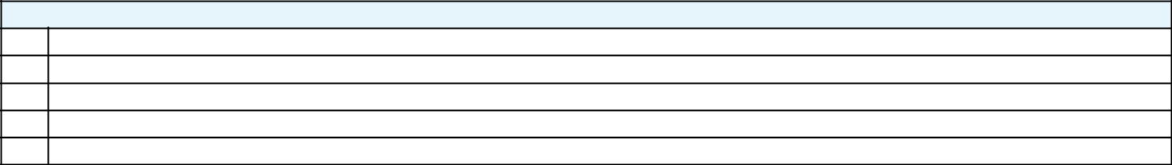

Check the appropriate box:

- Preliminary Proxy Statement

- CONFIDENTIAL, FOR USE OF THE COMMISSION ONLY (AS PERMITTED BY RULE 14a-6(e)(2)) ☑ Definitive Proxy Statement

- Definitive Additional Materials

- Soliciting Material Pursuant to ss.240.14a-12

GENERAL MOTORS COMPANY

(Name of Registrant as Specified In Its Charter)

(Name of Person(s) Filing Proxy Statement, if other than the Registrant)
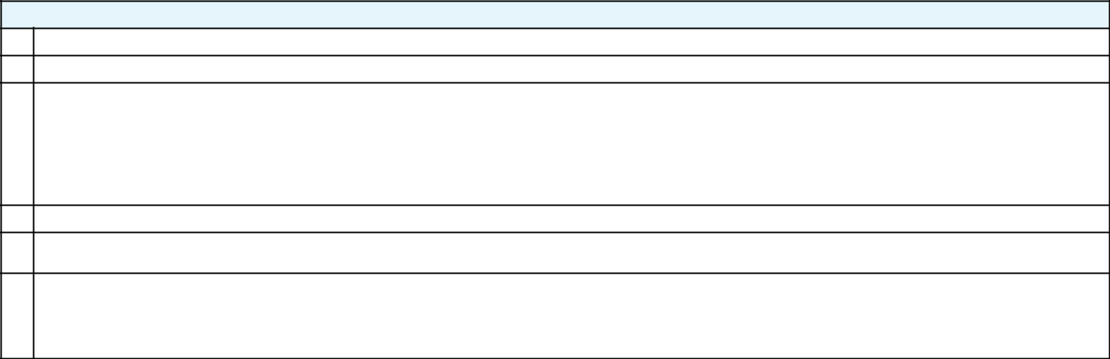

Payment of Filing Fee (Check the appropriate box):

- No fee required.

- Fee computed on table below per Exchange Act Rules 14a-6(i)(14) and 0-11.

  - Title of each class of securities to which transaction applies:

  - Aggregate number of securities to which transaction applies:

  - Per unit price or other underlying value of transaction computed pursuant to Exchange Act Rule 0-11 (set forth the amount on which the filing fee is calculated and state how it was determined):

  - Proposed maximum aggregate value of transaction:

  - Total fee paid:

- Fee paid previously with preliminary materials.

- Check box if any part of the fee is offset as provided by Exchange Act Rule 0-11(a)(2) and identify the filing for which the offsetting fee was paid previously. Identify the previous filing by registration statement number, or the Form or Schedule and the date of its filing.

  - Amount Previously Paid:

  - Form, Schedule or Registration Statement No.:

  - Filing Party:

  - Date Filed:

Table of Contents
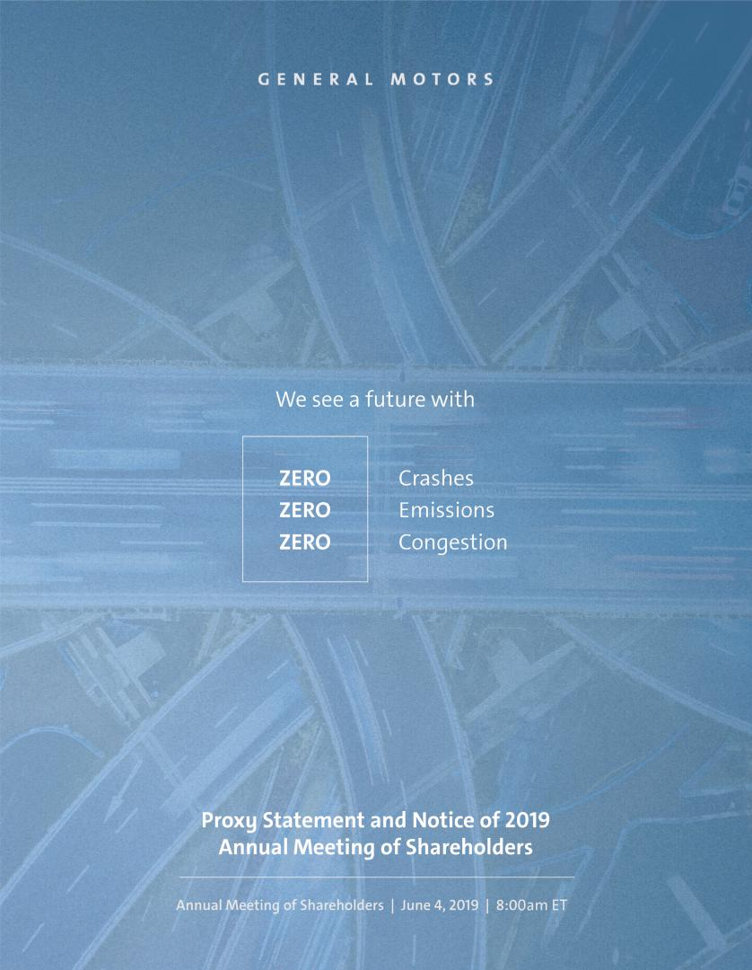

Table of Contents
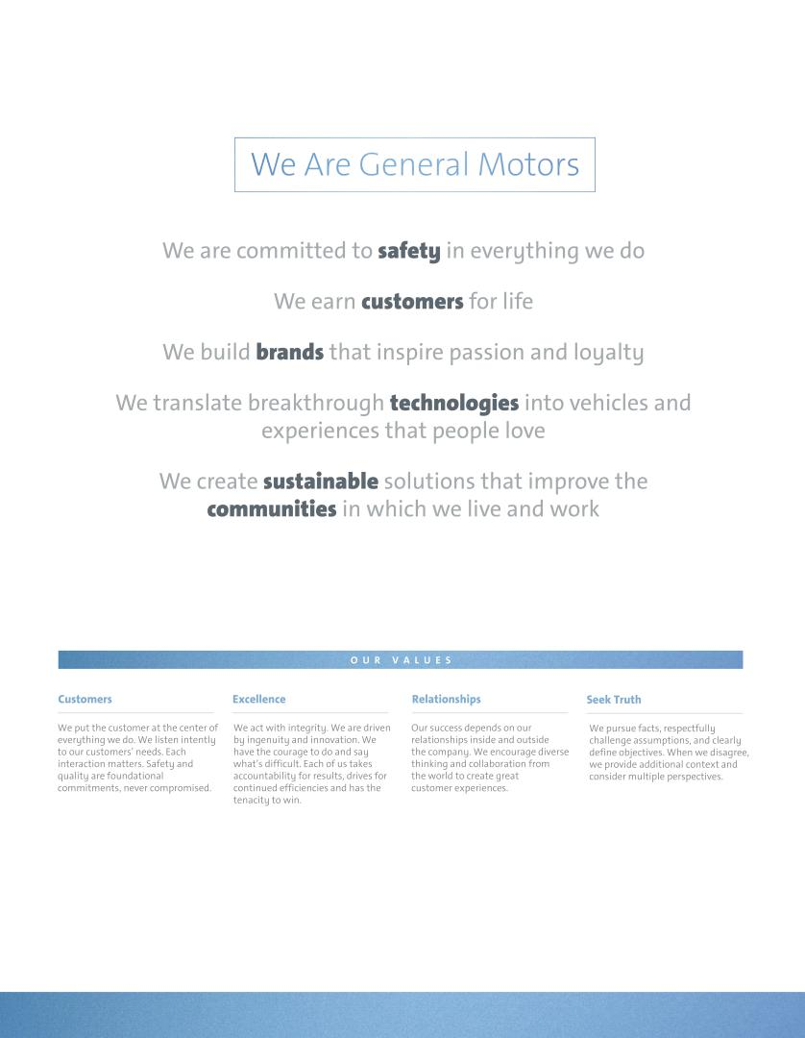

Table of Contents
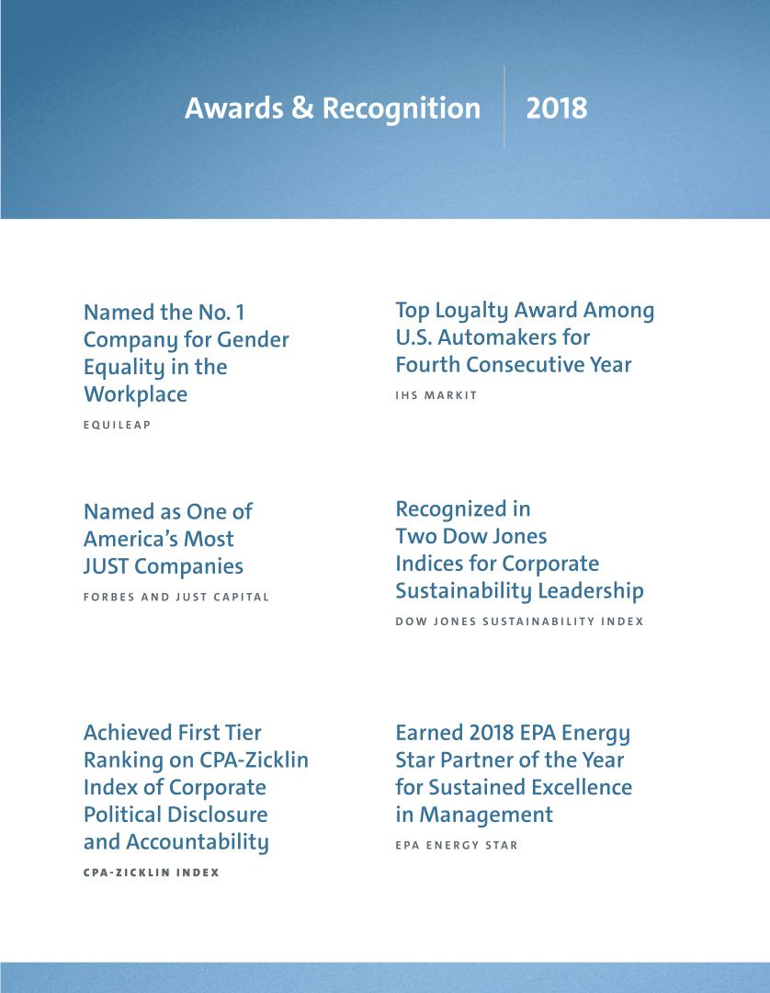

Table of Contents

We Are General Motors:


Accelerating GM’s Strategic

and Cultural Transformation

Boardroom perspectives from Mary Barra and Tim Solso

MARY T. BARRA THEODORE M. SOLSO

Chairman & Chief Executive Officer Independent Lead Director

How would you describe GM’s purpose and vision?

MARY: Our vision is to create a world with zero crashes, zero emissions, and zero congestion. Today’s technologies give us a unique opportunity to make personal mobility better, safer, and more sustainable. Each year, more than one million people are killed in crashes around the world – 40,000 in the U.S. alone. When you consider that human error is behind more than 90% of these crashes, we believe autonomous vehicles (“AVs”) will save lives.

We are fully committed to an all-electric future, and we are already building on the momentum of the groundbreaking Chevrolet Bolt EV. In January, we announced that our Cadillac brand will lead the way on our next-generation electric vehicle (“EV”) technology. At the same time, we are improving the efficiency of today’s vehicles with lightweighting and sophisticated new transmissions and engines. To redefine the future of transportation, we must execute with speed and discipline, and I am confident we have the team and the technology to lead.

How do you think about culture at GM?

MARY: Our culture will determine the long-term success of the Company. I’ve heard from many employees who feel that they are part of something bigger and who are excited about making a positive impact on the world.

We have been on a cultural journey since 2014, when the ignition switch recall threatened our recovery from bankruptcy. At our senior leadership team meeting that year, we realized that to

i

transform our culture, we needed to address the underlying issues that were holding us back. So as a team we aligned ourselves around a shared set of behaviors built on our core values that continue to guide our actions today. Since that time, we have introduced various initiatives to create a workplace and culture in which our team members can thrive, yet be accountable for their performance.

TIM: Your Board of Directors (the “Board”) believes that culture is key to realizing GM’s vision of zero crashes, zero emissions, and zero congestion. By sharing our outside perspectives, your Board has helped GM reshape its behaviors and ultimately, its culture, as it continues its transformation.

In November 2018, GM announced a comprehensive plan to accelerate its strategic transformation. Can you discuss why you took these actions?

TIM: We have been navigating the dramatic changes facing our industry and taking decisive actions to stay in front of this change. Over the years we have strengthened our core business by deploying resources in regions and franchises where we see higher-return opportunities over the long term.

MARY: Our focus all along has been to reposition the Company from one of trying to be all things to all people in all markets to one that is strategic, agile, and profitable. By accelerating GM’s transformation, we can more rapidly invest in the future of personal mobility. Our transformation plan involves tough but necessary actions. We took these actions following significant feedback and input from the Board – input that began during our annual strategic review in 2017 and continued throughout 2018. This is a dynamic transformation process, and we will continue to look around corners and over the horizon to make strategic decisions that strengthen our business today and position it for long-term success.

What is GM doing to create a more sustainable future?

TIM: Your Board understands that for GM to remain a compelling investment opportunity, the Company must contribute to a safer, more sustainable future, particularly through continued efforts to reduce emissions from vehicles and facilities. GM is committed to an all-electric future as well as maintaining a sustainable supply chain. For example, in 2018, GM sourced 20% of its total power from renewable sources – leading the automotive sector and progressing towards our commitment to source 100% of our power from renewable sources by 2050.

MARY: We believe in the science of climate change, and we recognize that the transportation sector is a contributor to global greenhouse gas emissions. We have called on lawmakers to establish a National Zero Emission Vehicle program – a comprehensive approach to drive the scale and infrastructure investments needed to enable the U.S. to lead the way to a zero-emissions future – as well as enact complementary policies to spur market acceptance and commercialization of EVs.

Table of Contents

Notice of 2019 Annual Meeting of Shareholders

April 18, 2019

Dear Fellow Shareholder:

The Board of Directors of General Motors Company (“General Motors,” “GM,” “the Company,” “we,” and “our”) cordially invites you to attend the 2019 Annual Meeting of Shareholders (“Annual Meeting”) on June 4, 2019, at 8:00 a.m. Eastern Time.

The Annual Meeting will be conducted online only, via live video webcast. You will be able to attend the meeting exclusively online and submit questions before and during the meeting by visiting gm.onlineshareholdermeeting.com. You will also be able to vote your shares electronically during the meeting.


Details about how to attend the Annual Meeting online and how to submit questions and cast your votes are provided under “Important Information About GM’s Online Annual Meeting” on the next page and “General Information About the Annual Meeting” on page 78.

At the Annual Meeting, you will be asked to:

- Elect the 11 Board-recommended director nominees named in this Proxy Statement;

- Approve, on an advisory basis, named executive officer (“NEO”) compensation;

- Ratify the selection of Ernst & Young LLP as the Company’s independent registered public accounting firm for 2019;

- Vote on two Rule 14a-8 shareholder proposals, if properly presented at the meeting; and

- Transact any other business that is properly presented at the meeting.

Record Date:

If you were a holder of record of GM common stock at the close of business on April 8, 2019, you are entitled to vote at the Annual Meeting. This Proxy Statement is provided in conjunction with GM’s solicitation of proxies to be used at the Annual Meeting. In addition to this Proxy Statement and proxy card or voting instruction form, the GM 2018 Annual Report on Form 10-K is provided in this package or is available on the internet.

Thank you for your interest in General Motors Company.

By Order of the Board of Directors,

Rick E. Hansen

Corporate Secretary

Meeting Information:
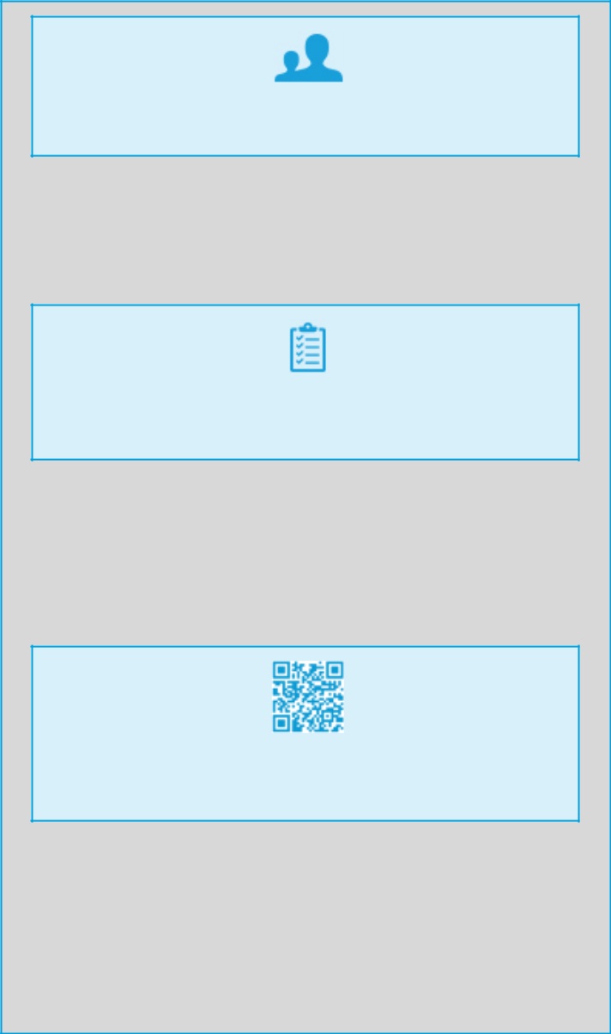

Date: June 4, 2019

Time: 8:00 a.m. Eastern Time

Place: Online via live webcast at gm.onlineshareholdermeeting.com

Your vote is important.

Please promptly submit your vote by internet, by telephone, or by signing, dating, and returning the enclosed proxy card or voting instruction form in the postage-paid envelope provided so that your shares will be represented and voted at the meeting.

We are first mailing these proxy materials to our shareholders on or about April 18, 2019.

How You Can Access the
Proxy Materials Online:

Important Notice Regarding the Availability of Proxy Materials for the 2019 Annual Meeting of Shareholders to Be Held on June 4, 2019.

Our Proxy Statement and 2018 Annual Report on Form 10-K are available at investor.gm.com/shareholder. You may scan the QR code above with your smartphone or other mobile device to view our Proxy Statement and Annual Report on Form 10-K.

ii

Table of Contents

Important Information About GM’s Online Annual Meeting

GM’s 2019 Annual Meeting will be conducted online only, via live video webcast. If you were a holder of record of GM common stock at the close of business on April 8, 2019, you are entitled to participate in the annual meeting on June 4, 2019. Below are some frequently asked questions regarding the new online format for our Annual Meeting.
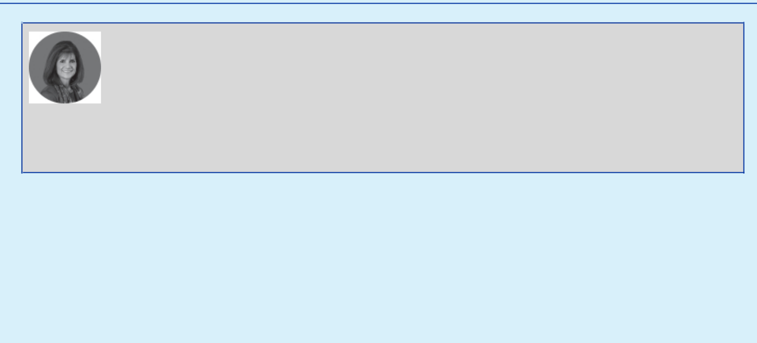

Patricia F. Russo Governance and Corporate Responsibility Committee Chair

Why did the Board decide to adopt an online format for the 2019 Annual Meeting?

“Your Board believes the online format will enhance attendance by providing convenient meeting access to all of our shareholders, regardless of where they live – not just those shareholders who have the time and means to travel to an in-person meeting. Over the past five years, attendance at our Annual Meeting has averaged less then 35 shareholders. This year, even shareholders without an internet connection or a computer will be able to listen to the meeting by calling a toll-free telephone number. In addition, we believe the online format will provide a better opportunity for shareholders to communicate with your Board by submitting questions before and during the meeting through the online portal and by calling in live via telephone during the meeting. Finally, the online meeting format will also eliminate many of the costs associated with holding a physical meeting, which is a smart choice for GM and its shareholders. We look forward to increasing participation this year while lowering operating costs for the Company.”

u How can I view and participate in the Annual Meeting? To participate, visit gm.onlineshareholdermeeting.com and login with your 16-digit control number included in your proxy materials.

u When can I join the Annual Meeting online? You may begin to log into the meeting platform beginning at 7:45 a.m. Eastern Time on June 4, 2019.

The meeting will begin promptly at 8:00 a.m. Eastern Time on June 4, 2019.

u How can I ask questions and vote? We encourage you to submit your questions and vote in advance by visiting proxyvote.com. Shareholders will also be permitted to ask questions by telephone during the meeting (subject to time restrictions). Shareholders may also vote and submit questions online in advance of and during the meeting. To participate in the meeting webcast visit gm.onlineshareholdermeeting.com.


COMMITMENT TO TRANSPARENCY

If there are questions pertinent to meeting matters that cannot be answered during the Annual Meeting due to time constraints, management will post answers to a representative set of such questions at investor.gm.com/shareholder. The questions and answers will be available as soon as practicable after the meeting and will remain available until GM’s 2020 Proxy Statement is filed.

u What if I lost my 16-digit control number? You will be able to login as a guest. To view the meeting webcast visit gm.onlineshareholdermeeting.com and register as a guest. You will not be able to vote your shares or submit questions during the meeting.

u What if I don’t have internet access? Please call (877) 328-2502 (toll free) or (412) 317-5419 (international) to listen to the meeting proceedings.

You will not be able to vote your shares during the meeting.

u What if I experience technical difficulties? Please call (800) 586-1548 (U.S.) or (303) 562-9288 (International) for assistance.

u Where can I find additional information? For additional information about how to attend the Annual Meeting, please see “General Information About the Annual Meeting” on page 78.

u What if I have additional questions? You may contact GM Shareholder Relations at shareholder.relations@gm.com or (313) 667-1432 for assistance.

iii

Table of Contents

Table of Contents

PROXY STATEMENT SUMMARY |  |  |  |  |  |  |  | 1
Agenda and Voting Recommendations |  |  |  |  |  |  |  | 1
Board Nominees |  |  |  |  |  |  |  | 1
Governance Highlights |  |  |  |  |  |  |  | 3
2018 Performance Snapshot |  |  |  |  |  |  |  | 4
Our Capital Allocation Framework |  |  |  |  |  |  |  | 5
Executive Compensation Highlights |  |  |  |  |  |  |  | 6
Environmental and Sustainability Performance |  |  |  |  |  |  |  | 7

ITEM NO. 1 – ELECTION OF DIRECTORS |  |  |  |  |  |  |  | 8
Overview of Your Board Nominees |  |  |  |  |  |  |  | 8
Board Membership Criteria, Refreshment, and Succession
 | Planning |  |  |  |  |  |  | 10
Your Board’s Nominees for Director |  |  |  |  |  |  |  | 11
Non-Employee Director Compensation |  |  |  |  |  |  |  | 18

CORPORATE GOVERNANCE |  |  |  |  |  |  |  |  |  |  |  |  |  |  |  |  |  |  |  |  |  |  | 21
Role of the Board of Directors |  |  |  |  |  |  |  |  |  |  |  |  |  |  |  |  |  |  |  |  |  |  | 21
Board Size |  |  |  |  |  |  |  |  |  |  |  |  |  |  |  |  |  |  |  |  |  |  | 21
Code of Business Conduct and Ethics: “Winning with
 | Integrity” |  |  |  |  |  |  |  |  |  |  |  |  |  |  |  |  |  |  |  |  |  | 21
Corporate Governance Guidelines |  |  |  |  |  |  |  |  |  |  |  |  |  |  |  |  |  |  |  |  |  |  | 22
Director Independence |  |  |  |  |  |  |  |  |  |  |  |  |  |  |  |  |  |  |  |  |  |  | 22
Board Leadership Structure |  |  |  |  |  |  |  |  |  |  |  |  |  |  |  |  |  |  |  |  |  |  | 22
Executive Sessions |  |  |  |  |  |  |  |  |  |  |  |  |  |  |  |  |  |  |  |  |  |  | 24
Board Committees |  |  |  |  |  |  |  |  |  |  |  |  |  |  |  |  |  |  |  |  |  |  | 24
Access to Outside Advisors |  |  |  |  |  |  |  |  |  |  |  |  |  |  |  |  |  |  |  |  |  |  | 28
Board and Committee Meetings and Attendance |  |  |  |  |  |  |  |  |  |  |  |  |  |  |  |  |  |  |  |  |  |  | 28
Board and Committee Oversight of Risk |  |  |  |  |  |  |  |  |  |  |  |  |  |  |  |  |  |  |  |  |  |  | 28
People Development |  |  |  |  |  |  |  |  |  |  |  |  |  |  |  |  |  |  |  |  |  |  | 29
CEO Succession Planning |  |  |  |  |  |  |  |  |  |  |  |  |  |  |  |  |  |  |  |  |  |  | 29
Board and Committee Evaluations |  |  |  |  |  |  |  |  |  |  |  |  |  |  |  |  |  |  |  |  |  |  | 29
Annual Evaluation of CEO |  |  |  |  |  |  |  |  |  |  |  |  |  |  |  |  |  |  |  |  |  |  | 30
Director Orientation and Continuing Education |  |  |  |  |  |  |  |  |  |  |  |  |  |  |  |  |  |  |  |  |  |  | 30
Director Service on Other Public Company Boards |  |  |  |  |  |  |  |  |  |  |  |  |  |  |  |  |  |  |  |  |  |  | 31
Compensation Committee Interlocks and Insider
 | Participation |  |  |  |  |  |  |  |  |  |  |  |  |  |  |  |  |  |  |  |  |  | 31
Shareholder Engagement |  |  |  |  |  |  |  |  |  |  |  |  |  |  |  |  |  |  |  |  |  |  | 31
Shareholder Protections |  |  |  |  |  |  |  |  |  |  |  |  |  |  |  |  |  |  |  |  |  |  | 32
Corporate Political Contributions and Lobbying
 | Expenditures |  |  |  |  |  |  |  |  |  |  |  |  |  |  |  |  |  |  |  |  |  | 33
Certain Relationships and Related Party Transactions |  |  |  |  |  |  |  |  |  |  |  |  |  |  |  |  |  |  |  |  |  |  | 33

EXECUTIVE COMPENSATION |  |  |  |  |  |  |  |  |  |  |  |  |  |  |  |  |  |  |  |  |  |  |  |  |  |  |  |  |  |  |  |  |  |  |  |  | 37
Compensation Overview |  |  |  |  |  |  |  |  |  |  |  |  |  |  |  |  |  |  |  |  |  |  |  |  |  |  |  |  |  |  |  |  |  |  |  |  | 38
Compensation Principles |  |  |  |  |  |  |  |  |  |  |  |  |  |  |  |  |  |  |  |  |  |  |  |  |  |  |  |  |  |  |  |  |  |  |  |  | 44
Compensation Elements |  |  |  |  |  |  |  |  |  |  |  |  |  |  |  |  |  |  |  |  |  |  |  |  |  |  |  |  |  |  |  |  |  |  |  |  | 44
Performance Measures |  |  |  |  |  |  |  |  |  |  |  |  |  |  |  |  |  |  |  |  |  |  |  |  |  |  |  |  |  |  |  |  |  |  |  |  | 45
Performance Results and Compensation Decisions |  |  |  |  |  |  |  |  |  |  |  |  |  |  |  |  |  |  |  |  |  |  |  |  |  |  |  |  |  |  |  |  |  |  |  |  | 47
Compensation Policies and Governance Practices |  |  |  |  |  |  |  |  |  |  |  |  |  |  |  |  |  |  |  |  |  |  |  |  |  |  |  |  |  |  |  |  |  |  |  |  | 55
Compensation Committee Report |  |  |  |  |  |  |  |  |  |  |  |  |  |  |  |  |  |  |  |  |  |  |  |  |  |  |  |  |  |  |  |  |  |  |  |  | 57
Executive Compensation Tables |  |  |  |  |  |  |  |  |  |  |  |  |  |  |  |  |  |  |  |  |  |  |  |  |  |  |  |  |  |  |  |  |  |  |  |  | 58
Equity Compensation Plan Information |  |  |  |  |  |  |  |  |  |  |  |  |  |  |  |  |  |  |  |  |  |  |  |  |  |  |  |  |  |  |  |  |  |  |  |  | 68
ITEM NO. 2 – |  |  |  |  |  |  |  | Board Proposal to Approve, on an
 |  |  |  |  |  |  |  | Advisory Basis, Named |  |  |  |  |  |  |  |  |  |  |  |  |  |  |  |  |  |  |  |  |  |  |  |  |  |  |  |  | 69
 |  |  |  |  |  |  |  | Executive Officer Compensation |  |  |  |  |  |  |  |  |  |  |  |  |  |  |  |  |  |  |  |  |  |  |  |  |  |  |  |  | 69
ITEM NO. 3 – |  |  |  |  |  |  |  | Board Proposal to Ratify the
 |  |  |  |  |  |  |  | Selection of Ernst & Young |  |  |  |  |  |  |  |  |  |  |  |  |  |  |  |  | LLP as
 |  |  |  |  |  |  |  | the Company’s Independent
 |  |  |  |  |  |  |  | Registered Public Accounting |  |  |  |  |  |  |  |  |  |  |  |  |  |  |  |  |  | Firm |  |  |  |  |  |  |  |  |  |  | 70
 |  |  |  |  |  |  |  | for 2019 |  |  |  |  |  |  |  |  |  |  |  |  |  |  |  |  |  |  |  |  |  |  |  |  |  |  |  |  | 70
Audit Committee Report |  |  |  |  |  |  |  |  |  |  |  |  |  |  |  |  |  |  |  |  |  |  |  |  |  |  |  |  |  |  |  |  |  |  |  |  | 71
Fees Paid to Independent Registered Public Accounting
 |  | Firm |  |  |  |  |  |  |  |  |  |  |  |  |  |  |  |  |  |  |  |  |  |  |  |  |  |  |  |  |  |  |  |  |  |  | 72
ITEM NO. 4 – |  |  |  |  |  |  |  | Shareholder Proposal Regarding |  |  |  |  |  |  |  |  |  |  |  |  |  |  |  |  |  |  |  |  |  |  |  |  |  |  |  |  | 73
 |  |  |  |  |  |  |  | Independent Board Chairman |  |  |  |  |  |  |  |  |  |  |  |  |  |  |  |  |  |  |  |  |  |  |  |  |  |  |  |  | 73
ITEM NO. 5 – |  |  |  |  |  |  |  | Shareholder Proposal Regarding
 |  |  |  |  |  |  |  | Report on Lobbying |  |  |  |  |  |  |  |  |  |  |  |  |  |  |  |  |  |  |  |  |  |  |  |  |  |  |  |  | 76
 |  |  |  |  |  |  |  | Communications and Activities |  |  |  |  |  |  |  |  |  |  |  |  |  |  |  |  |  |  |  |  |  |  |  |  |  |  |  |  | 76
GENERAL INFORMATION ABOUT |  |  |  |  |  |  |  |  |  |  |  |  |  |  |  |  |  |  |  |  |  |  |  |  |  |  |  |  |  |  |  |  |  |  |  |  | 78
THE ANNUAL MEETING |  |  |  |  |  |  |  |  |  |  |  |  |  |  |  |  |  |  |  |  |  |  |  |  |  |  |  |  |  |  |  |  |  |  |  |  | 78
APPENDIX A – |  |  |  |  |  |  |  | Non-GAAP Financial Measures |  |  |  |  |  |  |  |  |  |  |  |  |  |  |  |  |  |  |  |  |  |  |  |  |  |  |  |  | A-
 |  |  |  |  |  |  |  |  |  |  |  |  |  |  |  |  |  |  |  |  |  |  |  |  |  |  |  |  |  |  |  |  |  |  |  |  | 1
APPENDIX B – |  |  |  |  |  |  |  | Additional Information Regarding |  |  |  |  |  |  |  |  |  |  |  |  |  |  |  |  |  |  |  |  |  |  |  |  |  |  |  |  | B-
 |  |  |  |  |  |  |  | Change of Independent Registered |  |  |  |  |  |  |  |  |  |  |  |  |  |  |  |  |  |  |  |  |  |  |  |  |  |  |  |  | B-
 |  |  |  |  |  |  |  | Public Accounting Firms |  |  |  |  |  |  |  |  |  |  |  |  |  |  |  |  |  |  |  |  |  |  |  |  |  |  |  |  | 1

SECURITY OWNERSHIP INFORMATION |  |  |  |  |  | 35
Security Ownership of Directors, Named Executive Officers,
 | and Certain Other Beneficial Owners |  |  |  |  | 35
Section 16(a) Beneficial Ownership Reporting Compliance |  |  |  |  |  | 36


Cautionary Note on Forward-Looking Statements: This Proxy Statement contains “forward-looking” statements regarding GM’s current expectations within the meaning of the applicable securities laws and regulations. These statements are subject to a variety of risks and uncertainties that could cause actual results to differ materially from expectations. These risks and uncertainties include, but are not limited to, the risks detailed in GM’s filings with the Securities and Exchange Commission, including the “Risk Factors” section of GM’s Annual Report on Form 10-K for the fiscal year ended December 31, 2018. We assume no obligation to update any of these forward-looking statements.

iv

Table of Contents

PROXY STATEMENT SUMMARY

This summary highlights information contained elsewhere in this Proxy Statement. It does not contain all the information that you should consider. Please read the entire Proxy Statement carefully before voting.

Agenda and Voting Recommendations

Proposal |  |  |  |  |  |  |  |  | Board Vote Recommendation | Page Reference
BOARD PROPOSALS:
Item No. 1 – Election of Directors |  |  |  |  |  |  |  |  | FOR | 8
Item No. 2 – Approval of, on an Advisory Basis, |  |  |  |  |  |  |  |  | FOR | 69
 |  | Named Executive Officer Compensation |  |  |  |  |  |  | FOR | 69
Item No. 3 – Ratification of the Selection of
 |  | Ernst & Young LLP as the Company’s Independent |  |  |  |  |  |  | FOR | 70
 |  | Registered Public Accounting Firm for 2019 |  |  |  |  |  |  | FOR | 70
SHAREHOLDER PROPOSALS:
Item No. 4 – Independent Board Chairman |  |  |  |  |  |  |  |  | AGAINST | 73
Item No. 5 – Report on Lobbying Communications and Activities |  |  |  |  |  |  |  |  | AGAINST | 76

Board Nominees
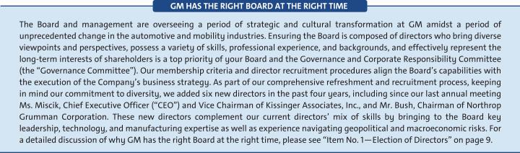

Composition of Board Nominees
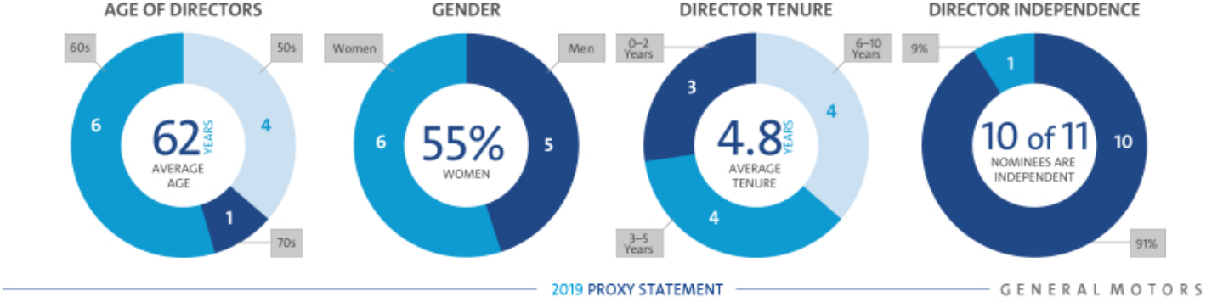

1

Table of Contents

PROXY STATEMENT SUMMARY

The following table provides summary information about each director nominee. For more detailed information about our directors, please see “Item No. 1 —Election of Directors—Your Board’s Nominees for Director” on page 11.

 |  | Director |  |  | Committee
Name | Age | Since | Principal Occupation | Independent | Memberships
Mary T. Barra | 57 | 2014 | Chairman & |  | Executive – Chair
Mary T. Barra | 57 | 2014 | Chief Executive Officer, |  | Executive – Chair
 |  |  | General Motors Company
 |  |  | Independent Lead Director,
Theodore M. Solso | 72 | 2012 | General Motors Company, and |  | Executive
 |  |  | Retired Chairman & Chief
 |  |  | Executive Officer, Cummins, Inc.
Wesley G. Bush | 58 | 2019 | Chairman, Northrop Grumman |  | Executive Compensation
 |  |  | Corporation |  | Finance
 |  |  | Retired Executive Vice President, |  | Audit
Linda R. Gooden | 66 | 2015 | Information Systems & Global |  | Cybersecurity – Chair
Linda R. Gooden | 66 | 2015 | Solutions, Lockheed Martin |  | Executive
 |  |  | Corporation |  | Risk
Joseph Jimenez | 59 | 2015 | Retired Chief Executive Officer, |  | Executive Compensation
 |  |  |  |  | Governance
 |  |  | Novartis AG |  | Governance
Jane L. Mendillo | 60 | 2016 | Retired President & |  | Finance
Jane L. Mendillo | 60 | 2016 | Chief Executive Officer, |  | Finance
 |  |  |  |  | Audit
 |  |  | Harvard Management Company |  | Audit
Judith A. Miscik | 60 | 2018 | Chief Executive Officer & |  | Risk
 |  |  |  |  | Audit
 |  |  | Vice Chairman, Kissinger Associates, Inc. |  | Audit
 |  |  | Chairman, Hewlett Packard |  | Executive
Patricia F. Russo | 66 | 2009 | Chairman, Hewlett Packard |  | Executive Compensation
 |  |  | Enterprise Company |  | Finance
 |  |  |  |  | Governance – Chair
 |  |  | Retired Executive Vice President |  | Audit – Chair
Thomas M. |  |  | Retired Executive Vice President |  | Cybersecurity
Schoewe | 66 | 2011 | & Chief Financial Officer, |  | Executive
 |  |  | Wal-Mart Stores, Inc. |  | Finance
 |  |  |  |  | Risk
Carol M. | 68 | 2009 | Retired Dean, Ivey Business |  | Executive
Stephenson | 68 | 2009 | School, The University of |  | Executive Compensation – Chair
Stephenson |  |  | Western Ontario |  | Governance
Devin N. Wenig | 52 | 2018 | President & |  | Risk
Devin N. Wenig | 52 | 2018 | Chief Executive Officer, |  | Risk
eBay Inc.

2

Table of Contents

PROXY STATEMENT SUMMARY

Governance Highlights

We recognize that strong corporate governance contributes to long-term shareholder value. We are committed to sound governance practices, including those described below.
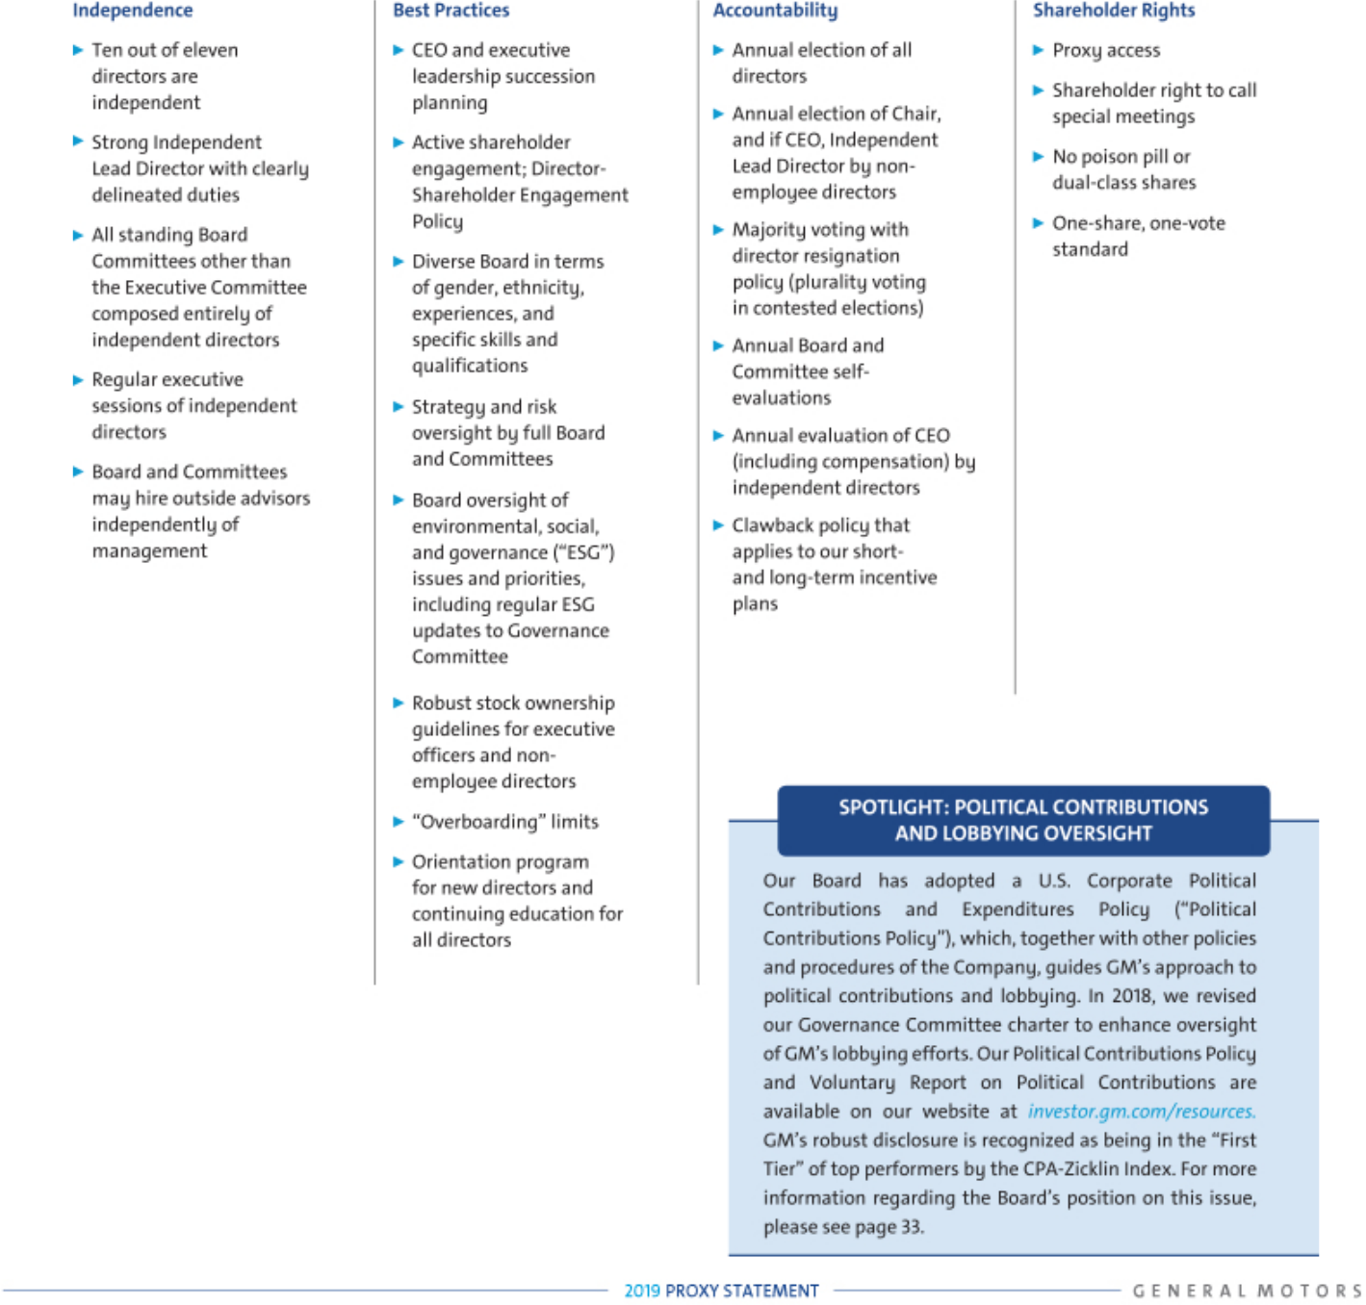

3

Table of Contents

PROXY STATEMENT SUMMARY

2018 Performance Snapshot

Full-Year 2018 Results Overview
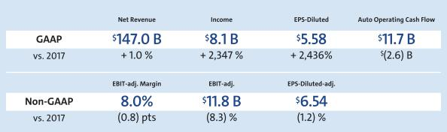

Note: The financial information above and included in this Proxy Statement relates to our continuing operations and not our discontinued operations, which consist of the Opel and Vauxhall businesses and certain other assets in Europe and the European financing subsidiaries and branches that were sold in 2017. EBIT-adjusted, EBIT-adjusted margin and EPS-diluted-adjusted are non-GAAP financial measures. Appendix A includes a reconciliation of these non-GAAP financial measures to their most directly comparable measures reported under generally accepted accounting principles in the United States.

Transformation Takes Shape in 2018


- GM reported strong full-year 2018 earnings driven by strong pricing, surging crossover sales, successful execution of the Company’s light-duty full-size truck launch, growth of GM Financial earnings, and disciplined cost control.

- In November 2018, the Company announced steps to align its product portfolio and capacity in North America with changed consumer preferences and transform its workforce to position the Company for long-term success.

- GM introduced the first production-ready autonomous vehicle built to operate safely with no driver or manual controls. GM Cruise has secured commitments of more than $5 billion from external investors who are attracted to Cruise’s integrated approach to software and hardware development.

- GM Financial had record full-year earnings and revenue performance in 2018.

- In the U.S., GM delivered nearly 3 million vehicles, helped by crossover sales that topped 1 million for the year. Average transaction prices (“ATPs”) were a record of nearly $36,000, while incentives as a percent of ATPs fell 0.3% year over year.

COMPARISON OF CUMULATIVE TOTAL RETURN

Cumulative Value of $100 Investment Through December 31, 2018

“GM delivered another strong year of earnings in a highly volatile environment in 2018. We will continue to make bold decisions to lead the transformation of this industry and drive significant shareholder value.”
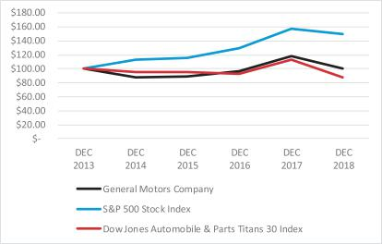

– Mary Barra, Chairman & CEO

4

Table of Contents

PROXY STATEMENT SUMMARY

Our Capital Allocation Framework

Your Board takes its role as the steward of your capital seriously. As a result, your Board has worked closely with management to establish a disciplined and transparent Capital Allocation Framework designed to drive long-term shareholder value. The Framework consists of the following three pillars:
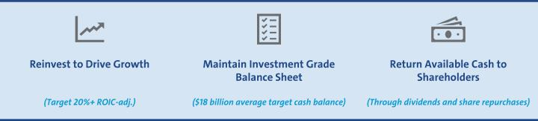

Capital Allocation Oversight: Strategic Transformation

Your Board, together with its Finance and Audit Committees, oversees GM’s critical capital allocation decisions, including establishing and maintaining the dividend rate, pursuing strategic investments, approving medium- and long-term capital plans, and maintaining GM’s overall liquidity. In November 2018, GM announced proactive steps to improve its overall business performance by driving cost efficiencies, lowering capital expenditures, and realigning manufacturing capacity with changed consumer preferences. These actions not only are expected to result in significantly improved adjusted automotive free cash flow by the end of 2020, but also will enable GM to allocate more resources to the future of mobility over the next two years. Your Board worked with management to ensure that this strategic transformation was undertaken in accordance with our Capital Allocation Framework, including by securing a $ 3 billion revolving credit facility to maintain liquidity and financial flexibility while funding immediate transformation costs. Your Board believes that over the long term, these bold decisions will enable GM to generate additional cash to fund reinvestment in higher-return growth opportunities, maintain a healthy balance sheet, and return additional cash to shareholders.

Reinvesting to Drive Growth and Returning Available Cash to Shareholders

Since 2011, GM has returned more than $25 billion to shareholders through dividends and share repurchases, while continuing to make investments in higher-return opportunities that have enhanced our ability to lead in the future of mobility and strengthened our core business. Key investments include GM’s 2016 decisions to invest in the ride-sharing company Lyft, Inc., (“Lyft”) and acquire Cruise Automation, Inc. The latter is now our subsidiary tasked with the development and commercialization of our AV technology. These strategic investments have been validated as our investment in Lyft has appreciated and Cruise has attracted $5 billion in external capital commitments.

5

Table of Contents

PROXY STATEMENT SUMMARY

Executive Compensation Highlights

We provide highlights of our compensation program below. Please review our Compensation Discussion and Analysis beginning on page 38 and the accompanying compensation tables beginning on page 58 of this Proxy Statement for a complete discussion of our compensation program.
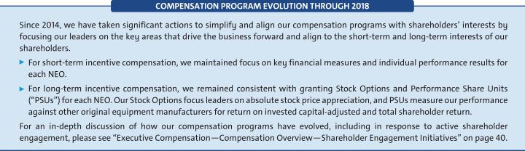

Performance-Based Compensation Structure
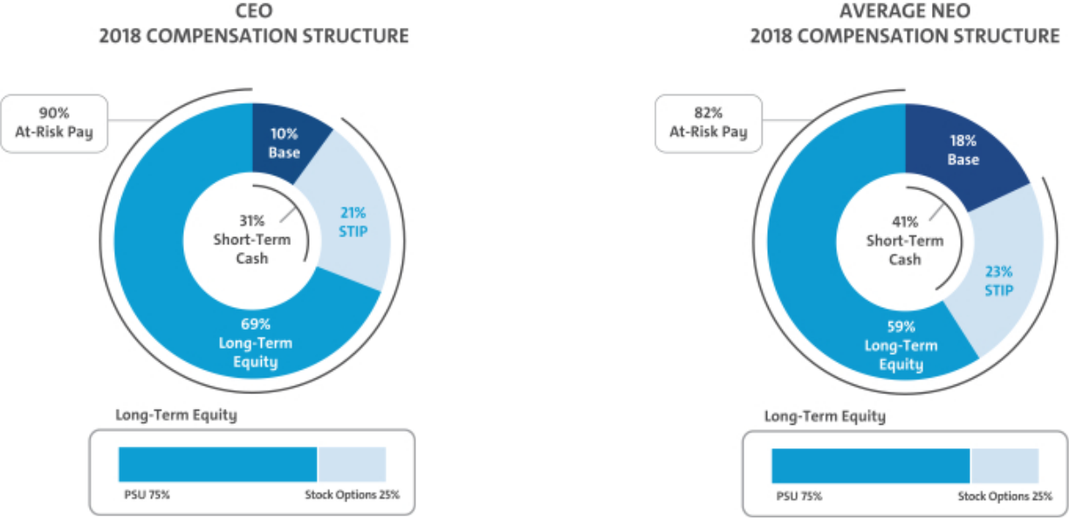

2018 Summary Compensation Snapshot

 |  |  |  |  |  | Change in
 |  |  |  |  |  | Pension
 |  |  |  |  |  | Value and
 |  |  |  |  | Nonequity | NQ Deferred
 |  |  | Stock | Option | Incentive Plan | Compensation | All Other
 | Salary | Bonus | Awards | Awards | Compensation | Earnings | Compensation | Total
Name | ($) | ($) | ($) | ($) | ($) | ($) | ($) | ($)
Mary T. Barra | 2,100,000 | — | 11,081,760 | 3,425,006 | 4,452,000 | — | 811,684 | 21,870,450
Dhivya Suryadevara | 668,100 | — | 2,446,635 | 796,263 | 1,192,500 | — | 402,592 | 5,506,090
Daniel Ammann | 1,450,000 | — | 3,993,891 | 1,234,383 | 1,921,300 | — | 372,307 | 8,971,881
Mark L. Reuss | 1,200,000 | — | 3,276,007 | 1,012,504 | 1,590,000 | — | 277,579 | 7,356,090
Alan S. Batey | 1,025,000 | — | 2,178,894 | 673,429 | 1,230,000 | — | 233,197 | 5,340,520
Charles K. Stevens, III | 1,100,000 | — | 3,255,775 | 1,006,252 | 1,320,000 | — | 257,153 | 6,939,180

Note: For additional information on the table above, please see the Summary Compensation Table in “Executive Compensation” on page 58.

6

Table of Contents

PROXY STATEMENT SUMMARY

Environmental and Sustainability Performance
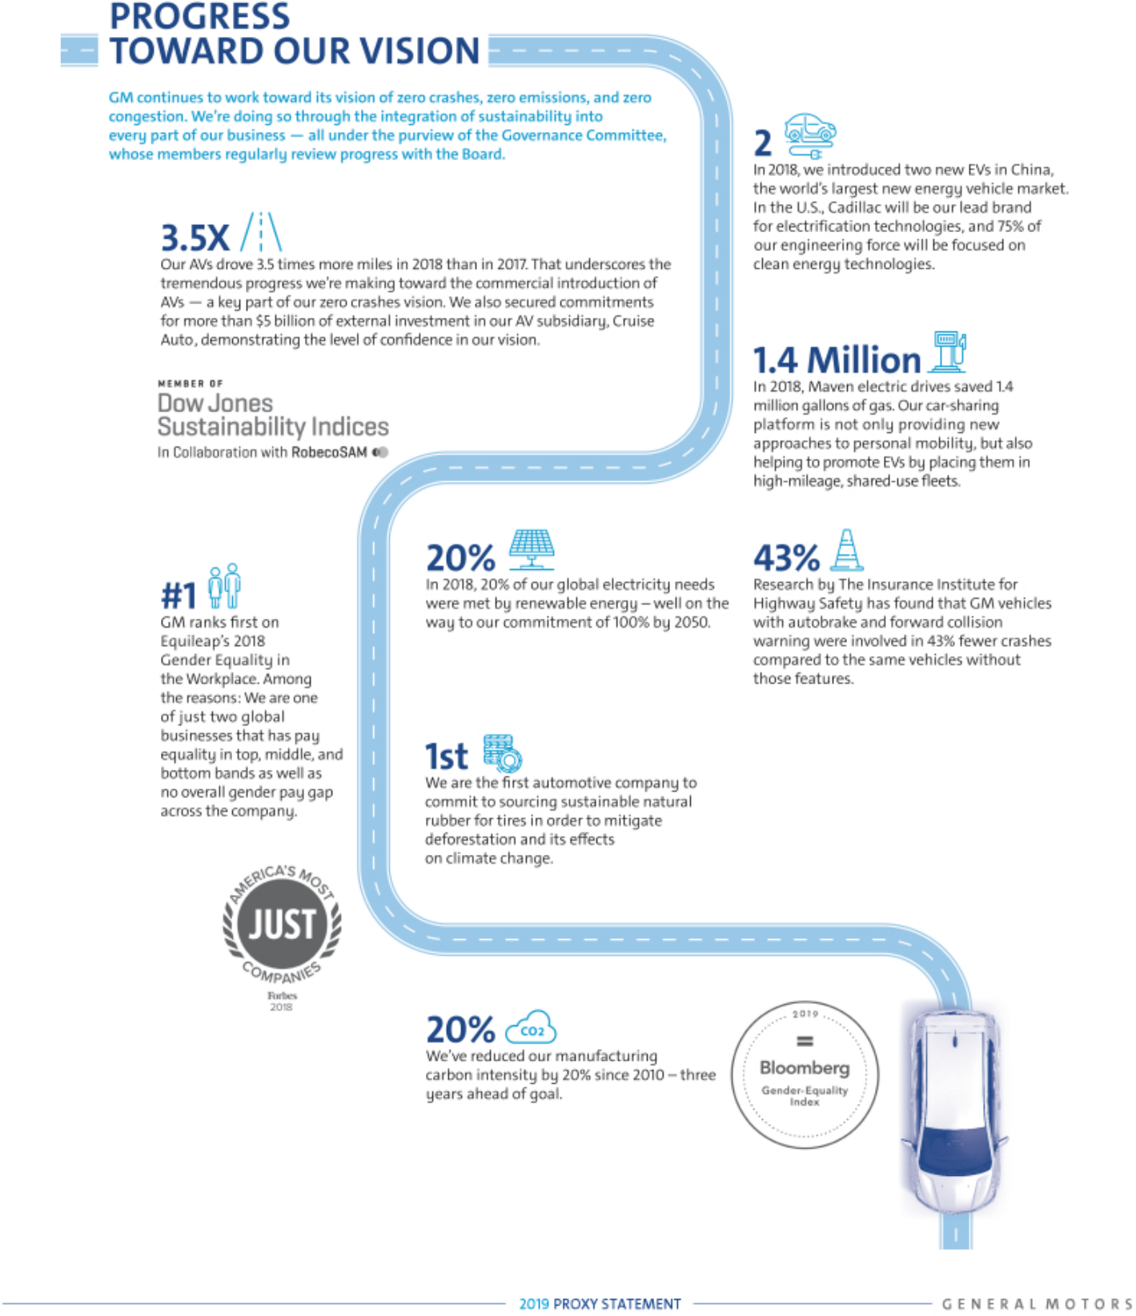

7

Table of Contents

ITEM NO. 1 – ELECTION OF DIRECTORS
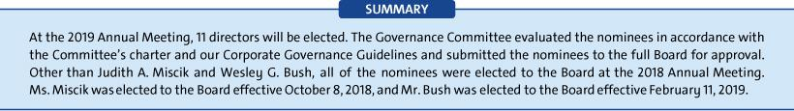

Overview of Your Board Nominees
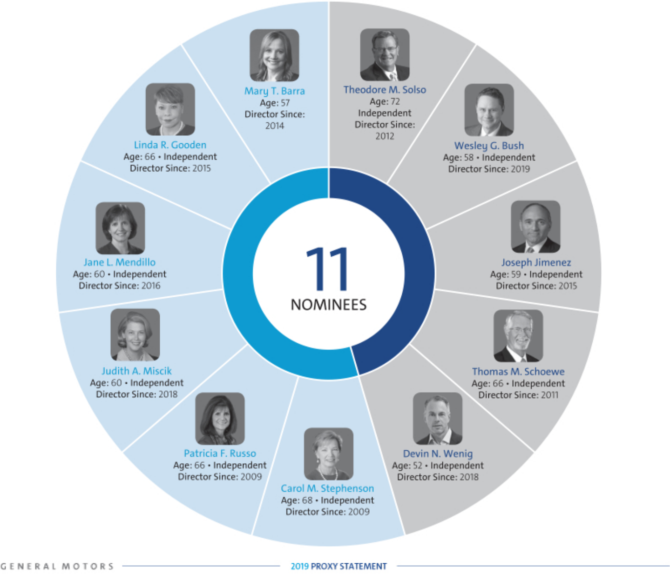

8

Table of Contents

ITEM NO. 1 – ELECTION OF DIRECTORS
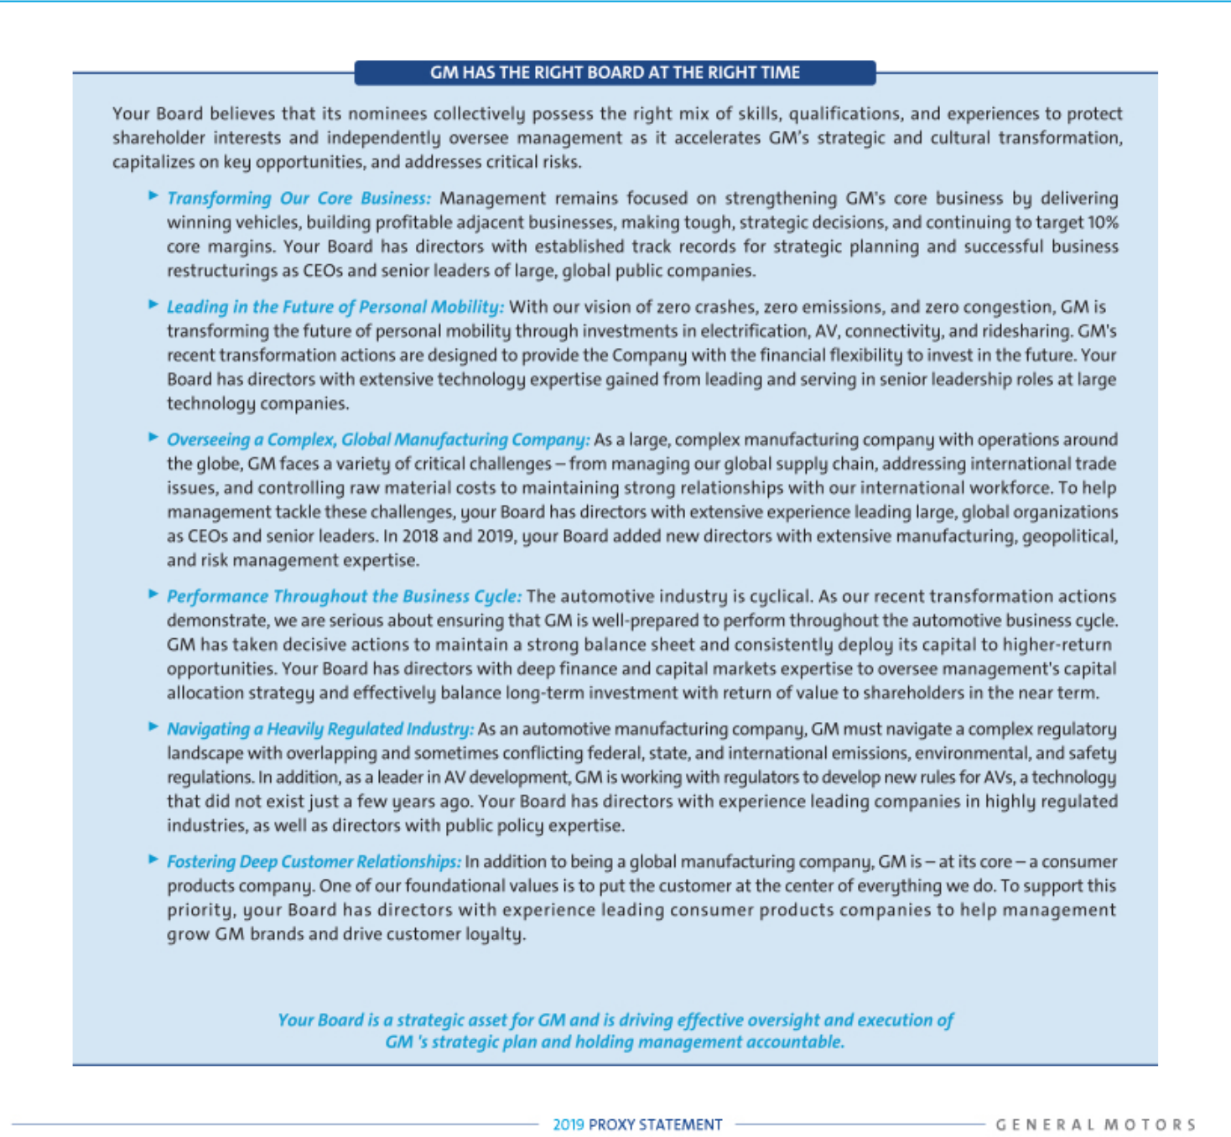

9

Table of Contents

ITEM NO. 1 – ELECTION OF DIRECTORS

Diversity of Skills, Qualifications, and Experience

Your Board nominees offer a diverse range of skills and experience in relevant areas.

SKILL/
QUALIFICATION | BARRA | SOLSO | BUSH | GOODEN | JIMENEZ | MENDILLO | MISCIK | RUSSO | SCHOEWE | STEPHENSON | WENIG
 | ● | ● | ● | ● | ● | ● | ● | ● | ● | ● | ●
 | ● | ●
 | ● | ● | ● | ● | ● |  |  | ● | ●
 | ● | ● | ● | ● |  |  |  | ● | ● | ● | ●
 | ● | ● | ● | ● | ● | ● | ● | ● | ● | ● | ●
 | ● | ● | ● | ● | ● | ● | ● | ● | ● | ● | ●
 | ● | ● | ● | ● | ● | ● |  | ● | ● | ● | ●
 |  |  |  | ● |  |  | ● |  |  | ●
 |  |  |  |  | ● |  |  | ● | ● | ● | ●
 | ● |  |  | ● | ● | ● | ● | ● |  | ●



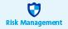





Board Membership Criteria, Refreshment, and Succession Planning

The selection of qualified directors is fundamental to the Board’s successful oversight of GM’s strategy and enterprise risks. Ensuring your Board is composed of directors who bring diverse viewpoints and perspectives, possess a variety of skills, professional experiences, and backgrounds, and effectively represent the long-term interests of shareholders is critical to your Board and the Governance Committee. The priorities for recruiting new directors are continually evolving based on the Company’s strategic needs and the skills composition of your Board at any particular time. These dynamic priorities ensure the Board remains a strategic asset capable of overseeing and helping management address the risks, trends, and opportunities that GM will face in the future.

In evaluating potential director candidates, the Governance Committee considers, among other factors, the criteria shown above in the skills and qualifications matrix for current directors and any additional characteristics that it believes one or more directors should possess based on an assessment of the needs of the Board at that time. In every case, director candidates must be able to contribute significantly to your Board’s discussion and decision-making on the broad array of complex issues facing GM. The Governance Committee also engages a reputable, qualified search firm that uses our skills matrix to inform the search and help identify and evaluate potential candidates.
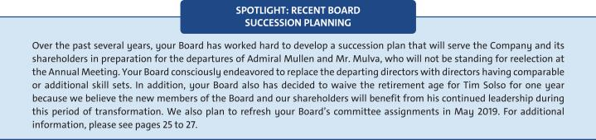

10

Table of Contents

ITEM NO. 1 – ELECTION OF DIRECTORS

- Board Diversity

The Governance Committee seeks individuals with a broad range of business experience and varied backgrounds. Although GM does not have a formal policy governing diversity among directors, your Board strives to identify candidates with diverse backgrounds. We recognize the value of overall diversity and consider members’ and candidates’ opinions, perspectives, personal and professional experiences, and backgrounds, including gender, race, ethnicity, and country of origin. We believe that the judgment and perspectives offered by a diverse board of directors improves the quality of decision making and enhances the Company’s business performance. We also believe such diversity can help the Board respond more effectively to the needs of customers, shareholders, employees, suppliers, and other stakeholders.

- Candidate Recommendations

The Governance Committee will consider persons recommended by shareholders for election to the Board. The Governance Committee will review the qualifications and experience of each recommended candidate using the same criteria for candidates proposed by Board members and communicate its decision to the candidate or the person who made the recommendation.

- Director Recruitment Process

Your Board’s Nominees for Director

Set forth below is important information about our director nominees. We believe each of your Board’s nominees is highly qualified with unique experiences that are particularly beneficial to GM.

The Board of Directors recommends a vote FOR each of the nominees below.

11

Table of Contents

ITEM NO. 1 – ELECTION OF DIRECTORS



Mary T. Barra

Chairman & Chief Executive Officer,

General Motors Company

57 years old

Director since: 2014

Committees

Executive (Chair)

Current Public Company Directorships

The Walt Disney Company

Prior Public Company Directorships

General Dynamics Corporation (2011 to 2017)

Prior Experience

Ms. Barra has served as Chairman of GM’s Board of Directors since January 2016 and Chief Executive Officer of GM since January 2014. Prior to that time, she served as Executive Vice President, Global Product Development, Purchasing and Supply Chain from 2013 to 2014; Senior Vice President, Global Product Development from 2011 to 2013; Vice President, Global Human Resources from 2009 to 2011; and Vice President, Global Manufacturing Engineering from 2008 to 2009. Ms. Barra began her career at GM in 1980.

Reasons for Nomination

- Extensive senior leadership experience as the CEO of GM and in other key leadership positions at the Company, including experience in operational excellence, strategic planning, purchasing and supply chain, human resources, and manufacturing and engineering.

- In-depth knowledge of the global automotive industry.

- Deep understanding of GM’s strengths, weaknesses, opportunities, challenges, risks, and corporate culture.
- Ability to drive the efficient execution of GM’s strategic plan and vision for the future.
- Strong leadership and management skills coupled with extensive engineering and global product development experience.
- Valuable knowledge of key governance matters gained as a director of GM and other large global public companies.

12

Theodore M. Solso

Independent Lead Director, General Motors Company, and Retired Chairman & Chief Executive Officer, Cummins, Inc.

72 years old

Director since: 2012

Committees

Executive

Current Public Company Directorships

Ad-Astra Rocket Company

Prior Public Company Directorships

Ashland Inc. (1999 to 2012) (Lead Director 2003 to 2010) and Ball Corporation (2003 to 2019) (Lead Director 2013 to 2019)

Prior Experience

Mr. Solso served as Non-Executive Chairman of the GM Board of Directors from 2014 to 2016. He was Chairman and Chief Executive Officer of Cummins, Inc., from 2000 until his retirement in 2011 and President and Chief Operating Officer of Cummins from 1995 to 2000.

Reasons for Nomination

- Extensive senior leadership experience gained as the CEO of Cummins, including automotive-related experience and experience in finance, accounting, and vehicle and workplace safety.
- Background leading a company through strong financial performance and shareholder returns, international growth, and business restructurings.
- Valuable knowledge of key governance matters, including environmental issues, corporate responsibility, diversity, and human rights issues, gained as the CEO of Cummins and the Independent Lead Director of GM and other large global public companies.

- Extensive experience in automotive manufacturing and engineering, including with respect to emissions reduction technology, development of diesel engines, and compliance with challenging emissions laws and regulations.

- Valuable insight into advancing the business priorities of GM’s international operations gained as the U.S. Chairman of the U.S.-Brazil CEO Forum.

Table of Contents

ITEM NO. 1 – ELECTION OF DIRECTORS


Wesley G. Bush

Chairman, Northrop Grumman Corporation

58 years old

Director since: 2019

Committees

Executive Compensation, Finance

Current Public Company Directorships

Northrop Grumman Corporation (“Northrop Grumman”) and Dow Inc.

Prior Public Company Directorships

Norfolk Southern Corporation

Prior Experience

In 2011, Mr. Bush was appointed Chairman of the Board of Directors of Northrop Grumman. He also served as the Chief Executive Officer of Northrop Grumman from 2010 to 2018. Prior to that, Mr. Bush served in numerous leadership roles at Northrop Grumman, including President and Chief Operating Officer, Chief Financial Officer, and President of the company’s Space Technology sector. He also served in a variety of leadership positions at TRW, Inc., before it was acquired by Northrop Grumman in 2002. He is a member of the National Academy of Engineering.

Reasons for Nomination

- Strong track record of creating shareholder value in a complex manufacturing enterprise known for its advanced engineering and technology.
- Strong financial acumen, excellent strategic instincts, and an ability to think broadly about complex business issues.
- Valuable knowledge of key governance matters, including compensation, finance, risk management, and environment, health, and safety, gained as a director of Northrop Grumman and other large global public companies.

- Valuable knowledge of key governance matters gained as a director of GM and other large global public companies.

Linda R. Gooden

Retired Executive Vice President, Information Systems &

Global Solutions, Lockheed Martin Corporation

66 years old

Director since: 2015

Committees

Audit, Cybersecurity (Chair), Executive, Risk

Current Public Company Directorships

Automatic Data Processing, Inc., and The Home Depot, Inc.

Prior Public Company Directorships

WGL Holdings, Inc., and Washington Gas & Light Company, a subsidiary of WGL Holdings, Inc.

Prior Experience

Ms. Gooden served as Executive Vice President, Information Systems & Global Solutions of Lockheed Martin Corporation (“Lockheed Martin”) from 2007 to 2013. She also served as Deputy Executive Vice President, Information and Technology Services of Lockheed Martin from October to December 2006; and President, Information Technology of Lockheed Martin from 1997 to December 2006.

Reasons for Nomination

- Significant senior leadership experience gained through various leadership positions at Lockheed Martin, including experience in technology, innovation, acquisitions, divestitures, business restructuring, and finance.

- Strong track record of identifying and mitigating enterprise risks in various senior leadership roles.
- Valuable insight into GM’s information technology (“IT”) function, technology systems and processes, and cybersecurity framework, including those related to mobility and autonomous vehicles, gained through various leadership roles at Lockheed Martin.

- Extensive expertise in cybersecurity and IT, as well as significant operational, strategic planning, and government relations experience.
- Valuable knowledge of key governance matters gained as a director of GM and other large global public companies.

13

Table of Contents

ITEM NO. 1 – ELECTION OF DIRECTORS


Joseph Jimenez

Retired Chief Executive Officer, Novartis AG

59 years old

Director since: 2015

Committees

Executive Compensation, Governance and Corporate Responsibility

Current Public Company Directorships

The Procter & Gamble Co.

Prior Public Company Directorships

Colgate-Palmolive Company (2010 to 2015)

Prior Experience

Mr. Jimenez served as Chief Executive Officer of Novartis AG (“Novartis”) from 2010 until his retirement in 2018. He was Head of Novartis’ Pharmaceuticals Division from October 2007 to 2010 and Head of Novartis’ Consumer Health Division from April to October 2007. Prior to joining Novartis, Mr. Jimenez served as Advisor to the Blackstone Group L.P., a private equity firm, from 2006 to 2007. He was President and Chief Executive Officer of H.J. Heinz Company (“Heinz”) North America from 2002 to 2006 and Executive Vice President, President and Chief Executive Officer of Heinz Europe from 1999 to 2002. Prior to joining Heinz, Mr. Jimenez held various leadership positions at ConAgra Foods Inc. (“ConAgra”), including President and Senior Vice President of two operating divisions from 1993 to 1998.

Reasons for Nomination

- Extensive senior leadership experience gained as the CEO of Novartis and in other senior leadership positions in the consumer products industry, including experience in international operations, strategic planning, and finance.

- Valuable insight into GM’s strategy to enhance the customer experience and earn customers for life gained through various senior leadership positions at Heinz and ConAgra and as a director of Procter & Gamble.

- Experience executing business restructurings and significant business transformations at both Heinz and Novartis.
- Valuable knowledge of key governance matters gained as the CEO of Novartis and a director of GM and other large global public companies.

14

Jane L. Mendillo

Retired President & Chief Executive Officer,

Harvard Management Company

60 years old

Director since: 2016

Committees

Audit, Finance

Current Public Company Directorships

Lazard Ltd.

Prior Public Company Directorships

None

Prior Experience

Ms. Mendillo served as President and Chief Executive Officer of the Harvard Management Company (“HMC”) from 2008 to 2014, managing Harvard University’s approximately $37 billion global endowment and related assets. Prior to joining HMC, she was Chief Investment Officer of Wellesley College from 2002 to 2008; and prior to that, she spent 15 years at HMC in investment management positions, including in public and private equity markets and alternative asset investments. She also serves as a Trustee to the Old Mountain Private Trust Company and a member of the board and executive committee of the Berklee College of Music. She has also previously served as Chair of the investment committee of the Partners Healthcare System; a member of the investment committees at Yale University and the Rockefeller Foundation; and a member of the board of directors and investment committees of the Mellon Foundation and the Boston Foundation.

Reasons for Nomination

- Extensive senior leadership experience gained as the CEO of HMC, including experience in risk and crisis management.
- Deep capital markets expertise gained from her more than 30 years managing globally diverse endowments and investment portfolios.
- Valuable insight into GM’s disciplined capital allocation framework and its financial policies and strategies.
- Valuable knowledge of key governance matters gained as a director of GM and another large global public company.

Table of Contents

ITEM NO. 1 – ELECTION OF DIRECTORS


Judith A. Miscik

Chief Executive Officer & Vice Chairman,

Kissinger Associates, Inc.

60 years old

Director since: 2018

Committees

Audit, Risk

Current Public Company Directorships

Morgan Stanley

Prior Public Company Directorship

EMC Corporation (2012 to 2016) and Pivotal Software, Inc.

(2014 to 2016)

Prior Experience

In July 2017, Ms. Miscik was appointed as Chief Executive Officer and Vice Chairman of Kissinger Associates, Inc. (“Kissinger Associates”). Prior to that time, she served as Co-Chief Executive Officer and Vice Chairman of Kissinger Associates from 2015 to 2017 and as President and Vice Chairman of Kissinger Associates from 2009 to 2015. Prior to joining Kissinger Associates, Ms. Miscik was the Global Head of Sovereign Risk at Lehman Brothers from 2005 to 2008 and served at the Central Intelligence Agency (“CIA”) from 1983 to 2005, where she was the Deputy Director for Intelligence from 2002 to 2005.

Reasons for Nomination

u Extensive leadership experience gained as CEO of Kissinger Associates and as Deputy Director for Intelligence at the CIA.
- Valuable experience in assessing and mitigating geopolitical and macroeconomic risks in both public and private sector roles, which will provide significant insight into GM’s overall strategy, particularly as GM navigates critical international issues such as trade and global economic conditions.

- Unique and extensive background in intelligence, security, risk analysis, and mitigation, which will provide significant insight into the Board’s oversight of GM’s enterprise risk identification and mitigation processes.

- Valuable knowledge of key governance matters gained as a director of GM and another large global company.

Patricia F. Russo

Chairman, Hewlett Packard Enterprise Company

66 years old

Director since: 2009

Committees

Executive, Executive Compensation, Finance, Governance and Corporate Responsibility (Chair)

Current Public Company Directorships

Hewlett Packard Enterprise Company (Chairman), KKR Management LLC, and Merck & Co. Inc.

Prior Public Company Directorships

Hewlett-Packard Company (2011 to 2015) (Lead Director 2014 to 2015)

and Alcoa, Inc. (2016)

Prior Experience

Ms. Russo served as Lead Director of the Hewlett-Packard Company Board of Directors from 2014 to 2015. She was Independent Lead Director of the GM Board of Directors from March 2010 to January 2014. She also served as Chief Executive Officer of Alcatel-Lucent S.A. (“Alcatel-Lucent”) from 2006 to 2008; Chairman and Chief Executive Officer of Lucent Technologies, Inc., (“Lucent”) from 2003 to 2006; and President and Chief Executive Officer of Lucent from 2002 to 2006.

Reasons for Nomination

- Extensive senior leadership gained as the CEO of Alcatel-Lucent and Lucent, including experience in corporate strategy, finance, sales and marketing, technology, and leadership development.
- Significant strategic business experience gained through managing critical technology disruptions and successfully leading Lucent through a severe industry downturn.
- Valuable insight into GM’s evaluation and execution of strategic transactions gained through experience overseeing Hewlett-Packard Company’s split into two companies, the Alcoa-Arconic split, and managing the Alcatel-Lucent merger.

- Valuable knowledge of key governance matters, including executive compensation, gained as the CEO of Alcatel-Lucent and Lucent and as a director of GM and other large global public companies.

15

Table of Contents

ITEM NO. 1 – ELECTION OF DIRECTORS


Thomas M. Schoewe

Retired Executive Vice President & Chief Financial Officer,

Wal-Mart Stores, Inc.

66 years old

Director since: 2011

Committees

Audit (Chair), Cybersecurity, Executive, Finance, Risk

Current Public Company Directorships

KKR Management LLC and Northrop Grumman Corporation

Prior Public Company Directorship

PulteGroup, Inc. (2009 to 2012)

Prior Experience

Mr. Schoewe served as Executive Vice President and Chief Financial Officer of Wal-Mart Stores, Inc. (“Wal-Mart”) from 2000 to 2011. Prior to joining Wal-Mart, he was Senior Vice President and Chief Financial Officer of Black & Decker Corporation (“Black & Decker”) from 1996 to 1999; Vice President and Chief Financial Officer of Black & Decker from 1993 to 1996; Vice President of Finance of Black & Decker from 1989 to 1993; and Vice President of Business Planning and Analysis of Black & Decker from 1986 to 1989.

Reasons for Nomination:

- Extensive financial expertise as the CFO of Wal-Mart and Black & Decker.
- Significant senior leadership experience gained in various leadership positions, including experience in financial reporting, accounting and controls, business planning and analysis, and risk management.
- Valuable insight into GM’s IT function, technology systems and processes, and cybersecurity framework gained through experience leading large-scale, transformational IT implementations at Wal-Mart and Black & Decker.

- Valuable knowledge of key governance matters gained as a director of GM and other large global public companies.

16

Carol M. Stephenson, O.C.

Retired Dean, Ivey Business School,

University of Western Ontario

68 years old

Director since: 2009

Committees

Executive, Executive Compensation (Chair), Governance and Corporate Responsibility

Current Public Company Directorships

Intact Financial Corporation (formerly ING Canada) and Maple Leaf Foods Inc.

Prior Public Company Directorships

Ballard Power Systems, Inc. (2012 to 2017) and Manitoba Telecom Services (2008 to 2016)

Prior Experience

Ms. Stephenson served as Dean of the Ivey Business School at the University of Western Ontario from 2003 until her retirement in 2013. Prior to joining the Ivey Business School, she was President and Chief Executive Officer of Lucent Technologies Canada from 1999 to 2003. She was also a member of the Advisory Board of General Motors of Canada, Limited, a GM subsidiary, from 2005 to 2009 and was appointed an officer of the Order of Canada in 2009.

Reasons for Nomination

- Significant senior leadership experience gained as Dean of the Ivey Business School and in leadership positions in the telecommunications industry.
- Valuable insight into GM’s strategy to strengthen our core business and transform the future of personal mobility gained through expertise in marketing, operations, strategic planning, technology development, and financial management.

- Extensive expertise in North American trade issues and the Canadian business environment gained as a director at several leading Canadian companies.
- Valuable knowledge of key governance matters, including executive compensation, gained as a director of GM and other large global public companies.

Table of Contents

ITEM NO. 1 – ELECTION OF DIRECTORS


Devin N. Wenig

President & Chief Executive Officer,

eBay Inc.

52 years old

Director since: 2018

Committees

Risk

Current Public Company Directorships

eBay Inc.

Prior Public Company Directorships

None

Prior Experience

In July 2015, Mr. Wenig was appointed as President and Chief Executive

Officer of eBay Inc. (“eBay”). Prior to that time, he served as President of

eBay’s Marketplaces business from 2011 to July 2015. Prior to joining

eBay, Mr. Wenig was Chief Executive Officer of Thomson Reuters

Corporation’s (“Thomson Reuters”) largest division, Thomson Reuters

Markets, from 2008 to 2011; Chief Operating Officer of Reuters Group plc

(“Reuters”) from 2006 to 2008; and President of Reuters Business

divisions from 2003 to 2006.

Reasons for Nomination

- Extensive senior leadership experience gained as the CEO of eBay, including experience in technology, global operations, and strategic planning.
- Critical technology insight into GM’s strategies related to the future of mobility, autonomous vehicles, vehicle connectivity, and data monetization gained through various roles at eBay.
- Valuable insight into GM’s strategy to enhance the customer experience and earn customers for life gained through various consumer-facing leadership roles at eBay, Thomson Reuters, and Reuters.

- Valuable knowledge of key governance matters gained as the CEO and as a director of eBay.

17

Table of Contents

ITEM NO. 1 – ELECTION OF DIRECTORS

Non-Employee Director Compensation

Our non-employee directors receive cash compensation as well as equity compensation in the form of GM Deferred Share Units (“DSUs”) for their Board service. Compensation for our non-employee directors is set by the Board at the recommendation of the Governance Committee.

- Guiding Principles


- Fairly compensate directors for their responsibilities and time commitments.

- Attract and retain highly qualified directors by offering a compensation program consistent with those at companies of similar size, scope, and complexity.

- Align the interests of directors with our shareholders by providing a significant portion of compensation in equity and requiring directors to continue to own our common stock (or common stock equivalents).

- Provide compensation that is simple and transparent to shareholders.

- Annual Review Process

The Governance Committee, which consists solely of independent directors, annually assesses the form and amount of non-employee director compensation and recommends changes, if appropriate, to the Board based upon competitive market practices. GM’s Legal Staff also supports the Committee in determining director compensation and designing the related benefit programs. In addition, if the Governance Committee determines it is necessary, it has the authority to engage the services of outside consultants, experts, and others to assist in designing and setting director compensation. As part of its annual review, the Committee conducts extensive benchmarking by reviewing director compensation data for the executive compensation peer group described in “Executive Compensation—Compensation Overview—Peer Group for Compensation Comparisons” on page 42. Following its annual review of GM’s director compensation in December 2018, the Governance Committee recommended that the Board maintain the same structure and level of compensation and stock ownership requirements for 2019 as were in place in 2018.

- Director Stock Ownership and Holding Requirements


- Each non-employee director is required to own our common stock or DSUs with a market value of at least $500,000.

- Each director has up to five years from the date he or she is first elected to the Board to meet this ownership requirement.

- Non-employee directors are prohibited from selling any GM securities or derivatives of GM securities, such as DSUs, while they are members of the Board.

- Ownership guidelines are reviewed each year to confirm they continue to be effective in aligning the interests of the Board and our shareholders.

- All of our directors are in compliance with our stock retention requirements. Ms. Miscik and Messrs. Bush and Wenig are within their five-year compliance period and are expected to meet the ownership requirement by the end of such period. All other directors have met or exceeded the ownership requirement.

- Annual Compensation

During 2018, compensation for non-employee directors consisted of the elements described in the table below. We do not pay any other retainers or meeting fees. The Independent Lead Director and Committee Chairs receive additional compensation due to the increased workload and additional responsibilities associated with these positions. In particular, Mr. Solso’s compensation as Independent Lead Director reflects the additional time commitment for this role, which includes, among other responsibilities, attending all Board Committee meetings, meeting with the Company’s investors, and attending additional meetings with the Company’s senior management, including the CEO. For additional information about the roles and responsibilities of our Independent Lead Director, see “Corporate Governance—Board Leadership Structure” on page 22.

Compensation Element | 2018
Board Retainer | $ 285,000
Independent Lead Director Fee | $ 100,000
Audit Committee Chair Fee | $30,000
All Other Committee Chair Fees (excluding the Executive Committee) | $20,000

18

Table of Contents

ITEM NO. 1 – ELECTION OF DIRECTORS

Non-employee directors are required to defer at least 50% of their annual Board retainer ($142,500) into DSUs under the General Motors Company Deferred Compensation Plan for Non-Employee Directors (the “Director Compensation Plan”). Directors may elect to defer all or half of their remaining Board retainer or amounts payable (if any) for serving as Committee Chair or Independent Lead Director into additional DSUs. The fees for a director who joins or leaves the Board or assumes additional responsibilities during the year are prorated for his or her period of service.

- How Deferred Share Units Work

Each DSU is equal in value to a share of GM common stock and is fully vested upon grant, but does not have voting rights. DSUs will not be available for disposition until after the director leaves the Board. After leaving the Board, the director will receive a cash payment or payments based on the number of DSUs in the director’s account valued at the average daily closing market price for the quarter immediately preceding payment. Directors will be paid in a lump sum or in annual installments for up to five years, based on their deferral elections. All DSUs granted are rounded up to the nearest whole unit. Any portion of the retainer that is deferred into DSUs may also earn dividend equivalents, which are credited at the end of each calendar year to each director’s account in the form of additional DSUs. DSUs granted are determined as follows:
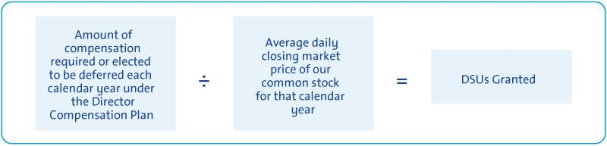

- Other Compensation

As outlined below, we provide certain additional benefits to non-employee directors.

Type |  | Purpose
u | Company Vehicles | We provide directors with the use of Company vehicles to provide feedback on our products as well
 |  | as enhance the public image of our vehicles. Retired directors also receive the use of a Company
 |  | vehicle for a period of time. Participants are charged with imputed income based on the lease value
 |  | of the vehicles and are responsible for associated taxes.
u | Personal Accident Insurance | We provide PAI coverage in the event of accidental death or dismemberment. Directors are
 | (“PAI”)⁽¹⁾ | responsible for associated taxes on the imputed income from the coverage.

- Ms. Barra, our sole employee director, does not receive additional compensation for her Board service other than the PAI benefit described above, the value of which is reported for Ms. Barra in the Summary Compensation Table on page 58.

Non-employee directors are not eligible to participate in any of the savings or retirement programs for our employees. Other than as described in this section, there are no separate benefit plans for directors.

19

Table of Contents

ITEM NO. 1 – ELECTION OF DIRECTORS

- 2018 Non-Employee Director Compensation Table

This table shows the compensation that each non-employee director received for his or her 2018 Board and Committee service.

 | Fees Earned or |  | All Other
 | Paid in Cash(1) | Stock Awards(2) | Compensation(3) | Total
Director | ($) | ($) | ($) | ($)
Linda R. Gooden | 162,500 | 126,073 | 18,782 | 307,355
Joseph Jimenez | 142,500 | 126,073 | 23,803 | 292,376
Jane L. Mendillo | 142,500 | 126,073 | 9,573 | 278,146
Judith A. Miscik⁽⁴⁾ | 35,625 | 34,487 | 1,394 | 71,506
Michael G. Mullen | 162,500 | 126,073 | 31,719 | 320,292
James J. Mulva | 162,500 | 126,073 | 29,115 | 317,688
Patricia F. Russo | 162,500 | 126,073 | 19,261 | 307,834
Thomas M. Schoewe | 172,500 | 126,073 | 37,282 | 335,855
Theodore M. Solso | 242,500 | 126,073 | 18,990 | 387,563
Carol M. Stephenson | 162,500 | 126,073 | 16,823 | 305,396
Devin N. Wenig⁽⁵⁾ | 106,875 | 97,072 | 10,889 | 214,836

- This column reflects director compensation eligible to be paid in cash, which consists of 50% of the annual Board retainer ($142,500) and any applicable Committee Chair or Independent Lead Director fees. Each of the following directors elected to receive DSUs in lieu of such amounts eligible to be paid in cash in the following amounts: Ms. Gooden—$20,000; Mr. Jimenez—$142,500; Ms. Mendillo—$142,500; Admiral Mullen—$20,000; Mr. Mulva—$162,500; Ms. Russo—$20,000; Mr. Solso
—$242,500; Ms. Stephenson—$81,250; and Mr. Wenig—$106,875.

- Reflects aggregate grant date fair value of DSUs granted in 2018, which does not include any cash fees that directors voluntarily elected to receive as DSUs. Grant date fair value is calculated by multiplying the number of DSUs granted by the closing price of GM common stock on December 31, 2018, which was $33.45. The holders of DSUs also receive dividend equivalents, which are reinvested in additional DSUs based on the market price of the common stock on the date the dividends are paid.

- The following table provides more information on the type and amount of benefits included in the All Other Compensation column.

 | Company
 | Vehicle
 | Program |  | Other
Director |  | (a) |  | (b) |  | Total
Ms. Gooden | $ | 18,542 | $ | 240 | $ | 18,782
Mr. Jimenez | $ | 23,563 | $ | 240 | $ | 23,803
Ms. Mendillo | $ | 9,333 | $ | 240 | $ | 9,573
Ms. Miscik | $ | 1,354 | $ | 40 | $ | 1,394
Admiral Mullen | $ | 31,479 | $ | 240 | $ | 31,719
Mr. Mulva | $ | 28,875 | $ | 240 | $ | 29,115

 | Company
 | Vehicle
 | Program | Other
Director | (a) | (b) | Total
Ms. Russo | $19,021 | $240 | $19,261
Mr. Schoewe | $37,042 | $240 | $37,282
Mr. Solso | $18,750 | $240 | $18,990
Ms. Stephenson | $16,583 | $240 | $16,823
Mr. Wenig | $10,729 | $160 | $10,889

  - The Company vehicle program includes the estimated annual lease value of the Company vehicles driven by directors. We include the annual lease value because it is more reflective of the value of the Company vehicle perquisite than the Company’s incremental costs, which are generally significantly lower because the Company manufactures and ordinarily disposes of Company vehicles for a profit, resulting in minimal incremental costs, if any. Taxes related to imputed income are the responsibility of each director.

  - Reflects the cost of premiums for providing personal accident insurance (annual premium cost of $240 is prorated, as applicable, for the period of service). In addition, Mr. Solso received tickets to attend a special event; the tickets had no incremental cost to the Company.

- Ms. Miscik joined the Board on October 8, 2018.

- Mr. Wenig joined the Board on April 18, 2018.

20

Table of Contents

CORPORATE GOVERNANCE

Role of the Board of Directors

GM is governed by a Board of Directors and Committees of the Board that meet throughout the year. The Board is elected by shareholders to oversee and provide guidance on the Company’s business and affairs. It is the ultimate decision-making body of the Company except for those matters reserved for shareholders by law or pursuant to the Company’s governance instruments. The Board is actively engaged in the process of strategic development and oversight of ongoing execution of the Company’s strategic plan. It oversees management’s activities

in connection with proper safeguarding of the assets of the Company, maintenance of appropriate financial and other internal controls, compliance with applicable laws and regulations, and proper governance. The Board is committed to sound corporate governance policies and practices that are designed and routinely assessed to enable the Company to operate its business responsibly, with integrity, and to position GM to compete more effectively, sustain its success, and build long-term shareholder value.


The Board is Actively Engaged in Shaping the Company’s Purpose and Overseeing

Strategy

Every year, the Board holds a multi-day session devoted to discussing, debating, challenging, and validating management’s strategic objectives, initiatives, and execution. During these discussions, directors engage in an active dialogue and shape various aspects of management’s strategy and execution. This annual strategy session is supplemented by frequent updates and discussions of GM’s strategy throughout the year – at every Board meeting and between regularly scheduled sessions as may be necessary from time to time. Since the last annual meeting, these strategy discussions included review of the Company’s recent transformation actions; Cadillac’s future growth plans; performance and strategic opportunities in China; regulatory issues related to vehicle efficiency standards; the Company’s electric vehicle execution strategy; and other issues critical to the future viability of the Company. Your Board also solicits independent views on GM’s business and key industry trends from outside experts – including investment bankers and buy- and sell-side analysts – as well as investors through its robust Director-Shareholder Engagement Policy. For additional information on shareholder engagement, please see pages 31 and 32.

Board Size

The Board sets the number of directors from time to time by resolution adopted by a majority of the directors. The Governance Committee reassesses the suitability of the Board’s size at least annually. The Board has the flexibility to increase or decrease the size of the Board as circumstances warrant. The Board is currently composed of 13 members, but Admiral Mullen and Mr. Mulva are not standing for reelection at the Annual Meeting. If

all of the Board’s nominees are elected, the Board will be composed of 11 members immediately following the Annual Meeting. If any nominee is unable to serve as a director or if any director leaves the Board between Annual Meetings, the Board, by resolution, may reduce the number of directors or elect an individual to fill the resulting vacancy.

Code of Business Conduct and Ethics: “Winning with Integrity”

The Board is committed to the highest legal and ethical standards in fulfilling its responsibilities. We have adopted a code of business conduct and ethics, “Winning with Integrity,” (“Code”) that applies to our directors, officers, and employees. “Winning with Integrity” forms the foundation for compliance with corporate policies and procedures and creates a Company-wide focus on uncompromising integrity in every aspect of our operations. The Code embodies our expectations for a number of topics, including workplace and vehicle safety, conflicts of

interest, protection of confidential information, insider trading, competition and fair dealing, human rights, community involvement and corporate citizenship, political activities and lobbying, preservation and use of Company assets, and compliance with all laws and regulations applicable to the conduct of our business. Employees are expected to report any conduct that they believe in good faith to be an actual or apparent violation of the Code.

21

Table of Contents

CORPORATE GOVERNANCE

Corporate Governance Guidelines

Our Corporate Governance Guidelines form a transparent framework for the effective governance of the Company. The Corporate Governance Guidelines address matters such as the respective roles and responsibilities of the Board and management, the Board’s leadership structure, the responsibilities of the Independent Lead Director, director independence, the Board membership criteria, Board Committees, and Board and CEO evaluation. The Governance Committee regularly reviews the Corporate Governance Guidelines and periodically recommends to your Board the adoption of amendments in response to changing regulations, evolving best practices, and shareholder concerns. For a summary of our corporate governance best practices, please see “Proxy Statement Summary—Governance Highlights” on page 3.

Find more online.


Our code of business conduct and ethics, “Winning with Integrity,” and Corporate Governance Guidelines and are available on our website at investor.gm.com/resources.

Director Independence

GM’s Bylaws and Corporate Governance Guidelines define our standards for director independence and reflect applicable New York Stock Exchange (“NYSE”) and U.S. Securities and Exchange Commission (“SEC”) requirements. At least two-thirds of our directors are and must continue to be independent under these standards. The Governance Committee annually assesses the independence of each director and makes recommendations to the Board. For a director to be “independent,” the Board must affirmatively determine that the director has no material relationship with the Company other than his or her service as a director. In addition, members of the Audit Committee and the Executive Compensation Committee (the “Compensation Committee”) must meet heightened independence standards under applicable NYSE and SEC rules. Consistent with these standards, the Board has reviewed all relationships between the Company and each director and considered all relevant quantitative and qualitative criteria. The Board has affirmatively determined that all directors were independent during 2018, and that all current members are independent, except Ms. Barra, who serves as CEO.

In recommending to the Board that it determine each director is independent, the Governance Committee considered whether there were any other facts or circumstances that might impair a director’s independence. None of these transactions were material to either GM or the director. The Governance Committee also considered that GM, in the ordinary course of business, during the last three years has sold fleet vehicles to and purchased products and services from companies at which some of our directors serve as non-employee directors or executives. The Board determined that these transactions were not material to GM or the other companies involved and that none of our directors had a material interest in transactions with these companies. In each case, these transactions were in the ordinary course of business for GM and the other companies involved and were on terms and conditions available to similarly situated customers and suppliers. Therefore, the Board determined they did not impair such director’s independence.

Board Leadership Structure

Your Board has the flexibility to decide when the positions of Chairman and CEO should be combined or separated and whether an executive or an independent director should be Chairman. This allows the Board to choose the leadership structure that will best serve the interests of our shareholders at any particular time. In January 2016, the Board recombined the positions of Chairman and CEO under the leadership of Ms. Barra and designated Mr. Solso as Independent Lead Director. For 2018, your Board unanimously voted to elect Ms. Barra as Chairman of the Board, and the independent directors unanimously voted to appoint Mr. Solso as the Independent Lead Director. The Board’s key duties include oversight of strategy, risk management, and legal and regulatory compliance as well as CEO succession planning. In each of these areas, the Board determined that a combined role of Chairman and CEO together with a strong Independent Lead Director and governance best practices is the optimal Board leadership structure for GM at this time. Mr. Solso’s perspective on your Board’s leadership structure is provided on the following page.

22

Table of Contents

CORPORATE GOVERNANCE


A Message from the Independent Lead Director Regarding Your Board’s Leadership Structure

As the Independent Lead Director, I regularly engage with GM’s investors and other key stakeholders on a variety of issues, including GM’s corporate governance structure and practices and, importantly, your Board’s leadership structure. I want to share with you the same message I deliver during these engagements.

Mary Barra Is the Right Person to Lead Your Board

Your Board carefully considers the appropriate leadership structure for GM and its shareholders on an annual basis and determines whether to combine or split the roles of Chairman and CEO. Your Board believes that Ms. Barra’s service as both Chairman and CEO has provided, and continues to provide, a clear and unified strategic vision for GM during this time of unprecedented industry change. As the individual with primary responsibility for managing the Company, Ms. Barra’s in-depth knowledge of our business and understanding of GM’s day-to-day operations brings focused leadership to your Board. She has been a key leader as we have defined our corporate purpose and vision, reset our culture of safety, and relentlessly focused on putting the customer at the center of everything we do. Her leadership of the Board is especially critical at this time as the Company implements its transformation acceleration, announced in November 2018, and prepares to negotiate important labor agreements in 2019.

Your Board Is Independent and Holds Management Accountable

Your Board holds management accountable. Ten of the eleven director nominees are independent. We have the right mix of skills, qualifications, and experiences to oversee, guide, and challenge the leadership team. We are engaged in shaping and overseeing GM’s strategy. Strategy is a part of every Board meeting, and your Board has been deeply involved in GM’s recent actions to accelerate GM’s transformation and invest in the future. During strategic discussions, Board members engage in active debate and dialogue, challenge and validate management assumptions, and shape various aspects of management’s strategy and execution.

My Role as the Independent Lead Director

My job is to complement Ms. Barra’s role as Chairman by providing strong independent leadership in my role as the Independent Lead Director with the following key duties and responsibilities:

u Presiding over all Board meetings when the Chairman is not present, including executive sessions of non-management directors, and advising the Chairman of any actions taken;

- Providing Board leadership if circumstances arise in which the role of the Chairman is potentially, or perceived to be, in conflict or if potential conflicts of interest arise for any director;

- Calling executive sessions for non-management directors, relaying feedback from these sessions to the Chairman, and implementing decisions made by the non-management directors;

- Leading non-management directors in the annual evaluation of the CEO’s performance, communicating it to the CEO, and overseeing the process for CEO succession;

- Advising on the scope, quality, quantity, and timeliness of the flow of information between management and the Board and approving Board meeting agendas and materials recommended by the Chairman;

u Approving Board meeting agendas to ensure sufficient time for discussion of all agenda items;

- Serving as a liaison between non-management directors and the Chairman when requested to do so (although all non-management directors have direct and complete access to the Chairman at any time that they deem necessary or appropriate);

- Interviewing, along with the Chair of the Governance Committee, all director candidates and making recommendations to the Governance Committee and the Board;

- Being available to advise the Chairs of the Committees of the Board in fulfilling their designated roles and responsibilities to the Board; and

- Being available, if requested by major shareholders, for consultation and communication in accordance with the Board’s Director-Shareholder Engagement Policy.

As always, I am proud to work closely with our Chairman and CEO and my fellow directors as we drive long-term shareholder value. Your Board has significantly refreshed its membership in recent years to ensure it maintains the right mix of skills, qualifications, and experiences to help lead GM through the continued transformation of its business and the automotive industry. As a part of your Board’s refreshment and succession planning, I look forward to continuing to provide strong and independent leadership throughout this important transition.

On behalf of the entire Board, thank you for your continued support.

Theodore M. Solso

Independent Lead Director

23

Table of Contents

CORPORATE GOVERNANCE

Executive Sessions

Independent directors have an opportunity to meet in executive session without management present as part of each regularly scheduled Board and Committee meeting. Executive sessions are chaired by the Independent Lead Director, Mr. Solso, or the respective Committee Chair.

During executive sessions, the independent directors may review CEO performance, compensation, and succession planning; strategy; key enterprise risks; future Board agendas and the flow of information to directors; corporate governance matters; and any other matters of importance to the Company raised during a meeting or otherwise presented by the independent directors.

The non-management directors of the Board, all of whom are independent, met in executive session six times in 2018.

Board Committees

Your Board of Directors has seven standing Committees: Audit, Cybersecurity, Executive Compensation, Finance, Governance, Risk, and Executive. The key responsibilities, recent activities, and focus areas of each Committee are set forth below, together with their current membership and the number of meetings held in 2018. Each Committee Chair meets regularly with management during the year to discuss Committee business, shape agendas, and facilitate efficient meetings. The Chairman, Ms. Barra, and the Independent Lead Director, Mr. Solso, attend all Committee meetings to serve as a resource and identify topics requiring the full Board’s attention. The Board has determined that each member of the Audit, Compensation, Governance, Cybersecurity, Finance, and Risk Committees is independent according to NYSE listing standards and our Corporate Governance Guidelines. In May 2019, we will refresh the Board’s Committee memberships and combine the Risk and the Cybersecurity Committees into a new Risk and Cybersecurity Committee. The new Committee memberships are described on pages 25 to 27.


Find more online.

Each Committee has a charter governing its activities.

Committee charters are available on our website at

investor.gm.com/resources.

24

Table of Contents

CORPORATE GOVERNANCE

Members: Thomas M. Schoewe (Chair), Linda R. Gooden, Jane L. Mendillo, Judith A. Miscik, and Michael G. Mullen


Meetings held in 2018: 7

Thomas M. Schoewe,

Chair

Key Responsibilities

- Monitors the effectiveness of GM’s financial reporting processes and systems and disclosure and internal controls;
- Selects and engages GM’s external auditors and reviews and evaluates the external auditor’s audit process;
- Reviews and evaluates the scope and performance of the internal audit function;
- Facilitates ongoing communications about GM’s financial position and affairs between the Board and the external auditors, GM’s financial and senior management, and GM’s internal audit staff;
- Reviews GM’s policies and procedures regarding ethics and compliance; and
- Oversees the preparation of the Audit Committee Report and related disclosures for the annual Proxy Statement.

The Board has determined that all members of the Audit Committee meet heightened independence and qualification criteria and are financially literate in accordance with the NYSE Corporate Governance Standards and SEC rules and that Ms. Gooden, Ms. Mendillo, and Mr. Schoewe are each qualified as an “audit committee financial expert” as defined by the SEC.
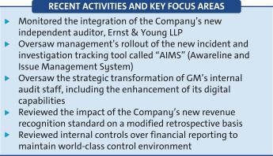

Members: Linda R. Gooden (Chair), Michael G. Mullen, and Thomas M. Schoewe


Meetings held in 2018: 4

Linda R. Gooden,

Chair

Key Responsibilities

- Oversees the effectiveness of the Company’s cybersecurity programs and its practices for identifying, assessing, and mitigating cybersecurity risks;
- Reviews the Company’s controls to prevent, detect, and respond to cyberattacks and breaches involving GM’s electronic information, intellectual property, sensitive data, connected products, and the connected ecosystem;

- Oversees management’s implementation of cybersecurity programs and risk policies and procedures and management’s actions to safeguard their effectiveness; and
- Evaluates the Company’s cyber-crisis preparedness, incident response plans, and disaster recovery capabilities.
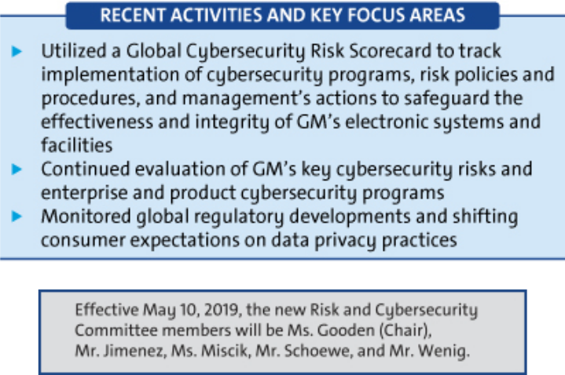

For additional information about the Audit Committee and its 2018

activities, see its report included in this Proxy Statement, beginning on

page 71.
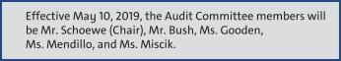

25

Table of Contents

CORPORATE GOVERNANCE

Members: Carol M. Stephenson (Chair), Wesley G. Bush, Joseph Jimenez, James J. Mulva, and Patricia F. Russo


Meetings held in 2018: 6

Carol M. Stephenson,

Chair

Key Responsibilities

- Oversees the Company’s executive compensation policies, practices, and programs;
- Reviews and approves corporate goals and objectives for compensation, evaluates performance (along with the full Board), and determines compensation levels for the Chairman and CEO;
- Reviews and approves compensation of NEOs, executive officers, and other senior leaders under its purview;
- Oversees compensation policies and practices so that the plans do not encourage unnecessary or excessive risks; and
- Oversees the Company’s compensation policies and practices that promote diversity and inclusion.

The Board has determined that all members of the Compensation Committee meet heightened independence and qualification criteria in accordance with NYSE listing standards and SEC rules. The Compensation Committee’s charter permits the Committee to delegate its authority to members of management and also form and delegate authority to subcommittees consisting of one or more members when it deems it appropriate.
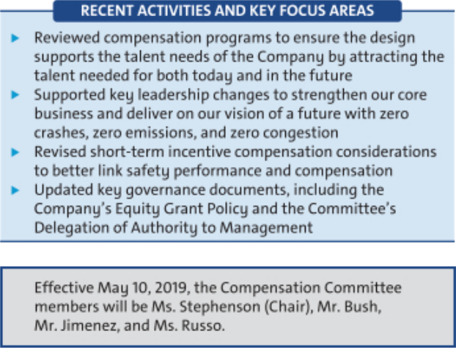

 | Members: James J. Mulva (Chair),
 | Wesley G. Bush, Jane L. Mendillo,
 | Patricia F. Russo, and Thomas M.
 | Schoewe
James J. Mulva, | Meetings held in 2018: 4
Chair


Key Responsibilities

- Assists the Board in its oversight of financial policies, strategies, and capital structure;
- Reviews the Company’s cash management policies and proposed capital plans, capital expenditures, dividend actions, stock repurchases, issuances of debt or equity securities, and credit facility and other borrowings;

- Reviews any significant financial exposures and contingent liabilities of the Company, including foreign exchange, interest rate, and commodities exposures, and the use of derivatives to hedge those exposures; and

- Reviews the regulatory compliance, administration, financing, investment performance, risk and liability profile, and funding of the Company’s U.S. pension obligations.
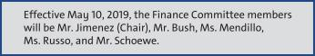

26

Table of Contents

 |  | CORPORATE GOVERNANCE
Members: Patricia F. Russo (Chair), |  | Members: Michael G. Mullen (Chair),
Joseph Jimenez, and Carol M. |  | Linda R. Gooden, Judith A. Miscik, James
Stephenson |  | J. Mulva, Thomas M. Schoewe, and Devin
 |  | N. Wenig
Meetings held in 2018: 4 |  | Admiral Michael G. Mullen, ^{Meetings held in 2018: 4}
Patricia F. Russo,
Chair |  | Chair
Key Responsibilities |  | Key Responsibilities
u Reviews the Company’s corporate governance framework, including all |  | u Assists the Board in its oversight of the Company’s risk management
significant governance policies and procedures; |  | framework and practices;
u Oversees Company policies and strategies related to corporate |  | u Reviews the Company’s risk culture, including open risk discussions
responsibility, sustainability, and political contributions and lobbying |  | and the integration of risk management into the Company’s behaviors,
activities; |  | decision making, and processes;

- Reviews the appropriate composition of the Board and recommendsu Reviews management’s evaluation of strategic and operating risks—

director nominees; | including risk concentrations, mitigating measures and the types and
u Oversees the self-evaluation process of the Board and Committees; | levels of risk that are acceptable in the pursuit and protection of
u Recommends compensation of non-employee directors to the Board; | shareholder value;
and | u Reviews the impact of the Company’s programs and practices regarding
u Reviews and approves related party transactions and any potential | vehicle and workplace safety; and
Board conflicts of interest, as applicable. | u Reviews risks related to the Company’s public policy positions in the
 | U.S. and internationally.

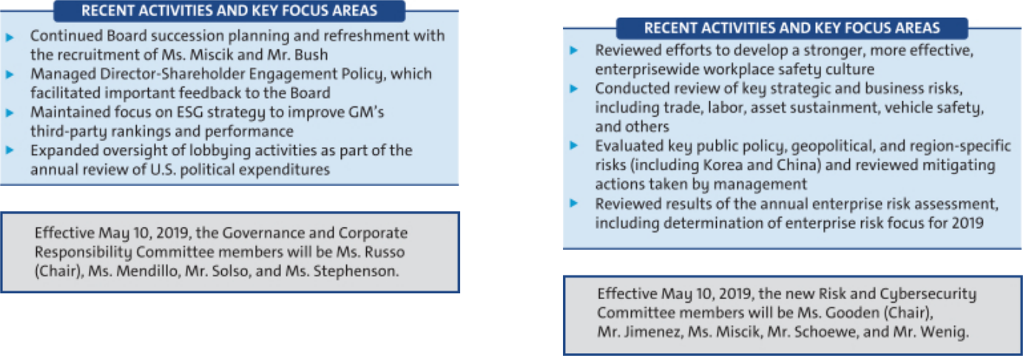

Your Board has an Executive Committee composed of the Chairman and CEO, the Independent Lead Director, and the Chairs of all other standing Committees. The Executive Committee is chaired by Ms. Barra, and it can act on certain limited

EXECUTIVE matters for the full Board in intervals between meetings of the Board. The Executive Committee meets as necessary, and all actions by the Executive Committee are reported and ratified at the next succeeding Board meeting. The Executive Committee did not meet in 2018.

27

Table of Contents

CORPORATE GOVERNANCE

Access to Outside Advisors

The Board and each Board Committee can select and retain the services of outside advisors at the Company’s expense.

Board and Committee Meetings and Attendance

In 2018, your Board held a total of 10 meetings, and average director attendance at Board and Committee meetings was 96%. Each director standing for re-election attended at least 75% of the total meetings of the Board and Committees on which he or she served in 2018. Directors are expected to attend our Annual Meeting of Shareholders, which is held in conjunction with a regularly scheduled Board meeting. All directors in office at such time attended the 2018 Annual Meeting.

Board and Committee Oversight of Risk
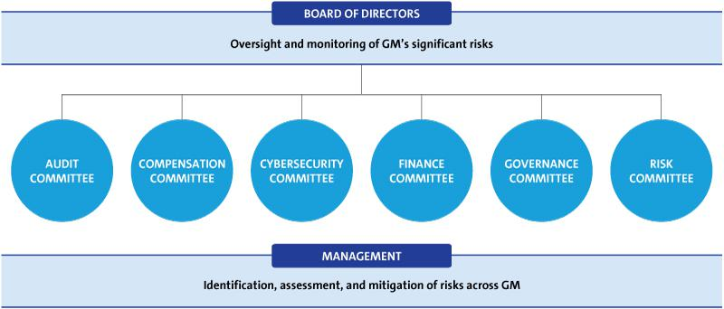

Your Board has the overall responsibility for risk oversight, with a focus on the most significant risks facing the Company. At GM, effective risk management is everyone’s responsibility, with the tone established by Ms. Barra, our CEO and Chief Risk Officer, and other members of management, specifically the Senior Leadership Team. The Senior Leadership Team also utilizes our Risk Advisory Council, an executive-level body with delegates from each business and function to discuss and monitor the most significant enterprise risks in a cross-functional setting. They are tasked with championing risk management practices and integrating them into their functional or regional business units. An annual risk assessment to prioritize the most significant enterprise risks to GM is reviewed with the Risk Committee and serves to guide the focus and selection of risks that are brought to the Risk Committee for review or covered by the full Board or Committees. Your Board discharges its risk oversight responsibilities both as a whole and through delegation to its Committees, particularly the Risk Committee. The Board receives regular reports from management on particular risks within the Company through review of the Company’s strategic plan and through regular communication with its Committees. Management provides comprehensive reports to the Risk Committee on the key strategic, operating, vehicle and workplace safety, financial, and compliance risks facing the Company, including management’s response to managing and mitigating such risks, as appropriate. The Strategic Risk Management, Compliance, and GM Audit Service teams play a key role in setting GM’s risk management guidelines, providing a consistent approach to risk and controls and independent assurance, which assists the Risk, Audit, and Cybersecurity Committees in fulfilling their oversight obligations.

The Chair of the Risk Committee coordinates with the Chairs of the other Board Committees in their review of the Company’s risks that have been delegated to these Committees to support them in coordinating the relationship between risk management policies and practices and their respective oversight responsibilities. Each of the other Committees, which meet regularly and report back to the Board, is responsible for oversight of risk management practices for categories of risks relevant to the subject matter of such Committee.

28

Table of Contents

CORPORATE GOVERNANCE

This structure allows the Company to pursue its risk management vision of:

- Creating a risk-aware culture across the enterprise to facilitate open transparent dialogue;

- Striving to focus on strategic and cross-functional analysis to identify future and emerging risks; and

- Making sure risks are taken into consideration before critical decisions are made.

As part of the risk management process, each of the Company’s business units and functions is responsible for identifying key risks that could affect the achievement of business goals and strategies or impact our customers or the environment, for assessing and prioritizing the risks, and for proposing actions to be taken to manage and mitigate such risks, as appropriate. In 2018, the Company launched a new forum, which includes the CEO and CFO, to encourage and monitor risk at a business and functional level. Each business unit and functional head reports on various risk management issues, including the integration of risk management practices into its area of responsibility, key risks to its business area, and any emerging risks. By the end of 2019, each of the Company’s business units and functions will have conducted such a review. Highlights of these reviews are provided to the Risk Committee on a quarterly basis.

Your Board believes that its structure for risk oversight provides for open communication between management and the Board and its Committees, which effectively supports management’s enterprise risk management program. In addition, strong independent directors chair each of the Committees involved in risk oversight, and all directors are involved in the risk assessment and ongoing risk reviews.

People Development


Your Board believes that one of its primary responsibilities is to oversee the development of executive-level |  | Board oversight
talent to successfully execute GM’s strategy. Management succession is regularly discussed by the directors |  | drives culture and
with the CEO and during the Board’s executive sessions. The Board reviews candidates for all senior executive |  | increases diversity
positions to confirm that qualified and diverse successor-candidates are available for all positions and that |  | and inclusive
development plans are being utilized to strengthen the skills and qualifications of successor-candidates. |  | behaviors.

The Board’s investment in people development does not stop with management succession planning. It actively takes an interest in making sure all employees are fully engaged and realizing their potential. To accomplish this, the Board annually reviews the diversity pipeline at all levels of the Company and receives an update on various hiring initiatives for diversity groups supported by the Company. At this time, the Board believes it has a deep and diverse talent pipeline from which to promote employees at all levels of the Company.

Since 2012, another tool the Board has used to monitor people development is review of results from the Company’s salaried and hourly Workplace of Choice survey. This provides the Board with feedback and enables it to hold leaders accountable for developing talent and maintaining a winning culture.

The Board also believes that visits to Company facilities enable it to judge the Company’s cultural journey first-hand. For example, within the past year, the Board has visited the Company’s Global Propulsion Engineering Center, its Performance and Racing Center, its Research and Development laboratories, and its autonomous vehicle subsidiary, Cruise. These experiences enable the Board to judge whether the Company is adopting business practices that create the engaged and stable workforce that is needed to create competitive advantage.


For additional information on human capital management initiatives and actions to create an inclusive culture, see our Sustainability Report at gmsustainability.com and Diversity and Inclusion Report at

gm.com/content/dam/company/docs/us/en/gmcom/GM_Diversity_and_Inclusion.pdf

CEO Succession Planning

Our Independent Lead Director oversees the process for CEO succession and leads, at least annually, the Board’s discussion of CEO succession planning. Our CEO provides the Board with recommendations for and evaluations of potential CEO successors and reviews with the Board development plans for these successors. Directors engage with potential CEO and senior management talent at Board and Committee meetings and in less formal settings to enable directors to personally assess candidates. The Board reviews management succession in the ordinary course of business as well as contingency planning in the event of an emergency or unanticipated event.

Board and Committee Evaluations

The Board and each Committee conduct an annual self-evaluation to assess effectiveness and consider opportunities for improvement. As part of the evaluation process, each director completes a written questionnaire and is also interviewed by the Chairman and, if requested

29

Table of Contents

CORPORATE GOVERNANCE

or needed, the Independent Lead Director. The results of the written questionnaires are compiled anonymously by the Corporate Secretary in the form of summaries for the full Board and each Committee. The feedback received from the questionnaires and interviews is reviewed and discussed by the Governance Committee (as it relates to both the Board and all Committees) and each other Committee (as it relates to such Committee). Following review and discussion by the Committees, the Chairman and the Chair of the Governance Committee summarize the results of the evaluations and report to the full Board for discussion and any action items. In addition, the Chairman and, if applicable, the Independent Lead Director provide feedback from the individual director interviews to the full Board.

Matters considered in evaluations include the following:


u The effectiveness of the Board’s leadership and Committee structure;

u Board and Committee skills’ composition and diversity and Board succession planning;

u Board and Committee culture and dynamics, including the effectiveness of discussion and debate at Board and Committee meetings;

u The quality of Board and Committee agendas and the appropriateness of Board and Committee priorities;

u The dynamics between the Board and management, including the quality of management presentations and information provided to the Board and Committees; and

u The contributions and performance of individual directors, including the Chairman, Independent Lead Director, and Committee Chairs.

Annual Evaluation of CEO

The CEO reports annually to the Board regarding achievement of previously established goals and objectives. The non-management directors, meeting separately in executive session, annually conduct a formal evaluation of the CEO, which is communicated to the CEO by the Independent Lead Director. The evaluation is based on both objective and subjective criteria, including, but not limited to: the Company’s financial performance; accomplishment of ongoing initiatives in furtherance of the Company’s long-term strategic objectives; and development of the Company’s top management team. The results of the evaluation are considered by the Compensation Committee in its deliberations when determining the compensation of the CEO as further described in “Executive Compensation” on page 37.

Director Orientation and Continuing Education

All new directors participate in the Company’s director orientation program, which generally commences promptly after the meeting at which a new director is elected. The Governance Committee oversees this orientation program to on-board new directors through the preparation of GM-specific and other background materials and meetings with senior management. The orientation also includes tours of one or more GM plants, a visit to the Design Studio at the Warren Technical Center, dealer visits, and/or attendance at auto show events. The orientation enables new directors to become familiar with the Company’s business and strategic plans; significant financial matters; core values, including ethics, compliance programs, and corporate governance practices; and other key policies and practices, including, but not limited to sustainability, vehicle and workplace safety, public policy and governance relations, risk management, and investor relations.

Continuing education opportunities are provided to keep directors updated with information about the Company and its strategy, operations, products, and other matters relevant to Board service. Board members are encouraged to visit GM facilities and dealers and attend auto shows and other key corporate and industry events to enhance their understanding of the Company and its competitors in the auto industry. In addition, all directors are encouraged to attend, at our expense, director continuing education programs sponsored by governance organizations and other institutions.

30

Table of Contents

CORPORATE GOVERNANCE

Director Service on Other Public Company Boards

The Board recognizes that service on other public company boards provides valuable governance and leadership experience that benefits the Company. The Board also believes, however, that it is critical that directors dedicate sufficient time to their service on the Company’s Board. Directors are expected to advise the Chairman of the Board, Independent Lead Director, or Chair of the Governance Committee in advance of accepting an invitation to serve on another board of directors or any audit committee of another public company board. This provides an opportunity to assess the impact of joining another board based on various factors relevant to the specific situation, including the nature and extent of a director’s other professional obligations and the time commitment attendant to the new position. Directors who are engaged in active, full-time employment, for example, could have less time to devote to Board service than a director whose principal occupation is serving on boards.

Our Corporate Governance Guidelines provide that without obtaining the approval of the Board:


- A director may not serve on the boards of more than four other public companies (excluding nonprofits and subsidiaries).
- No member of the Audit Committee may serve on more than two other public company audit committees.

In general, senior members of management may not serve on the board of more than one other public company or for-profit entity and must obtain the approval of the Governance Committee prior to accepting an invitation to serve on an outside board.

All directors and senior members of management are in compliance with this policy.

Compensation Committee Interlocks and Insider Participation

Mses. Stephenson and Russo and Messrs. Bush, Jimenez, and Mulva served on the Compensation Committee in 2018. During 2018 and as of the date of this Proxy Statement, none of the members of the Compensation Committee was or is an officer or employee of the Company, and no executive officer of the Company served or serves on the compensation committee or board of any company that employed or employs any member of the Company’s Compensation Committee or Board of Directors.

Shareholder Engagement

A priority for the Board is to meet with and hear from shareholders. Your Board and management regularly engage with shareholders in a variety of forums – from in-person and telephonic meetings to investor events and industry conferences. This dialogue helps the Board and management gain feedback on a variety of topics, including strategic and financial performance, operations, products, executive compensation, Board composition, and leadership structure, as well as on important environmental and social issues. The constructive insights, experiences, and ideas exchanged during these engagements enable your Board to further evaluate and assess key initiatives from different perspectives and viewpoints.

31

Table of Contents

CORPORATE GOVERNANCE


DIRECTOR-SHAREHOLDER ENGAGEMENT POLICY
(adopted in 2016)

u Frequent and

recurring proactive

and reactive engagement sessions with our largest shareholders

The table below provides an overview of the common themes we have heard since our last annual meeting that led to boardroom discussion and action.

Message | Actions
Encouraged to communicate the Board’s succession | Please see page 9 for actions taken to maintain the
plan given retirements of Admiral Michael G. Mullen | right Board at the right time for GM.
and James J. Mulva.

Encouraged to further explain the Board’s role in capital Please see page 5 for a description of GM’s current

allocation planning. Capital Allocation Framework and the Board’s oversight role in its development and oversight.

u Shareholders and analysts invited to Board meetings on an annual basis

Since the beginning of 2019, members of the Board, including our Independent Lead Director, have met in person with shareholders representing approximately 21% of shares outstanding.

Encouraged to further explain how GM’s corporate | Launched “We Are General Motors” to further align
purpose and culture align with its long-term strategy | employees with our purpose and vision of zero
and how they enhance human capital management | crashes, zero emissions, and zero congestion.
initiatives. | Please see the Q&A on page i for additional
 | information on GM’s approach to culture and
 | strategy.
Encouraged to enhance the Board’s oversight of | Amended the Governance Committee charter to
lobbying activities. | include oversight of lobbying activities. Please see
 | page 33 for additional information on GM’s
 | comprehensive political and lobbying disclosure.
Encouraged to develop processes and disclosures | Conducted first internal climate workshop to analyze,
related to climate change. | prepare, and adapt to two-degree scenario planning.
 | See Sustainability Report at gmsustainability.com for
 | additional information.

Encouraged to include safety and ESG metrics in

executive compensation decisions.

Added safety as a consideration in individual performance for short-term incentive awards to further drive accountability and reinforce or safety culture.



Find more online.

Instructions on contacting our Board of Directors are available on our website at investor.gm.com/resources.

Shareholder Protections

Your Board is committed to governance structures and practices that protect shareholder value and important shareholder rights. Our Governance Committee regularly reviews these structures and practices, which include the following:

- Supermajority of independent directors serving on the Board, with all standing committees (except the Executive Committee) composed entirely of independent directors;

- Annual election of all directors;

- Annual election by non-employee directors of Chairman and, if Chairman is CEO, Independent Lead Director;

- Oversight of code of business conduct and ethics, “Winning with Integrity;

- One-share, one-vote standard;

- Majority voting standard for the election of directors in uncontested elections (plurality voting standard in contested elections), coupled with a director resignation policy;

- Shareholder right to call for a special meeting;

- Proxy access permitting a shareholder, or a group of up to 20 shareholders owning at least 3% of the Company’s outstanding voting shares continuously for at least three years, to nominate

32

Table of Contents

 |  | CORPORATE GOVERNANCE
and include in the Company’s proxy materials director nominees (two | u | Oversight of political contributions and lobbying;
individuals or 20% of the Board, whichever is greater); | u | Executive sessions without management present; and
u No poison pill or dual-class shares;
u Director-Shareholder Engagement Policy that contemplates proactive

and productive engagement with shareholders.

Corporate Political Contributions and Lobbying Expenditures

We participate in the political process to help shape public policy and address legislation that impacts GM, our industry, and our shareholders. GM has a history of supporting and will continue to support public policies that work to drive or are necessary to further the achievement of our long-term, sustainable growth. To guide our activities, the Board has adopted a U.S. Corporate Political Contributions and Expenditures Policy (“Political Contributions Policy”). The Political Contributions Policy and the other policies and procedures of the Company guide GM’s approach to political contributions.

In addition, as specified in its charter, the Governance Committee oversees this policy and annually reviews the Company’s engagement in the public policy process. The Governance Committee also annually reviews all corporate political contributions, reviews GM Political Action Committee (“GM PAC”) contributions and expenditures (which are funded entirely by voluntary employee contributions) and the process by which they are made, and receives multiple updates each year regarding the Company’s lobbying expenditures.

The Board also receives a monthly report on the most pressing public policy issues. It uses this report to continuously assess which issues are important to the Company’s long-term interests and which organizations the Company is working with to advance those interests.


In keeping with our goal of transparency, our Political Contributions Policy and annual voluntary report of U.S. political contributions (the “Report”) are available on our website at investor.gm.com/resources.

The Report includes information about contributions to political organizations known as “section 527 organizations”; corporate contributions to individual candidates for state and local office; portions of dues or similar payments to trade associations and social welfare organizations to the extent the dues or other payments equal or exceed $50,000 and are attributable to political purposes; and links to the GM quarterly and semi-annual reports required by the Lobbying Disclosure Act.

Certain Relationships and Related Party Transactions

Our code of business conduct and ethics, “Winning with Integrity,” requires all of our employees and directors to avoid any activity that is in conflict with our business interests. In addition, your Board has adopted a written policy regarding the review and approval or ratification of “related party transactions.” Under the Related Party Transactions Policy, which is administered by our Governance Committee, directors and executive officers must report any potential related party transactions (including transactions involving immediate family members of directors and executive officers) to the General Counsel or Corporate Secretary to determine whether the transaction constitutes a related party transaction.

For purposes of our Related Party Transactions Policy, a related party transaction includes transactions in which our Company is a participant, the amount involved exceeds $120,000, and a “related party” has or will have a direct or an indirect material interest. Related parties of our Company consist of directors (including nominees for election as directors), executive officers, shareholders beneficially owning more than 5% of the Company’s voting securities, and the immediate family members of these individuals.

Once a related party transaction has been identified, the Governance Committee will review all of the relevant facts and circumstances and approve or disapprove entry into the transaction.


Find more online.

Our Related Party Transactions Policy is available on

our website at investor.gm.com/resources.

33

Table of Contents

CORPORATE GOVERNANCE

- Factors Used in Assessing Related Party Transactions

u Whether the terms of the related party transaction are fair to the | u Whether the Company was notified about the related party
Company and on the same basis as if the transaction had occurred | transaction before its commencement, and if not, why preapproval
on an arms-length basis; | was not sought and whether subsequent ratification would be
u Whether there are any compelling business reasons for the Company | detrimental to the Company; and
 | u Whether the related party transaction would present an improper
to enter into the related party transaction and the nature of alternative
transactions, if any; | conflict of interest for any director or executive officer of the Company,
u Whether the related party transaction would impair the independence | taking into account the specific facts and circumstances of such
 | transaction.
of an otherwise independent director; | transaction.

If any member of the Governance Committee has a potential interest in any related party transaction, such member will recuse himself or herself and abstain from voting on the approval or ratification of the related party transaction, but may participate in all or a portion of the Governance Committee’s discussions of the related party transaction if requested by the Chair of the Governance Committee. As required under SEC rules, we disclose all related party transactions annually in our Proxy Statement.

The son of Craig Glidden, Executive Vice President and General Counsel, is employed by the Company in a non-executive position and in 2018 received compensation of $248,767 and customary Company benefits. His total compensation is similar to the total compensation provided to other employees of the same level with similar responsibilities. The terms of his son’s employment with GM were approved by the Governance and Corporate Responsibility Committee pursuant to the Company’s Related Party Transactions Policy.

In the first quarter of 2018, we repurchased 2,518,257 shares of our common stock from the UAW Retiree Medical Benefits Trust, a greater than 5% beneficial owner of GM’s common stock, at a cash price of $39.71 per share, for a total consideration of $100 million (the “Repurchase”). The price paid in the Repurchase represented a 1% discount over the closing price of our common stock on the day the Repurchase was announced. The Repurchase was made pursuant to our previously authorized stock repurchase program and was approved by the Board pursuant to the Company’s Related Party Transactions Policy.

34

Table of Contents

SECURITY OWNERSHIP INFORMATION

Security Ownership of Directors, Named Executive Officers, and Certain Other Beneficial Owners

The following table and accompanying footnotes show information regarding the beneficial ownership of GM’s issued and outstanding common stock by

- each of our directors and NEOs, and all directors and executive officers as a group, each as of April 1, 2019, and (ii) each person known by us to beneficially own more than 5% of the issued and outstanding common stock as of the dates indicated in the footnotes. All directors and officers have sole voting and dispositive power over the shares.

 |  |  |  |  | Shares of Common |  | Percentage of
 |  |  |  |  | Stock Beneficially |  | Outstanding
Name |  |  |  |  | Owned |  | Shares
 | Non-Employee Directors
(1)
 | Wesley G. Bush |  |  |  | — |  | *
 | Linda R. Gooden |  |  |  | 1,000 | (2) | *
 | Joseph Jimenez |  |  |  | 32,330 | (2) | *
 | Jane L. Mendillo |  |  |  | 4,560 | (2) | *
 | Judith A. Miscik |  |  |  | — |  | *
 | Michael G. Mullen |  |  |  | 750 | (2) | *
 | James J. Mulva |  |  |  | 28,343 | (2) | *
 | Patricia F. Russo |  |  |  | 12,300 | (2) | *
 | Thomas M. Schoewe |  |  |  | 22,005 | (2) | *
 | Theodore M. Solso |  |  |  | 5,000 | (2) | *
 | Carol M. Stephenson |  |  |  | 800 | (2) | *
 | Devin N. Wenig |  |  |  | — |  | *
 | Named Executive Officers
(1)
 | Mary T. Barra |  |  |  | 3,703,390 | (3) | *
 | Dhivya Suryadevara |  |  |  | 167,043 | (3) | *
 | Daniel Ammann |  |  |  | 1,009,850 | (3) | *
 | Mark L. Reuss |  |  |  | 655,717 | (3) | *
 | Alan S. Batey |  |  |  | 279,857 | (3) | *
 | Charles K. Stevens III |  |  |  | 165,174 | (3) | *
 | All Directors and Executive Officers as a Group (23 persons, including the foregoing) |  |  |  | 7,235,093 | (3) | *
 | Certain Other Beneficial Owners
(4)
 | Capital World Investors ** |  |  |  | 103,755,329 |  | 7.3%
(5)
 | The Vanguard Group(6) |  |  |  | 100,405,163 |  | 7.1%
 | UAW Retiree Medical Benefits Trust |  |  |  | 100,150,000 |  | 7.0%
(7)
 | BlackRock, Inc. ** |  |  |  | 78,211,614 |  | 5.5%
(8)
 | Berkshire Hathaway Inc. |  |  |  | 72,269,696 |  | 5.1%
(9)
 |  |  |  |  |  |  | 35

Table of Contents

SECURITY OWNERSHIP INFORMATION

- Less than 1%.

- BlackRock, Inc., and certain affiliates of Capital World Investors provide investment management services to Company-sponsored pension plans. The total amount of the fees will fluctuate based on allocation decisions made by the applicable fiduciary.

- c/o General Motors Company, 300 Renaissance Center, Detroit, Michigan 48265.

- Directors are granted Deferred Share Units (“DSUs”), which are unit equivalents of our common stock, under the Director Compensation Plan described on page 18. Directors hold the following number of DSUs: 16,912 DSUs for Ms. Gooden; 29,881 DSUs for Mr. Jimenez; 20,875 DSUs for Ms. Mendillo; 1,043 DSUs for Ms. Miscik; 25,103 DSUs for Adm. Mullen; 55,980 DSUs for Mr. Mulva; 35,010 DSUs for Ms. Russo; 30,005 DSUs for Mr. Schoewe; 74,342 DSUs for Mr. Solso; 59,317 DSUs for Ms. Stephenson; and 5,928 DSUs for Mr. Wenig.

- These amounts include shares that may be acquired upon exercise of stock options that are currently exercisable or will become exercisable within 60 days of April 1, 2019, as follows: 2,655,387 shares for Ms. Barra; 156,302 shares for Ms. Suryadevara; 995,850 shares for Mr. Ammann; 342,248 shares for Mr. Reuss; 189,324 shares for Mr. Batey; and 165,174 shares for Mr. Stevens.

- The Company is permitted to rely on the information reported by each beneficial owner in filings with the Securities and Exchange Commission (“SEC”) and has no reason to believe that the information is incomplete or inaccurate or that the beneficial owner should have filed an amended report and did not.

- Based solely on information set forth in Schedule 13G filed with the SEC on February 14, 2019, Capital World Investors reported that as of December 31, 2018, it had sole voting and dispositive power for 103,755,329 shares of GM’s outstanding common stock. No shared voting or dispositive powers were reported. Capital World Investors divisions of Capital Research and Management Company and Capital International Limited collectively provide investment management services under the name Capital World Investors. The address for Capital World Investors is 333 South Hope Street, Los Angeles, California 90071.

- Based solely on Schedule 13G/A filed with the SEC on February 11, 2019, The Vanguard Group reported that it and its subsidiaries listed on Appendix A of Schedule 13G/A were the beneficial owners of 100,405,163 shares of GM’s outstanding common stock as of December 31, 2018. As of December 31, 2018, The Vanguard Group had the sole power to vote 1,506,930 shares; the sole power to dispose of 98,680,854 shares; the shared power to vote 284,478 shares; and the shared power to dispose of 1,724,309 shares. The address for The Vanguard Group is 100 Vanguard Boulevard, Malvern, Pennsylvania 19355.

- Based solely on information set forth in a Form 4 filed with the SEC on March 5, 2018, the UAW Retiree Medical Benefits Trust, as advised by its fiduciary and investment advisor Brock Fiduciary Services LLC, reported that as of March 5, 2018, it had shared voting and dispositive power of 100,150,000 shares of GM’s outstanding common stock. No sole voting and dispositive powers were reported. The address for the UAW Retiree Medical Benefits Trust is 200 Walker Street, Detroit, Michigan 48207. The UAW Medical Benefits Trust’s percentage ownership is based on 1,420,831,726 shares of our common stock outstanding as of April 8, 2019.

Pursuant to the Stockholders Agreement dated October 15, 2009, between the Company and the UAW Retiree Medical Benefits Trust, the Trust will vote its shares of our common stock on each matter presented to the shareholders at the Annual Meeting in the same proportionate manner as the holders of our common stock other than our directors and executive officers. The Trust will be subject to the terms of the Stockholders Agreement until it beneficially owns less than 2% of the shares of our common stock then issued and outstanding.

- Based solely on information set forth in Schedule 13G/A filed with the SEC on February 4, 2019, Blackrock, Inc., reported that it and its subsidiaries listed on Exhibit A to Schedule 13G/A were the beneficial owners of 78,211,614 shares of GM’s outstanding common stock as of December 31, 2018. BlackRock reported having sole voting power for 67,432,668 shares and sole dispositive power of 78,211,614 shares. No shared voting or dispositive powers were reported. The address for BlackRock, Inc., is 55 East 52nd Street, New York, New York 10055.

- Based solely on information set forth in Schedule 13G filed with the SEC on February 14, 2019, Warren E. Buffet and Berkshire Hathaway Inc. and its subsidiaries listed on Exhibit A to Schedule 13G reported being the beneficial owners of 72,269,696 shares of GM’s outstanding common stock as of December 31, 2018, having shared voting and dispositive power of 72,269,696 shares. No sole voting or dispositive power was reported.

Section 16(a) Beneficial Ownership Reporting Compliance

Federal securities laws require that our directors and executive officers and shareholders that own more than 10% of our common stock report to the SEC and the Company certain changes in ownership and ownership information within specified periods. Based solely on a review of the reports furnished to us or filed with the SEC and upon information furnished by these people, we believe that during 2018 all of our directors and officers timely filed all reports they were required to file under Section 16(a) of the Securities Exchange Act of 1934.

36

Table of Contents

EXECUTIVE COMPENSATION

Compensation Discussion and Analysis (CD&A) |  |  |  |  |  | Executive Compensation Tables
Compensation Overview |  |  |  |  | 38 | Summary Compensation Table |  |  |  |  |  |  |  |  |  | 58
Compensation Principles |  |  |  |  | 44 | Grants of Plan-Based Awards |  |  |  |  |  |  |  |  |  | 60
Compensation Elements |  |  |  |  | 44 | Outstanding Equity Awards at Fiscal Year-End |  |  |  |  |  |  |  |  |  | 61
Performance Measures |  |  |  |  | 45 | Option Exercises and Stock Vested |  |  |  |  |  |  |  |  |  | 62
Performance Results and Compensation Decisions |  |  |  |  | 47 | Pension Benefits |  |  |  |  |  |  |  |  |  | 62
Compensation Policies and Governance Practices |  |  |  |  | 55 | Nonqualified Deferred Compensation Plan |  |  |  |  |  |  |  |  |  | 64
Compensation Committee Report |  |  |  |  | 57 | Potential Payments Upon Termination |  |  |  |  |  |  |  |  |  | 64
 |  |  |  |  |  | Equity Compensation Plan Information |  |  |  |  |  |  |  |  |  | 68

AFCF | – | Automotive Free Cash Flow | NEO | – | Named Executive Officer
DB | – | Defined Benefit | NQ | – | Non-Qualified
DC | – | Defined Contribution | OEM | – | Original Equipment Manufacturer
DSV | – | Driving Stockholder Value | PSU | – | Performance Share Unit
EBIT | – | Earnings Before Interest and Taxes | RSA | – | Restricted Stock Award
EPS | – | Earnings Per Share | ROIC | – | Return on Invested Capital
ESG | – | Environmental, Social, and Governance | RSU | – | Restricted Stock Unit
LTIP | – | Long-Term Incentive Plan | STIP | – | Short-Term Incentive Plan
GAAP | – | Generally Accepted Accounting Principles | STIP | – | Short-Term Incentive Plan
GAAP | – | Generally Accepted Accounting Principles | TSR | – | Total Shareholder Return


 | Mary T. Barra | Chairman and Chief Executive Officer
 | Dhivya Suryadevara | Executive Vice President and Chief Financial Officer
 | Daniel Ammann | President
 | Mark L. Reuss | Executive Vice President and President, Global Product Group and Cadillac
 | Alan S. Batey | Executive Vice President and President, North America
 | Charles K. Stevens, III | Advisor and Former Executive Vice President and Chief Financial Officer
Positions as of December 31, 2018.






37

Table of Contents
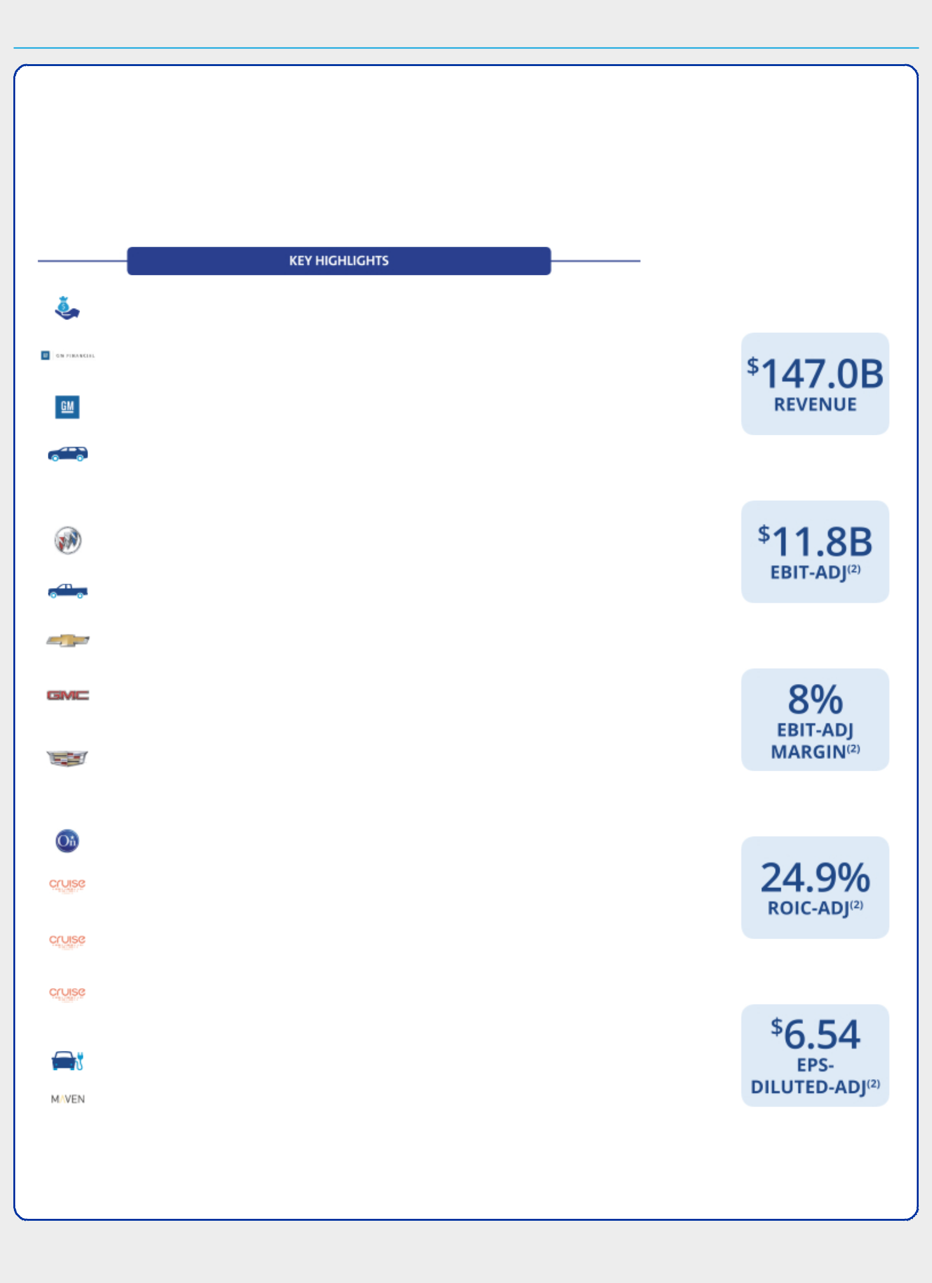

EXECUTIVE COMPENSATION

Compensation Overview

- Our Company Performance

In 2018, we continued to focus on our goal of a world with zero crashes, zero emissions, and zero congestion. The results below demonstrate how we are positioning GM to win in the core automotive business and the future of personal mobility:

$2.3 billion returned to shareholders through dividends and share repurchases, increased revenue 1% to $147.0 billion, and achieved the Company’s second-highest EPS-adjusted of $6.54 in a highly volatile environment in 2018

GM Financial generated record-breaking earnings before tax of $1.9 billion, up 58.3% versus 2017

Delivered record average transaction prices in the U.S. of nearly $36,000 for 2018

In the U.S., across all brands, sold nearly 1.3 million crossovers and SUVs. The following five vehicles had record calendar-year sales: Chevrolet Traverse, Chevrolet Equinox, Chevrolet Trax, Buick Encore, and GMC Terrain

Sold more than 1.2 million Buick vehicles worldwide and expanded the Buick Avenir line, which represents 20% of Buick’s retail sales in the U.S.

In the U.S., Chevrolet and GMC sold nearly 1 million pickup trucks, more than any other automaker for the fifth consecutive year

Launched the all-new 2019 Chevrolet Silverado 1500. Debuted the all-new 2019 Chevrolet Blazer to further compete in the mid-size SUV category

Launched the all-new 2019 GMC Sierra 1500. More than 70% of GMC deliveries were premium Denali and AT4 models in the U.S. in 2018

Launched the first-ever Cadillac XT4 compact SUV, which became the best-selling vehicle in its segment just two months after launch. Cadillac will introduce a new model on average every six months through 2021

Provided complimentary Crisis Assist to OnStar-enabled vehicles in the areas impacted by Hurricane Florence, Hurricane Michael, and the California wildfires

SoftBank committed to investing a total of $2.25 billion in GM Cruise to further strengthen the Company’s plan to commercialize autonomous vehicle technology at large scale

Collaborated with Honda, which has committed $2.75 billion to develop and deploy a new, purpose-built, shared autonomous vehicle with GM and GM Cruise

Autonomous vehicle test fleet fully transitioned to Gen 3 vehicles that are intended for commercial launch. Partnered with DoorDash to pilot zero emission food deliveries in San Francisco

Revealed the next-generation battery electric vehicle architecture and announced that Cadillac will lead the Company’s move toward an all-electric future

Expanded car-sharing platform to include peer-to-peer rental offerings to 190,000 Maven members as of year-end 2018

(1) The financial information relates to our continuing operations.

We ended 2018

with the following

key financial results⁽¹⁾:

- These are non-GAAP financial measures. Refer to Appendix A for a reconciliation of EBIT-adjusted, EBIT-adjusted margin, ROIC-adjusted, and EPS-diluted-adjusted to their closest comparable GAAP measure.

38

Table of Contents


EXECUTIVE COMPENSATION

- Leadership Changes

The Company made the following leadership changes:

- Charles K. Stevens, III – Transitioned to an advisory role effective September 1, 2018, after serving as Executive Vice President and Chief Financial Officer since January 15, 2014; retired from the Company effective March 1, 2019.

- Dhivya Suryadevara – Promoted to Executive Vice President and Chief Financial Officer effective September 1, 2018, succeeding Charles K. Stevens, III.

- Daniel Ammann – Transitioned to Chief Executive Officer of GM Cruise effective January 1, 2019.

- Mark L. Reuss – Assumed additional responsibilities for Global Cadillac as Executive Vice President and President, Global Product Group and Cadillac, effective June 21, 2018. Named President on January 3, 2019, succeeding Daniel Ammann.

- Alan S. Batey – Transitioned to an advisory role effective April 1, 2019, after serving as Executive Vice President and President, North America, since January 15, 2014.

- Compensation Governance and Best Practices

WHAT WE DO

- Provide short-term and long-term incentive plans with performance targets aligned to business goals

- Conduct annual advisory vote for shareholders to approve executive compensation

- Maintain a Compensation Committee composed entirely of independent directors

- Require stock ownership for all senior leaders

- Continue to engage with shareholders on various topics with members of management and directors, including our Compensation Committee and our Independent Lead Director

- Include non-compete and non-solicitation terms in all grant agreements with senior leaders

- Retain an independent executive compensation consultant to the Compensation Committee

- Maintain an Insider Trading Policy requiring directors, executive officers, and all other senior leaders to trade only during established window periods after contacting the GM Legal Staff prior to any sales or purchases of common stock

- Require equity awards to have a double trigger (termination of employment and change in control) to initiate protection provisions of outstanding awards

- Complete an annual incentive compensation risk review

- Maintain a clawback policy that applies to actions that damage GM’s reputation

- Design simple and clear compensation programs that provide senior leaders direct line-of-sight to business goals

- Conduct an annual audit of senior executive expenses and perquisites

WHAT WE DON’T DO

- Provide gross-up payments to cover personal income taxes or excise taxes pertaining to executive severance benefits

- Allow directors or executives to engage in hedging or pledging of GM securities

- Reward executives for excessive, imprudent, inappropriate, or unnecessary risk-taking

- Allow the repricing or backdating of equity awards

39

Table of Contents
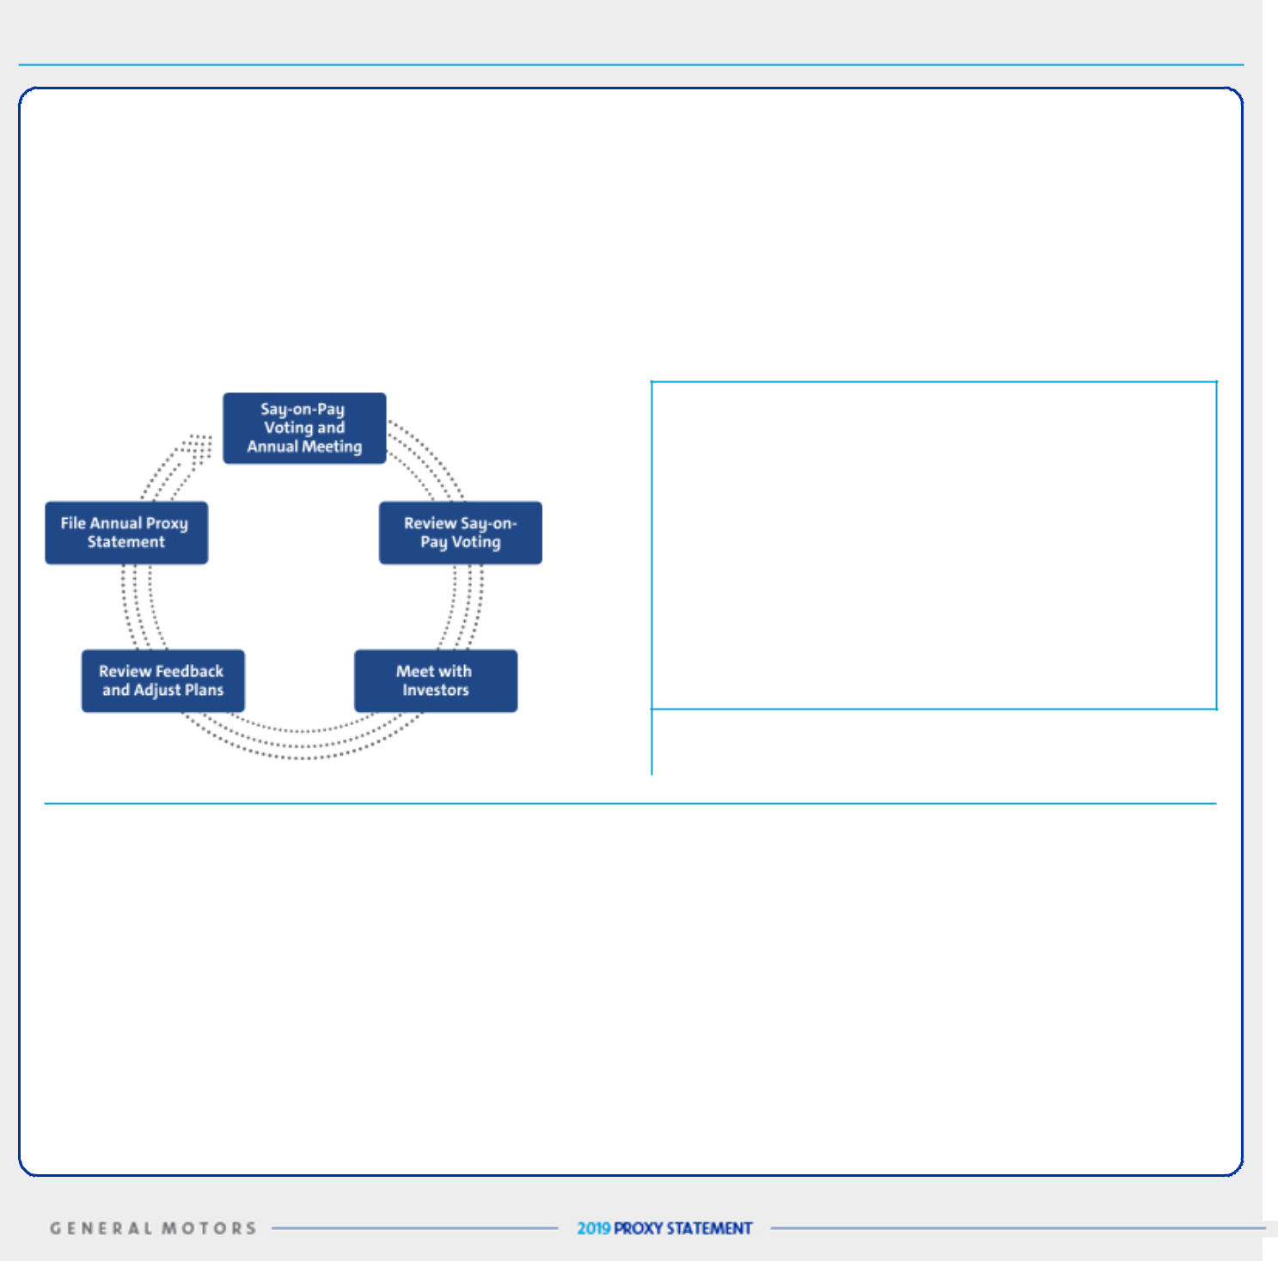

EXECUTIVE COMPENSATION

- Shareholder Engagement Initiatives

The Company values investor feedback and will continue to seek feedback through engagement initiatives to align our executive compensation programs with shareholder expectations. We view shareholder engagement as an important and continuous cycle. In 2018 and early 2019, members of the Board and/or management met with shareholders representing approximately 21% of our outstanding common stock on a range of issues. Through these engagements, we received feedback in support of our existing executive compensation program and, in particular, the Compensation Committee’s decision to further drive accountability and reinforce our safety culture. These discussions, Say-on-Pay voting results, aligning to the Company vision and strategic goals, and other factors are key drivers in our ongoing assessment of our compensation programs and help shape future programs. As the compensation programs evolve, the Board will remain committed to continuing the dialogue with shareholders on our compensation philosophy and practices.

SHAREHOLDER SAY-ON-PAY

The Compensation Committee seeks to align the Company’s executive compensation program with the interests of the Company’s shareholders. The Compensation Committee considers the results of the annual Say-on-Pay vote, the long-term vision and strategic goals of the Company, input from management, input from its independent compensation consultant, and investor engagement feedback when setting compensation for our executives. In 2018, 96.7% of our shareholders voted in favor of our compensation programs. Discussions with investors and shareholder Say-on-Pay voting are key drivers in our compensation design to continue alignment between our compensation programs and the interests of shareholders.

Investor Alignment Topics | 2018 Activities
Evaluate ESG Performance | We continue to factor performance related to Company and individual ESG results when determining
 | individual STIP payouts for our NEOs. As displayed in the “Our Company Performance” section on page 38
 | and in the “Performance Results and Compensation Decisions” section for individuals starting on page 49,
 | we have added a green leaf to represent results that reflect our ongoing commitment to ESG performance
 | outcomes.
Balanced Pay Plans | Based on the feedback from our investors relating to both our STIP and LTIP, we elected to keep our
 | measures and weightings the same for all plans in 2018. We continue to evaluate the external market and
 | hold conversations with investors to ensure the competitiveness and appropriateness of our plans.
Measure Relative Performance | Our PSUs measure both Relative ROIC-adjusted and Relative TSR against the Company’s OEM peers to
 | drive our performance to be at the top of the industry regardless of where we are in our business cycle.
Simple Compensation Plans | We simplified our compensation plans in 2017 and kept the same measures for 2018 to focus our most
 | senior leaders on both key operational performance measures and individual results in the STIP. This change
 | enhanced line-of-sight into compensation for each senior leader including a focus on safety in everything we
 | do. We maintained the LTIP structure to focus senior leaders on outperformance to our peers and increasing
 | stock price to create value for our shareholders.

40

Table of Contents
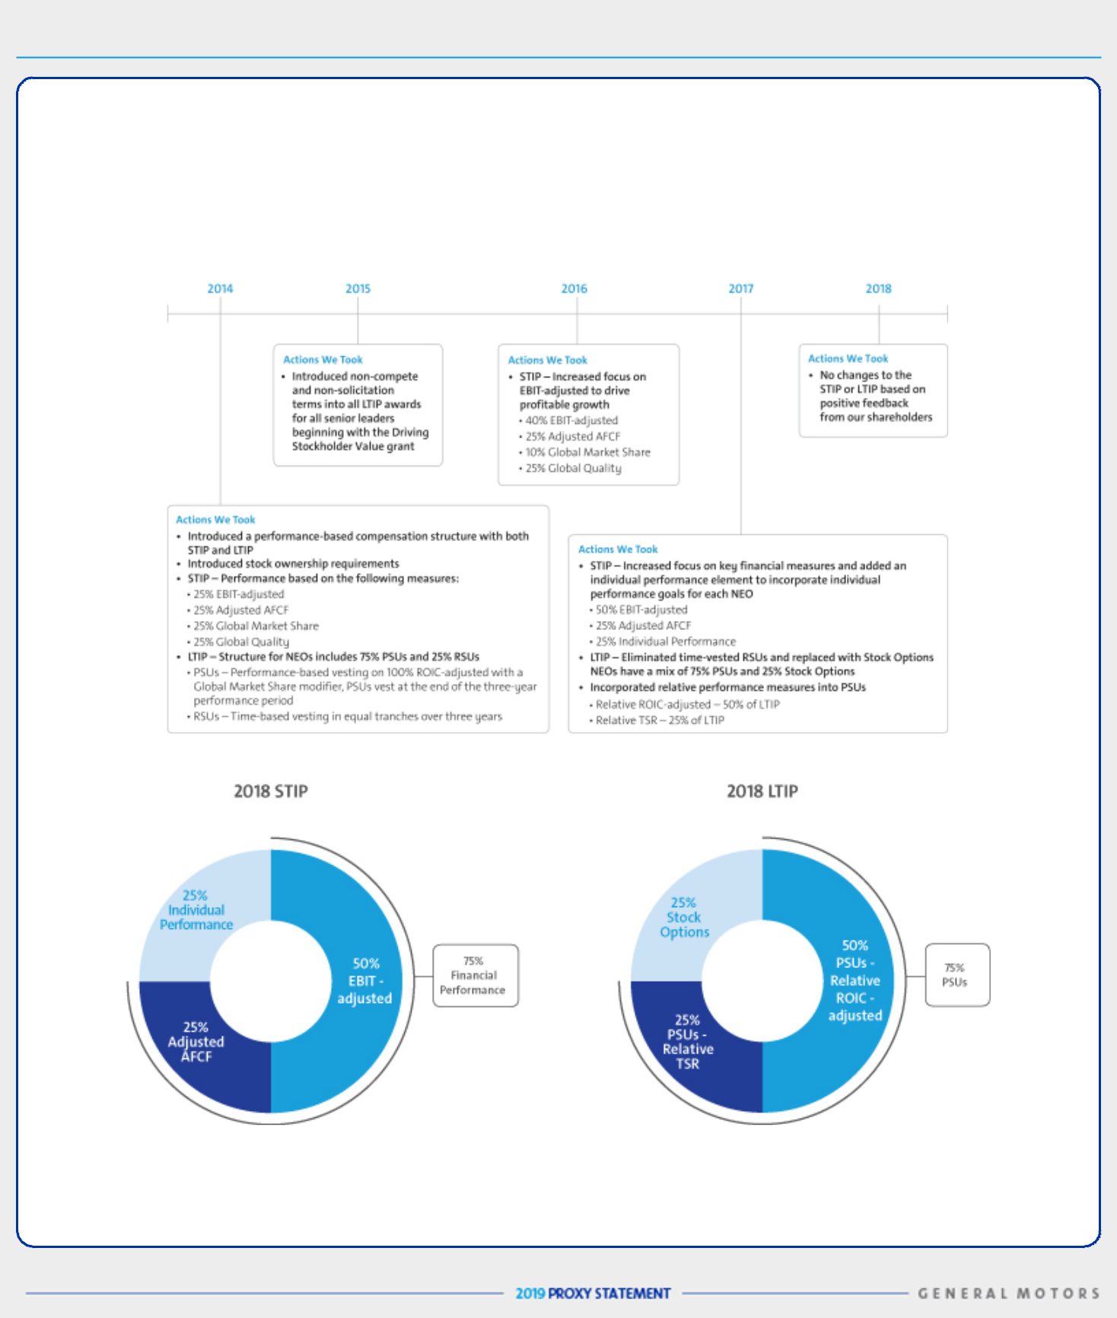

EXECUTIVE COMPENSATION

- Compensation Program Evolution

Our compensation programs focus our leadership on key areas that drive the business forward and align to the short-term and long-term interests of our shareholders. The Compensation Committee regularly reviews and discusses plan performance at each Compensation Committee meeting. The Compensation Committee considers many factors when electing to make plan changes for future incentive plans including results, market trends, feedback from their independent compensation consultant, and shareholder feedback. The table below shows the actions we have taken to simplify the compensation programs and to evolve and align the programs with shareholders’ interests:

The 2018 STIP focuses leadership on key financial measures (75% of STIP) and individual performance (25% of STIP). The total payout for the STIP ranges from 0% to 200% of target based on actual performance against pre-established goals. The Compensation Committee determines individual performance using a rigorous assessment process measuring performance against pre-established operational goals, safety results, and other measures. Threshold performance of at least one financial measure must be met for individual performance payout to be funded at any level.

41

Table of Contents


EXECUTIVE COMPENSATION

The 2018 LTIP features Stock Options (25% of total LTIP) to align our most senior leaders with our shareholders’ interest in stock price appreciation and PSUs with relative performance measures that drive long-term results. The PSUs measure our Relative ROIC-adjusted (50% of total LTIP) and Relative TSR (25% of total LTIP).

Focusing performance on key financial measures and individual operational performance measures in the short term, combined with measuring Relative ROIC-adjusted and Relative TSR compared to our OEM peers in the long term, provides direct alignment of our executive compensation program with the interests of our shareholders and focuses senior leaders on making the investments that will provide profitable long-term growth.

- Peer Group for 2018-2020 LTIP Performance

We use the following OEMs in the Dow Jones Automobile & Parts Titans 30 Index to measure relative performance for Relative ROIC-adjusted and Relative TSR measures for the 2018-2020 PSU awards.

Dow Jones Automobiles & Parts Titans 30 Index – OEM Peer Group⁽¹⁾
Bayerische Motoren Werke AG | Hyundai Motor Co. | Renault SA
Daimler AG | Kia Motors Corp. | Suzuki Motor Corp.
Fiat Chrysler Automobiles NV | Mazda Motor Corp. | Tesla, Inc.
Ford Motor Company | Nissan Motor Co. Ltd | Toyota Motor Company
Honda Motor Co. Ltd. | Peugeot SA | Volkswagen AG

- GM is a member of the Dow Jones Automobiles & Parts Titans 30 Index. Our performance will be determined on a continuous ranking for performance relative to OEM peers following the completion of the performance period.

- Peer Group for Compensation Comparisons

The Compensation Committee annually reviews the peer group for compensation comparisons and makes updates as needed to align with both the established criteria and Company strategy. We do not limit the peer group to our industry alone because we believe compensation practices for NEOs at other large U.S.-based multinationals affect our ability to attract and retain diverse talent around the globe.

In determining 2018 compensation, the Compensation Committee considers the following factors when selecting our peer group:

• Traded on major U.S. exchange |  | • | Technology focused
• Revenue greater than $25 billion |  | • | Durable goods manufacturer
• | Significant international revenue | • | Business/production complexity
• | Capital-intensive operations | • Consumers who are the end user

• Comparable R&D expenditures as a percent of revenue |  |  | • Strong brand reputation
Company |  | Industry | Company |  | Industry
3M Company |  | Industrial Conglomerates | Honeywell International Inc. |  | Aerospace and Defense
The Boeing Company |  | Aerospace and Defense | IBM Corporation |  | IT Consulting and Other
The Boeing Company |  | Aerospace and Defense | IBM Corporation |  | Services
Caterpillar Inc. |  | Construction Machinery and | Intel Corporation |  | Semiconductors
Caterpillar Inc. |  | Heavy Trucks | Intel Corporation |  | Semiconductors
Deere & Company |  | Agricultural and Farm Machinery | Johnson & Johnson |  | Pharmaceuticals
DowDuPont Inc.⁽¹⁾ |  | Diversified Chemicals | PepsiCo, Inc. |  | Soft Drinks and Food
Ford Motor Company |  | Automobile Manufacturers | Pfizer Inc. |  | Pharmaceuticals
General Electric Company |  | Industrial Conglomerates | The Procter & Gamble Company |  | Household Products
HP, Inc. |  | Technology Hardware, | United Technologies Corp. |  | Aerospace and Defense
HP, Inc. |  | Storage, and Peripherals | United Technologies Corp. |  | Aerospace and Defense

- The Compensation Committee removed DowDuPont Inc. at their June 2018 meeting based on announced corporate restructuring.

42

Table of Contents
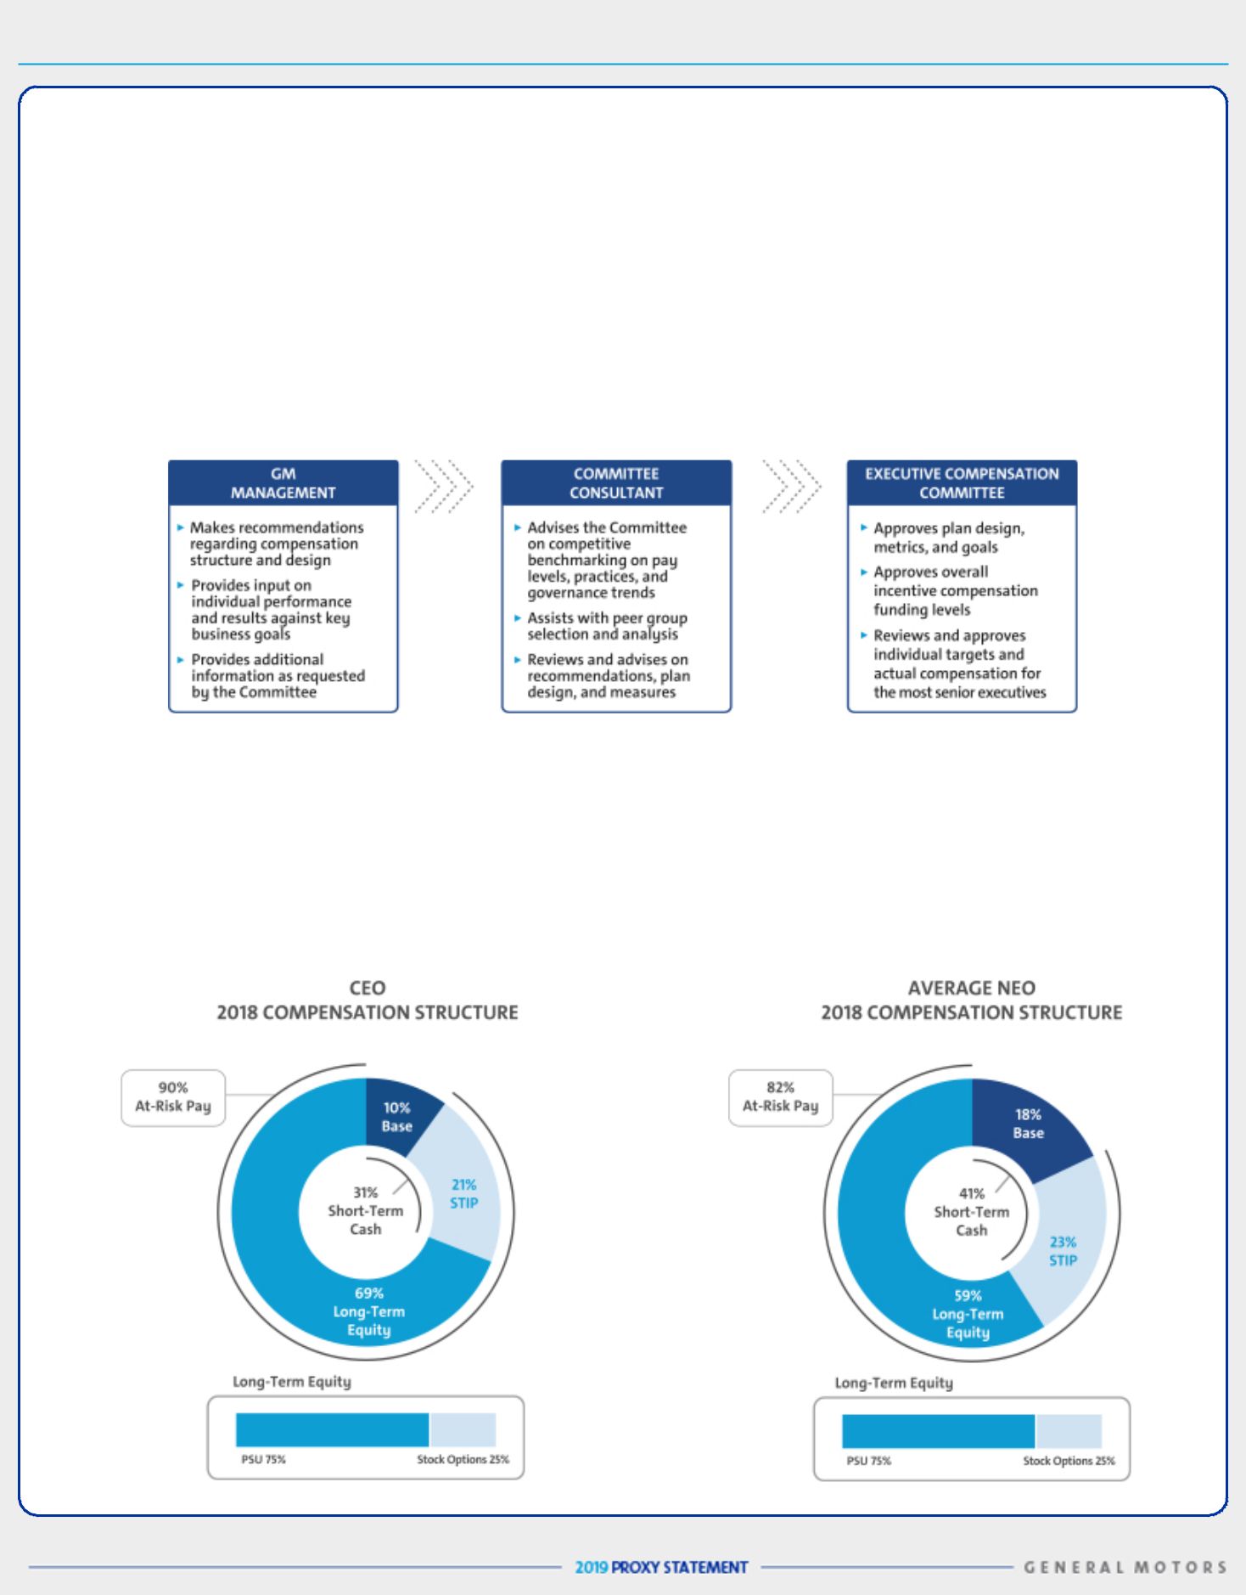

EXECUTIVE COMPENSATION

- How We Use Comparator Data to Assess Compensation

We use executive compensation surveys composed of a broad array of industrial companies to benchmark relevant market data for executive positions. In addition, we benchmark pay practices and compensation levels against the proxy statement disclosures of our peer group and adjust this data to reflect GM’s size and market expected compensation trends. Furthermore, the Compensation Committee reviews an analysis completed by their independent compensation consultant of the competitive position of each of our executives to the benchmark data.

We review each element of compensation compared with the market and generally target each element of our total direct compensation (base salary, STIP, and LTIP) for the executive group on average to be at or near the market median. An individual element or an individual’s total direct compensation may be positioned above or below the market median due to considerations such as specific responsibilities, experience, and performance.

- How We Plan Compensation

- Performance-Based Compensation Structure

Our NEOs are incentivized on optimizing long-term financial returns for our shareholders through increasing profitability, increasing margins, putting the customer at the center of everything we do, growing the business, and driving innovation.

The performance-based structure for 2018 incorporates both short-term and long-term incentives established from financial and operational metrics for fiscal year 2018 and beyond. In addition to base salary and the STIP award, this structure, shown graphically below, includes an LTIP award composed of PSUs and Stock Options in order to focus our executives on long-term Company performance. The Compensation Committee believes a majority of compensation should be in the form of equity to align the interests of executives with those of shareholders.

43

Table of Contents

EXECUTIVE COMPENSATION

Compensation Principles

The compensation provided to our senior leaders continues to be guided by the following principles:

- Aligned with Shareholders – Compensation paid should align directly with the long-term interests of our shareholders and our executives should share with them in the performance and value of our common stock;

- Performance-Based – Compensation paid should be based on a balance of financial and operational goals reflecting strong financial performance relative to our OEM competitors. The goals should be aggressive but achievable, within our executives control, and reward commitments met;

- Recognize Individual Performance – Compensation paid should motivate executives to perform at their best, reflecting their clear line-of-sight and contributions as well as their behaviors and demonstration of GM’s core values. Individual performance must be aligned with Company performance and desired behaviors;

- Simple Design – Our compensation plan should be easy to understand, communicate, and minimize unintended consequences;

- Avoidance of Incentive to Take Excessive Risk – The compensation structure should avoid incentives to take unnecessary or excessive risk. Compensation should be paid over a period of time that takes into account the potential risk over the same time period;

- Appropriate Allocation of Compensation Components – The compensation structure should appropriately allocate total compensation into fixed and variable pay elements resulting in an appropriate mix of short-term and long-term pay elements; and

- Comparable Target Compensation – Overall target compensation should be competitive (market median) compared to individuals at peer group companies so that the Company can attract, motivate, and retain talent.

Compensation Elements

- Compensation Structure

The NEOs 2018 compensation structure is market competitive with each pay element targeted at or near the market median. The 2018 compensation structure included the following pay elements:
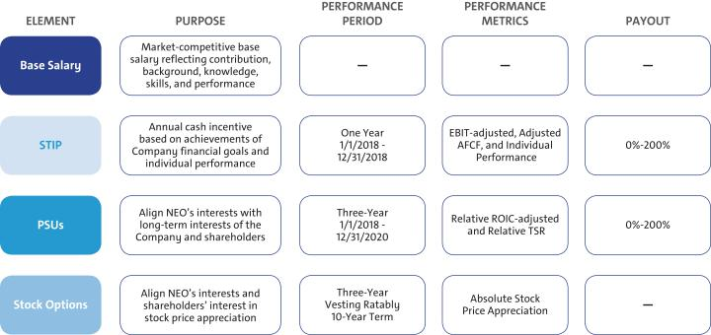

- Perquisites and Other Compensation

We provide perquisites and other compensation to our NEOs consistent with market practices. The following perquisites and other compensation were provided to NEOs in 2018:

- Personal Air Travel – Ms. Barra is prohibited by Company policy from commercial air travel due to security reasons identified by an independent third-party security consultant. As a result, the Company pays the costs associated with the use of private aircraft for both business and personal use. Other NEOs may travel on private aircraft in certain circumstances with prior approval from the CEO or the Senior Vice President, Global Human Resources. All NEOs incur imputed income for any personal travel.

44

Table of Contents

EXECUTIVE COMPENSATION

- Company Vehicle Programs – NEOs are eligible to participate in the Executive Company Vehicle Program and may use evaluation vehicles for the purpose of providing feedback on Company products. In addition, NEOs are eligible to use driver services provided by the Company and in accordance with Company policies.

- Security – NEOs may receive security services, including home security systems and monitoring, for specific security-related reasons identified by independent third-party security consultants. We maintain security staff in order to provide all employees with a safe and secure environment to align with and reinforce our safety culture.

- Financial Counseling – NEOs are eligible to receive financial counseling, estate planning, and tax preparation services through an approved provider.

- Executive Physicals – NEOs are eligible to receive executive physicals with an approved provider.

- 2018 Target Compensation

Our target total direct compensation for each NEO in 2018 was as follows:

 |  |  |  | Target Total Cash | LTIP |  | Target Total
 | Base Salary | STIP | STIP | Target Total Cash | PSUs | Stock | Target Total
 | Base Salary | STIP | STIP | Compensation | PSUs | Options | Compensation
 |  |  |  |  | (1)
Name | ($) | (%) | ($) | ($) | ($) | ($) | ($)
Mary T. Barra | 2,100,000 | 200% | 4,200,000 | 6,300,000 | 10,275,000 | 3,425,000 | 20,000,000
Dhivya Suryadevara | 900,000 | 125% | 1,125,000 | 2,025,000 | 2,231,250 | 743,750 | 5,000,000
Daniel Ammann | 1,450,000 | 125% | 1,812,500 | 3,262,500 | 3,703,125 | 1,234,375 | 8,200,000
Mark L. Reuss | 1,200,000 | 125% | 1,500,000 | 2,700,000 | 3,037,500 | 1,012,500 | 6,750,000
Alan S. Batey | 1,025,000 | 125% | 1,281,300 | 2,306,300 | 2,020,275 | 673,425 | 5,000,000
Charles K. Stevens, III | 1,100,000 | 125% | 1,375,000 | 2,475,000 | 3,018,750 | 1,006,250 | 6,500,000

- The number of PSUs awarded is determined by using the target PSU value divided by the closing price on the date of grant. PSUs with performance tied to Relative TSR are valued in the Summary Compensation Table using a Monte Carlo analysis resulting in amounts that may be higher or lower than target.

Performance Measures

- How We Set Performance Targets

Annually, the Compensation Committee approves the performance measures for the STIP and LTIP. The Compensation Committee reviews recommendations from management, receives input from their independent compensation consultant, evaluates the annual budget and mid-term business plan, and reviews prior-year performance to approve value-creating goals tied to long-term shareholder value.

- 2018 STIP Performance

The STIP rewards NEOs for performance linked to the Company’s achievement of annual financial goals, operational performance goals, and individual performance results. The Compensation Committee annually reviews and approves STIP goals that align with shareholders through the achievement of the business plan and strategic objectives. 2018 STIP targets were challenging goals set at the beginning of the performance period based on the business plan. Individual performance is assessed using an individual performance scorecard measuring results against pre-established goals that the Compensation Committee approves at the beginning of the year. Individual performance results and final individual compensation decisions are discussed beginning on page 49.

STIP awards, if any, are determined following final Company performance against the measures displayed below and the Compensation Committee’s assessment of individual performance. The table below describes each STIP performance measure, its weighting, its target, and the behaviors each measure drives:

STIP Measure | Weight | Target | Leadership Behaviors
EBIT-adjusted ($B)⁽¹⁾ | 50% | $ 12.9 | Focus on operating profit and driving strong profitability
Adjusted AFCF ($B)⁽¹⁾⁽²⁾ | 25% | $5.4 | Focus on driving strong cash flow to invest in the business
Individual Performance | 25% | 25 pts. | Focus on individual performance goals and behaviors that impact business results

- Measure adjusted for incentive purposes and excludes certain business operations.

- Adjusted AFCF for incentive purposes excludes payments related to certain recall-related expenses attributable to events occurring in 2014. For a description of how Adjusted AFCF is calculated, see Appendix A.

45

Table of Contents

EXECUTIVE COMPENSATION

The potential payouts for each Company performance measure ranges from 0% to 200% of target, based on actual Company performance, with the threshold performance level being 50% of EBIT-adjusted and 39% of Adjusted AFCF. Final STIP awards are calculated as follows:
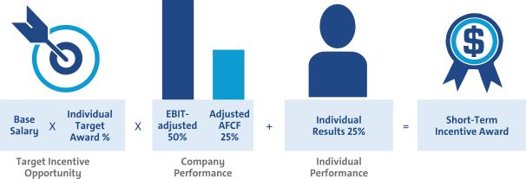

- 2018–2020 LTIP Performance

Grants under the LTIP are intended to link the financial interests of NEOs with the long-term interests of shareholders. The structure for NEOs includes 75% PSUs and 25% Stock Options. PSUs cliff-vest following a three-year performance period and Stock Options vest ratably over three years.

The 2018–2020 PSUs will be awarded based on Relative ROIC-adjusted and Relative TSR performance against our OEM peers displayed on page 42. PSU performance measures promote the efficient use of capital for long-term growth to create value for shareholders with an increased focus on stock price appreciation. The following table shows the PSU performance measures and the behaviors each measure drives:

Performance Measure | PSU Weight | Payout |  | Leadership Behaviors
Relative ROIC-adjusted |  | Threshold (50%) | – 35th Percentile | Focus on making sound investments that follow the disciplined capital
Relative ROIC-adjusted | 67% | Target (100%) | – 60th Percentile | approach of driving 20% or higher returns in world-class vehicles and
 |  | Maximum (200%) | – 100th Percentile | leading technology
 |  | Threshold (50%) | – 25th Percentile | Focus on delivering shareholder returns that outperform our OEM
Relative TSR | 33% | Target (100%) | – 50th Percentile
 |  |  |  | peers
 |  | Maximum (200%) | – 75th Percentile | peers

The 2018–2020 PSUs vest and are awarded and delivered following the completion of the three-year performance period beginning January 1, 2018 and may be earned at a level between 0% and 200% of target based on actual Company results. When determining grant amounts, the Compensation Committee considers factors such as individual responsibilities, experience, and performance. In addition, the Compensation Committee factors relevant market compensation comparison data and seeks input from their independent compensation consultant. Final PSU awards are calculated as follows:
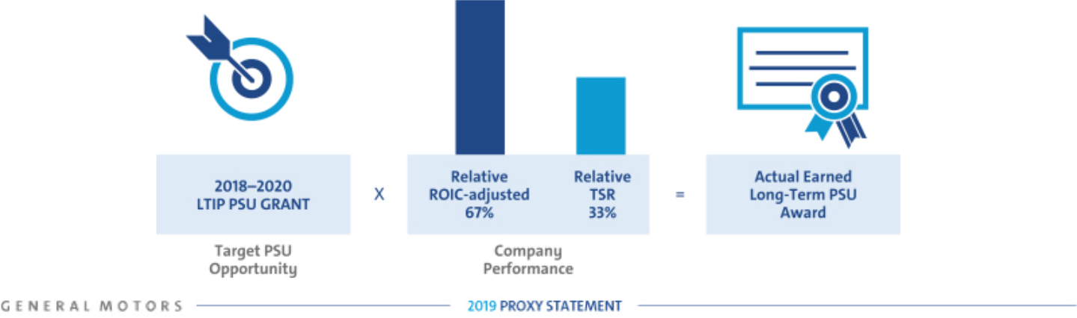

46

Table of Contents

EXECUTIVE COMPENSATION

- Summary of Outstanding Performance Awards
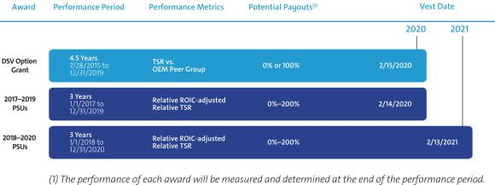

Award Performance Period Performance Metrics Potential Payouts (1) Vest Date 2020 2021 DSV Option Grant 7/28/2015 4.5 Years to 12/31/2019 TSR vs. OEM Peer Group 0% or 100% 2/15/2020 20172019 PSUs 1/1/2017 3 Years to 12/31/2019 Relative ROIC-adjusted Relative TSR 0%200% 2/14/2020 20182020 PSUs 1/1/2018 3 Years to 12/31/2020 Relative ROIC-adjusted Relative TSR 0%200% 2/13/2021 (1) The performance of each award will be measured and determined at the end of the performance period.

Performance Results and Compensation Decisions

- 2018 STIP Results

The Company portion of the 2018 STIP award was calculated based on the Company’s achievement of EBIT-adjusted and Adjusted AFCF performance measures. In addition, each NEO has an individual performance portion of their STIP that measures performance against pre-established goals. Final STIP performance approved by the Compensation Committee is displayed below:

 |  |  |  |  | Performance | Performance
STIP Measure | Weight | Threshold | Target | Maximum | Results | Payout
EBIT-adjusted ($B)⁽¹⁾ | 50% | $7.0 | $12.9 | $14.2 | $12.5 | 48%
Adjusted AFCF ($B)⁽¹⁾⁽²⁾ | 25% | $0.0 | $5.4 | $6.4 | $4.7 | 23%
Individual Performance | 25% | 0 pts. | 25 pts. | 50 pts. | 25 – 35 pts. | 25%–35%
Result |  |  |  |  |  | 96%–106%

- Measure adjusted for incentive purposes and excludes certain business operations.

- Adjusted AFCF for incentive purposes excludes payments related to certain recall-related expenses attributable to events occurring in 2014. Final performance result excludes $0.6B in pre-funding payments to certain non-U.S. pensions in Q3 2018. For a description of how Adjusted AFCF is calculated, see Appendix A.

Despite significant incremental commodity and foreign exchange headwinds, the Company delivered strong performance in 2018. As demonstrated by the results above, the Compensation Committee continues to set challenging performance targets.

- 2016–2018 LTIP Results

The 2016–2018 PSU awards vested on February 10, 2019, based on Company performance for the three-year period beginning January 1, 2016, against pre-established performance targets for ROIC-adjusted and the Global Market Share modifier. The following performance was approved by the Compensation Committee:

 |  |  |  |  | Performance | Performance
LTIP Measure | Weight | Threshold | Target | Maximum | Results | Payout
ROIC-adjusted | 100% | 12.0% | 20.0% | 28.0% | 27.3%⁽¹⁾ | 191%
Result |  |  |  |  |  | 166%⁽²⁾

- Represents the average of ROIC-adjusted for 2016 through 2018. ROIC-adjusted for 2016 was 28.9%. ROIC-adjusted for 2017 and 2018 was 28.2% and 24.9%, respectively, as reported on a continuing operations basis.

- The three-year average Global Market Share modifier reduces the payout 25 points if below 10.8% and increases the payout 25 points if at or above 11.6%, not to exceed plan maximum of 200%. The Company achieved a result of 10.7%, excluding the impact of the Company’s decision to exit markets during the performance period, thus a 25-point reduction was applied to the payout.

47

Table of Contents

EXECUTIVE COMPENSATION

Focusing leadership on ROIC-adjusted has resulted in significant performance improvements since calendar year 2012, when ROIC-adjusted was 16.0%. The Company continues to focus on delivering 20% or higher ROIC-adjusted results. We ended calendar year 2018 with ROIC-adjusted of 24.9%. Despite external pressures impacting TSR over the 2016-2018 performance period, we continued to meet our ROIC commitments while investing in the future. The 2016-2018 PSUs are the final awards that measure absolute ROIC-adjusted. Beginning with the 2017-2019 PSUs, performance is measured on Relative ROIC-adjusted and Relative TSR against OEM peers from the Dow Jones Automobiles & Parts Titans 30 Index.

- One-Time 2015–2020 DSV Option Grant

The DSV option grant was a one-time grant made on July 28, 2015, to senior leaders to secure non-compete and non-solicitation terms and to drive an increased focus on stock price appreciation. The DSV option grant featured 40% time-based vesting, which vested on February 15, 2017, and 60% performance-based vesting that vests upon meeting or exceeding the median TSR relative to the OEM peer group on the date of grant. Shown below are the results of two of the three performance-based tranches. The final 20% tranche remains outstanding with the performance period ending on December 31, 2019.

DSV Measure | Performance Period | Vesting Date | Weight | Target TSR | Result | Vesting
Relative TSR | July 28, 2015–December 31, 2018 | February 15, 2019 | 20% | 50th Percentile | 88th Percentile | 100%
Relative TSR | July 28, 2015–December 31, 2017 | February 15, 2018 | 20% | 50th Percentile | 87th Percentile | 100%

48

Table of Contents

EXECUTIVE COMPENSATION

- Compensation Decisions for Mary T. Barra

Mary T. Barra, Chairman and Chief Executive Officer


Ms. Barra’s 2018 performance directly aligned with the Company’s strategic objectives:

Core

u Furthered progress towards creating a safety culture through various initiatives u Returned $2.3 billion to shareholders through dividends and share repurchases

u Navigated significant headwinds to deliver $147.0B in Revenue, $11.8B in EBIT-adjusted, and EPS-diluted-adjusted of $6.54 while positioning GM to lead in the future
u Achieved record revenue for GM Financial

u Achieved ROIC-adjusted result of 24.9% for 2018

u Executed restructuring of GM Korea and announced a robust business plan intended to return GM Korea to profitability
u Launched the all-new 2019 Chevrolet Silverado and 2019 GMC Sierra 1500 u Led all automakers by delivering 1.3 million crossovers and SUVs in the U.S.

u Introduced the Cadillac XT4 and announced plans for all-new Cadillac models every six months on average through the end of 2021, including an all-new fully electric Cadillac
u Named one of America’s Most JUST Companies according to Forbes and JUST Capital

u Earned the most Wildlife Habitat Council Conservation Certification sites at 75, leading the industry

Transformation

u Reaffirmed strategy towards a world with zero crashes, zero emissions, and zero congestion
u Announced strategic investments in GM Cruise by both SoftBank and Honda

u Advanced our strategy to deploy self-driving vehicles in dense urban environments

u Developed battery cell and module components through a joint development with Honda u Reached 200,000 electric vehicle sales in the U.S.

u Aligned manufacturing capacity with market conditions by focusing on delivering vehicles based on customer demand
u Transformed product development to drive world-class levels of engineering and advance technologies and focus on improving quality and speed to market

The Compensation Committee held Ms. Barra’s base salary at $2,100,000 based on the competitive market analysis provided by the Compensation Committee’s independent compensation consultant. In February 2018, the Compensation Committee awarded Ms. Barra an annual LTIP grant of $13.7 million, consisting of 75% PSUs and 25% Stock Options.

The Compensation Committee awarded Ms. Barra 35 points based on her results, highlighted above, for the 2018 STIP performance year. The total compensation for Ms. Barra in 2018, including salary, STIP, and LTIP awards, is displayed below.

Pay Element | Majority of Pay Is At-Risk | Awarded Value
Base Salary | Only Fixed Pay Element | $ | 2,100,000
STIP | Performance to Metrics | $ | 4,452,000
PSUs⁽¹⁾ | Performance to Metrics and Stock Price | $ | 11,081,760
Stock Options⁽²⁾ | Performance to Stock Price | $ | 3,425,006
TOTAL |  | $ | 21,058,766

- PSUs are subject to performance vesting; value reflects grant date fair value at target performance for Relative ROIC-adjusted awards and probable performance results from the Monte Carlo analysis to value Relative TSR awards.

- Stock Options are subject to time-based vesting.

Awarded value reflects the amount included in the Summary Compensation Table, excluding change in pension value and all other compensation.
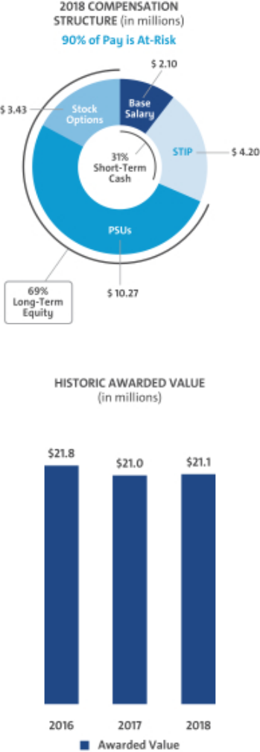

49

Table of Contents

EXECUTIVE COMPENSATION

- Compensation Decisions for Dhivya Suryadevara

Dhivya Suryadevara, Executive Vice President and Chief Financial Officer


2018 performance highlights for Ms. Suryadevara include:
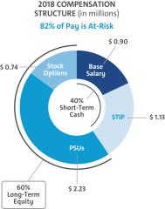

- Furthered progress towards creating a safety culture through various initiatives

- Navigated significant headwinds to deliver $147.0B in Revenue, $11.8B in EBIT-adjusted, 8% EBIT-adjusted margin, 24.9% ROIC-adjusted, and EPS-diluted-adjusted of $6.54 while positioning GM to lead in the future
- Completed $6.5B cost savings program by 2018 per target, resulting in improved margins

- Instilled an increased focus on free cash flow Company-wide

- Played an integral role in the SoftBank and Honda investments in GM Cruise

- Accelerated GM’s transformation, expected to increase annual adjusted AFCF by $6B by year-end 2020 on a run-rate basis
- Improved investor relations outreach and perception

Ms. Suryadevara was promoted to Executive Vice President and Chief Financial Officer effective September 1, 2018. The Compensation Committee determined a base salary of $900,000 based on the competitive market analysis provided by the Compensation Committee’s independent compensation consultant. In February 2018, Ms. Suryadevara was awarded an annual LTIP grant of $0.74 million. In October 2018, following her promotion, the Compensation Committee awarded an additional LTIP grant of $2.45 million. Both grants consisted of 75% PSUs and 25% Stock Options.

The Compensation Committee awarded Ms. Suryadevara 35 points based on her results, highlighted above, for the 2018 STIP performance year. The total compensation for Ms. Suryadevara in 2018, including salary, STIP, and LTIP awards, is displayed below.
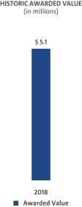

Pay Element | Majority of Pay Is At-Risk | Awarded Value
Base Salary | Only Fixed Pay Element | $ | 668,100
STIP | Performance to Metrics | $ | 1,192,500
(1) | Performance to Metrics and Stock Price | $ | 2,446,635
PSUs | Performance to Metrics and Stock Price | $ | 2,446,635
Stock Options(2) | Performance to Stock Price | $ | 796,263
TOTAL |  | $ | 5,103,498

- PSUs are subject to performance vesting; value reflects grant date fair value at target performance for Relative ROIC-adjusted awards and probable performance results from the Monte Carlo analysis to value Relative TSR awards.

- Stock Options are subject to time-based vesting.

Awarded value reflects the amount included in the

Summary Compensation Table, excluding change in

pension value and all other compensation.

50

Table of Contents

EXECUTIVE COMPENSATION

- Compensation Decisions for Daniel Ammann

Daniel Ammann, President


2018 performance highlights for Mr. Ammann include:
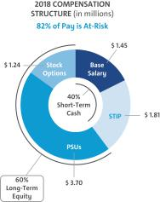

- Furthered progress towards creating a safety culture through various initiatives

- Navigated significant headwinds to deliver $147.0B in Revenue, $11.8B in EBIT-adjusted, and EPS-diluted-adjusted of $6.54 while positioning GM to lead in the future
- Achieved ROIC-adjusted result of 24.9% for 2018

- Continued to drive operational excellence to improve overall business performance

- Successfully restructured GM Korea with a plan in place toward enterprise level profitability

- Led the successful investments of SoftBank and Honda in GM Cruise

- Continued to drive strategy and execution towards scale and deployment of autonomous vehicles
- Implemented a strong cybersecurity team at GM Cruise

The Compensation Committee held Mr. Ammann’s base salary at $1,450,000 based on the competitive market analysis provided by the Compensation Committee’s independent compensation consultant. In February 2018, the Compensation Committee awarded Mr. Ammann an annual LTIP grant of $4.94 million, consisting of 75% PSUs and 25% Stock Options. Mr. Ammann’s 2018 compensation structure remained the same as his 2017 compensation structure.

The Compensation Committee awarded Mr. Ammann 35 points based on his results, highlighted above, for the 2018 STIP performance year. The total compensation for Mr. Ammann in 2018, including salary, STIP, and LTIP awards, is displayed below.
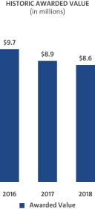

Pay Element | Majority of Pay Is At-Risk | Awarded Value
Base Salary | Only Fixed Pay Element | $1,450,000
STIP | Performance to Metrics | $1,921,300
(1) | Performance to Metrics and Stock Price | $3,993,891
PSUs | Performance to Metrics and Stock Price | $3,993,891
Stock Options(2) | Performance to Stock Price | $1,234,383
TOTAL |  | $8,599,574

- PSUs are subject to performance vesting; value reflects grant date fair value at target performance for Relative ROIC-adjusted awards and probable performance results from the Monte Carlo analysis to value Relative TSR awards.

- Stock Options are subject to time-based vesting.

Awarded value reflects the amount included in the

Summary Compensation Table, excluding change in

pension value and all other compensation.

51

Table of Contents

EXECUTIVE COMPENSATION

- Compensation Decisions for Mark L. Reuss

Mark L. Reuss, Executive Vice President and President, Global Product Group and

Cadillac
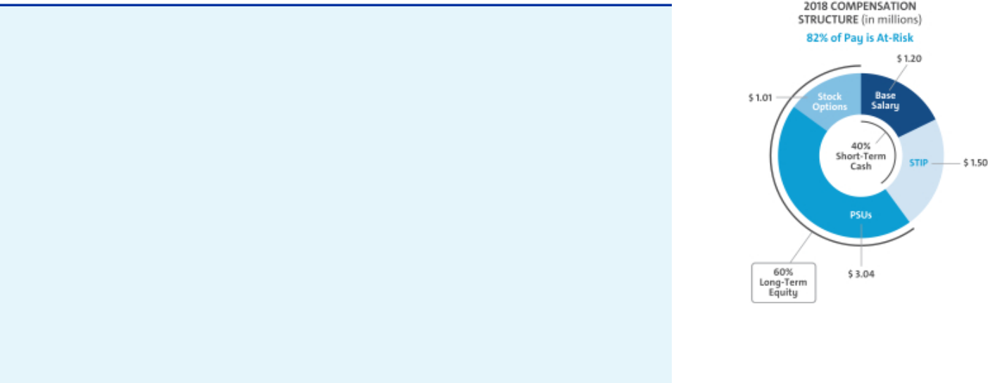

2018 performance highlights for Mr. Reuss include:

- Furthered progress towards creating a safety culture through various initiatives

- Positioned GM as a recognized leader in automotive cybersecurity and autonomous vehicle safety
- Launched 14 vehicles globally, including the Bolt AV, the Chevrolet Silverado, and the GMC Sierra
- Successfully completed insourcing initiatives, reducing overall costs

- Partnered with Autodesk to introduce the next generation of vehicle lightweighting

- Received the IHS Automotive Loyalty Award for the fourth straight year

- Transformed product development to drive world-class levels of engineering and advance technologies while focusing on improving quality and speed to market
- Achieved record global sales for Cadillac

- Launched the brand-new Cadillac XT4 which became the best-selling vehicle in its segment just two months after launch
- Announced plans for all-new Cadillac models every six months on average through the end of 2021, including an all-new fully electric Cadillac
- Positioned Cadillac racing as a leader, winning the Rolex 24 at Daytona in January 2019 for the third year in a row
- Continued the plans for global electrification with Cadillac as the lead brand for future electric vehicles

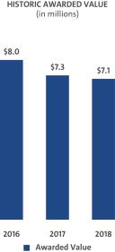

The Compensation Committee held Mr. Reuss’ base salary at $1,200,000 based on the competitive market analysis provided by the Compensation Committee’s independent compensation consultant. In February 2018, the Compensation Committee awarded Mr. Reuss an annual LTIP grant of $4.05 million, consisting of 75% PSUs and 25% Stock Options. Mr. Reuss’ 2018 compensation structure remained the same as his 2017 compensation structure.

The Compensation Committee awarded Mr. Reuss 35 points based on his results, highlighted above, for the 2018 STIP performance year. The total compensation for Mr. Reuss in 2018, including salary, STIP, and LTIP awards, is displayed below.

Pay Element | Majority of Pay Is At-Risk | Awarded Value
Base Salary | Only Fixed Pay Element | $1,200,000
STIP | Performance to Metrics | $1,590,000
PSUs | Performance to Metrics and Stock Price | $3,276,007
(1)
Stock Options(2) | Performance to Stock Price | $1,012,504
TOTAL |  | $7,078,511

(1) | PSUs are subject to performance vesting; value reflects grant date fair value at target performance for
 | Relative ROIC-adjusted awards and probable performance results from the Monte Carlo analysis to value | Awarded value reflects the amount included in the
 | Relative TSR awards. | Awarded value reflects the amount included in the
 | Relative TSR awards. | Summary Compensation Table, excluding change in
(2) | Stock Options are subject to time-based vesting. | Summary Compensation Table, excluding change in
(2) | Stock Options are subject to time-based vesting. | pension value and all other compensation.
52

Table of Contents

EXECUTIVE COMPENSATION

- Compensation Decisions for Alan S. Batey

Alan S. Batey, Executive Vice President and President, North America
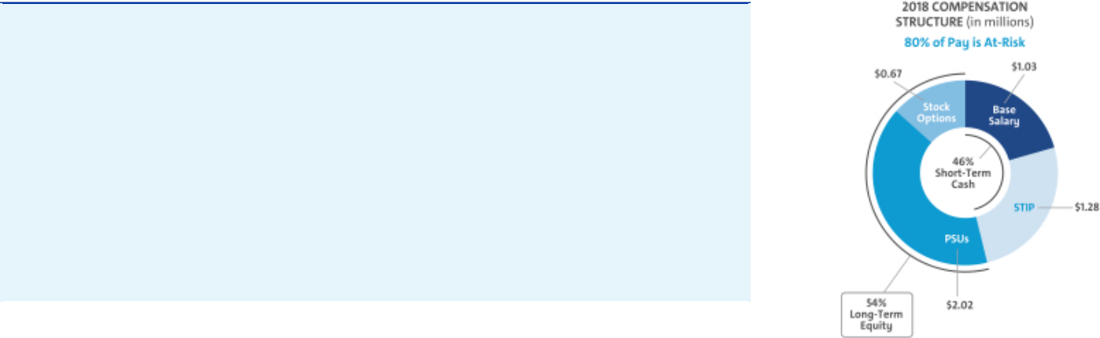

2018 performance highlights for Mr. Batey include:

- Furthered progress towards creating a safety culture through various initiatives

- Achieved fifth consecutive year of pickup truck sales leadership in the U.S.

- Led all automakers by delivering 1.3 million crossovers and SUVs in the U.S.

- Sold more than 134,800 units of the Chevrolet Colorado in the U.S., its best year yet

- Achieved EBIT-adjusted of $10.8B and EBIT-adjusted margins of 9.5% in North America

- Delivered record Average Transaction Prices in the U.S. of nearly $36,000 for 2018

- Maintained our leadership position as the #1 OEM in Canada

- Doubled the accessories business in North America since 2013

- Continue to drive participation in GM Loyalty rewards

- Received the IHS Automotive Loyalty Award for the fourth straight year

The Compensation Committee held Mr. Batey’s base salary at $1,025,000 based on the competitive market analysis provided by the Compensation Committee’s independent compensation consultant. In February 2018, the Compensation Committee awarded Mr. Batey an annual LTIP grant of $2.69 million, consisting of 75% PSUs and 25% Stock Options. Mr. Batey’s 2018 compensation structure remained the same as his 2017 compensation structure.
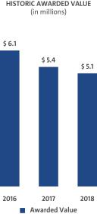

The Compensation Committee awarded Mr. Batey 25 points based on his results, highlighted above, for the 2018 STIP performance year. The total compensation for Mr. Batey in 2018, including salary, STIP, and LTIP awards, is displayed below.

Pay Element | Majority of Pay Is At-Risk | Awarded Value
Base Salary | Only Fixed Pay Element | $ | 1,025,000
STIP | Performance to Metrics | $ | 1,230,000
(1) | Performance to Metrics and Stock Price | $ | 2,178,894
PSUs | Performance to Metrics and Stock Price | $ | 2,178,894
Stock Options(2) | Performance to Stock Price | $ | 673,429
TOTAL |  | $ | 5,107,323

- PSUs are subject to performance vesting; value reflects grant date fair value at target performance for Relative ROIC-adjusted awards and probable performance results from the Monte Carlo analysis to value Relative TSR awards.

- Stock Options are subject to time-based vesting.

Awarded value reflects the amount included in the

Summary Compensation Table, excluding change in

pension value and all other compensation.

53

Table of Contents

EXECUTIVE COMPENSATION

- Compensation Decisions for Charles K. Stevens, III

Charles K. Stevens, III, Advisor and Former Executive Vice President and

Chief Financial Officer
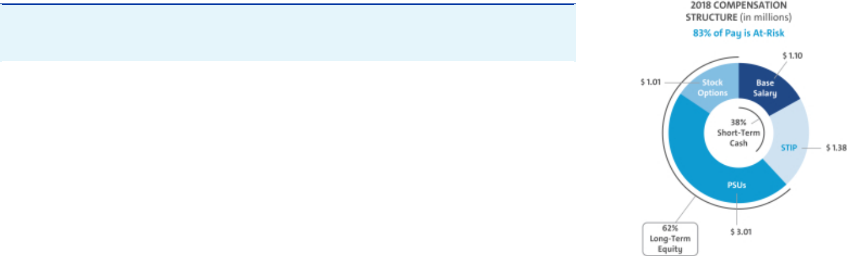

Mr. Stevens retired on March 1, 2019, following more than 40 years of service with the Company. He played a key role as a trusted advisor while assisting in the transition of the responsibilities of Chief Financial Officer to Ms. Suryadevara.

The Compensation Committee held Mr. Stevens’ base salary at $1,100,000 based on the competitive market analysis provided by the Compensation Committee’s independent compensation consultant. In February 2018, the Compensation Committee awarded Mr. Stevens an annual LTIP grant of $4.02 million, consisting of 75% PSUs and 25% Stock Options.

Mr. Stevens stepped down from his position as Executive Vice President and Chief Financial Officer effective September 1, 2018, and served as an Advisor through his retirement on March 1, 2019. The Compensation Committee awarded Mr. Stevens 25 points for the 2018 STIP performance year. The total compensation for Mr. Stevens in 2018, including salary, STIP, and LTIP awards, is displayed below.

Pay Element |  | Majority of Pay Is At-Risk | Awarded Value
Base Salary |  | Only Fixed Pay Element | $1,100,000
STIP |  | Performance to Metrics | $1,320,000
PSUs(1) |  | Performance to Metrics and Stock Price | $3,255,775
Stock Options | (2) | Performance to Stock Price | $1,006,252
TOTAL |  |  | $6,682,027
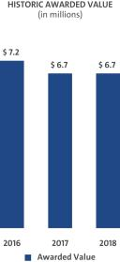

- PSUs are subject to performance vesting; value reflects grant date fair value at target performance for Relative ROIC-adjusted awards and probable performance results from the Monte Carlo analysis to value Relative TSR awards.

- Stock Options are subject to time-based vesting.

Awarded value reflects the amount included in the

Summary Compensation Table, excluding change in

pension value and all other compensation.

54

Table of Contents

EXECUTIVE COMPENSATION

Compensation Policies and Governance Practices

- Stock Ownership Requirements

The Company requires our senior leaders to own GM stock to align the interests of senior leaders with those of our shareholders. The stock ownership requirements:

- Cover all senior leaders;

- Set five years as the time frame to meet ownership requirements;

- Require senior leaders to hold vested shares to maintain ownership requirements;

- Establish a multiple of each executive’s base salary on the date they are first covered;

- Make it possible to meet ownership requirements by owning either a multiple of base salary or a required number of shares; and

- Count only actual share holdings and unvested RSUs.

The table below shows the stock ownership requirement by level in the Company. As of December 31, 2018, all NEOs have met or are on track to meet stock ownership requirements by their respective dates.
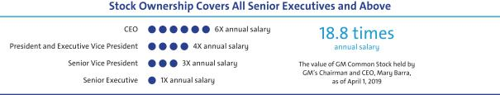

- Compensation Risk Assessment

The Compensation Committee annually reviews the potential impact of our compensation programs on organizational risk. The Compensation Committee discusses the compensation programs and risk mitigation features when evaluating whether the programs encourage or reward employees for engaging in excessive, imprudent, inappropriate, or unnecessary risk.

The annual risk review, completed on October 8, 2018, with assistance from our human resources, audit, legal, and strategic risk management organizations, involved analyzing our current compensation programs in relation to risk. Our analysis concluded that our compensation programs include the following risk mitigation features:

- Mix of Pay Elements – Base salary, STIP, PSUs, and Stock Options are included in the executive compensation program.

- Short-Term and Long-Term Programs – The mix of our short-term and long-term compensation programs appropriately reward employees while balancing risk through the delayed payment of long-term awards.

- Adjustments to Compensation – Maximum payout caps are in place for incentive compensation and the Compensation Committee has the ability to apply negative discretion.

- Compensation Committee Oversight – Our Compensation Committee reviews plan performance and approves all executive compensation programs and payouts.

- Multiple Performance Metrics – Multiple performance measures work together to balance risk in our incentive compensation programs.

- Stock Ownership Requirements – All senior leaders are subject to stock ownership requirements of at least 1x their salary as described above.

- Clawback Provisions – All awards are subject to the Recoupment of Incentive Compensation policy as described below.

In 2018, the Compensation Committee determined that our compensation programs have sufficient risk mitigation features and do not encourage or reward employees for engaging in excessive, imprudent, inappropriate, or unnecessary risk. Based on the Compensation Committee’s review, the Committee determined our compensation programs to be low risk.

55

Table of Contents

EXECUTIVE COMPENSATION

- Policy on Recoupment of Incentive Compensation

We have a corporate policy to recover incentive compensation paid to executive officers in cases where financial statements are restated because of employee fraud, negligence, or intentional misconduct. Under this clawback policy, posted on our website at gm.com/investors/resources, if the Board or an appropriate Board Committee determines any bonus, retention award, or short or long-term incentive compensation has been paid to any executive officer based on materially inaccurate misstatement of earnings, revenues, gains, or other criteria, including reputational harm, the Board or Compensation Committee will take the action it deems necessary to recover the compensation paid, remedy the misconduct, and prevent its recurrence. For this purpose, a financial statement or performance metric will be treated as materially inaccurate when an employee knowingly engaged in providing inaccurate information or knowingly failed to timely correct information relating to those financial statements or performance metrics. We will continue to review our policy to ensure it is consistent with all legal requirements and in the best interests of the Company and its shareholders.

- Insider Trading Policy

Our insider trading policy prohibits our employees from buying or selling GM securities when in possession of material nonpublic information. Any sale or purchase of common stock by directors, executive officers, and all other senior leaders must be made during pre-established periods after receiving preclearance by a member of the GM Legal Staff or according to the preapproved Rule 10b5-1 plan.

Trading in GM derivatives (i.e., puts or calls), engaging in short sales, and pledging of GM securities is also prohibited. All GM executive officers are in compliance with the policy of not pledging any shares of common stock. This policy is posted on our website at gm.com/investors/resources.

- Tax Considerations

In tax years commencing prior to January 1, 2018, Internal Revenue Code (“IRC”) Section 162(m) generally disallowed federal tax deductions for compensation in excess of $1 million paid to the CEO and the next three highest-paid officers (other than the CFO) (collectively the “Covered Executives”). The Tax Cuts and Jobs Act, enacted on December 22, 2017, substantially modified IRC Section 162(m) and, among other things, eliminated the performance-based compensation exception to the $1 million deduction limit effective as of January 1, 2018. As a result, beginning in 2018, compensation paid to Covered Executives in excess of $1 million will generally be nondeductible, whether or not it is performance-based. In addition, beginning in 2018, the Covered Executives include any individual who served as the CEO or CFO at any time during the taxable year and the next three highest paid officers (other than the CEO and CFO) for the taxable year, and once an individual becomes a Covered Executive for any taxable year beginning after December 31, 2016, that individual will remain a Covered Executive for all future years, including following any termination of employment.

The Tax Cuts and Jobs Act includes a transition relief rule pursuant to which the changes to IRC Section 162(m) described above will not apply to compensation payable pursuant to a written binding contract that was in effect on November 2, 2017, and is not materially modified after that date. To the extent it is applicable to our existing arrangements, the Compensation Committee may avail itself of this transition relief rule. Moreover, to maintain flexibility in attracting and retaining talented executives, the Compensation Committee does not limit its actions with respect to executive compensation to preserve deductibility under IRC Section 162(m) if the Compensation Committee determines that doing so is in the best interests of our shareholders.

56

Table of Contents

EXECUTIVE COMPENSATION

- Compensation Committee and Consultant Independence

Our Compensation Committee is composed entirely of independent directors as determined by the Board under NYSE standards and as defined for various regulatory purposes. Farient Advisors assisted the Compensation Committee in 2018. Farient Advisors is an independent compensation consulting firm that takes direction from and is solely responsible to the Compensation Committee. The Compensation Committee is also aided in its deliberations by in-house legal counsel.

Under its charter, the Compensation Committee has the authority to hire outside consultants and advisors at the Company’s expense. The Compensation Committee retains the services of Farient Advisors for advice on issues related to the compensation of NEOs and other executive compensation-related matters. A representative of Farient Advisors attended all Compensation Committee meetings, either in person or via telephone, consulted with and advised the Compensation Committee members on executive compensation, including the structure and amounts of various pay elements, and developed executive benchmarking data for the Compensation Committee. Farient Advisors provided no services to the Company’s management.

The Compensation Committee annually reviews the performance of the compensation consultant and considers the following factors when assessing consultant independence in accordance with NYSE standards:

- Services provided to GM management outside the services provided to the Compensation Committee;

- Fees paid as a percentage of Farient Advisors’ total revenue;

- Policies and procedures of Farient Advisors designed to prevent conflicts of interest;

- Any business or personal relationships between members of the Compensation Committee and Farient Advisors;

- Stock ownership by employees of Farient Advisors; and

- Any business or personal relationships between GM and Farient Advisors.

The Compensation Committee reviewed the performance and independence of Farient Advisors and determined that Farient Advisors was independent based on the standards above.

- Employment and Termination Agreements

The Company has no employment or termination agreements with any of our 2018 NEOs. All NEOs participate in the General Motors LLC U.S. Executive Severance Program filed as an exhibit to the 2018 Form 10-K.

Compensation Committee Report

The Compensation Committee has reviewed and discussed with management the CD&A and, based on that review and discussion, has recommended to the Board of Directors that the CD&A be included in this Proxy Statement and incorporated by reference into the GM 2018 Annual Report on Form 10-K.

Compensation Committee*

Carol M. Stephenson (Chair)

Joseph Jimenez

James J. Mulva

Patricia F. Russo

- Wesley G. Bush was not a member of the Compensation Committee at the time the Committee approved its Report.

57

Table of Contents

EXECUTIVE COMPENSATION

Executive Compensation Tables

- Summary Compensation Table

 |  |  |  |  |  |  |  |  |  | Change in
 |  |  |  |  |  |  |  |  |  | Pension
 |  |  |  |  |  |  |  |  |  | Value and
 |  |  |  |  |  |  |  | Nonequity |  | NQ Deferred
Name and |  | Salary | Bonus | Stock |  | Option |  | Incentive Plan |  | Compensation | All Other |  | Total
Principal |  | Salary | Bonus | Awards | (2) | Awards | (3) | Compensation | (4) | Earnings | Compensation | (6) | Total
Position | Year | ($) | ($) |  | (2) |  | (3) |  | (4) | (5) |  | (6) | ($)
 |  |  |  | ($) |  | ($) |  | ($) |  | ($) | ($) |  | ($)
(1)
Mary T. Barra | 2018 | 2,100,000 | — | 11,081,760 |  | 3,425,006 |  | 4,452,000 |  | — | 811,684 |  | 21,870,450
Chairman and Chief
Executive Officer | 2017 | 2,100,000 | — | 10,737,570 |  | 3,250,003 |  | 4,956,000 |  | 52,792 | 861,683 |  | 21,958,048
 | 2016 | 2,000,000 | — | 13,000,036 |  |  | — | 6,760,000 |  | 181,777 | 640,246 |  | 22,582,059
Dhivya Suryadevara | 2018 | 668,100 | — | 2,446,635 |  | 796,263 |  | 1,192,500 |  | — | 402,592 |  | 5,506,090
Executive Vice President and
Chief Financial Officer
Daniel Ammann | 2018 | 1,450,000 | — | 3,993,891 |  | 1,234,383 |  | 1,921,300 |  | — | 372,307 |  | 8,971,881
President
President | 2017 | 1,450,000 | — | 4,078,222 |  | 1,234,378 |  | 2,138,800 |  | — | 356,918 |  | 9,258,318
 | 2016 | 1,450,000 | — | 4,700,032 |  |  | — | 3,513,100 |  | — | 560,852 |  | 10,223,984
Mark L. Reuss | 2018 | 1,200,000 | — | 3,276,007 |  | 1,012,504 |  | 1,590,000 |  | — | 277,579 |  | 7,356,090
Executive Vice President
and President, Global | 2017 | 1,200,000 | — | 3,345,168 |  | 1,012,504 |  | 1,770,000 |  | 54,390 | 344,446 |  | 7,726,508
Product Group and Cadillac
Product Group and Cadillac | 2016 | 1,200,000 | — | 3,900,018 |  |  | — | 2,905,000 |  | 134,777 | 272,866 |  | 8,412,661
Alan S. Batey | 2018 | 1,025,000 | — | 2,178,894 |  | 673,429 |  | 1,230,000 |  | — | 233,197 |  | 5,340,520
Executive Vice President
and President, North America | 2017 | 1,025,000 | — | 2,224,928 |  | 673,426 |  | 1,447,800 |  | 316,601 | 287,373 |  | 5,975,128
 | 2016 | 950,000 | — | 2,700,035 |  |  | — | 2,406,900 |  | 133,151 | 225,078 |  | 6,415,164
Charles K. Stevens, III | 2018 | 1,100,000 | — | 3,255,775 |  | 1,006,252 |  | 1,320,000 |  | — | 257,153 |  | 6,939,180
Advisor and Former
Executive Vice President and | 2017 | 1,100,000 | — | 3,076,744 |  | 931,251 |  | 1,622,500 |  | 54,114 | 316,430 |  | 7,101,039
Chief Financial Officer
Chief Financial Officer | 2016 | 1,100,000 | — | 3,450,007 |  |  | — | 2,673,800 |  | 135,146 | 244,132 |  | 7,603,085

- Titles reflect the NEO’s position as of December 31, 2018. Ms. Suryadevara first became a NEO in 2018. Mr. Stevens became an Advisor on September 1, 2018, and retired on March 1, 2019.

- Stock Awards displays the grant date fair value of PSUs issued under the LTIP, computed in accordance with Financial Accounting Standards Board (“FASB”) Accounting Standards Codification (“ASC”) Topic 718. PSUs will vest based on GM’s performance against Relative ROIC-adjusted and Relative TSR. The maximum award for PSUs for the 2018–2020 performance period is 200% of PSUs granted. The assumptions used for the Monte Carlo analysis of the PSUs are summarized below:

 |  |  | Risk-Free Interest |  | Valuation Price as a
Grant Date | Stock Price | Implied Volatility | Rate | Valuation Price | Percent of Target
2/13/2018 | $41.40 | 28% | 2.30% | $51.25 | 123.8%
10/1/2018 | $34.20 | 28% | 2.88% | $35.02 | 102.4%

There is no dividend yield as dividends are assumed to be reinvested for the TSR calculation. The table below shows the PSUs valued based on the closing stock price on the date of grant and the maximum grant value based on maximum performance.

 | Value of PSU Awards at Target and Maximum Performance
 | 2018 Target | 2018 Maximum
 | ($) | ($)
Mary T. Barra | 10,275,025 | 20,550,050
Dhivya Suryadevara | 2,388,814 | 4,777,628
Daniel Ammann | 3,703,147 | 7,406,294
Mark L. Reuss | 3,037,518 | 6,075,036
Alan S. Batey | 2,020,279 | 4,040,558
Charles K. Stevens, III | 3,018,764 | 6,037,528

58

Table of Contents

EXECUTIVE COMPENSATION

- Option Awards displays the grant date fair value of Stock Options issued under the LTIP, computed in accordance with FASB ASC Topic 718 using a Black-Scholes valuation. The assumptions used for the Black-Scholes valuation of the Stock Options are summarized below:

Grant Date | Dividend Yield | Implied Volatility | Risk-Free Interest Rate | Expected Option Life | Grant Date Fair Value
2/13/2018 | 3.67% | 28% | 2.72% | 6.00 years | $8.28
10/1/2018 | 4.44% | 28% | 3.00% | 5.36 years | $6.15

- All NEOs were eligible for a payment under the STIP for 2018 performance based on the Company’s achievement of annual performance goals and individual performance. Individual performance decisions for each NEO are determined by the Compensation Committee; results are discussed beginning on page 49.

- These amounts represent the actuarial change in the present value of the NEO’s accrued benefit for 2018 attributed to year-over-year variances in applicable discount rates, lump sum interest rates, mortality rates, and employer contributions to tax-qualified and non-tax-qualified plans as described in “Pension Benefits” on page 62. The Company does not credit interest at above-market rates to any deferred accounts, and no interest amounts are included in these totals. In 2018 the actuarial present value decreased in the amount of $54,653 for Ms. Barra, $1,589 for Ms. Suryadevara, $58,827 for Mr. Reuss, $167,591 for Mr. Batey, and $21,205 for Mr. Stevens. Mr. Ammann is not eligible for defined benefit pension plans.

- The amounts included as All Other Compensation are described in the table below.

All Other Compensation

 | M.T. Barra | D. Suryadevara | D. Ammann | M.L. Reuss | A.S. Batey | C.K. Stevens
 | ($) | ($) | ($) | ($) | ($) | ($)
Perquisites and Other
Personal Benefits(1) | 290,589 | 321,066 | 166,065 | 43,668 | 37,236 | 42,734
Employer Contributions
to Savings Plans(2) | 507,360 | 80,632 | 201,552 | 226,200 | 189,374 | 207,350
Life and Other | 13,735 | 894 | 4,690 | 7,711 | 6,587 | 7,069
Insurance Benefits
(3)
TOTAL | 811,684 | 402,592 | 372,307 | 277,579 | 233,197 | 257,153

- The amounts included as Perquisites and Other Personal Benefits are described in the table below.

- Includes employer contributions to tax-qualified and non-tax-qualified savings and retirement plans during 2018.

- Includes premiums paid by the Company for Group Variable Universal Life insurance for executives. Executives are responsible for any ordinary income taxes resulting from the cost of the GM-paid premiums. For Ms. Barra, amounts also include the Company’s cost of premiums for providing personal accident insurance for members of the Board.

Perquisites and Other Personal Benefits

 | M.T. Barra | D. Suryadevara | D. Ammann | M.L. Reuss | A.S. Batey | C.K. Stevens
 | ($) | ($) | ($) | ($) | ($) | ($)
Personal Travel(1) | 140,599 | — | 67,277 | — | — | —
Security | 89,884 | — | 55,434 | — | — | —
(2)
Company Vehicle Programs(3) | 44,696 | 23,387 | 32,994 | 33,308 | 26,876 | 27,324
Executive Physical | 5,050 | — | — | — | — | 5,050
(4)
Financial Counseling | 10,360 | 8,906 | 10,360 | 10,360 | 10,360 | 10,360
(5)
Other | — | 288,773 | — | — | — | —
(6)(7)
TOTAL | 290,589 | 321,066 | 166,065 | 43,668 | 37,236 | 42,734

- Personal travel pursuant to Company policy as discussed on page 44 includes incremental costs (fuel, flight crew expenses, landing fees, ground transportation fees, and other miscellaneous variable expenses) associated with aircraft use. Ms. Barra serves on outside boards which is viewed as directly and integrally related to her role as Chairman and CEO and her professional development. The cost of travel to outside boards for 2018 was $113,521 which we do not consider a perquisite.

- Amounts include the incremental cost of providing security services and residential security system monitoring for Ms. Barra and Mr. Ammann as recommended by an independent third-party security consultant. For security personnel employed by the Company, the cost is the actual incremental cost of expenses incurred by the security personnel. Total salary, wages, and benefits are not allocated as the Company already incurs these costs for business purposes.

- Includes the cost of providing cars and drivers and the estimated annual lease value of the Company vehicles, inclusive of fuel and insurance, driven by NEOs. The annual lease value is included because it is more reflective of the value of the Company vehicle perquisite than of the Company’s incremental costs, which are generally significantly lower because the Company manufactures and ordinarily disposes of Company vehicles for a profit, resulting in minimal incremental costs, if any. Taxes related to imputed income are the responsibility of each participant.

- Costs associated with executive physicals with our approved provider.

- Costs associated with financial counseling and estate planning services with our approved provider.

59

Table of Contents

EXECUTIVE COMPENSATION

- The total amount disclosed for Ms. Suryadevara relates to her position location change to Detroit, Michigan, including $128,629 of relocation tax benefits. Relocation assistance and associated relocation tax benefits are consistent with our standard relocation program and available to all employees.

- Occasionally unused tickets from sponsorship agreements are made available for personal use. Tickets are included in sponsorship agreements and typically result in no incremental costs to the Company. In 2018, there were no incremental costs associated with the personal use of tickets to GM-sponsored events. Occasionally, limited souvenirs may be included as part of a sponsorship agreement and no incremental costs are incurred by the Company.

- Grants of Plan–Based Awards

STIP awards for the 2018 performance year were made under the terms of the 2017 STIP. PSU and Stock Option grants were made to each NEO under the terms of the 2017 LTIP. PSUs vest and deliver at the end of the performance period and will be earned at a level between 0% and 200% of target. PSUs are based on the achievement of performance conditions relating to Relative ROIC-adjusted and Relative TSR over a three-year performance period from January 1, 2018, to December 31, 2020. The Stock Options vest ratably over a three-year period.

 |  |  |  |  |  |  |  |  |  | All Other | All Other
 |  |  |  | Estimated Future Payouts |  |  | Estimated Future Payouts |  |  | Stock | Option | Exercise
 |  |  |  |  |  |  |  |  |  | Awards: | Awards: | or Base | Grant Date
 |  |  |  | Under Non-Equity Incentive |  |  | Under Equity Incentive |  |  | Number of | Number of | Price of | Fair Value
 |  |  |  |  | Plan Awards |  | Plan Awards |  |  | Shares of | Securities | Option | of Stock
 | Award | Grant | Approval | Threshold | Target | Maximum | Threshold | Target | Maximum | Stock or | Underlying | Awards | and Option
Name | Type | Date | Date | ($) | ($) | ($) | (#) | (#) | (#) | Units (#) | Options (#) | ($/share) | Awards($)(1)
Mary T. Barra | STIP | 1/1/2018 | 12/12/2017 | 409,500 | 4,200,000 | 8,400,000
 | Options | 2/13/2018 | 12/12/2017 |  |  |  |  |  |  |  | 413,648 | 41.40 | 3,425,006
 | PSU | 2/13/2018 | 12/12/2017 |  |  |  | 40,951 | 248,189 | 496,378 |  |  |  | 11,081,760
Dhivya Suryadevara | STIP | 1/1/2018 | 12/12/2017 | 109,688 | 1,125,000 | 2,250,000
 | Options | 2/13/2018 | 12/12/2017 |  |  |  |  |  |  |  | 22,193 | 41.40 | 183,759
 | Options | 10/1/2018 | 6/11/2018 |  |  |  |  |  |  |  | 99,594 | 34.20 | 612,504
 | PSU | 2/13/2018 | 12/12/2017 |  |  |  | 2,197 | 13,316 | 26,632 |  |  |  | 594,564
 | PSU | 10/1/2018 | 6/11/2018 |  |  |  | 8,865 | 53,729 | 107,458 |  |  |  | 1,852,071
Daniel Ammann | STIP | 1/1/2018 | 12/12/2017 | 176,719 | 1,812,500 | 3,625,000
 | Options | 2/13/2018 | 12/12/2017 |  |  |  |  |  |  |  | 149,080 | 41.40 | 1,234,383
 | PSU | 2/13/2018 | 12/12/2017 |  |  |  | 14,759 | 89,448 | 178,896 |  |  |  | 3,993,891
Mark L. Reuss | STIP | 1/1/2018 | 12/12/2017 | 146,250 | 1,500,000 | 3,000,000
 | Options | 2/13/2018 | 12/12/2017 |  |  |  |  |  |  |  | 122,283 | 41.40 | 1,012,504
 | PSU | 2/13/2018 | 12/12/2017 |  |  |  | 12,106 | 73,370 | 146,740 |  |  |  | 3,276,007
Alan S. Batey | STIP | 1/1/2018 | 12/12/2017 | 124,927 | 1,281,300 | 2,562,600
 | Options | 2/13/2018 | 12/12/2017 |  |  |  |  |  |  |  | 81,332 | 41.40 | 673,429
 | PSU | 2/13/2018 | 12/12/2017 |  |  |  | 8,052 | 48,799 | 97,598 |  |  |  | 2,178,894
Charles K. Stevens, III | STIP | 1/1/2018 | 12/12/2017 | 134,063 | 1,375,000 | 2,750,000
 | Options | 2/13/2018 | 12/12/2017 |  |  |  |  |  |  |  | 121,528 | 41.40 | 1,006,252
 | PSU | 2/13/2018 | 12/12/2017 |  |  |  | 12,031 | 72,917 | 145,834 |  |  |  | 3,255,775

- This column shows the aggregate grant date fair value of PSUs and Stock Options granted to the NEOs in 2018. The aggregate grant date fair value is the amount that the Company expects to expense in its financial statements over the vesting schedule. All grant date fair values have been computed in accordance with FASB ASC Topic 718.

60

Table of Contents

EXECUTIVE COMPENSATION

- Outstanding Equity Awards at Fiscal Year-End

 |  |  |  | Option Awards |  |  |  |  |  | Stock Awards(1)
 |  |  |  |  |  |  |  |  |  |  |  | Equity
 |  |  |  |  |  |  |  |  |  |  | Equity | Incentive
 |  |  |  |  | Equity |  |  |  |  |  | Incentive | Plan Awards:
 |  |  |  |  | Incentive |  |  |  |  |  | Plan Awards: | Market or
 |  |  | Number of | Number of | Plan Awards: |  |  |  |  | Market | Number of | Payout Value
 |  |  | Securities | Securities | Number of |  |  |  | Number | Value of | Unearned | of Unearned
 |  |  | Underlying | Underlying | Securities |  |  |  | of Shares | Shares or | Shares, Units, | Shares, Units,
 |  |  | Unexercised | Unexercised | Underlying |  |  |  | or Units of | Units of | or Other | or Other
 |  |  | Options | Options | Unexercised | Option | Option |  | Stock That | Stock That | Rights That | Rights That
 |  | Grant | Exercisable | Unexercisable | Unearned | Exercise | Expiration |  | Have Not | Have Not | Have Not | Have Not
Name |  | Date | (#) | (#) | Options (#) | Price ($) | Date |  | Vested (#) | Vested ($) | Vested (#) | Vested ($)
Mary T. Barra | 2/13/2018 |  | — | 413,648⁽²⁾ |  | 41.40 | 2/11/2028 |  |  |  | 248,189⁽⁷⁾⁽⁸⁾ | 8,301,922⁽⁸⁾
 | 6/7/2017 |  | 217,537 | 435,074⁽³⁾ |  | 34.34 | 6/7/2027
 | 2/14/2017 |  |  |  |  |  |  |  |  |  | 261,816⁽⁷⁾⁽⁸⁾ | 8,757,745⁽⁸⁾
 | 2/10/2016 |  |  |  |  |  |  |  | 623,181⁽⁶⁾⁽⁷⁾ | 20,845,404
 | 7/28/2015 |  | 1,561,823 | 520,607⁽⁴⁾ | 520,607⁽⁵⁾ | 31.32 | 7/28/2025
Dhivya Suryadevara | 10/1/2018 |  | — | 99,594⁽²⁾ |  | 34.20 | 2/11/2028 |  |  |  | 53,729⁽⁷⁾⁽⁸⁾ | 1,797,235⁽⁸⁾
 | 2/13/2018 |  | — | 22,193⁽²⁾ |  | 41.40 | 2/11/2028 |  |  |  | 13,316⁽⁷⁾⁽⁸⁾ | 445,420⁽⁸⁾
 | 6/7/2017 |  | 12,299 | 24,599⁽³⁾ |  | 34.34 | 6/7/2027
 | 2/14/2017 |  |  |  |  |  |  |  |  |  | 14,803⁽⁷⁾⁽⁸⁾ | 495,160⁽⁸⁾
 | 2/10/2016 |  |  |  |  |  |  |  | _{35,235}(6)(7) | 1,178,611
 | 7/28/2015 |  | 68,331 | 22,776⁽⁴⁾ | 22,776⁽⁵⁾ | 31.32 | 7/28/2025
Daniel Ammann | 2/13/2018 |  | — | 149,080⁽²⁾ |  | 41.40 | 2/11/2028 |  |  |  | 89,448⁽⁷⁾⁽⁸⁾ | 2,992,036⁽⁸⁾
 | 6/7/2017 |  | 82,622 | 165,245⁽³⁾ |  | 34.34 | 6/7/2027
 | 2/14/2017 |  |  |  |  |  |  |  |  |  | 99,440⁽⁷⁾⁽⁸⁾ | 3,326,268⁽⁸⁾
 | 2/10/2016 |  |  |  |  |  |  |  | 225,305⁽⁶⁾⁽⁷⁾ | 7,536,452
 | 7/28/2015 |  | 585,684 | 195,228⁽⁴⁾ | 195,227⁽⁵⁾ | 31.32 | 7/28/2025
Mark L. Reuss | 2/13/2018 |  | — | 122,283⁽²⁾ |  | 41.40 | 2/11/2028 |  |  |  | _{73,370}(7)(8) | 2,454,227⁽⁸⁾
 | 6/7/2017 |  | 67,771 | 135,543⁽³⁾ |  | 34.34 | 6/7/2027
 | 2/14/2017 |  |  |  |  |  |  |  |  |  | 81,566⁽⁷⁾⁽⁸⁾ | 2,728,383⁽⁸⁾
 | 2/10/2016 |  |  |  |  |  |  |  | 186,955⁽⁶⁾⁽⁷⁾ | 6,253,645
 | 7/28/2015 |  | — | 165,944⁽⁴⁾ | 165,943⁽⁵⁾ | 31.32 | 7/28/2025
Alan S. Batey | 2/13/2018 |  | — | 81,332⁽²⁾ |  | 41.40 | 2/11/2028 |  |  |  | _{48,799}(7)(8) | 1,632,327⁽⁸⁾
 | 6/7/2017 |  | — | 90,151⁽³⁾ |  | 34.34 | 6/7/2027
 | 2/14/2017 |  |  |  |  |  |  |  |  |  | 54,251⁽⁷⁾⁽⁸⁾ | 1,814,696⁽⁸⁾
 | 2/10/2016 |  |  |  |  |  |  |  | 129,432⁽⁶⁾⁽⁷⁾ | 4,329,500
 | 7/28/2015 |  | — | 117,137⁽⁴⁾ | 117,136⁽⁵⁾ | 31.32 | 7/28/2025
Charles K. Stevens, III | 2/13/2018 |  | — | 121,528⁽²⁾ |  | 41.40 | 2/11/2028 |  |  |  | _{72,917}(7)(8) | 2,439,074⁽⁸⁾
 | 6/7/2017 |  | 62,333 | 124,665⁽³⁾ |  | 34.34 | 6/7/2027
 | 2/14/2017 |  |  |  |  |  |  |  |  |  | 75,021⁽⁷⁾⁽⁸⁾ | 2,509,452⁽⁸⁾
 | 2/10/2016 |  |  |  |  |  |  |  | 165,383⁽⁶⁾⁽⁷⁾ | 5,532,061
 | 7/28/2015 |  | 124,729 | 124,729⁽⁴⁾ | 124,729⁽⁵⁾ | 31.32 | 7/28/2025

- The awards are valued based on the closing price of common stock on the NYSE on December 31, 2018 which was $33.45.

- Option awards granted on February 13, 2018, and October 1, 2018, vest ratably each February 13 of 2019, 2020, and 2021.

- Option awards granted on June 7, 2017, vest ratably each February 14 of 2018, 2019, and 2020.

- Option awards granted under the DSV option grant on July 28, 2015. This portion represents the 20% of the award that features performance-based vesting and vested on February 15, 2019, for the performance period ending December 31, 2018.

- Option awards granted under the DSV option grant on July 28, 2015. This portion represents the unearned 20% of the award that features performance-based vesting and vests on February 15, 2020, for the performance period ending December 31, 2019.

- RSU awards granted on February 10, 2016, vest ratably each February 10 of 2017, 2018, and 2019.

- 2018 PSU awards granted on February 13, 2018, cliff-vest on February 13, 2021, upon completion of results for the performance period January 1, 2018–December 31, 2020. 2017 PSU awards granted on February 14, 2017, cliff-vest on February 14, 2020, upon completion of results for the performance period January 1, 2017– December 31, 2019. 2016 PSU awards granted on February 10, 2016, cliff-vested on February 10, 2019, upon completion of results for the performance period January 1, 2016–December 31, 2018. The final performance for the 2016–2018 PSU was 166% and is discussed on page 47.

- Assumes target-level payout of PSU awards. If maximum-level payout of PSU awards, the number of shares (and market value of such shares) with respect to unvested 2017–2019 PSUs and 2018–2020 PSUs outstanding as of December 31, 2018, was for Ms. Barra 523,632 ($17,515,490) and 496,378 ($16,603,844); for Mr. Ammann 198,880 ($6,652,536) and 178,896 ($5,984,071); for Mr. Reuss 163,132 ($5,456,765) and 146,740 ($4,908,453); for Mr. Batey 108,502

61

Table of Contents

EXECUTIVE COMPENSATION

($3,629,392) and 97,598 ($3,264,653); and for Mr. Stevens 150,042 ($5,018,905) and 145,834 ($4,878,147), respectively. For Ms. Suryadevara, the number of shares (and market value of such shares) for maximum-level payout with respect to unvested 2017–2019 PSUs and 2018–2020 PSUs granted on February 13, 2018, and 2018–2020 PSUs granted on October 1, 2018, outstanding as of December 31, 2018, was 29,606 ($990,321), 26,632 ($890,840), and 107,458 ($3,594,470), respectively.

- Option Exercises and Stock Vested

 | Option Awards |  |  | Stock Awards
 |  | (1) |  |  | (2)
 | Number of Shares | Value Realized on |  | Number of Shares | Value Realized on
 | Acquired on | Exercise |  | Acquired on Vesting | Vesting
Name | Exercise (#) | ($) |  | (#) | ($)
Mary T. Barra | — | — |  | 543,476 | 22,532,515
Dhivya Suryadevara | — | — |  | 14,820 | 614,437
Daniel Ammann | — | — |  | 203,278 | 8,427,906
Mark L. Reuss | 165,944 | 1,746,760 |  | 172,500 | 7,151,850
Alan S. Batey | 162,212 | 1,760,604 |  | 121,607 | 5,041,826
Charles K. Stevens, III | — | — |  | 131,217 | 5,440,257

- The aggregate dollar value realized upon exercise is computed by multiplying the number of shares at exercise by the difference between the market price of common stock and the exercise price of the options.

- The aggregate dollar value realized upon vesting is computed by multiplying the number of shares vested by the closing stock price on the vesting date.

- Pension Benefits

GM Salaried Retirement Plan

Eligibility and Vesting: The GM Salaried Retirement Plan (“SRP”) is a funded, tax-qualified retirement program that covers eligible employees hired prior to January 1, 2007. Employees who commenced service on or after January 1, 2007 are eligible to participate only in defined contribution plans. Employees are vested in the SRP after five years of qualifying service. The plan permitted employee contributions, which vested immediately, until December 31, 2006. All Defined Benefit accruals were frozen on September 30, 2012 with service continuing towards eligibility to retire.

Benefit Formula:

Service Prior to January 1, 2001: The plan provided benefits on both a contributory and noncontributory formula. The contributory formula factors the contributions of the employee and earnings for each fiscal year. The formulas were frozen effective December 31, 2006, and effective January 1, 2007, employees continued to participate in the SRP under a new formula that provided a pension accrual equal to 1.25% of the employee’s eligible earnings up to the IRS-prescribed limits for tax-qualified plans. The 1.25% accruals were frozen September 30, 2012.

Service from January 1, 2001, to December 31, 2006: The plan provided benefits under a cash balance formula with pay credits based on age through December 31, 2006, when the formula was frozen, with balances continuing to earn interest credits thereafter.

Time and Form of Payment: For employees hired prior to January 1, 2001, the accumulated benefit an employee earns over his or her career with the Company is payable starting after retirement. Normal retirement age is defined as age 65. Employees who commenced service prior to 1988 may elect early retirement after 30 years of credited service or 85 points, based on combined age and service, or age 60 and 10 or more years of service, with certain age-reduction factors applied. The plan also provides Social Security supplements for those hired prior to 1988. Additionally, for employees hired on or after January 1, 1988, and prior to December 31, 2000, Social Security supplements are not payable, and age-reduction factors are greater for retirements prior to age 62. The plan provides a single-life annuity, a spousal joint and survivor annuity, contingent annuitant optional form of payment, or 100% lump sum option. For employees hired from January 1, 2001, to December 31, 2006, the plan provides a single-life annuity, contingent annuitant optional form of payment, or a 100% lump sum option.

Tax Code Limitations on Benefits: Section 415 of the IRC limits the benefits payable under the GM SRP. For 2018, the maximum single life annuity a NEO could have received under these limits was $220,000 per year. This ceiling is actuarially adjusted in accordance with IRS rules to reflect employee contributions, actual forms of distribution, and actual retirement dates.

62

Table of Contents

EXECUTIVE COMPENSATION

GM Executive Retirement Plan

Eligibility and Vesting: The GM Executive Retirement Plan (“DB ERP”) is an unfunded, non-tax-qualified retirement program that covers eligible executives to provide retirement benefits above amounts available under our other pension programs.

Benefit Formula:

Service Prior to January 1, 2007: The supplemental pension will equal the greater of (a) 2% of the average monthly base salary multiplied by all years of contributory service less the sum of all benefits payable under the GM SRP plus the maximum Social Security benefit as of January 2007 multiplied by all years of contributory service or (b) 1.5% of the average monthly base salary plus annual incentive plan compensation multiplied by all years of contributory service, up to a maximum of 35 years, less the sum of all benefits payable under the GM SRP plus 100% of the maximum Social Security benefit as of January 2007. In both cases, the base salary and annual incentive plan payments are determined using the highest 60 months out of the last 120 months prior to retirement.

Service from January 1, 2007, to September 30, 2012: For employees hired prior to January 1, 2001, the supplemental pension will equal 1.25% multiplied by their annual base salary plus short-term incentive payments and is applicable to amounts in excess of the IRS-prescribed limit applicable to tax-qualified plans.

Time and Form of Payment: Normal retirement age under the plan is age 65; however, employees who commenced service prior to January 1, 2007, may retire at age 60 with 10 or more years of service without any reduction in benefits. Employees may also retire at age 55 with 10 or more years of service with benefits reduced using the same factors as are utilized for early retirement under the GM SRP. The GM DB ERP is payable as a five-year certain annuity, with payments starting upon the retirement of the executive and continuing for 60 months.

VML Pension Plan

Eligibility and Vesting: The Vauxhall Motors (“VML”) Pension Plan is a funded defined benefit plan open to all GM United Kingdom employees prior to October 2012, when it closed to new entrants.

Benefit Formula:

Service Prior to May 31, 2009: The VML Pension Plan gave an annual pension equal to 1/55th times pensionable service times Final Pensionable Pay.

Pensionable Pay is defined as basic pay less the lower earnings limit.

Service from June 1, 2009: The VML Pension plan gave an annual pension equal to 1/60th times pensionable service times Final Pensionable Pay.

Increases in pensionable pay are limited to the annual rate of Retail Price Index inflation other than for one-off increases due to promotions.

Time and Form of Payment: Normal retirement age under the plan is age 65. Deferred members can take their pension from age 55 subject to a reduction, using the plans early retirement factors.

 |  | Number of Years
 |  | of Eligible Credited | Present Value
 |  | Service as of | of Accumulated | Payments During
 |  | December 31, | Benefits | Last Fiscal Year
Name | Plan Name | 2018 | (2) | ($)
Name | Plan Name | 2018 | ($) | ($)
 |  | (1)
Mary T. Barra | SRP | 36.3 | 1,061,151 | —
 | DB ERP | 36.3 | 943,710 | —
Dhivya Suryadevara | SRP | 14.3 | 9,572 | —
Daniel Ammann | — | — | — | —
(3)
Mark L. Reuss | SRP | 31.8 | 846,630 | —
 | DB ERP | 31.8 | 581,956 | —
Alan S. Batey | SRP | 39.3 | 50,912 | —
(4)
 | VML Pension Plan | 31.8 | 2,601,491 | —
Charles K. Stevens, III | SRP | 39.5 | 1,160,088 | —
 | DB ERP | 39.5 | 434,445 | —

- Eligible service recognizes credited service under the frozen qualified SRP in addition to future service to determine retirement eligibility.

- The present value of the SRP benefit amount shown takes into consideration the ability to elect a joint and survivor annuity form of payment as well as the ability to elect to receive the annuity as a lump sum. For SRP and DB ERP benefits, the present value represents the value of the benefit payable at age 60 (or immediately if over age 60). Present values shown here are based on the mortality and discount rate assumptions used in the December 31, 2018, FASB ASC Topic 715, “Compensation-Retirement Benefits,” except where needed to meet proxy statement requirements. The discount rates used for calculations as of December 31, 2018, for the SRP is 4.38%; for the DB ERP is 4.07%; and for the VML Pension Plan is 2.77%.

63

Table of Contents

EXECUTIVE COMPENSATION

- Mr. Ammann is eligible to participate only in defined contribution plans offered by the Company.

- Mr. Batey is a participant in the VML Pension Plan from his service in the United Kingdom.

- Nonqualified Deferred Compensation Plan

We maintain certain deferred compensation programs and arrangements for executives.

The DC ERP allows for the equalization of benefits for highly compensated salaried employees under the Retirement Savings Plan when such employees’ contribution and benefit levels exceed the maximum limitations on contributions and benefits imposed by Section 2004 of Employment Retirement Income Security Act of 1974, commonly known as ERISA, as amended, and Sections 401(a)(17) and 415 of the IRC, as amended. The DC ERP is maintained as an unfunded plan and we bear all expenses for administration of the plan and payment of amounts to participants.

Aggregate account balances disclosed below include both vested and unvested contributions by GM. Contributions made prior to 2007 were vested immediately. Contributions made between January 1, 2007, and September 30, 2012, vest when the participant attains age 55 with 10 years of service and the benefit is payable as a five-year certain annuity, with payments starting upon the retirement of the executive and continuing for 60 months. Contributions made on October 1, 2012, and later vest when the participant attains three years of service, regardless of age, and the benefit is payable as a 100% lump sum upon the retirement of the executive.

The table below reflects December 31, 2018, balances for the nonqualified deferred compensation plan and any contributions, earnings, or withdrawals during the year.

 |  | Executive | Registrant | Aggregate | Aggregate | Aggregate
 |  | Contributions | Contributions | Earnings | Withdrawals | Balance at 2018
 |  | in the Last | in the Last | in the Last | and | Fiscal
 |  | Fiscal Year | Fiscal Year | Fiscal Year | Distributions | Year End
 |  |  | (1) | (2) |  | (3)
Name | Plan | ($) | ($) | ($) | ($) | ($)
Mary T. Barra | DC ERP | — | 491,186 | (132,955) | — | 2,101,247
Dhivya Suryadevara | DC ERP | — | 66,032 | (18,375) | — | 218,547
Daniel Ammann | DC ERP | — | 183,052 | (10,884) | — | 813,167
Mark L. Reuss | DC ERP | — | 216,200 | (66,590) | — | 945,078
Alan S. Batey | DC ERP | — | 166,436 | (46,733) | — | 784,061
Charles K. Stevens, III | DC ERP | — | 198,183 | (56,397) | — | 924,420

- The amounts shown are included in All Other Compensation in the Summary Compensation Table.

- The amounts shown are not reported in Change in Pension Value and Nonqualified Deferred Compensation Earnings in the Summary Compensation Table because we do not pay above-market earnings on deferred compensation.

- The following amounts have been included in the Summary Compensation Table in prior years: $1,399,888 (Ms. Barra), $576,333 (Mr. Ammann), $653,666 (Mr. Reuss), $375,092 (Mr. Batey), and $648,179 (Mr. Stevens).

- Potential Payments Upon Termination

The Company does not maintain individual employment agreements with any NEO that provide guaranteed payments in the event of a termination of employment or change in control. In the event that a NEO’s position with the Company is eliminated, including the elimination of the NEO’s position as a result of a change in control, the NEO would be eligible for a severance payment under the General Motors LLC U.S. Executive Severance Program (“Executive Severance Program”).

The table below shows the potential payments to each NEO assuming a termination of employment on December 31, 2018, due to each of the following: voluntary separation or termination for cause; qualifying termination under the Executive Severance Program; full career status retirement; disability; death; and change in control with termination of employment. Each of the separation events is described in more detail below. These provisions are generally applicable to participants in each of the applicable plans, and they are not reserved only for NEOs. The payments below are in addition to the present value of the accumulated benefits from each NEO’s qualified and nonqualified pension plans shown in the Pension Benefits table on page 62, and the aggregate balance due to each NEO that is shown in the Nonqualified Deferred Compensation Plan table above.

For purposes of the following table, the Company describes these terminations and potential payments:

- Voluntary Separation or Termination for Cause – A voluntary separation occurs when an executive voluntarily terminates employment with the Company. A full career status retirement receives different treatment, as discussed below. A termination for cause occurs when an executive is dismissed from employment by the Company for cause, which is considered to include, but is not limited to, the executive’s gross negligence, willful misconduct, or violation of state or federal securities laws. Under each of these scenarios, executives generally forfeit all outstanding equity awards and are not eligible for any award or payment under the STIP.

64

Table of Contents

EXECUTIVE COMPENSATION

- Executive Severance Program – A separation occurs when an executive’s position is eliminated or the Company and an executive agree to mutually end the employment relationship. An executive will be eligible to receive a severance payment from the Company calculated based on his or her position and reflected as a multiple of base salary, COBRA, and a STIP award at target. An executive will receive cash payments of the value of the equity awards that are scheduled to vest within the next year after separation at the time of vesting. All unvested Stock Options are usually forfeited. An executive is also eligible for outplacement assistance based on position. All the potential payments are contingent upon the executive entering into a mutual separation agreement.

- Full Career Status Retirement – A full career status retirement occurs when an executive reaches the age of 55 with 10 or more years of continuous service or age 62 or older and the executive voluntarily separates from the Company. If an executive enters into a separation or severance agreement, they cannot also elect full career status retirement.

In the event of a full career status retirement, the executive is generally eligible for a prorated STIP award based on months of active service in the performance year as of their retirement date and once final performance has been determined. RSUs granted within one year prior to the date of retirement are prorated based on months of active service from the grant date to the date of retirement. RSUs granted more than one year prior to the date of retirement continue to vest in accordance with their vesting schedule. PSUs granted within one year prior to the date of retirement are prorated based on months of active service prior to the date of retirement and will be adjusted for final company performance against the performance measures contained in the awards; such awards will be payable following approval of such performance. PSUs granted more than one year prior to the date of retirement will remain outstanding until the end of the performance period, at which time they will be adjusted for final company performance and be settled following approval of such performance. Stock options granted within one year prior to the date of retirement are prorated based on months of active service from the grant date to the date of retirement. Stock options granted more than one year prior to the date of retirement will continue to vest in accordance with their vesting schedule.

- Disability – Disability occurs when an executive terminates employment by reason of their inability to engage in any gainful activity due to a medically determinable physical or mental impairment that can be expected to result in death or can be expected to last for a continuous period of not less than 12 months. Executives are eligible for a full-year STIP award related to the year in which termination occurs once final company performance has been determined. RSUs continue to vest according to their vesting schedule. PSUs vest immediately upon such termination and will remain outstanding until the end of the performance period, at which time they will be adjusted for final company performance and be settled following approval of such performance. Stock options will continue to vest in accordance with their vesting schedule.

- Death – Following the death of an executive, the beneficiary of the executive will be eligible to receive the full-year STIP award subject to adjustment for final company performance. RSUs immediately vest in full and are settled within 90 days of death. PSUs vest immediately upon death and will remain outstanding until the end of the performance period, at which time they will be adjusted for final company performance and be settled following approval of such performance. Stock options vest immediately upon death.

- Change in Control (Double Trigger) – In the event of a termination of employment resulting from a change in control, an executive will be eligible for severance under the Executive Severance Program that provides a severance payment based on position and a multiple of base salary and COBRA. Executives also receive a STIP award at target and the STIP award for the prior year, if such award has been determined, but not paid. If the STIP award for the prior year has not been determined, the award shall be determined at target and paid. All RSU awards will generally vest and become payable immediately prior to the change in control. For PSUs, the performance period will end immediately prior to the change in control and awards will be determined based on actual performance and converted to a time-based award. Stock options immediately vest and are exercisable upon termination as a result of a change in control.

65

Table of Contents

EXECUTIVE COMPENSATION

Amounts shown in the following table are calculated by assuming that the relevant employment termination event occurred on December 31, 2018.

 |  | Voluntary
 |  | Separation or | Executive |  |  |  | Change in
Name | Compensation | Termination | Severance | Retirement(4) | Disability | Death | Control with
Name | Element | for Cause | Program | Retirement(4) | Disability | Death | Termination
 | (1)(2)(3)
Mary T. Barra | Cash | — | 4,237,656 | — | — | — | 4,222,656
 | STIP | — | 4,200,000 | 4,032,000 | 4,032,000 | 4,032,000 | 4,200,000
 | LTIP | — | 20,845,404 | 34,357,634 | 40,122,858 | 40,122,858 | 40,122,858
 | TOTAL | — | 29,283,060 | 38,389,634 | 44,154,858 | 44,154,858 | 48,545,514
Dhivya Suryadevara | Cash | — | 1,381,992 | — | — | — | 1,366,992
 | STIP | — | 1,125,000 | — | 1,080,000 | 1,080,000 | 1,125,000
 | LTIP | — | 1,178,611 | — | 4,013,452 | 4,013,452 | 4,013,452
 | TOTAL | — | 3,685,603 | — | 5,093,452 | 5,093,452 | 6,505,444
Daniel Ammann | Cash | — | 2,206,992 | — | — | — | 2,191,992
 | STIP | — | 1,812,500 | — | 1,740,000 | 1,740,000 | 1,812,500
 | LTIP | — | 7,536,452 | — | 14,686,425 | 14,686,425 | 14,686,425
 | TOTAL | — | 11,555,944 | — | 16,426,425 | 16,426,425 | 18,690,917
Mark L. Reuss | Cash | — | 1,852,836 | — | — | — | 1,837,836
 | STIP | — | 1,500,000 | 1,440,000 | 1,440,000 | 1,440,000 | 1,500,000
 | LTIP | — | 6,253,645 | 10,438,850 | 12,143,174 | 12,143,174 | 12,143,174
 | TOTAL | — | 9,606,481 | 11,878,850 | 13,583,174 | 13,583,174 | 15,481,010
Alan S. Batey | Cash | — | 1,569,492 | — | — | — | 1,554,492
 | STIP | — | 1,281,250 | 1,230,000 | 1,230,000 | 1,230,000 | 1,281,250
 | LTIP | — | 4,329,500 | 7,141,964 | 8,275,524 | 8,275,524 | 8,275,524
 | TOTAL | — | 7,180,242 | 8,371,964 | 9,505,524 | 9,505,524 | 11,111,266
Charles K. Stevens, III⁽⁵⁾ | Cash | — | — | — | — | — | —
 | STIP | — | — | 1,320,000 | — | — | —
 | LTIP | — | — | 7,195,522 | — | — | —
 | TOTAL | — | — | 8,515,522 | — | — | —

- Cash amounts shown for Executive Severance Program and Change in Control with Termination are based on the Executive Severance Program. Payments are 2X base salary for the CEO and 1.5X base salary for all other NEOs. Under the Executive Severance Program, the CEO is eligible for a cash payment equal to 24 months of COBRA premiums and the other NEOs are eligible for a cash payment equal to 18 months of COBRA premiums. There are no cash payments due upon Retirement, Disability, or Death.

- STIP amounts shown under Retirement, Disability, and Death are based on a full-year award and final company performance. STIP amounts shown for Executive Severance Program and Change in Control with Termination reflect target-level performance. Executives forfeit STIP awards for Voluntary Separation or Termination for Cause.

- LTIP amounts shown reflect the value of unvested RSU awards, PSU awards, and Stock Options that may vest upon termination. The value of the awards is based on the closing stock price on December 31, 2018, of $33.45. Under the Executive Severance Program, structure equity awards are delivered in cash once vested; the value displayed reflects the value of awards that would be subject to payment based on awards outstanding as of December 31, 2018.

- Ms. Barra, Mr. Reuss, Mr. Batey, and Mr. Stevens were eligible for full career status retirement as of December 31, 2018.

- Since Mr. Stevens retired on March 1, 2019, the table only reflects a termination based on his retirement on that date. The value of the LTIP awards is based on the closing stock price on March 1, 2019, of $39.53.

66

Table of Contents

EXECUTIVE COMPENSATION

- CEO Pay Ratio

Our CEO, who leads our global workforce of 173,000 (103,000 are located in the United States and 70,000 are non-U.S. employees) earned $21,870,450 in total compensation in 2018 as reported in the Summary Compensation Table.

To identify our median employee, we:

- Excluded all employees (8,175) in the following 26 countries under the SEC’s 5% de minimis exception: Chile (200), China (771), Colombia (1,188), Germany (17), Ecuador (716), Egypt (809), Indonesia (44), Ireland (221), Israel (246), Italy (714), Japan (39), New Zealand (37), Peru (43), Philippines (372), Romania (1), Russia (106), Singapore (44), South Africa (10), Switzerland (26), Taiwan (9), Thailand (1,943), United Arab Emirates (205), United Kingdom (52), Uruguay (13), Uzbekistan (7), and Vietnam (342)

- Calculated year-to-date payroll as of November 1, 2018, for all employees, excluding the CEO

- Identified the middle 51 employees using year-to-date payroll converted to U.S. dollars as a consistently applied compensation measure

- Calculated annual total compensation for the 51 middle employees based on the same SEC requirements that apply to determine total compensation in the Summary Compensation Table

- Re-ranked all middle 51 employees and selected the median employee

At GM, we believe that fair and equitable pay is an essential element of any successful organization and we invest in our employees with market competitive pay and benefits. We compensate our employees to create alignment with the short-term and long-term goals tied to the success of the organization and align to our vision of zero crashes, zero emissions, and zero congestion.

Based on our calculation we can reasonably estimate that our median employee earned $77,849 in 2018. The ratio of our CEO’s compensation to that of our median employee is estimated to be 281:1.

The SEC’s rules for identifying the median employee and calculating the pay ratio based on that employee’s annual total compensation allow companies to adopt a variety of methodologies to calculate the median employee, excluding up to 5% of the workforce, and make reasonable estimates and assumptions that may impact their employee populations. As a result, the pay ratio reported by other companies may not be comparable to the pay ratio reported above. Other companies have different employee populations and compensation practices and the ability to utilize different methodologies, exclusions, estimates, and assumptions in calculating their own pay ratios.

67

Table of Contents

EXECUTIVE COMPENSATION

Equity Compensation Plan Information

The following table provides information as of December 31, 2018, about the Company’s common stock that may be issued upon the exercise of options, warrants, and rights under all the Company’s existing equity compensation plans.

 |  |  | Number of Securities
 |  |  | Remaining Available for
 | Number of Securities to |  | Future Issuance Under
 | be Issued Upon Exercise | Weighted-Average Exercise | Equity Compensation Plan
 | of Outstanding Options, | Price of Outstanding Options, | (excluding securities
 | Warrants, and Rights | Warrants, and Rights | reflected in column (A))
Plan Category | (A) | (B) | (C)
Equity compensation plans approved by security holders | 42,292,048(1) | $33.36 | 35,165,607
Equity compensation plans not approved by security holders(2) | 1,826,890(3) | — | 15,187
Total | 44,118,938(4) | $33.36 | 35,180,794

- The number includes the following:

  - 26,058,051 shares represent options.

  - 13,792,124 shares represent PSU awards assuming performance is achieved at target. For performance above target, awards may be settled in common stock, cash, or a combination of both.

  - 2,441,873 shares represent RSUs.

- 2016 Equity Incentive Plan – refer to Note 21 in our Annual Report on Form 10-K for the fiscal year ended December 31, 2016.

- Represents RSUs, RSAs, and PSUs. PSUs may be issued upon achievement of performance conditions.

- Excludes 3,988,220 stock-based units that are required to be settled in cash pursuant to award agreements.

The following table provides information on share usage for awards granted and performance awards vested/earned during fiscal year 2018 under the Company’s equity compensation plans.

 |  | Performance Awards
 | Granted (1) | Vested/Earned
RSUs | 900,000 | —
RSAs | — | —
PSUs | 4,400,000 | 6,500,000
Time-Based Stock Options | 3,800,000 | —
Performance-Based Stock Options | — | 4,800,000

- Excludes 4,600,000 stock-based units that are required to be settled in cash pursuant to award agreements.

68

Table of Contents

ITEM NO. 2 – BOARD PROPOSAL TO APPROVE, ON AN ADVISORY BASIS, NAMED EXECUTIVE OFFICER COMPENSATION

Executive compensation is an important matter for our shareholders. The Dodd-Frank Wall Street Reform and Consumer Protection Act requires that we provide you with the opportunity to vote to approve, on a nonbinding advisory basis, the compensation of our named executive officers, as disclosed in this Proxy Statement in accordance with the compensation disclosure rules of the SEC (sometimes referred to as “Say-on-Pay”).

The Compensation Committee has approved the compensation arrangements for our named executive officers described in our Compensation Discussion and Analysis beginning on page 38 and the accompanying compensation tables beginning on page 58 of this Proxy Statement. We urge you to read the Compensation Discussion and Analysis for a more complete understanding of our executive compensation plans, including our compensation philosophy, objectives, and the 2018 compensation of named executive officers.

We are asking shareholders to vote in favor of the following resolution:

RESOLVED, that the compensation paid to the Company’s named executive officers, as disclosed pursuant to Item 402 of Regulation S-K, including the Compensation Discussion and Analysis, compensation tables, and the related narrative discussion, is hereby APPROVED.

As an advisory vote, this proposal is nonbinding. Although the vote is nonbinding, the Board of Directors and the Compensation Committee value the opinions of our shareholders and will consider the outcome of the vote when making future compensation decisions for named executive officers.

The next Say-on-Pay vote will occur at our 2020 Annual Meeting and the next Say-on-Frequency vote will also occur at our 2020 Annual Meeting.

Vote Required

The affirmative vote of a majority of the shares of our common stock

present or represented by proxy and entitled to vote at the Annual

Meeting is required for approval of this proposal. If you own shares

through a broker, bank, or other nominee, you must instruct your broker,

bank, or other nominee on how to vote your shares to ensure that your

shares will be represented and voted on this proposal.

The Board of Directors recommends a vote FOR the advisory proposal to approve named executive officer compensation.

69

Table of Contents

ITEM NO. 3 – BOARD PROPOSAL TO RATIFY THE SELECTION OF ERNST & YOUNG LLP AS THE COMPANY’S INDEPENDENT REGISTERED PUBLIC ACCOUNTING FIRM FOR 2019
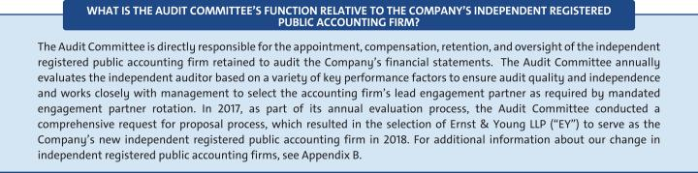

The Audit Committee has selected EY as the Company’s independent registered public accounting firm for the fiscal year ending December 31, 2019, because it believes it is in the best interest of the Company and its shareholders. Accordingly, the Board of Directors recommends that shareholders ratify the Audit Committee’s selection of EY as the Company’s independent registered public accounting firm for 2019. If the shareholders do not ratify the selection of EY as the independent registered public accounting firm for the Company for 2019, the Committee will reconsider whether to engage EY, but may ultimately determine to engage EY or another audit firm without resubmitting the matter to shareholders.

Even if the shareholders ratify the selection of EY, the Committee may, in its sole discretion, terminate the engagement of EY and direct the appointment of another independent registered public accounting firm at any time during the year, although it has no current intention to do so.

We expect that representatives of EY will be present at the Annual Meeting. They will have an opportunity to make a statement if they so desire and are expected to be available to respond to appropriate questions by shareholders.

The Board of Directors recommends a vote FOR the proposal to ratify the selection of Ernst & Young LLP as the independent registered public accounting firm for GM and its subsidiaries for 2019.

70

Table of Contents

ITEM NO. 3 – BOARD PROPOSAL TO RATIFY THE SELECTION OF ERNST & YOUNG LLP AS

THE COMPANY’S INDEPENDENT REGISTERED PUBLIC ACCOUNTING FIRM FOR 2019

Audit Committee Report

The Audit Committee (the “Committee”) of the General Motors Board of Directors is a standing committee composed of five directors: Thomas M.

Schoewe (Chair), Linda R. Gooden, Jane L. Mendillo, Judith A. Miscik, and Michael G. Mullen.
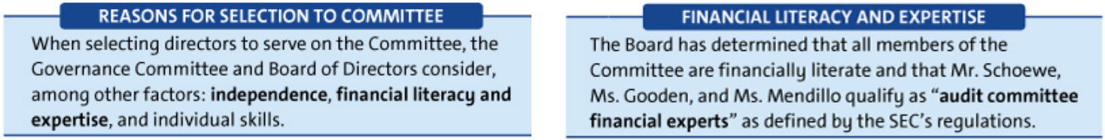

Purpose

The Committee’s core purpose is to assist the Board by providing oversight of:

- The quality and integrity of GM’s financial statements;

- GM’s compliance with legal and regulatory requirements; and

- The qualifications, performance, and independence of GM’s external auditors and internal audit staff.

The Committee operates under a written charter adopted by the Committee and approved by the Board of Directors. The Committee’s charter is posted on our website at investor.gm.com/resources. The Committee’s charter is reviewed at least annually and updated as necessary to address changes

in regulatory requirements, authoritative guidance, evolving oversight practices, and shareholder feedback.

Management is responsible for the Company’s internal controls and the financial reporting process and has delivered its opinion on the effectiveness of the Company’s controls. The auditor is responsible for performing an independent audit of the Company’s consolidated financial statements and opining on the effectiveness of those controls in accordance with the standards of the Public Company Accounting Oversight Board (United States) (the “PCAOB”) and issuing its reports thereon. As provided in its charter, the Committee’s responsibilities include monitoring and overseeing these processes.

Required Disclosures

In 2018, the Committee met seven times and fulfilled all of its core charter obligations. Consistent with its charter responsibilities, the Committee met and held discussions with management and EY regarding the Company’s audited financial statements and internal controls for the year ended December 31, 2018. In this context, management represented to the Committee that the Company’s consolidated financial statements were prepared in accordance with accounting principles generally accepted in the United States. The Committee reviewed and discussed the consolidated financial statements with management and the auditor and further

discussed with the auditor the matters required to be discussed by the standards of the PCAOB.

EY also provided to the Committee the written disclosures and the letter required by the applicable requirements of the PCAOB concerning independence, and the Committee discussed with the auditor the auditor’s independence. The Committee also considered and determined that the provision of non-audit services to GM is compatible with maintaining the auditor’s independence. The Committee concluded that EY was independent from the Company and management.

Recommendation

Based upon the Committee’s discussions with management and the auditor as described in this report and the Committee’s review of the representation of management and the reports of the auditors to the Committee, the Committee recommended to the Board of Directors, and the Board of Directors approved, the inclusion of the audited consolidated financial statements in the Company’s Annual Report on Form 10-K for the year ended December 31, 2018, as filed with the U.S. Securities and Exchange Commission on February 6, 2019.

Audit Committee*

Thomas M. Schoewe (Chair)

Linda R. Gooden

Jane L. Mendillo

Michael G. Mullen

- Judith A. Miscik was not a member of the Audit Committee at the time the Committee approved its Report.

The preceding Audit Committee Report shall not be deemed incorporated by reference by any general statement incorporating by reference this Proxy Statement or any portion hereof into any filing under the Securities Act of 1933, as amended, or the Securities Exchange Act of 1934, as amended, and shall not otherwise be deemed filed thereunder.

71

Table of Contents

ITEM NO. 3 – BOARD PROPOSAL TO RATIFY THE SELECTION OF ERNST & YOUNG LLP AS

THE COMPANY’S INDEPENDENT REGISTERED PUBLIC ACCOUNTING FIRM FOR 2019

Fees Paid to Independent Registered Public Accounting Firm

The Audit Committee retained EY to audit the Company’s consolidated financial statements and the effectiveness of internal controls as of and for the year ended December 31, 2018. The Company and its subsidiaries also retained EY and certain of its affiliates, as well as other accounting and consulting firms, to provide various other services in 2018. EY initially presented the proposed annual audit services and their related fees to the Audit Committee for approval on an audit-year basis.

The services performed by EY in 2018 were preapproved in accordance with the preapproval policy and procedures established by the Committee. This policy requires that prior to the provision of services by the auditor, the Committee will be presented with a description of the types of audit-related, tax, and all other services expected to be performed by the auditor during the fiscal year with the amounts budgeted for each category (Audit-Related, Tax, and All Other Services). Any requests for services for $1 million or more that were not initially contemplated and approved by the Audit Committee must thereafter be submitted to the Audit Committee (or the Chair of the Audit Committee in an urgent case) for specific preapproval. Requests for services less than $1 million individually can be approved by management based on the amounts approved for each category. Management must report actual spending for each category to the full Audit Committee periodically during the year.

These services are actively monitored (both spending and work content) by the Audit Committee to maintain the appropriate objectivity and independence in EY’s core work, which is the audit of the Company’s consolidated financial statements and internal controls. The Audit Committee determined that all services provided by EY in 2018 were compatible with maintaining the independence of EY.

The following table summarizes the fees for professional audit services provided by (i) EY for the audit of the Company’s annual financial statements for the year ended December 31, 2018, and (ii) Deloitte & Touch LLP (“Deloitte”) for the audit of the Company’s annual financial statements for the year ended December 31, 2017, as well as the fees billed for other services rendered by EY and Deloitte, respectively, during these periods.

 |  | 2018 | 2017
Type of Fees |  | ($ in millions) | ($ in millions)
 | Audit | 23 | 26
 | Audit-Related | 5 | 6
 | Tax | 4 | 5
 | Subtotal | 32 | 37
 | All Other Services | 3 | 6
 | TOTAL | 35 | 43

Audit Fees – Includes fees for the integrated audit of the Company’s annual consolidated financial statements and attestation of the effectiveness of the Company’s internal controls over financial reporting, including reviews of the interim financial statements contained in the Company’s Quarterly Reports on Form 10-Q and audits of statutory financial statements.

Audit-Related Fees – Includes fees for assurance and related services that are traditionally performed by the independent registered public accounting firm. More specifically, these services include employee benefit plan audits, comfort letters in connection with funding transactions, other attestation services, and consultation concerning financial accounting and reporting standards.

Tax Fees – Includes fees for tax compliance, tax planning, and tax advice. Tax compliance involves preparation of original and amended tax returns and claims for refund. Tax planning and tax advice encompass a diverse range of services, including assistance with tax audits and appeals, tax advice related to mergers and acquisitions and employee benefit plans, and requests for rulings or technical advice from taxing authorities.

All Other Fees – Includes fees for services that are not contained in the above categories and consists of permissible advisory services.

72

Table of Contents

ITEM NO. 4 – SHAREHOLDER PROPOSAL REGARDING

INDEPENDENT BOARD CHAIRMAN

We will provide the name, address, and share ownership of the shareholder who submitted this Rule 14a-8 shareholder proposal upon a shareholder’s request. The shareholder proponent is responsible for the content of the proposal for which we and our Board accept no responsibility.

Proposal 4 – Independent Board Chairman

Shareholders request our Board of Directors to adopt as policy, and amend our governing documents as necessary, to require henceforth that the Chair of the Board of Directors, whenever possible, to be an independent member of the Board. The Board would have the discretion to phase in this policy for the next CEO transition, implemented so it does not violate any existing agreement.

If the Board determines that a Chairman who was independent when selected is no longer independent, the Board shall select a new Chair who satisfies the requirements of the policy within a reasonable amount of time. Compliance with this policy is waived if no independent director is available and willing to serve as Chairman. This proposal requests that all the necessary steps be taken to accomplish the above.

It was reported that 53% of the Standard & Poors 1,500 firms separate these 2 positions (2015 report): Chairman and CEO. This proposal topic won 50%-plus support at 5 major U.S. companies in 2013 including 73%-support at Netflix.

Having a board chairman who is independent of management is a practice that will move in the direction of better vetted management decisions on questionable practices such as promotion of rolling back fuel economy standards and a $14 billion Stock Buyback Plan. This is of the utmost importance since the automobile industry is undergoing the greatest change since 1900.

A December 2018 article had the headline:

Senators Pressuring GM to Halt $14B Stock Buyback Plan

“We are deeply concerned about the recent actions by General Motors Company (GM) to close factories in the United States, at the same time that GM is expanding production in Mexico and buying back its own stock. We are writing to request information about how GM may be benefiting from new tax incentives for offshoring that were created by the 2017 tax act, and to ask that GM cancel further stock buybacks,” the senators said in the letter to Mary Barra.

These buybacks make no sense, since GM’s stated purpose for closing factories is to free up cash flow for investments in electric and autonomous vehicles. GM has spent $10.6 billion on stock buybacks since 2015, and plans to continue these buybacks until it has spent $14 billion. These buybacks give a windfall to GM’s executives while diverting cash flow that GM could use to invest in electric and autonomous vehicles without laying off American workers, the letter added.

Stock buybacks can be a sign of short-termism for executives – sometimes boosting share price without boosting the underlying value, profitability, or ingenuity of the company. A dollar spent repurchasing a share is a dollar that cannot be spent on new equipment, an acquisition or entry into a new market.

This proposal topic won impressive 41%-support at our 2017 annual meeting. This 41%-support would have been higher (perhaps 45%) if all shareholders had access to independent proxy voting advice.

Please vote yes: Independent Board Chairman - Proposal 4

73

Table of Contents

ITEM NO. 4 – SHAREHOLDER PROPOSAL REGARDING INDEPENDENT BOARD CHAIRMAN

The Board of Directors recommends a vote AGAINST this proposal for the following reasons:


u The Board should have the flexibility and is in the best position to decide who should serve as its Chairman.

u Ms. Barra’s service as Chairman and CEO provides a clear and unified strategic vision for GM that fosters a nimble and responsive Board.

u GM’s strong Independent Lead Director and commitment to governance best practices already ensure management accountability to shareholders by independent directors.

Your Board should have the flexibility and is in the best position to determine who should serve as Chairman – whether that person is an independent director or CEO.

GM operates in a very competitive and fast-changing industry. Your Board and management must constantly assess industry change and disruption. Your Board is composed of directors with diverse backgrounds, experience, perspectives, and in-depth knowledge about GM. With this expertise, it is uniquely positioned to evaluate GM’s key challenges and needs, including the optimal Board leadership structure.

It is critical that your Board have the flexibility to choose the best person to serve as Chairman and not be arbitrarily constrained by a one-size-fits-all policy that has been empirically shown to have little relation to long-term shareholder value. The proposal would remove the Board’s current flexibility to determine the leadership structure that best serves the interests of GM and its shareholders.

Your Board evaluates its leadership structure annually as well as in connection with any future CEO transition. Although your Board has in the past, and may again in the future, determine that separating the roles of Chairman and CEO would best serve shareholders, your Board presently believes that a combined role, coupled with a strong Independent Lead Director and other governance best practices, is in the best interests of shareholders at this time.

Your Board believes that Mary Barra’s service as Chairman and CEO has provided, and continues to provide, a clear and unified strategic vision for GM during this time of unprecedented industry change.

During Ms. Barra’s tenure, GM has taken bold, strategic actions to grow long-term shareholder value, strengthened its core business, invested to lead in the future of mobility, and articulated GM’s vision for zero crashes, zero emissions, and zero congestion. In 2018, Ms. Barra announced additional plans to accelerate GM’s transformation for the future, which are expected to increase annual adjusted automotive free cash flow by year-end 2020.

Ms. Barra’s Board leadership is complemented by a strong Independent Lead Director.

While Ms. Barra’s in-depth knowledge of our businesses and understanding of day-to-day operations bring focused leadership to your Board, the independent directors also recognize the importance of strong independent leadership. As the Independent Lead Director, Mr. Solso provides leadership and oversight for shareholders, including focus on strategic risk management, compliance, governance, and CEO succession planning. The specific duties of the Independent Lead Director are discussed on page 23.

GM’s strong corporate governance practices reinforce Board independence and management accountability.

The Board has established and maintains numerous best-in-class governance practices to reinforce and facilitate management accountability and provide meaningful independent oversight, including:

- Annual election of directors;

- Annual evaluation of CEO performance and compensation by non-management directors;
- Executive sessions held at most Board and Committee meetings without management present;
- Six of our seven standing Committees, including the Compensation Committee, being composed entirely of independent directors; and
- Directors having unrestricted access to management and independent, outside advisors.

Your Board routinely engages directly with shareholders, reinforcing management accountability.

Since implementing the Director-Shareholder Engagement Policy in 2016, directors have annually conducted in-person meetings with our largest shareholders. These engagements help shape the Board’s perspective on many issues, such as Board leadership, succession planning, and refreshment; executive compensation, including the link between corporate strategy and executive compensation; and corporate responsibility, environmental, social, and other current and emerging issues so that your Board and management can understand and address the issues that are important to our shareholders. Examples of the Board incorporating feedback include adopting proxy access (2016), making significant changes to our compensation programs (2017), and integrating three new directors into the Board (2018 to 2019).

GM’s disciplined capital allocation strategy is aligned with the long-term interests of shareholders.

In the supporting statement for the shareholder’s proposal, the proponent incorrectly suggests that GM’s decision to buy back

74

Table of Contents

ITEM NO. 4 – SHAREHOLDER PROPOSAL REGARDING INDEPENDENT BOARD CHAIRMAN


GM shares was not subject to independent Board oversight. In fact, your Board has worked closely with management in recent years to develop a disciplined capital allocation framework that consists of

- deploying capital to higher-return opportunities, (2) maintaining an investment grade balance sheet, and (3) returning available cash to shareholders in the form of dividends and share buybacks. Your Board believes that GM’s shares remain under-valued and that returning cash to shareholders through buybacks is a critical component of GM’s capital allocation strategy that is in the long-term best interests of shareholders.

Your Board’s current leadership structure is consistent with the practices of the largest U.S. public companies.

According to a recent Shearman & Sterling’s Corporate Governance & Executive Compensation Survey of the 100 largest

U.S. public companies, only 12 companies have a policy that requires separate individuals to serve as chairman and CEO; the overwhelming majority of corporate policies provide boards with the flexibility to separate or combine the positions. Contrary to the proponent’s statements, your Board’s flexible approach to its leadership structure does not make it an outlier among its peers.

Therefore, your Board of Directors recommends a vote AGAINST this shareholder proposal.

Learn More

Our Independent Lead Director, Mr. Solso, shares his perspective on your Board’s current leadership structure in his letter to shareholders on page 23.

75

Table of Contents

ITEM NO. 5 – SHAREHOLDER PROPOSAL REGARDING REPORT ON LOBBYING COMMUNICATIONS AND ACTIVITIES

We will provide the name, address, and share ownership of the shareholders who submitted this Rule 14a-8 shareholder proposal upon a shareholder’s request. The shareholder proponents are responsible for the content of the proposal for which we and our Board accept no responsibility.

Resolved, the shareholders of General Motors Company (“GM”) request the preparation of a report, updated annually, disclosing:

- Company policy and procedures governing lobbying, both direct and indirect, and grassroots lobbying communications.

- Payments by GM used for (a) direct or indirect lobbying or

(b) grassroots lobbying communications, in each case including the amount of the payment and the recipient.

- Description of management’s decision making process and the Board’s oversight for making payments described above.

For purposes of this proposal, a “grassroots lobbying communication” is a communication directed to the general public that (a) refers to specific legislation or regulation, (b) reflects a view on the legislation or regulation and (c) encourages the recipient of the communication to take action with respect to the legislation or regulation. “Indirect lobbying” is lobbying engaged in by a trade association or other organization of which GM is a member.

Both “direct and indirect lobbying” and “grassroots lobbying communications” include efforts at the local, state and federal levels.

The report shall be presented to the Governance and Corporate Responsibility Committee and posted on GM’s website.

GM spent $71,495,000 from 2010—2017 on federal lobbying (opensecrets.org). This figure does not include state lobbying expenditures in the 49 states where GM lobbies but disclosure is uneven or absent (https://publicintegrity.org/state-politics/amid-federal-gridlock-lobbying-rises-For example, GM spent $2,756,602 on lobbying in California from 2010— 2017. GM’s lobbying over fuel efficiency standards has attracted

considerable media scrutiny (https://nexusmedianews.com/the-stunning-hypocrisy-of-u-s-automakers-90

GM belongs to the Business Roundtable, which lobbies against the right of shareholders to file resolutions, and is also a member of the Alliance of Automobile Manufacturers, which spent over $15.5 million on lobbying for 2016 and 2017. GM does not disclose its memberships in, or payments to, trade associations, or the amounts used for lobbying. GM discloses trade association payments used for political contributions, but not payments used for lobbying. This leaves a serious disclosure gap, as trade associations generally spend far more on lobbying than on political contributions.

We are concerned that GM’ s lack of lobbying disclosure presents significant reputational risk when it contradicts the company’ s public positions. For example, GM states that it believes climate change is real and is committed to reducing greenhouse gas emissions, yet the Alliance of Automobile Manufacturers has questioned climate science and lobbied to weaken fuel standards, which will severely hamper the ability to meet

climate goals (http://theconversation.com/when-corporations-take-credit-for-green-deeds-As shareholders, we believe that companies should ensure there is alignment between their own positions and their lobbying, including through trade associations.

Supporting Statement

We encourage transparency in the use of GM’s corporate funds to

influence legislation and regulation, both directly and

indirectly. Investors participating in the Climate Action 100+, representing

$32 trillion in assets under management, seek enhanced disclosure

regarding alignment with the Paris agreement by GM and other

companies.

76

Table of Contents

ITEM NO. 5 – SHAREHOLDER PROPOSAL REGARDING REPORT ON LOBBYING COMMUNICATIONS AND ACTIVITIES

The Board of Directors recommends a vote AGAINST this proposal for the following reasons:


u GM already provides comprehensive political and lobbying disclosure.

u The success of our business depends on our ability to successfully advocate for sound public policies.

u GM’s political activities are subject to thorough Board review and oversight.

GM already provides comprehensive political and lobbying disclosure.

As part of our overall effort to promote political transparency and accountability, GM publishes an annual voluntary report of political contributions (available for each of the past five years at investor.gm.com/resources). Included in this report are

- contributions to section 527 organizations; (2) contributions to individual candidates for state and local office; (3) portions of dues or similar payments to 501(c)(6) trade associations and section 501(c)(4) organizations to the extent the dues or other payments equal or exceed $50,000 and are attributable to political purposes; and (4) a link to all contributions by GM PAC.

In addition, GM files publicly available federal Lobbying Disclosure Act Reports each quarter, which disclose GM’s lobbying expenditures, describe legislation and general issues that were the topic of communication, and identify the individual who lobbied on behalf of GM. GM also files similar periodic reports with state agencies.

The 2018 CPA-Zicklin Index of Corporate Political Disclosure and Accountability ranked GM’s lobbying disclosure in the First Tier.

In 2018, the Center for Political Accountability’s Zicklin Index of Corporate Political Accountability and Disclosure, which benchmarks the political disclosure and accountability policies and practices of leading U.S. public companies, has recognized the quality of our disclosure and ranked GM among the First Tier of S&P 500 companies.

GM protects and promotes shareholder value by participating in the political process.

Public policy decisions can significantly affect GM’s strategies, operations, and, ultimately, shareholder value. To protect shareholder value, GM exercises its fundamental right and responsibility to participate in the legislative, regulatory and political processes to ensure decisionmakers are informed by our expertise and insights when considering policies that impact GM. GM does this by making political contributions to candidates and entities that support our industry and our vision for the future of mobility, by engaging in direct and indirect lobbying, and by participating in various business and policy organizations that advocate positions designed to support GM’s business and enhance long-term shareholder value. For example, we recently proposed a National Zero Emission Vehicle program that we believe could place more than 7 million long-range electric vehicles on the road by 2030.

GM’s political activities are subject to thorough review and independent oversight.

GM participation in the political process is subject to best-in-class corporate governance practices. All corporate political contributions are centrally controlled, budgeted, and reviewed for compliance with the law and consistency with GM’s policies and strategic goals. At least annually, management reviews with the Governance Committee all political contributions, including those made by GM PAC and various GM state political action committees.

Additional lobbying disclosure is unnecessary.

Your Board believes GM’s lobbying activities are transparent and the adoption of this proposal is unnecessary given the information that is already publicly available.

Therefore, your Board of Directors recommends a vote AGAINST this shareholder proposal.

77

Table of Contents

GENERAL INFORMATION ABOUT THE ANNUAL MEETING

- Voting and Meeting Information

Vote Requirements and Board Recommendations

 |  |  |  |  | Effect of
Agenda |  | Board |  | Effect of | Broker
Item | Description | Recommendation | Vote Requirement for Approval | Abstentions | Non-Vote
1 | Election of Directors (1) | FOR | Majority of votes cast | No effect | No effect
2 | Approval of, on an Advisory Basis, NEO | FOR |  | Counted as | No effect
2 | compensation (“Say on Pay”) | FOR |  | “AGAINST” | No effect
 | Ratification of the Selection of Ernst & Young LLP |  |  | Counted as | Discretionary
3 | as the Company’s Independent Registered Public | FOR | Majority of shares present | Counted as | Discretionary
 |  |  |  | “AGAINST” | vote
 | Accounting Firm for 2019 |  | (in person or by proxy) | “AGAINST” | vote
4 | Shareholder Proposal Regarding Independent | AGAINST | and entitled to vote | Counted as | No effect
4 | Board Chairman | AGAINST |  | “AGAINST” | No effect
5 | Shareholder Proposal Regarding Report on | AGAINST |  | Counted as | No effect
5 | Lobbying Communications and Activities | AGAINST |  | “AGAINST” | No effect

- Each person elected as director will serve a one-year term and until his or her successor has been duly elected and qualified or until his or her earlier resignation or removal. If any nominee becomes unable to serve, proxies will be voted for the election of such other person as the Board may designate, unless the Board chooses to reduce the number of directors.

Other Matters to Be Presented at the Annual Meeting

We do not know of any matters to be voted on by shareholders at the Annual Meeting other than those included in this Proxy Statement. The Company received notice that one individual (who purportedly owns 52 shares of common stock) intended to nominate himself and one other person for election as a director. This individual’s notice did not comply with the Company’s Bylaws, and therefore the Company does not intend to submit his nominations for shareholder election. If any matter, other than the election of the Company’s nominees for director or items 2 to 5 in this Proxy Statement, is properly presented at the meeting, your executed proxy gives the Proxies (as defined below) discretionary authority to vote your shares in accordance with their best judgment with respect to the matter.

Attending the Online Annual Meeting

This year the Annual Meeting will be conducted online only, via a live video webcast. To participate in the online meeting, visit gm.onlineshareholdermeeting.com and enter the 16-digit control number included on your notice of internet availability of the proxy materials (“Notice”), on your proxy card, or on the instructions that accompanied your proxy materials. You may begin to log into the meeting platform beginning at 7:45 a.m. Eastern Time on June 4, 2019. The meeting will begin promptly at 8:00 a.m. Eastern Time on June 4, 2019.

If you do not have internet access or you have lost your 16-digit control number, you can call (877) 328-2502 (toll free) or (412) 317-5419 (international) to listen to the meeting proceedings; however, you will not be able to vote your shares or submit questions during the meeting.

If you experience technical difficulties during the check-in process or during the meeting, please call (800) 586-1548 (U.S.) or (303) 562-9288 (international) for assistance. If you need additional shareholder support, please e-mail shareholder.relations@gm.com or call (313) 667-1432 for assistance.

Submitting Questions

Shareholders may submit questions either before or during the meeting. If you want to ask a question before the meeting, log in to proxyvote.com and enter your 16-digit control number. Once past the login screen, click on “Questions for Management,” type in your question and click “Submit.” If you want to ask a question during the meeting you may do so in two ways: either log into the online meeting platform at gm.onlineshareholdermeeting.com, type your question into the “Ask a Question” field, and click “Submit”; or call (877) 328-2502 (toll free) or (412) 317-5419 (international). Only shareholders with a valid control number will be allowed to ask questions.

Questions pertinent to meeting matters will be answered during the meeting, subject to time constraints. If there are questions pertinent to meeting matters that cannot be answered during the meeting due to time constraints, management will post answers to a representative set of such questions at investor.gm.com/shareholder. The questions and answers will be available as soon as practicable after the meeting and will remain available until GM’s 2020 Proxy Statement is filed.

Voting at the Annual Meeting

Shareholders of record and beneficial owners will be able to vote their shares electronically during the Annual Meeting. However, even if you plan to participate in the Annual Meeting online, we recommend that you also vote by proxy as described below so that your votes will be counted if you later decide not to participate in the Annual Meeting.

78

Table of Contents

GENERAL INFORMATION ABOUT THE ANNUAL MEETING

Quorum

The presence of the holders of a majority of the outstanding shares of our common stock, in person or by proxy, will constitute a quorum for transacting business at the Annual Meeting. Abstentions and broker non-votes are counted as present for purposes of establishing a quorum at the meeting.

Proxies

The Board appointed the following executive officers to act as proxies: Mary T. Barra and Craig B. Glidden (collectively, the “Proxies”). If you sign and return your proxy card or voting instruction form with voting instructions, one or more of the Proxies will vote your shares as you direct on the matters described in this Proxy Statement. If you sign and return your proxy card or voting instruction form without voting instructions, one or more of the Proxies will vote your shares as recommended by the Board.

Who Can Vote

If you are a holder of the Company’s common stock as of the close of business on April 8, 2019, or you hold a valid proxy, you are entitled to vote at the Annual Meeting. On that date, the Company had 1,420,831,726 shares of common stock outstanding and entitled to vote. Each share of our common stock entitles the holder to one vote.

Voting Without Attending the Annual Meeting

To vote your shares without attending the meeting, please follow the instructions for voting on the Notice, on your proxy card, or on the voting instructions form. When you timely submit your proxy or voting instructions in the proper form, your shares will be voted according to your instructions. You may give instructions to vote for or against or abstain from voting for the election of all the Board of Directors’ nominees or any individual nominee and to vote for or against or abstain from voting on each of the other matters submitted for voting. If you sign, date, and return the proxy card or voting instruction form without specifying how you wish to cast your vote, your shares will be voted by the Proxies according to the recommendations of the Board of Directors, as indicated above. internet and telephone voting is available 24 hours a day, through 11:59 p.m. Eastern Time on Monday, June 3, 2019.

Revoking Your Proxy

After you have submitted your proxy or voting instructions by Internet, telephone, or mail, you may revoke your proxy at any time until it is voted at the Annual Meeting. If you are a shareholder of record, you may do this by (1) granting a new proxy bearing a later date (which automatically revokes the earlier proxy); (2) sending a written notice of revocation to the Corporate Secretary at Mail Code 482-C24-A68, 300 Renaissance Center, Detroit, Michigan 48265, or by e-mail to shareholder.relations@gm.com; or (3) by participating in the Annual Meeting and voting your shares electronically during the meeting. Participation in the Annual Meeting will not cause your previously granted proxy to be revoked unless you specifically make that request. For shares that you hold beneficially in the name of a broker, bank, or other nominee (that is, in “street name”), you may change your vote by submitting new voting instructions to your broker, bank, or nominee, or by participating in the meeting and electronically voting your shares during the meeting.

Annual Meeting Voting Results

Our independent inspector of elections, Broadridge Financial Services, Inc., will tabulate the vote at the Annual Meeting. We will provide voting results on our website and in a Current Report on Form 8-K filed with the SEC.

“Shareholder of Record” and “Beneficial Shareholder”

If your shares are owned directly in your name in an account with GM’s stock transfer agent, Computershare Trust Company, N.A. (“Computershare”), you are considered the “shareholder of record” of those shares in your account. If your shares are held in an account with a broker, bank, or other nominee as custodian on your behalf, you are considered a “beneficial shareholder” of those shares, which are held in street name. The broker, bank, or other nominee is considered the shareholder of record for those shares. As the beneficial owner, you have the right to instruct the broker, bank, or other nominee on how to vote the shares in your account. In order for your shares to be voted in the way you would like, you must provide voting instructions to your broker, bank, or other nominee by the deadline provided in the proxy materials you receive from your broker, bank, or other nominee. If you do not provide voting instructions to your broker, bank, or other nominee, whether your shares can be voted on your behalf depends on the type of item being considered for vote. Under NYSE rules, brokers are permitted to exercise discretionary voting authority only on “routine” matters. Therefore, your broker may vote on Item No. 3 (“Ratification of the Selection of Ernst & Young LLP as the Company’s Independent Registered Public Accounting Firm for 2019”) even if you do not provide voting instructions because it is considered a routine matter. Your broker is not permitted to vote on the other agenda Items if you do not provide voting instructions because those items involve matters that are considered nonroutine.

79

Table of Contents

GENERAL INFORMATION ABOUT THE ANNUAL MEETING

Householding

SEC rules permit companies to send a single Proxy Statement and Annual Report on Form 10-K or Notice to two or more shareholders that share the same address, subject to certain conditions. Each shareholder will continue to receive a separate proxy card, voting instruction form, or Notice, and it will include the unique 16-digit control number that is needed to vote those shares and to access and vote during the Annual Meeting. This “householding” rule will benefit both the shareholders and GM by reducing the volume of duplicate information shareholders receive and reducing GM’s printing and mailing costs.

If one set of these documents was sent to your household for the use of all GM shareholders in your household and one or more of you would prefer to receive additional sets or if multiple copies of these documents were sent to your household and you want to receive one set, please contact Broadridge Financial Solutions, Inc., by calling toll-free at 866-540-7095 or by writing to Broadridge Financial Solutions, Inc., Householding Department, 51 Mercedes Way, Edgewood, New York 11717.

If a broker, bank, or other nominee holds your shares, please contact your broker, bank, or other nominee directly if you have questions about delivery of materials, require additional copies of the Proxy Statement or Annual Report on Form 10-K, or wish to receive multiple copies of proxy materials, which would require you to state that you do not consent to householding.

- Shareholder Proposals and Director Nominations

Type of Proposal | Rule 14a-8 Proposals by | Director Nominees for | Other Proposals or
 | Shareholders | Inclusion in Next Year’s | Nominees for
 | for Inclusion in Next Year’s Proxy | Proxy Statement | Representation at Next Year’s
 | Statement | (Proxy Access) | Annual Meeting
Rules/Provisions | SEC rules and our Bylaws permit | Our Bylaws permit a shareholder or | Our Bylaws require that any
 | shareholders to submit proposals for | group of shareholders (up to 20) who | shareholder proposal, including a
 | inclusion in our Proxy Statement if the | have owned a significant amount of | director nomination, that is not
 | shareholder and the proposal meet the | common stock (at least 3%) for a | submitted for inclusion in next year’s
 | requirements specified in SEC Rule 14a-8. | significant amount of time (at least | Proxy Statement (either under SEC
 |  | three years) to submit director | Rule 14a-8 or our proxy access
 |  | nominees (up to 20% of the Board or | bylaw), but is instead sought to be
 |  | two directors, whichever is greater) | presented directly at the next year’s
 |  | for inclusion in our Proxy Statement if | Annual Meeting must be received at
 |  | the shareholder(s) and the | our principal executive offices no
 |  | nominee(s) satisfy the requirements | earlier than 180 days and no later
 |  | specified in our Bylaws. | than 120 days before the first
 |  |  | anniversary of this year’s Annual
 |  |  | Meeting.
When to Send These Proposals | Proposals must be received at our principal | Proposals must be sent no earlier than December 7, 2019, and no later than
 | executive offices no later than 11:59 p.m. | 11:59 p.m. Eastern Time on February 5, 2020.
 | Eastern Time on December 20, 2019.
Where to Send These Proposals | Mail proposals to our Corporate Secretary at Mail Code 482-C24-A68, 300 Renaissance Center, Detroit, Michigan 48265,
 | or send proposals by e-mail to shareholder.relations@gm.com.
What to Include | Proposals must conform to and include the | Proposals must include information required by our Bylaws, which are
 | information required by SEC Rule 14a-8. | available on our website at
 |  | investor/gm.com/resources.

- Annual Report on Form 10-K and Other Investor Materials

You may download a copy of our 2018 Annual Report on Form 10-K by visiting the “SEC Filings” section of our website at investor.gm.com/sec-filings. Other publications available for download at this website include our Proxy Statement and our quarterly reports on Form 10-Q, and our code of conduct, “Winning with Integrity.” Alternatively, you may request a printed copy of these publications by writing to Shareholder Relations at General Motors Company, Mail Code: 482-C23-A68, 300 Renaissance Center, Detroit, Michigan 48265 or by e-mail to shareholder.relations@gm.com.

80

Table of Contents

GENERAL INFORMATION ABOUT THE ANNUAL MEETING

- Cost of Proxy Solicitation

We will pay our cost for soliciting proxies for the Annual Meeting. The Company will distribute proxy materials and follow-up reminders, if any, by mail and electronic means. We have engaged Morrow Sodali, LLC (“Morrow”), a professional proxy solicitation firm, located at 470 West Avenue, Stamford, Connecticut 06902 to assist with the solicitation of proxies and to provide related advice and informational support for a service fee, plus customary disbursements. We expect to pay Morrow an aggregate fee, including reasonable out-of-pocket expenses, of up to $25,000, depending on the level of services actually provided. GM directors, officers, and employees may also solicit proxies by mail, telephone, or personal visits. They will not receive any additional compensation for their services.

General Motors will provide copies of these proxy materials to banks, brokerage houses, fiduciaries, and custodians holding in their names shares of our common stock beneficially owned by others so that they may forward these proxy materials to the beneficial owners. As usual, we will reimburse brokers, banks, and other nominees for their reasonable expenses in forwarding proxy materials to beneficial owners.

81

Table of Contents

APPENDIX A: NON-GAAP FINANCIAL MEASURES

Non-GAAP Reconciliations

Our Company reports its financial results in accordance with generally accepted accounting principles in the United States (“GAAP”). However, management believes that certain non-GAAP financial measures provide users with additional meaningful financial information.

Our non-GAAP measures presented in this Proxy Statement include earnings before interest and taxes (“EBIT”)–adjusted, presented net of noncontrolling interests, earnings per share (“EPS”)–diluted–adjusted, and ROIC-adjusted. These measures relate to our continuing operations and not our discontinued operations. Our calculation of these non-GAAP measures may

not be comparable with similarly titled measures of other companies due to potential differences between companies in the method of calculation. As a result, the use of these non-GAAP measures has limitations and should not be considered superior to, in isolation from, or as a substitute for related GAAP measures. See our Annual Report on Form 10-K for the fiscal year ended December 31, 2018, and our subsequent filings with the SEC for additional information about the non-GAAP measures presented herein, including a description of the use of such measures. The numbers in the tables below may not sum due to rounding.

($B) | 2018 | 2017
Net Income (Loss) Attributable to Stockholders | 8.0 | (3.9)
Loss from Discontinued Operations, Net of Tax | 0.1 | 4.2
Subtract:
Income tax expense | 0.5 | 11.5
Automotive interest expense | 0.7 | 0.6
Automotive interest income | (0.3) | (0.3)
Add Back Special Items:
Transformation activities⁽¹⁾ | 1.3 | –
GMI restructuring⁽²⁾ | 1.1 | 0.5
Ignition switch recall and related legal matters⁽³⁾ | 0.4 | 0.1
Total Special items | 2.9 | 0.7
EBIT-adjusted | $ 11.8 | $ 12.8
Net Sales and Revenue | 147.0 | 145.6
EBIT-adjusted Margin | 8.0% | 8.8%

- These adjustments were excluded because of a strategic decision to accelerate our transformation for the future to strengthen our core business, capitalize on the future of personal mobility, and drive significant cost efficiencies. The adjustments primarily consist of employee separation charges and accelerated depreciation.

- These adjustments were excluded because of a strategic decision to rationalize our core operations by exiting or significantly reducing our presence in various international markets to focus resources on opportunities expected to deliver higher returns. The adjustments primarily consist of employee separation charges, asset impairments, and supplier claims in the year ended December 31, 2018, all in Korea. The adjustment in the year ended December 31, 2017, primarily consists of asset impairments and other restructuring actions in India, South Africa, and Venezuela.

- These adjustments were excluded because of the unique events associated with the ignition switch recall, which included various investigations, inquiries, and complaints from constituents.

$ per Share | 2018 | 2017
Diluted Earnings (Loss) per Common Share | $ 5.53 | $(2.60)
Diluted loss per common share – discontinued operations | 0.05 | 2.82
Adjustments⁽¹⁾ | 2.03 | 0.44
Tax effect of adjustments⁽²⁾ | (0.29) | (0.14)
Tax adjustments⁽³⁾ | (0.78) | 6.10
EPS-diluted-adjusted | $ 6.54 | $ 6.62

- Refer to the reconciliation of EBIT-adjusted on a continuing operations basis above for adjustment details.

- The tax effect of each adjustment is determined based on the tax laws and valuation allowance status of the jurisdiction to which the adjustment relates.

- In the year ended December 31, 2018, the adjustment consists of: (1) a nonrecurring tax benefit related to foreign earnings; and (2) tax effects related to U.S. tax reform legislation. In the year ended December 31, 2017, the adjustment consisted of the tax expense of $7.3 billion related to U.S. tax reform legislation and the establishment of a valuation allowance against deferred tax assets of $2.3 billion that are no longer realizable as a result of the sale of the Opel/Vauxhall Business, partially offset by tax benefits related to tax settlements. These adjustments were excluded because impacts of tax legislation and valuation allowances are not considered part of our core operations.

A-

1

Table of Contents

($B) | 2018
EBIT-adjusted | 11.8
Average equity⁽¹⁾ | 37.4
Add: Average automotive debt and interest liabilities (excluding capital leases) | 14.4
Add: Average automotive net pension & OPEB liability | 18.3
Less: Average automotive net income tax asset | (22.7)
ROIC-adjusted average net assets | 47.4
ROIC-adjusted | 24.9%

- Includes equity of noncontrolling interests where the corresponding earnings are included in EBIT-adjusted.

Adjusted Automotive Free Cash Flow

In the section titled “Executive Compensation,” we present one of our incentive compensation measures, adjusted automotive free cash flow, which is not prepared in accordance with GAAP. Below is a reconciliation of adjusted automotive free cash flow (as calculated for incentive compensation purposes) to net automotive cash provided by operating activities – continuing operations, its nearest GAAP measure.

($B) | 2018
Net automotive cash provided by operating activities – continuing operations | 11.7
Less: capital expenditures – continuing operations | (8.7)
Adjustments
Transformation activities | 0.0
Korea restructuring | 0.8
Incentive compensation adjustments⁽¹⁾ | 0.8
Total adjustments | 1.7
Adjusted automotive free cash flow (for incentive compensation purposes) | 4.7

- Reflects the pre-funding of certain non-U.S. pension plan contributions in the third quarter of 2018 and recall-related expenses attributable to events occurring in 2014. Note: Amounts may not sum due to rounding.

A-2

Table of Contents

APPENDIX B: ADDITIONAL INFORMATION

REGARDING CHANGE OF INDEPENDENT
REGISTERED PUBLIC ACCOUNTING FIRMS

As reported on the Company’s Current Report on Form 8-K, dated September 25, 2017, and amended on February 12, 2018, the Audit Committee approved the engagement of Ernst & Young LLP (“EY”) as the Company’s independent registered public accounting firm for the Company’s fiscal year ending December 31, 2018. Deloitte & Touche LLP (“Deloitte”) continued as the Company’s independent registered public accounting firm through the year ending December 31, 2017. On February 6, 2018, when the Company filed its Annual Report on Form 10-K for the fiscal year ended December 31, 2017, with the U.S. Securities and Exchange Commission, Deloitte completed its audit of the Company’s consolidated financial statements for such fiscal year, and the Company’s retention of Deloitte as our independent registered public accounting firm with respect to the audit of Company’s consolidated U.S. GAAP financial statements ended as of that date.

- Deloitte’s reports on our consolidated financial statements as of and for the fiscal years ended December 31, 2016 and 2017, did not contain any adverse opinion or disclaimer of opinion, nor were they qualified or modified as to uncertainty, audit scope, or accounting principles.

- During the fiscal years ended December 31, 2016 and 2017, and the subsequent interim period through February 6, 2018 (the effective date of Deloitte’s dismissal) there were: (i) no disagreements within the meaning of Item 304(a)(1)(iv) of Regulation S-K and the related instructions between the Company and Deloitte on any matters of accounting principles or practices, financial statement disclosure, or auditing scope or procedure that, if not resolved to Deloitte’s satisfaction, would have caused Deloitte to make reference thereto in their reports; and (ii) no “reportable events” within the meaning of Item 304(a)(1)(v) of Regulation S-K.

- During the fiscal years ended December 31, 2016 and 2017, and the subsequent interim period through February 6, 2018 (the effective date of Deloitte’s dismissal), neither the Company nor anyone on its behalf has consulted with EY regarding: (i) the application of accounting principles to a specific transaction, either completed or proposed, or the type of audit opinion that might be rendered on the Company’s financial statements, and neither a written report nor oral advice was provided to the Company that EY concluded was an important factor considered by the Company in reaching a decision as to any accounting, auditing, or financial reporting issue; (ii) any matter that was the subject of a disagreement within the meaning of Item 304(a)(1)(iv) of Regulation S-K and the related instructions; or (iii) any reportable event within the meaning of Item 304(a)(1)(v) of Regulation S-K.

B-1

Table of Contents
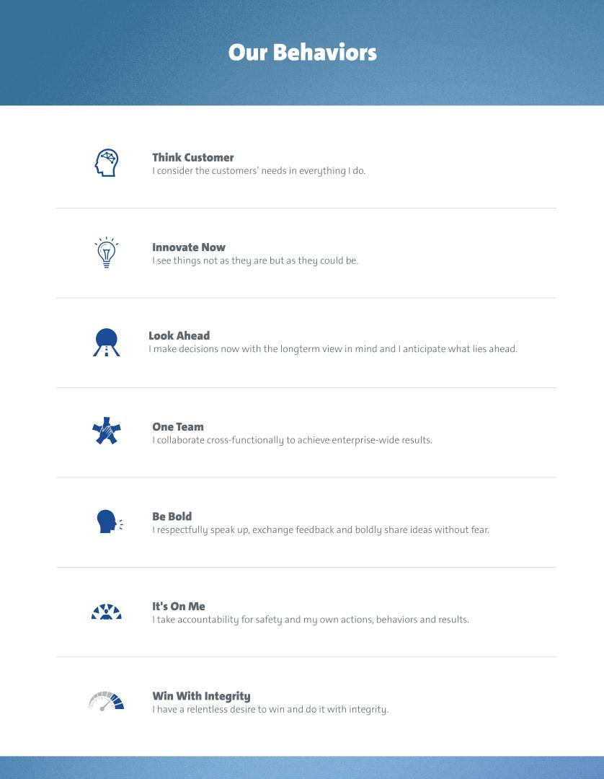

Table of Contents

GENERAL MOTORS COMPANY
GENERAL MOTORS GLOBAL HEADQUARTERS MAIL CODE 482-C24-A31 300 RENAISSANCE CENTER
DETROIT, MI 48265
VOTE BY INTERNET
Before The Meeting - Go to www.proxyvote.com or scan the QR Barcode above
Use the internet to transmit your voting instructions and for electronic delivery of
information up until 11:59 p.m. Eastern Time on Monday, June 3, 2019. Have your proxy
card in hand when you access the website and follow the instructions to obtain your records
and to create an electronic voting instruction form.

During The Meeting - Go to GM.onlineshareholdermeeting.com
You may attend the meeting via the internet and vote during the meeting. Have the
information that is printed in the box marked by the arrow available and follow the
instructions.

VOTE BY TELEPHONE - 1-800-690-6903
Use any touch-tone telephone to transmit your voting instructions up until 11:59 p.m.
Eastern Time on Monday, June 3, 2019. Have your proxy card in hand when you call and
then follow the instructions.

If you vote by internet or telephone, do not mail this proxy card.

VOTE BY MAIL

Mark, sign, and date this proxy card and promptly return it in the enclosed postage-paid
envelope or return it to: Vote Processing, c/o Broadridge, 51 Mercedes Way, Edgewood,
NY 11717.

TO VOTE, MARK BLOCKS BELOW IN BLUE OR BLACK INK AS FOLLOWS:
E74319-P16865 KEEP THIS PORTION FOR YOUR RECORDS

— — — — — — — — — — — — — — — — — — — — — — — — — — — — — — — — — — — — — — — — — — — — — — — —
DETACH AND RETURN THIS PORTION ONLY

THIS PROXY CARD IS VALID ONLY WHEN SIGNED AND DATED.


GENERAL MOTORS COMPANY

If you wish to vote in accordance with the Board of Directors’ recommendations, you need only sign, date, and return this proxy card.
The Board of Directors recommends a vote FOR ALL
Board nominees listed in Item 1.

- Election of Directors

Nominees: |  | For | Against | Abstain
1a. | Mary T. Barra | ☐ | ☐ | ☐
1b. | Wesley G. Bush | ☐ | ☐ | ☐
1c. | Linda R. Gooden | ☐ | ☐ | ☐
1d. | Joseph Jimenez | ☐ | ☐ | ☐
1e. | Jane L. Mendillo | ☐ | ☐ | ☐
1f. | Judith A. Miscik | ☐ | ☐ | ☐
1g. | Patricia F. Russo | ☐ | ☐ | ☐
1h. | Thomas M. Schoewe | ☐ | ☐ | ☐
1i. | Theodore M. Solso | ☐ | ☐ | ☐
1j. | Carol M. Stephenson | ☐ | ☐ | ☐
1j. | Carol M. Stephenson | ☐ | ☐ | ☐
1k. | Devin N. Wenig | ☐ | ☐ | ☐
1k. | Devin N. Wenig | ☐ | ☐ | ☐

The Board of Directors recommends a vote FOR Board Items 2 and 3.

- Advisory Approval of the Company’s Executive Compensation

- Ratification of the Selection of Ernst & Young LLP as GM’s Independent Registered Public Accounting Firm for 2019

The Board of Directors recommends a vote AGAINST shareholder Items 4 and 5.

- Shareholder Proposal Regarding Independent Board Chairman

- Shareholder Proposal Regarding Report on Lobbying Communications and Activities

For Against Abstain

☐ ☐ ☐

☐ ☐ ☐

For Against Abstain

☐ ☐ ☐

☐ ☐ ☐

NOTE: Please sign exactly as your name(s) appear(s) hereon. When shares are held jointly, each holder should sign. When signing as attorney, executor, administrator, guardian, trustee, custodian, or in any other representative capacity, give full title as such. Corporations should provide the full name of corporation and name and title of the authorized officer signing the proxy card.

Signature [PLEASE SIGN WITHIN BOX] Date Signature (Joint Owners) Date

Table of Contents

Important Notice Regarding the Availability of Proxy Materials for the Annual Meeting: The Proxy Statement, Notice of 2019 Annual Meeting of Shareholders and Annual Report are available at www.proxyvote.com.


Meeting Type: |  | Meeting Information
Meeting Type: | Annual Meeting
For holders as of: April 8, 2019

Date: June 4, 2019 Time: 8:00 a.m. Eastern Time

Location: Meeting live via the internet only - please visit

GM.onlineshareholdermeeting.com.

The company will be hosting the meeting live via the internet only

this year. To attend the meeting via the internet please visit

GM.onlineshareholdermeeting.com and be sure to have the

information that is printed in the box marked by the arrow

(located on the reverse side of this

proxy card).

PLEASE VOTE TODAY!

SEE REVERSE SIDE FOR THREE EASY WAYS TO VOTE

— — — — — — — — — — — — — — — — — — — — — — — — — — — — — — — — — — — — — — — — — — — — — — — — —
E74320-P16865


THIS PROXY IS SOLICITED ON BEHALF OF THE BOARD OF DIRECTORS

The undersigned shareholder(s) of General Motors Company authorize(s) Mary T. Barra and Craig B. Glidden, and either of them, as proxies with full power of substitution, to vote the common stock of the undersigned in the manner specified on this proxy card and in their discretion upon all other matters (including on the election of any nominees for director that are not identified on this proxy) that may come before the 2019 Annual Meeting of Shareholders of General Motors Company, to be held at 8:00 a.m. Eastern Time on June 4, 2019, or any adjournment or postponement thereof. The undersigned hereby revokes all proxies previously given.

On matters for which you do not specify a choice, the shares will be voted in accordance with the recommendation of the Board of Directors; therefore, if no direction is made, this proxy will be voted FOR ALL of General Motors Company’s director nominees in Item 1; FOR Items 2 and 3; and AGAINST Items 4 and 5.

YOUR VOTE IS VERY IMPORTANT - PLEASE VOTE TODAY

Please see the reverse side for internet, mail, and telephone voting instructions.

(Continued and to be marked, signed, and dated on the reverse side)

