Table of Contents

UNITED STATES

SECURITIES AND EXCHANGE COMMISSION
Washington, D.C. 20549

SCHEDULE 14A

Proxy Statement Pursuant to Section 14(a) of the Securities

Exchange Act of 1934

☑ Filed by the Registrant ☐ Filed by a Party other than the Registrant
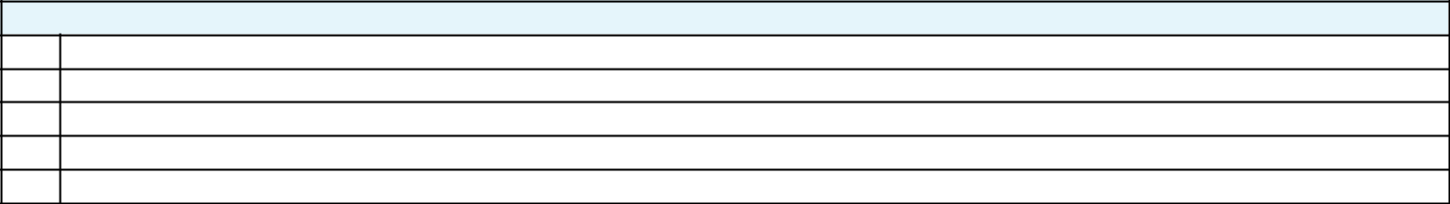

Check the appropriate box:

- Preliminary Proxy Statement

- CONFIDENTIAL, FOR USE OF THE COMMISSION ONLY (AS PERMITTED BY RULE 14a-6(e)(2)) ☑ Definitive Proxy Statement

- Definitive Additional Materials

- Soliciting Material Pursuant to ss.240.14a-12

 |  | GENERAL MOTORS COMPANY
 |  | (Name of Registrant as Specified In Its Charter)
 |  | (Name of Person(s) Filing Proxy Statement, if other than the Registrant)
Payment of Filing Fee (Check the appropriate box):
☑ | No fee required.
☐ | Fee computed on table below per Exchange Act Rules 14a-6(i)(14) and 0-11.
 | (1) | Title of each class of securities to which transaction applies:
 | (2) | Aggregate number of securities to which transaction applies:
 | (3) | Per unit price or other underlying value of transaction computed pursuant to Exchange Act Rule 0-11 (set forth the amount on which the filing fee is calculated
 |  | and state how it was determined):
 | (4) | Proposed maximum aggregate value of transaction:
 | (5) | Total fee paid:
☐ | Fee paid previously with preliminary materials.
☐ | Check box if any part of the fee is offset as provided by Exchange Act Rule 0-11(a)(2) and identify the filing for which the offsetting fee was paid
 | previously. Identify the previous filing by registration statement number, or the Form or Schedule and the date of its filing.
 | (1) | Amount Previously Paid:
 | (2) | Form, Schedule or Registration Statement No.:
 | (3) | Filing Party:
 | (4) | Date Filed:

Table of Contents


Proxy Statement and Notice 2020 Annual Meeting of Shareholders

June 16, 2020 | 8:00 a.m. ET

Table of Contents
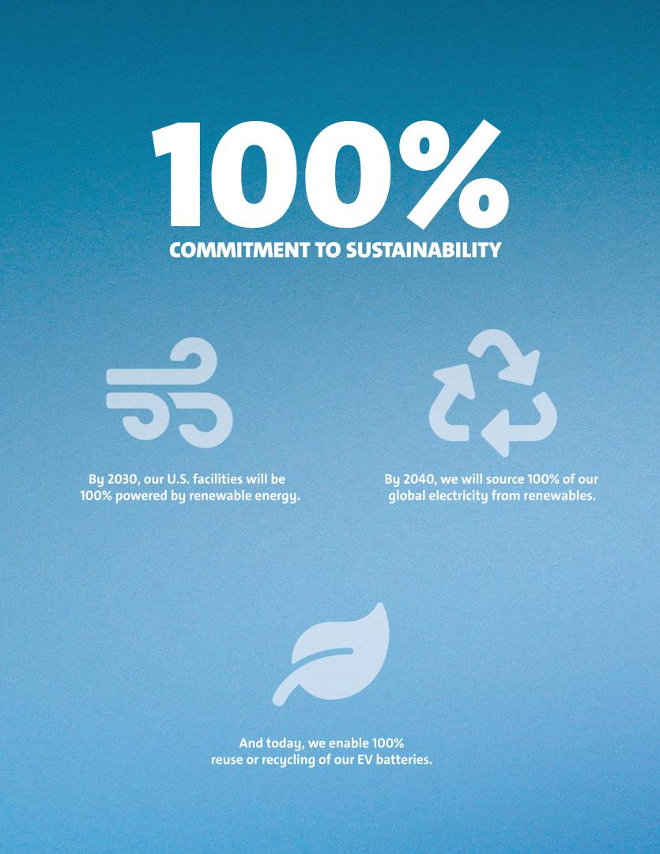

Table of Contents
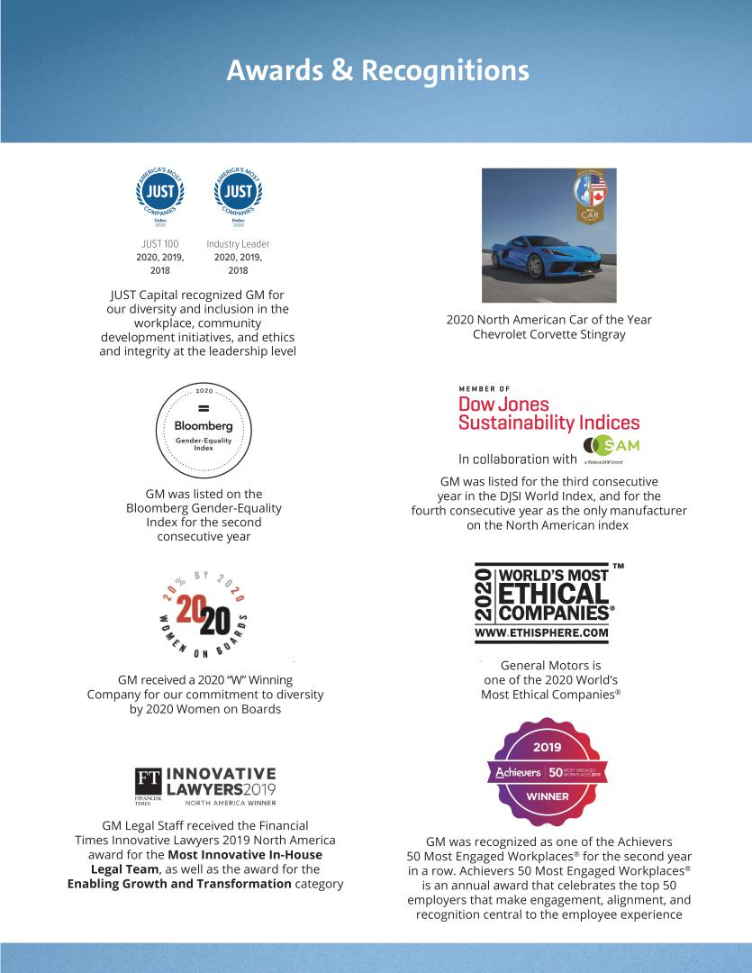

Table of Contents

To Our Fellow Shareholders:

As I write this letter, the world is in the midst of responding to the COVID-19 pandemic and its significant impact on public health, the global economy, and our industry. Your Board of Directors and the GM team have been taking swift and necessary actions to protect our Company and its employees, customers, communities, shareholders, and other stakeholders. I’d like to share what we are doing right now as we look ahead to the 2020 Annual Meeting and beyond to position the Company for long-term strength.

Commitment to Our Employees

Ever since COVID-19 emerged, GM has proactively addressed everything within our control, with the health and safety of our employees as our top priority. To help prevent the spread of COVID-19 in our workforce and communities, we asked our employees to work from home if their work permits it. This included a systematic and orderly suspension of a majority of our vehicle manufacturing operations around the world, including in North America. We are working closely with governments, health and public safety officials, and employee representatives as we monitor our production status on a week-to-week basis. Where our facilities continue to operate, we have adopted stringent and comprehensive safety measures to ensure a safe working environment. These measures include physical distancing, monitoring employee health daily, requiring employees to wear masks inside our facilities, and regularly sterilizing high-traffic public areas.

Commitment to Our Customers

Vehicles are an integral part of our lives and livelihood and, in trying times like these, we want to be a resource for our customers. We have taken a variety of actions to help them— including providing complimentary OnStar Crisis Assist services and in-vehicle data to owners of compatible vehicles. OnStar advisors can help with special routing assistance, including to a hospital or clinic, and contact family members, emergency medical dispatch, and first responders. GM Financial’s Customer Experience team is also standing by to help customers affected by COVID-19 discuss personalized options in these uncertain times. Lastly, our digital Shop Click Drive dealer digital tool allows customers to arrange for the purchase and delivery of vehicles from home where available.

Commitment to Our Communities

We are also constantly exploring ways to help our communities in this time of crisis. Last month, we were proud to announce a collaboration with Ventec Life Systems to expand production of Ventec’s V-Pro and VCSN critical-care ventilators to GM’s Kokomo, Indiana, plant. GM leveraged its IT, purchasing and logistics, supply chain, product development, manufacturing, talent acquisition,

April 27, 2020

and legal expertise to support this work, which resulted in an initial contract with the U.S. Department of Health and Human services for 30,000 ventilators. GM is also making face masks in its plant in Warren, Michigan, and we continue to investigate other ways we can use our expertise and resources to lend a hand in combatting the COVID-19 pandemic.

Commitment to Our Shareholders

GM is aggressively pursuing austerity measures to preserve cash and is taking necessary steps to manage our liquidity, ensure the ongoing viability of our operations, and protect shareholder value. We recently drew down approximately $16 billion from our revolving credit facilities – a proactive measure to fortify our balance sheet, increase our cash position, and preserve financial flexibility in light of current uncertainty in global markets. We also implemented pay deferments for all salaried employees. Over the past several years, we have made strategic decisions and structural changes that have transformed the Company. These actions have better positioned us to face this challenge.

Advancing Toward Our Vision

In this Proxy Statement, we share important details about your Board’s role in shaping GM’s purpose, strategy, governance, and culture. We have faced significant challenges in the last year, including a six-week labor stoppage in North America, difficult industry conditions in China and, now, COVID-19. Despite these challenges, we have improved and continue to improve our business through ongoing cost savings actions, operational excellence, and strong product launches, while advancing toward our vision of a world with zero crashes, zero emissions, and zero congestion.

Right Board at the Right Time

In recent years, your Board has worked to strategically refresh its membership to ensure it has the breadth of experience to guide the Company during times just like these – when companies are facing new and unexpected challenges. Even in the face of this current environment of uncertainty, I continue to believe GM has an unprecedented opportunity to do more for our stakeholders and, ultimately, the planet. We have the right Board, at the right time, to ensure we emerge from this even stronger.

Sincerely,
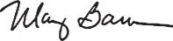

Mary T. Barra

Chairman and Chief Executive Officer

300 Renaissance Center | Detroit, Michigan 48265

Table of Contents

Notice of 2020 Annual Meeting of Shareholders

April 27, 2020

Dear Fellow Shareholder:

The Board of Directors of General Motors Company cordially invites you to attend the 2020 Annual Meeting of Shareholders.

At the Annual Meeting, you will be asked to:

- Elect the 11 Board-recommended director nominees named in this Proxy Statement;

- Approve, on an advisory basis, Named Executive Officer compensation;

- Approve, on an advisory basis, the frequency of future advisory votes on Named Executive Officer compensation;

- Approve the General Motors Company 2020 Long-Term Incentive Plan;

- Ratify the selection of Ernst & Young LLP as the Company’s independent registered public accounting firm for 2020;

- Vote on four Rule 14a-8 shareholder proposals, if properly presented at the meeting; and

- Transact any other business that is properly presented at the meeting.

Record Date: April 17, 2020.

A list of registered shareholders will be available for examination for any purpose that is germane to the meeting for 10 business days before the Annual Meeting. Shareholders may request to review the list by emailing shareholder.relations@gm.com.

This Proxy Statement is provided in conjunction with GM’s solicitation of proxies to be used at the Annual Meeting. Thank you for your interest in General Motors Company.

By Order of the Board of Directors,

Rick E. Hansen

Corporate Secretary

Meeting Information:


Date: June 16, 2020

Time: 8:00 a.m. Eastern Time

Place: Online via live webcast at virtualshareholdermeeting.com/GM2020

Your vote is important.

Please promptly submit your vote by internet, by telephone, or by signing, dating, and returning the enclosed proxy card or voting instruction form in the postage-paid envelope provided so that your shares will be represented and voted at the meeting.

We are first mailing these proxy materials to our shareholders on or about April 27, 2020.

How You Can Access the
Proxy Materials Online:

Important Notice Regarding the Availability of Proxy Materials for the 2020 Annual Meeting of Shareholders to Be Held on June 16, 2020.

Our Proxy Statement and 2019 Annual Report are available at investor.gm.com/shareholder. You may scan the QR code above with your smartphone or other mobile device to view our Proxy Statement and Annual Report.

ii

Table of Contents

Helpful Resources

Annual Meeting: investor.gm.com/shareholder

Proxy Statement
Annual Report

Governance Documents: investor.gm.com/resources

Board Committee Charters
Bylaws and Certificate of Incorporation Corporate Governance Guidelines

Key Compliance Policies: investor.gm.com/resources

Winning with Integrity: Our Values and Guidelines for Employee Conduct
Policy on Recoupment of Incentive Compensation Related Party Transactions Policy Insider Trading Policy

ESG Policies: investor.gm.com/resources

Voluntary Report of 2019 Political Contributions Company Policy on Corporate Political Contributions
and Expenditures
Conflict Minerals Policy
Environmental Policy
Global Human Rights Policy
Global Integrity Policy

Supplier Code of Conduct

Sustainability Report: gmsustainability.com

Investors Relations: investor.gm.com/investor-relations


Defined Terms and Commonly Used Acronyms

Annual Meeting | GM’s Annual Meeting of
 | Shareholder to be held on
 | June 16, 2020
AV | Autonomous Vehicle
CEO | Chief Executive Officer
CFO | Chief Financial Officer
Code of Conduct | Winning with Integrity: Our Values
 | and Guidelines for Employee
 | Conduct
Committees | Audit Committee
 | Executive Committee
 | Executive Compensation
 | Committee
 | Governance and Corporate
 | Responsibility Committee
 | Finance Committee
 | Risk and Cybersecurity
 | Committee
DSU | Deferred Share Unit
ESG | Environmental, Social, and
 | Governance
EV | Electric Vehicle
EY | Ernst & Young LLP
GM or the Company | General Motors Company
Governance | Governance and Corporate
Committee | Responsibility Committee
LTIP | Long-Term Incentive Plan
NEO | Named Executive Officer
NYSE | New York Stock Exchange
SEC | U.S. Securities and Exchange
 | Commission

iii

Table of Contents

Table of Contents

PROXY VOTING ROADMAP |  |  |  |  |  |  |  |  |  |  |  |  |  |  |  | 1
BOARD OF DIRECTORS |  |  |  |  |  |  |  |  |  |  |  |  |  |  |  | 2
Diversity of Skills, Qualifications, and Experience |  |  |  |  |  |  |  |  |  |  |  |  |  |  |  | 3
Director Biographies |  |  |  |  |  |  |  |  |  |  |  |  |  |  |  | 4
NON-EMPLOYEE DIRECTOR COMPENSATION |  |  |  |  |  |  |  |  |  |  |  |  |  |  |  | 10
CORPORATE GOVERNANCE |  |  |  |  |  |  |  |  |  |  |  |  |  |  |  | 14
The Board of Directors |  |  |  |  |  |  |  |  |  |  |  |  |  |  |  | 14
Board Leadership Structure and Composition |  |  |  |  |  |  |  |  |  |  |  |  |  |  |  | 15
Message from the Lead Independent Director |  |  |  |  |  |  |  |  |  |  |  |  |  |  |  | 16
Board Committees |  |  |  |  |  |  |  |  |  |  |  |  |  |  |  | 18
Board and Committee Oversight of Risk |  |  |  |  |  |  |  |  |  |  |  |  |  |  |  | 22
Your Board’s Governance Policies and Practices |  |  |  |  |  |  |  |  |  |  |  |  |  |  |  | 25
Shareholder Engagement |  |  |  |  |  |  |  |  |  |  |  |  |  |  |  | 27
Shareholder Protections and Governance Best Practices |  |  |  |  |  |  |  |  |  |  |  |  |  |  |  | 28
Certain Relationships and Related Party Transactions |  |  |  |  |  |  |  |  |  |  |  |  |  |  |  | 29
SPOTLIGHT ON KEY ESG INITIATIVES |  |  |  |  |  |  |  |  |  |  |  |  |  |  |  | 30
SECURITY OWNERSHIP INFORMATION |  |  |  |  |  |  |  |  |  |  |  |  |  |  |  | 33
AUDIT COMMITTEE REPORT |  |  |  |  |  |  |  |  |  |  |  |  |  |  |  | 35
EXECUTIVE COMPENSATION |  |  |  |  |  |  |  |  |  |  |  |  |  |  |  | 37
Compensation Overview |  |  |  |  |  |  |  |  |  |  |  |  |  |  |  | 38
Compensation Principles |  |  |  |  |  |  |  |  |  |  |  |  |  |  |  | 45
Compensation Elements |  |  |  |  |  |  |  |  |  |  |  |  |  |  |  | 45
Performance Measures |  |  |  |  |  |  |  |  |  |  |  |  |  |  |  | 47
Performance Results and Compensation Decisions |  |  |  |  |  |  |  |  |  |  |  |  |  |  |  | 50
Compensation Policies and Governance Practices |  |  |  |  |  |  |  |  |  |  |  |  |  |  |  | 58
Compensation Committee Report |  |  |  |  |  |  |  |  |  |  |  |  |  |  |  | 61
Executive Compensation Tables |  |  |  |  |  |  |  |  |  |  |  |  |  |  |  | 62
CEO Pay Ratio |  |  |  |  |  |  |  |  |  |  |  |  |  |  |  | 73
Equity Compensation Plan Information |  |  |  |  |  |  |  |  |  |  |  |  |  |  |  | 74
BOARD PROPOSALS |  |  |  |  |  |  |  |  |  |  |  |  |  |  |  | 75
Item No. 1 – Election of Directors |  |  |  |  |  |  |  |  |  |  |  |  |  |  |  | 75
Item No. 2 – Advisory Approval of Named Executive Officer
 |  | Compensation |  |  |  |  |  |  |  |  |  |  |  |  |  | 76
Item No. 3 – Advisory Approval of the Frequency of Future
 |  | Advisory Votes on Named Executive Officer Compensation |  |  |  |  |  |  |  |  |  |  |  |  |  | 77
Item No. 4 – Ratification of the Selection of the Independent
 |  | Registered Public Accounting Firm for 2020 |  |  |  |  |  |  |  |  |  |  |  |  |  | 78
 |  |  |  |  |  |  |  | Company 2020
Item No. 5 – Approval of the General Motors
 |  | Long-Term Incentive Plan |  |  |  |  |  |  |  |  |  |  |  |  |  | 80
SHAREHOLDER PROPOSALS |  |  |  |  |  |  |  |  |  |  |  |  |  |  |  | 90
Item No. 6 – Shareholder Written Consent |  |  |  |  |  |  |  |  |  |  |  |  |  |  |  | 90
Item No. 7 – Proxy Access Amendment: Shareholder
 |  | Aggregation Limit |  |  |  |  |  |  |  |  |  |  |  |  |  | 92
 |  |  |  |  | on Human Rights Policy Implementation
Item No. 8 – Report |  |  |  |  |  |  |  |  |  |  |  |  |  |  |  | 94
Item No. 9 – Report on Lobbying Communications and Activities |  |  |  |  |  |  |  |  |  |  |  |  |  |  |  | 96
GENERAL INFORMATION ABOUT ANNUAL |  |  |  |  |  |  |  |  |  |  |  |  |  |  |  | 98
 |  | MEETING |  |  |  |  |  |  |  |  |  |  |  |  |  | 98
APPENDIX A – Non-GAAP Financial Measures |  |  |  |  |  |  |  |  |  |  |  |  |  |  |  | A-1
APPENDIX B – General Motors Company 2020 |  |  |  |  |  |  |  |  |  |  |  |  |  |  |  | B-1
 |  | Long-Term Incentive Plan |  |  |  |  |  |  |  |  |  |  |  |  |  | B-1

INDEX OF FREQUENTLY ACCESSED INFORMATION


Auditor Fees | 79
Beneficial Ownership Table | 33
Board and Committee Evaluations | 25
Burn Rate | 83
CEO Pay Ratio | 73
CEO Succession Planning | 25
Clawback Policies | 59
Climate Change Risk Oversight | 24
Code of Business Conduct and Ethics | 25
Compensation Decisions for our NEOs | 50
Corporate Governance Guidelines | 25
Cybersecurity and Privacy Risk Oversight | 24
Director Biographies | 4
Director Compensation | 12
Director Independence | 14
Director Skills Matrix | 3
Environmental & Sustainability Highlights | 30
Executive Perquisites | 63
Financial Performance | 38
Human Capital Management | 31
Independent Lead Director Duties | 15
Lobbying Disclosure | 28
Pay-for-Performance | 50
Peer Group | 43
Related Party Transactions | 29
Risk Oversight | 22
Shareholder Engagement | 27
Stock Ownership Requirements | 10
Supply Chain Governance and Compliance | 32

iv

Table of Contents

PROXY VOTING ROADMAP

BOARD PROPOSALS

BOARD

RECOMMENDATION

PAGE

Item 1 – Election of Directors |  | FOR | 75
Item 2 | – Advisory Approval of Named Executive Officer Compensation | FOR | 76
Item 3 | – Advisory Approval of the Frequency of Future Advisory Votes on | 1 YEAR | 77
 | Named Executive Officer Compensation | 1 YEAR | 77
Item 4 | – Ratification of the Selection of the Independent Registered
 | Public Accounting Firm for 2020 | FOR | 78
Item 5 | – Approval of the General Motors Company 2020 Long-Term | FOR | 80
 | Incentive Plan | FOR | 80

SHAREHOLDER PROPOSALS

BOARD

RECOMMENDATION

PAGE

Item 6 | – Shareholder Written Consent | AGAINST | 89
Item 7 | – Proxy Access Amendment: Shareholder Aggregation Limit | AGAINST | 91
Item 8 | – Report on Human Rights Policy Implementation | AGAINST | 93
Item 9 | – Report on Lobbying Communications and Activities | AGAINST | 95

1

Table of Contents

BOARD OF DIRECTORS

Snapshot of Your Board Nominees

 | Director
Name & Principal Occupation | Age Since Independent | Committee Memberships


Mary T. Barra

Chairman & Chief Executive Officer, | 58 | 2014 | Executive – Chair
General Motors Company


Theodore M. Solso

Independent Lead Director, General Motors Company, | 73 | 2012 | Executive
and Retired Chairman & Chief Executive Officer, | 73 | 2012 | Governance
Cummins, Inc.


Wesley G. Bush |  |  | Audit
Retired Chairman & Chief Executive Officer, | 59 | 2019 | Executive Compensation
Northrop Grumman Corporation |  |  | Finance
Linda R. Gooden |  |  | Audit
Retired Executive Vice President, Information Systems | 67 | 2015 | Executive
& Global Solutions, Lockheed Martin Corporation |  |  | Risk and Cybersecurity – Chair
Joseph Jimenez |  |  | Executive
Joseph Jimenez | 60 | 2015 | Executive Compensation
Retired Chief Executive Officer, | 60 | 2015 | Executive Compensation
Retired Chief Executive Officer, | 60 | 2015 | Finance – Chair
Novartis AG |  |  | Finance – Chair
Novartis AG |  |  | Risk and Cybersecurity
Jane L. Mendillo |  |  | Audit
Retired President & Chief Executive Officer, | 61 | 2016 | Finance
Harvard Management Company |  |  | Governance
Judith A. Miscik | 61 | 2018 | Audit
Chief Executive Officer & Vice Chairman, | 61 | 2018 | Audit
Chief Executive Officer & Vice Chairman, | 61 | 2018 | Risk and Cybersecurity
Kissinger Associates, Inc. |  |  | Risk and Cybersecurity
Patricia F. Russo |  |  | Executive
Patricia F. Russo | 67 | 2009 | Executive Compensation
Chairman, Hewlett Packard | 67 | 2009 | Executive Compensation
Chairman, Hewlett Packard | 67 | 2009 | Finance
Enterprise Company |  |  | Finance
Enterprise Company |  |  | Governance – Chair
Thomas M. Schoewe |  |  | Audit – Chair
Thomas M. Schoewe | 67 | 2011 | Executive
Retired Executive Vice President & | 67 | 2011 | Executive
Retired Executive Vice President & | 67 | 2011 | Finance
Chief Financial Officer, Wal-Mart Stores, Inc. |  |  | Finance
Chief Financial Officer, Wal-Mart Stores, Inc. |  |  | Risk and Cybersecurity
Carol M. Stephenson |  |  | Executive
Retired Dean, Ivey Business School, | 69 | 2009 | Executive Compensation – Chair
The University of Western Ontario |  |  | Governance
Devin N. Wenig | 53 | 2018 | Risk and Cybersecurity
Retired President & Chief Executive Officer, | 53 | 2018 | Risk and Cybersecurity
eBay Inc.







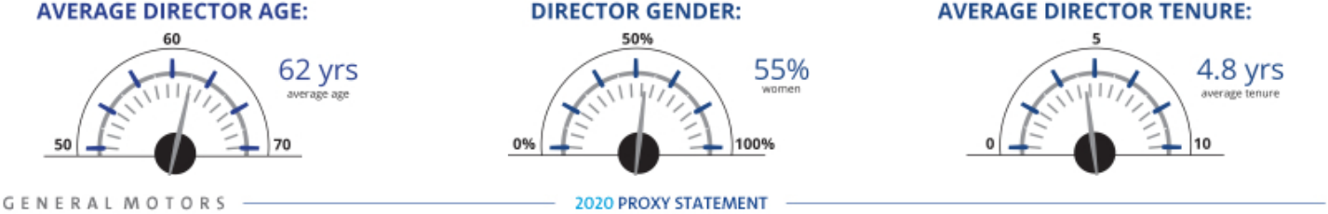

2

Table of Contents

BOARD OF DIRECTORS

Diversity of Skills, Qualifications, and Experience

Your Board nominees offer a diverse range of skills and experience in relevant areas.

SKILL/ | M. | T. | W. | L. | J. | J. | J. | P. | T. | C. | D.
QUALIFICATION | BARRA | SOLSO | BUSH | GOODEN | JIMENEZ | MENDILLO | MISCIK | RUSSO | SCHOEWE | STEPHENSON | WENIG
 | ✓ | ✓ | ✓ | ✓ | ✓ | ✓ | ✓ | ✓ | ✓ | ✓ | ✓
 | ✓ | ✓
 | ✓ | ✓ | ✓ | ✓ | ✓ |  |  | ✓ | ✓
 | ✓ | ✓ | ✓ | ✓ |  |  |  | ✓ | ✓ | ✓ | ✓
 | ✓ | ✓ | ✓ | ✓ | ✓ | ✓ | ✓ | ✓ | ✓ | ✓ | ✓
 | ✓ | ✓ | ✓ | ✓ | ✓ | ✓ | ✓ | ✓ | ✓ | ✓ | ✓
 | ✓ | ✓ | ✓ | ✓ | ✓ | ✓ | ✓ | ✓ | ✓ | ✓ | ✓
 |  |  |  | ✓ |  |  | ✓ |  |  | ✓
 |  |  |  |  | ✓ |  |  | ✓ | ✓ | ✓ | ✓
 | ✓ |  |  | ✓ | ✓ | ✓ | ✓ | ✓ |  | ✓
 |  |  |  | ✓ |  |  |  |  | ✓
 |  |  |  |  |  |  |  |  |  |  | 3









Table of Contents

BOARD OF DIRECTORS

Director Biographies

Set forth below is a short biography of each director nominee.



Mary T. Barra, Age 58

Chairman & Chief Executive Officer,

General Motors Company

Committees: Executive (Chair)

Current Public Company Directorships: The Walt

Disney Company

Prior Public Company Directorships: General Dynamics Corporation (2011 to 2017)

Prior Experience: Ms. Barra has served as Chairman of GM’s Board of Directors since January 2016 and CEO of GM since January 2014. Prior to that time, she served as Executive Vice President, Global Product Development, Purchasing and Supply Chain from 2013 to 2014; Senior Vice President, Global Product Development from 2011 to 2013; Vice President, Global Human Resources from 2009 to 2011; and Vice President, Global Manufacturing Engineering from 2008 to 2009. Ms. Barra began her career at GM in 1980.

Reasons for Nomination: Ms. Barra has in-depth knowledge of the Company and the global automotive industry; extensive senior leadership, strategic planning, operational and business experience; and a strong engineering background with experience in global product development.

4

Theodore M. Solso, Age 73

Independent Lead Director,
General Motors Company, and Retired Chairman & Chief
Executive Officer, Cummins, Inc.

Committees: Executive, Governance

Current Public Company Directorships: Ad-Astra Rocket

Company

Prior Public Company Directorships: Ashland Inc. (1999 to 2012) (Lead Director 2003 to 2010) and Ball Corporation (2003 to 2019) (Lead Director 2013 to 2019)

Prior Experience: Mr. Solso served as Non-Executive Chairman of the GM Board of Directors from 2014 to 2016. He was Chairman and CEO of Cummins, Inc., from 2000 until his retirement in 2011, and President and Chief Operating Officer of Cummins from 1995 to 2000.

Reasons for Nomination: Mr. Solso has extensive experience in automotive manufacturing and engineering, emissions reduction technology, and compliance with emissions laws and regulations. He also has extensive senior leadership experience in finance, accounting, corporate governance, and vehicle and workplace safety.

Table of Contents

BOARD OF DIRECTORS


Wesley G. Bush, Age 59

Retired Chairman and Chief Executive Officer,

Northrop Grumman Corporation

Committees: Audit, Executive Compensation, Finance

Current Public Company Directorships: Dow Inc. and

Cisco Systems Inc.

Prior Public Company Directorships: Norfolk Southern Corporation and Northrop Grumman Corporation

Prior Experience: Mr. Bush served as Chairman of the Board of Directors of Northrop Grumman Corporation (“Northrop Grumman”) from 2011 to 2019. He also served as the CEO of Northrop Grumman from 2010 to 2018. Prior to that, Mr. Bush served in numerous leadership roles at Northrop Grumman, including President and Chief Operating Officer, Chief Financial Officer, and President of the company’s Space Technology sector. He also served in a variety of leadership positions at TRW, Inc., before it was acquired by Northrop Grumman in 2002.

Reasons for Nomination: Mr. Bush has valuable experience in a manufacturing enterprise known for its advanced engineering and technology; strong financial acumen; and knowledge of key governance issues, including risk management.

Linda R. Gooden, Age 67

Retired Executive Vice President, Information Systems & Global Solutions, Lockheed Martin Corporation

Committees: Audit, Executive, Risk and Cybersecurity (Chair)

Current Public Company Directorships: The Home

Depot, Inc.

Prior Public Company Directorships: WGL Holdings, Inc., and Washington Gas & Light Company, a subsidiary of WGL Holdings, Inc.

Prior Experience: Ms. Gooden served as Executive Vice President, Information Systems and Global Solutions of Lockheed Martin Corporation (“Lockheed Martin”) from 2007 to 2013. She served as Deputy Executive Vice President, Information and Technology Services of Lockheed Martin from October to December 2006; and President, Information Technology of Lockheed Martin from 1997 to December 2006.

Reasons for Nomination: Ms. Gooden has extensive expertise in cybersecurity and information technology, operational and strategic planning, and government relations, as well as valuable insight into GM’s cybersecurity framework related to mobility and autonomous vehicles.

5

Table of Contents

BOARD OF DIRECTORS


Joseph Jimenez, Age 60

Retired Chief Executive Officer, Novartis AG

Committees: Executive, Executive Compensation, Finance (Chair), Risk and Cybersecurity

Current Public Company Directorships: The Procter &

Gamble Co.

Prior Public Company Directorships: Colgate-Palmolive Company (2010 to 2015)

Prior Experience: Mr. Jimenez served as CEO of Novartis AG (“Novartis”) from 2010 until his retirement in 2018. He led Novartis’ Pharmaceuticals Division from October 2007 to 2010 and its Consumer Health Division in 2007. From 2006 to 2007, Mr. Jimenez served as Advisor to the Blackstone Group L.P. He was Executive Vice President, President and CEO of Heinz Europe from 2002 to 2006, and President and CEO of H.J. Heinz Company North America from 1999 to 2002.

Reasons for Nomination: Mr. Jimenez has extensive senior leadership experience in the consumer products industry, international operations, strategic planning, and finance.

6

Jane L. Mendillo, Age 61

Retired President & Chief Executive Officer,

Harvard Management Company

Committees: Audit, Finance, Governance

Current Public Company Directorships: Lazard Ltd.

Prior Public Company Directorships: None

Prior Experience: Ms. Mendillo was President and CEO of the Harvard Management Company (“HMC”) from 2008 to 2014. From 2002 to 2008, she was Chief Investment Officer of Wellesley College. Before that, she spent 15 years at HMC in investment management positions. She previously chaired the Partners Healthcare System’s investment committee, served as a member of Yale University’s and the Rockefeller Foundation’s investment committees and as a director and investment committee member of the Mellon Foundation and the Boston Foundation.

Reasons for Nomination: Ms. Mendillo has experience in risk and crisis management, as well as valuable insight into GM’s capital allocation framework, financial policies, and business strategies.

Table of Contents

BOARD OF DIRECTORS


Judith A. Miscik, Age 61

Chief Executive Officer & Vice Chairman,

Kissinger Associates, Inc.

Committees: Audit, Risk and Cybersecurity

Current Public Company Directorships: Morgan Stanley

Prior Public Company Directorships: EMC Corporation (2012 to 2016) and Pivotal Software, Inc. (2014 to 2016)

Prior Experience: In 2017, Ms. Miscik was appointed as CEO and Vice Chairman of Kissinger Associates, Inc. (“Kissinger Associates”). Prior to that time, she served as Co-Chief Executive Officer and Vice Chairman of Kissinger Associates from 2015 to 2017 and as President and Vice Chairman of Kissinger Associates from 2009 to 2015. Prior to joining Kissinger Associates, Ms. Miscik was the Global Head of Sovereign Risk at Lehman Brothers from 2005 to 2008; and from 2002 to 2005, Deputy Director for Intelligence at the U.S. Central Intelligence Agency from 1983 to 2005, which she jointed in 1983.

Reasons for Nomination: Ms. Miscik has a unique and extensive background in intelligence, security, and risk analysis, bringing valuable experience in assessing and mitigating geopolitical and macroeconomic risks in both the public and private sectors.

Patricia F. Russo, Age 67

Chairman, Hewlett Packard Enterprise Company

Committees: Executive, Executive Compensation, Finance, Governance

Current Public Company Directorships: Hewlett Packard Enterprise Company (Chairman), KKR Management LLC, and Merck & Co. Inc.

Prior Public Company Directorships: Hewlett-Packard Company (2011 to 2015) (Lead Director 2014 to 2015) and Alcoa, Inc. (2016)

Prior Experience: Ms. Russo served as Lead Director of the Hewlett-Packard Company Board of Directors from 2014 to 2015. She was Independent Lead Director of the GM Board of Directors from March 2010 to January 2014. She also served as CEO of Alcatel-Lucent S.A. from 2006 to 2008; Chairman and CEO of Lucent Technologies, Inc., (“Lucent”) from 2003 to 2006; and President and CEO of Lucent from 2002 to 2006.

Reasons for Nomination: Ms. Russo has extensive senior leadership experience in corporate strategy, finance, sales and marketing, technology, and leadership development, as well as experience managing business-critical technology disruptions.

7

Table of Contents

BOARD OF DIRECTORS


Thomas M. Schoewe, Age 67

Retired Executive Vice President &

Chief Financial Officer, Wal-Mart Stores, Inc.

Committees: Audit (Chair), Executive, Finance, Risk and Cybersecurity

Current Public Company Directorships: KKR Management LLC and Northrop Grumman Corporation

Prior Public Company Directorship: PulteGroup, Inc. (2009 to 2012)

Prior Experience: Mr. Schoewe served as Executive Vice President and Chief Financial Officer of Wal-Mart Stores, Inc. (“Wal-Mart”) from 2000 to 2011. Prior to joining Wal-Mart, he was Senior Vice President and Chief Financial Officer of Black & Decker Corporation (“Black & Decker”) from 1996 to 1999. Prior to that, he served in numerous leadership roles at Black & Decker, including Vice President and Chief Financial Officer, Vice President of Finance, and Vice President of Business Planning and Analysis.

Reasons for Nomination: Mr. Schoewe has senior leadership experience in financial reporting, accounting and controls, business planning and analysis, and risk management. He also has valuable insight into GM’s technology systems and processes and cybersecurity framework.

8

Carol M. Stephenson, O.C., Age 69

Retired Dean, Ivey Business School,

University of Western Ontario

Committees: Executive, Executive Compensation (Chair), Governance and Corporate Responsibility

Current Public Company Directorships: Intact Financial Corporation (formerly ING Canada) and Maple Leaf Foods Inc.

Prior Public Company Directorships: Ballard Power Systems, Inc. (2012 to 2017) and Manitoba Telecom Services (2008 to 2016)

Prior Experience: Ms. Stephenson served as Dean of the Ivey Business School at the University of Western Ontario from 2003 until her retirement in 2013. Prior to joining the Ivey Business School, she was President and CEO of Lucent Technologies Canada from 1999 to 2003 and a member of the Advisory Board of General Motors of Canada, Limited, a GM subsidiary, from 2005 to 2009. Ms. Stephenson is an officer of the Order of Canada.

Reasons for Nomination: Ms. Stephenson has expertise in marketing, operations, strategic planning, technology development, financial management, and executive compensation. She also has extensive expertise in North American trade issues.

Table of Contents


Devin N. Wenig, Age 53

Retired President & Chief Executive Officer,

eBay Inc.

Committees: Risk and Cybersecurity

Current Public Company Directorships: None

Prior Public Company Directorships: eBay Inc. (2015 to 2019)

Prior Experience: Mr. Wenig served as President and CEO of eBay Inc. (“eBay”), as well as a member of its Board of Directors, from July 2015 to August 2019. Prior to that time, he served as President of eBay’s Marketplaces business from 2011 to July 2015. Prior to joining eBay, Mr. Wenig was CEO of Thomson Reuters Corporation’s largest division, Thomson Reuters Markets, from 2008 to 2011; Chief Operating Officer of Reuters Group plc (“Reuters”) from 2006 to 2008; and President of Reuters Business divisions from 2003 to 2006.

Reasons for Nomination: Mr. Wenig has extensive senior leadership experience in technology, global operations, and strategic planning. His experience leading technology companies provides key insights into GM’s cybersecurity framework and strategy related to the future of mobility, autonomous vehicles, vehicle connectivity, and data monetization.

BOARD OF DIRECTORS

9

Table of Contents

NON-EMPLOYEE DIRECTOR COMPENSATION

Our non-employee directors receive cash compensation as well as equity compensation in the form of GM DSUs for their Board service. Compensation for our non-employee directors is set

by the Board at the recommendation of the Governance Committee.

Guiding Principles


- Fairly compensate directors for their responsibilities and time commitments.

- Attract and retain highly qualified directors by offering a compensation program consistent with those at companies of similar size, scope, and complexity.

- Align the interests of directors with our shareholders by providing a significant portion of compensation in equity and requiring directors to continue to own our common stock (or common stock equivalents) until retirement.

- Provide compensation that is simple and transparent to shareholders.

- Annual Review Process

The Governance Committee annually assesses the form and amount of non-employee director compensation and recommends changes, if appropriate, to the Board. As part of its annual review, the Committee conducts extensive benchmarking by reviewing director compensation data for the executive compensation peer group described in “Executive Compensation—Compensation Overview—Peer Group for Compensation Comparisons” on page 43 of this Proxy Statement.

In December 2019, following its annual review of GM’s director compensation, the Board and the Governance Committee approved an increase in non-employee director compensation. In March 2020, the Board and the Governance Committee, in response to the COVID-19 pandemic, approved a 20% temporary reduction in base annual compensation, effective April 1, 2020, and continuing until at least October 2020, but no later than March 15, 2021. Beginning in 2020, director compensation will be as set forth on page 11 of this Proxy Statement.

Director Stock Ownership and Holding Requirements


- Each non-employee director is required to own our common stock or DSUs with a market value of at least $500,000.

- Each director has up to five years from the date he or she is first elected to the Board to meet this ownership requirement.

- Non-employee directors are prohibited from selling any GM securities or derivatives of GM securities, such as DSUs, while they are members of the Board.

- Ownership guidelines are reviewed each year to confirm they continue to be effective in aligning the interests of the Board and our shareholders.

- All of our directors are in compliance with our stock retention requirements.

10

Table of Contents

NON-EMPLOYEE DIRECTOR COMPENSATION

Annual Compensation

The 2019 and 2020 compensation for non-employee directors are described in the table below. We do not pay any other retainers or meeting fees. The Independent Lead Director and Committee Chairs receive additional compensation due to the increased workload and additional responsibilities associated with these positions. In particular, Mr. Solso’s compensation as Independent Lead Director reflects the additional time commitment for this role, which

includes, among other responsibilities, attending all Board Committee meetings, meeting with the Company’s investors, and attending additional meetings with the Company’s senior management, including the CEO. For additional information about the roles and responsibilities of our Independent Lead Director, see “Corporate Governance—Board Leadership Structure and Composition” on page 15 of this Proxy Statement.

 |  |  |  | 2020 |  | 2020
 |  |  |  | (Pre- |  | (Post-
 |  |  |  | COVID- |  | COVID-
Compensation Element |  | 2019 |  | 19) |  | 19)
Board Retainer | $ | 285,000 | $ | 305,000 | $ | 244,000
Independent Lead Director Fee | $ | 100,000 | $ | 100,000 | $ | 100,000
Audit Committee Chair Fee | $ | 30,000 | $ | 30,000 | $ | 30,000
All Other Committee Chair Fees (excluding the Executive
Committee) | $ | 20,000 | $ | 20,000 | $ | 20,000

Non-employee directors are required to defer at least 50% of their annual Board retainer into DSUs under the General Motors Company Deferred Compensation Plan for Non-Employee Directors (the “Director Compensation Plan”). Directors may elect to defer all or half of their remaining Board retainer or

amounts payable (if any) for serving as a Committee Chair or Independent Lead Director into additional DSUs. The fees for a director who joins or leaves the Board, or assumes additional responsibilities during the year, are prorated for his or her period of service.

How Deferred Share Units Work

Each DSU is equal in value to one share of GM common stock and is fully vested upon grant, but does not have voting rights. DSUs will not be available for disposition until after the director leaves the Board. After leaving the Board, the director will receive a cash payment or payments based on the number of DSUs in the director’s account valued at the average daily closing market price for the quarter immediately preceding payment. Directors will be

paid in a lump sum or in annual installments for up to five years, based on their deferral elections. All DSUs granted are rounded up to the nearest whole unit. Any portion of the retainer that is deferred into DSUs may also earn dividend equivalents, which are credited at the end of each calendar year to each director’s account in the form of additional DSUs. DSUs granted are determined as follows:
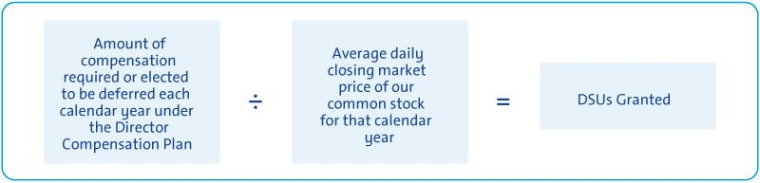

11

Table of Contents

NON-EMPLOYEE DIRECTOR COMPENSATION

Other Compensation

We provide certain additional benefits to non-employee directors.

Type |  | Purpose
u | Company Vehicles | We provide directors with the use of Company vehicles to provide feedback on our products
 |  | as well as enhance the public image of our vehicles. Retired directors also receive the use of
 |  | a Company vehicle for a period of time. Participants are charged with imputed income based
 |  | on the lease value of the vehicles and are responsible for associated taxes.
u | Personal Accident | We provide PAI coverage in the event of accidental death or dismemberment. Directors are
 | Insurance (“PAI”)(1) | responsible for associated taxes on the imputed income from the coverage.

- Ms. Barra, our sole employee director, does not receive additional compensation for her Board service other than the PAI benefit described above, the value of which is reported for Ms. Barra in the Summary Compensation Table on page 62 of this Proxy Statement.

Non-employee directors are not eligible to participate in any of the savings or retirement programs for our employees. Other than as described in this section, there are no separate benefit plans for directors.

2019 Non-Employee Director Compensation Table

This table shows the compensation that each non-employee director received for his or her 2019 Board and Committee service.

 | Fees Earned or |  |  |  | All Other
 | Paid in Cash(1) |  | Stock Awards(2) |  | Compensation(3) |  | Total
Director |  | ($) |  | ($) |  | ($) | ($)
Wesley G. Bush (4) | $ | 130,625 | $ | 127,185 | $ | 7,825 | $265,635
Linda R. Gooden | $ | 162,500 | $ | 138,860 | $ | 16,344 | $317,704
Joseph Jimenez (5) | $ | 157,500 | $ | 138,860 | $ | 36,740 | $333,100
Jane L. Mendillo | $ | 142,500 | $ | 138,860 | $ | 11,323 | $292,683
Judith A. Miscik | $ | 142,500 | $ | 138,860 | $ | 25,469 | $306,829
Michael G. Mullen (6) | $ | 76,250 | $ | 69,430 | $ | 39,370 | $185,050
James J. Mulva (7) | $ | 76,250 | $ | 69,430 | $ | 30,787 | $176,467
Patricia F. Russo | $ | 162,500 | $ | 138,860 | $ | 15,740 | $317,100
Thomas M. Schoewe | $ | 172,500 | $ | 138,860 | $ | 45,948 | $357,308
Theodore M. Solso | $ | 242,500 | $ | 138,860 | $ | 21,990 | $403,350
Carol M. Stephenson | $ | 162,500 | $ | 138,860 | $ | 15,384 | $316,744
Devin N. Wenig | $ | 142,500 | $ | 138,860 | $ | 35,948 | $317,308

- This column reflects director compensation eligible to be paid in cash, which consists of 50% of the annual Board retainer ($142,500) and any applicable Committee Chair or Independent Lead Director fees. Each of the following directors elected to receive DSUs in lieu of such amounts eligible to be paid in cash in the following amounts: Mr. Bush—$130,625; Mr. Jimenez —$157,500; Ms. Mendillo— $142,500; Admiral Mullen—$76,250; Mr. Mulva—$76,250; Ms. Russo—$91,250; Mr. Solso—$242,500; Ms. Stephenson—$81,250; and Mr. Wenig—$142,500.

12

Table of Contents

NON-EMPLOYEE DIRECTOR COMPENSATION

- Reflects aggregate grant date fair value of DSUs granted in 2019, which does not include any cash fees that directors voluntarily elected to receive as DSUs. Grant date fair value is calculated by multiplying the number of DSUs granted by the closing price of GM common stock on December 31, 2019, which was $36.60. The holders of DSUs also receive dividend equivalents, which are reinvested in additional DSUs based on the market price of the common stock on the date the dividends are paid.

- The following table provides more information on the type and amount of benefits included in the All Other Compensation column.

 | Company
 | Vehicle
 | Program |  | Other
Director |  | (a) | (b) |  | Total
Mr. Bush | $ | 7,625 | $ 200 | $ | 7,825
Ms. Gooden | $ | 16,104 | $ 240 | $ | 16,344
Mr. Jimenez | $ | 36,500 | $ 240 | $ | 36,740
Ms. Mendillo | $ | 11,083 | $ 240 | $ | 11,323
Ms. Miscik | $ | 25,229 | $ 240 | $ | 25,469
Adm. Mullen | $ | 39,250 | $ 120 | $ | 39,370

 | Company
 | Vehicle
 | Program | Other
Director | (a) | (b) | Total
Mr. Mulva | $30,667 | $ 120 | $30,787
Ms. Russo | $15,500 | $ 240 | $15,740
Mr. Schoewe | $45,708 | $ 240 | $45,948
Mr. Solso | $21,750 | $ 240 | $21,990
Ms. Stephenson | $15,144 | $ 240 | $15,384
Mr. Wenig | $35,708 | $ 240 | $35,948

  - The Company vehicle program includes the estimated annual lease value of the Company vehicles driven by directors. We include the annual lease value because it is more reflective of the value of the Company vehicle perquisite than the Company’s incremental costs, which are generally significantly lower because the Company manufactures and ordinarily disposes of Company vehicles for a profit, resulting in minimal incremental costs, if any. Taxes related to imputed income are the responsibility of each director.

  - Reflects the cost of premiums for providing personal accident insurance (annual premium cost of $240 is prorated, as applicable, for the period of service).

- Mr. Bush joined the Board on February 11, 2019.

- Mr. Jimenez was appointed Chair of the Finance Committee on April 16, 2019.

- Adm. Mullen retired from the Board effective June 4, 2019.

- Mr. Mulva retired from the Board effective June 4, 2019.

13

Table of Contents

CORPORATE GOVERNANCE

The Board of Directors

GM is governed by a Board of Directors and Committees of the Board that meet throughout the year. The Board is elected by shareholders to oversee and provide guidance on the Company’s business and affairs. It is the ultimate decision-making body of the Company except for those matters reserved for shareholders by law or pursuant to the Company’s governance instruments. Among other things, the Board oversees company strategy and execution of the strategic plan. In addition, it oversees management’s proper safeguarding of the assets of

the Company, maintenance of appropriate financial and other internal controls, compliance with applicable laws and regulations, and proper governance. The Board is committed to sound corporate governance policies and practices that are designed and routinely assessed to enable the Company to operate its business responsibly, with integrity, and to position GM to compete more effectively, sustain its success, and build long-term shareholder value.

- Board Size

The Board sets the number of directors from time to time by a resolution adopted by a majority of the directors. The Governance Committee reassesses the suitability of the Board’s size at least annually. The Board has the flexibility to increase or decrease the size of the Board as circumstances warrant, although the Company’s Certificate of Incorporation limits the total number of directors to 17. There are currently 11

members of the Board. If all of the Board’s nominees are elected, the Board will be composed of 11 members immediately following the Annual Meeting. If any nominee is unable to serve as a director or if any director leaves the Board between annual meetings, the Board, by resolution, may reduce the number of directors or elect an individual to fill the resulting vacancy.

- Director Independence

GM’s Bylaws and Corporate Governance Guidelines define our standards for director independence and reflect applicable NYSE and SEC requirements. At least two-thirds of our directors are and must be independent under these standards. In addition, all members of the Audit Committee and the Executive Compensation Committee (the “Compensation Committee”) must meet heightened independence standards under applicable NYSE and SEC rules.

The Governance Committee annually assesses the independence of each director and makes recommendations to the Board. For a director to be “independent,” the Board must determine that the director has no material relationship with the Company other than his or her service as a director.

In recommending to the Board that it determine each director is independent, the Governance Committee considered whether there were any other facts or circumstances that might impair a director’s independence. The Governance Committee also considered that GM, in the ordinary course of

business, during the last three years, has sold fleet vehicles to and purchased products and services from companies at which some of our directors serve as non-employee directors or executives. The Board determined that these transactions were not material to GM or the other companies involved and that none of our directors had a material interest in the transactions with these companies. In each case, these transactions were in the ordinary course of business for GM and the other companies involved, and were on terms and conditions available to similarly situated customers and suppliers. Therefore, the Board determined they did not impair such directors’ independence.

Consistent with these standards, the Board has reviewed all relationships between the Company and each director and considered all relevant quantitative and qualitative criteria. The Board has affirmatively determined that all directors were independent during 2019, and that all current members are independent, except Ms. Barra, who serves as CEO.

14

Table of Contents

CORPORATE GOVERNANCE

Board Leadership Structure and Composition

Your Board has the flexibility to decide when the positions of Chairman and CEO should be combined or separated, and whether an executive or an independent director should be Chairman. This allows the Board to choose the leadership structure that it believes will best serve the interests of our shareholders at any particular time. In January 2016, the Board recombined the positions of Chairman and CEO under the leadership of Ms. Barra and designated Mr. Solso as Independent Lead Director. Prior to that time, Mr. Solso served as the Board’s non-executive chairman.

Since then, each year your Board has voted to elect Ms. Barra as Chairman of the Board, and the independent directors have voted to appoint Mr. Solso as the Independent Lead Director. Your Board believes that, right now, combining the role of Chairman and CEO and electing a strong Independent Lead Director is the optimal Board leadership structure for GM.

DUTIES OF THE INDEPENDENT LEAD DIRECTOR


u Presiding over all Board meetings when the Chairman is not present, including executive sessions of non-management directors, and advising the Chairman of any actions taken;

u Providing Board leadership if circumstances arise in which the Chairman is actually, potentially, or perceived to have a conflict of interest;

u Calling executive sessions for non-management directors, relaying feedback from these sessions to the Chairman, and implementing decisions made by the non-management directors;

u Leading non-management directors in the annual evaluation of the CEO’s performance, communicating the results of that evaluation to the CEO, and overseeing CEO succession planning;

u Approving Board meeting agendas to ensure sufficient time for discussion of all items;

u Advising on the scope, quality, quantity, and timeliness of the flow of information between management and the Board;


u Serving as a liaison between non-management directors and the Chairman when requested to do so (although all non-management directors have direct and complete access to the Chairman at any time that they deem necessary or appropriate);

u Interviewing, along with the Chair of the Governance Committee, all director candidates and making recommendations to the Governance Committee and the Board;

u Being available to advise the Board Committee Chairs in fulfilling their designated roles and responsibilities to the Board; and

- Engaging, when requested to do so, with shareholders.

15

Table of Contents

CORPORATE GOVERNANCE


A Message from the Independent Lead Director

As the Independent Lead Director it is my responsibility to help my fellow independent directors oversee and shape the partnership between management and the Board. Let me briefly highlight a few areas of focus that I believe demonstrate our oversight and help forge an effective partnership that drives strong Company performance and enables GM to effectively mitigate risk in these challenging times.

Focused Board Leadership: Why Your Board Believes that the Roles of Chairman and CEO Should Be Combined Right Now

Your Board carefully considers the appropriate leadership structure for GM and its shareholders on an annual basis and determines whether to combine or separate the roles of Chairman and CEO. Your Board believes that Ms. Barra’s service as both Chairman and CEO continues to provide a clear and unified strategic vision for GM – particularly in times like this as the Board supports management’s efforts to mitigate the impact of the COVID-19 pandemic on our business and the communities where we operate. As the individual with primary responsibility for managing the Company, Ms. Barra’s in-depth knowledge of our business and understanding of GM’s day-to-day operations has provided focused leadership that has enabled GM to respond decisively to this uncertain environment. Ms. Barra has been a significant asset to the Board throughout her tenure as GM has taken bold, strategic actions to strengthen its core business, invest in technologies that will redefine the future of personal transportation, and be prepared to weather storms like the one we are facing today in COVID-19.

My Role as the Independent Lead Director

My job is to complement Ms. Barra’s role by providing strong, independent leadership. My key duties and responsibilities are described on page 15 of this Proxy Statement. In my role, I provide independent oversight of GM’s management team for our shareholders, including a specific focus on strategic risk management, compliance, governance, and CEO succession planning.

Your Board is Shaping the Company’s Strategy and Overseeing Risk

Your Board plays an important role in shaping management’s development and execution of GM’s strategy and overseeing its risk management processes. In recent weeks, the Board has been actively engaged with management as it has taken actions to safeguard our employees and our business in response to COVID-19. For more on our recent efforts, see “Responding to the COVID-19 Pandemic” on page 22 of this Proxy Statement. From a strategy perspective, the Board dedicates a portion of each meeting to strategic reviews that span the Company’s regions, vehicle franchises, adjacent businesses, and other key initiatives. In addition, the Board holds an annual multi-day session devoted to discussing, debating, challenging, and validating management’s overall strategy. Since the last annual meeting, these strategic reviews and discussions included labor and workforce issues, EV and AV execution, Cadillac rebranding, fuel economy regulation, capital allocation, workplace and vehicle safety, international reorganization, and various alternative future business scenarios. Your Board also regularly solicits independent views on GM’s business and key industry trends from outside experts, including investment bankers and buy- and sell-side analysts— as well as from shareholders through our routine engagements.

GM has the Right Board at the Right Time

Your Board has significantly refreshed its membership in recent years to ensure it remains a strategic asset. Since 2018, we have added three new directors, each of whom has helped bolster the Board’s expertise in technology and managing operational, strategic, geopolitical, and economic risks. As a result, I believe that the director nominees listed on page 2 of this Proxy Statement individually and collectively possess the right mix of skills, qualifications, and experience for GM as we continue to execute our vision of a world with zero crashes, zero emissions, and zero congestion.

I am proud to work closely with our Chairman and CEO and my fellow directors as we drive long-term shareholder value. On behalf of the entire Board, thank you for your continued support.

Theodore M. Solso

Independent Lead Director

16

Table of Contents

CORPORATE GOVERNANCE

- Board Membership Criteria, Refreshment, and Succession Planning

The selection of qualified directors is fundamental to the Board’s successful oversight of GM’s strategy and enterprise risks. We seek directors who bring diverse viewpoints and perspectives, possess a variety of skills, professional experiences, and backgrounds, and effectively represent the long-term interests of shareholders. The priorities for recruiting new directors are continually evolving based on the Company’s strategic needs. It is important that the Board remains a strategic asset capable of overseeing and helping management address the risks, trends, and opportunities that GM will face in the future. In evaluating potential director candidates, the

Governance Committee considers, among other factors, the criteria on page 3 of this Proxy Statement in the skills and qualifications matrix for current directors and any additional characteristics that it believes one or more directors should possess based on an assessment of the needs of the Board at that time. In every case, director candidates must be able to contribute significantly to your Board’s discussion and decision making on the broad array of complex issues facing GM. The Governance Committee also engages a reputable, qualified search firm that uses our skills matrix to inform the search and help identify and evaluate potential candidates.

Director Recruitment Process
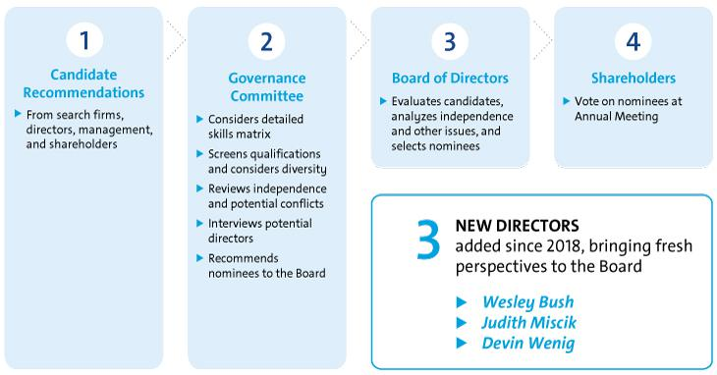

Board Diversity

The Governance Committee seeks individuals with a broad range of business experience and varied backgrounds. Although GM does not have a formal policy governing diversity among directors, your Board strives to identify candidates with diverse backgrounds. Your Board recognizes the value of overall diversity and considers members’ and candidates’ opinions, perspectives, personal and

professional experiences, and backgrounds, including gender, race, ethnicity, and country of origin. The judgment and perspectives offered by a diverse board of directors improves the quality of decision making and enhances the Company’s business performance. Such diversity can help the Board respond more effectively to the needs of customers, shareholders, employees, suppliers, and other stakeholders.

17

Table of Contents

CORPORATE GOVERNANCE

Candidate Recommendations

The Governance Committee will consider director candidates recommended by shareholders. The Governance Committee will review the qualifications and experience of each recommended candidate using the same criteria for candidates proposed by

Board members, and communicate its decision to the candidate or the person who made the recommendation. Shareholder nominations must be submitted to the Company by the deadlines found on page 101 of this Proxy Statement.

Board Committees

Your Board of Directors has six standing Committees: Audit, Compensation, Executive, Finance, Governance, and Risk and Cybersecurity. The key responsibilities, recent activities, and focus areas of each Committee, together with their current membership and the number of meetings held in 2019, are set forth on pages 19 to 21 of this Proxy Statement. Each Committee Chair meets regularly with management during the year to discuss

Committee business, shape agendas, and facilitate efficient meetings. The Chairman, Ms. Barra, attends all Committee meetings to serve as a resource and identify topics requiring the full Board’s attention. The Board has determined that each member of the Audit, Compensation, Finance, Governance, and Risk and Cybersecurity Committees is independent according to NYSE listing standards and our Corporate Governance Guidelines.

- Board and Committee Meetings and Attendance

In 2019, your Board held eight meetings, and average director attendance at Board and Committee meetings was 97%. Each director standing for re-election attended at least 81% of the total meetings of the Board and Committees on which he or she

served in 2019. Directors are encouraged to attend our Annual Meeting of Shareholders, which is held in conjunction with a regularly scheduled Board meeting. All directors then in office attended the 2019 Annual Meeting.

- Executive Sessions

Independent directors have an opportunity to meet in executive session without management present as part of each regularly scheduled Board and Committee meeting. Executive sessions are chaired by our Independent Lead Director, Mr. Solso, or the respective Committee Chair.

During executive sessions of the Board, the independent directors may review CEO performance, compensation, and succession planning; strategy;

key enterprise risks; future Board agendas and the flow of information to directors; corporate governance matters; and any other matters of importance to the Company raised during a meeting or otherwise presented by the independent directors.

The non-management directors of the Board, all of whom are independent, met in executive session six times in 2019.

- Access to Outside Advisors

The Board and each Board Committee can select and retain
the service of outside advisors at the Company’s expense.

18

Table of Contents

CORPORATE GOVERNANCE

AUDIT

Members: Thomas M. Schoewe (Chair), Wesley G. Bush, Linda R. Gooden, Jane L. Mendillo, and Judith A. Miscik


Thomas M. Schoewe, | Meetings held in 2019: 6
Chair | Meetings held in 2019: 6

Key Responsibilities

u Monitors the effectiveness of GM’s financial reporting processes and systems and disclosure and internal controls;

u Selects and engages GM’s external auditors and reviews and evaluates the audit process;
u Reviews and evaluates the scope and performance of the internal audit function;
u Facilitates ongoing communications about GM’s financial position and affairs between the Board and the external auditors, GM’s financial and senior management, and GM’s internal audit staff;

u Reviews GM’s policies and procedures regarding ethics and compliance; and
u Oversees the preparation of the Audit Committee Report and related disclosures for the annual Proxy Statement.

The Board has determined that all members of the Audit Committee meet heightened independence and qualification criteria and are financially literate in accordance with the NYSE Corporate Governance Standards and SEC rules, and that Mr. Bush, Ms. Gooden, Ms. Mendillo, and Mr. Schoewe are each qualified as an “audit committee financial expert” as defined by the SEC.

Recent Activities and Key Focus Areas

u Oversaw the implementation of a suite of new systems and system architectures designed to enhance the Company’s close, consolidation, planning, and reporting processes

u Reviewed the financial impacts and disclosures relating to the 2019 labor disruption and GM’s continued transformational cost savings actions

u Reviewed the expected impact on GM Financial of the adoption of a new accounting standard relating to the recognition of expected credit losses

EXECUTIVE COMPENSATION

Members: Carol M. Stephenson

(Chair), Wesley G. Bush, Joseph

Jimenez, and Patricia F. Russo

Carol M. Stephenson,

Chair Meetings held in 2019: 5

Key Responsibilities

u Reviews the Company’s executive compensation policies, practices, and programs;

u Reviews and approves corporate goals and objectives for compensation, evaluates performance (along with the full Board), and determines compensation levels for the Chairman and CEO;

u Reviews and approves compensation of NEOs, executive officers, and other senior leaders under its purview;

u Reviews compensation policies and practices so that the plans do not encourage unnecessary or excessive risks; and

u Reviews the Company’s compensation policies and practices that promote diversity and inclusion.

The Board has determined that all members of the Compensation Committee meet heightened independence and qualification criteria in accordance with NYSE listing standards and SEC rules. The Compensation Committee’s charter permits the Committee to delegate its authority to members of management and also form and delegate authority to subcommittees consisting of one or more members when it deems it appropriate.

Recent Activities and Key Focus Areas

u Conducted a competitive process for the selection of the Company’s new compensation consultant, Frederic W. Cook & Co.

u Performed an in-depth review and analysis of GM’s incentive compensation plans, adding performance caps to GM’s LTIP in order to further align interests with those of our shareholders

19

Table of Contents

CORPORATE GOVERNANCE

FINANCE

Members: Joseph Jimenez (Chair), Wesley G. Bush, Jane L. Mendillo, Patricia F. Russo, and Thomas M. Schoewe


Joseph Jimenez, | Meetings held in 2019: 4
Chair | Meetings held in 2019: 4

Key Responsibilities

u Reviews financial policies, strategies, and capital structure;

u Reviews the Company’s cash management policies and proposed capital plans, capital expenditures, dividend actions, stock repurchase programs, issuances of debt or equity securities, and credit facility and other borrowings;

u Reviews any significant financial exposures and risks, including foreign exchange, interest rate, and commodities exposures, and the use of derivatives to hedge those exposures; and

u Reviews the regulatory compliance, administration, financing, investment performance, risk and liability profile, and funding of the Company’s pension obligations.

Recent Activities and Key Focus Areas

u Oversaw $1.2 billion fundraising effort by Cruise, including a $0.7 billion investment by GM

u Monitored efforts to create structural cost savings and increased focus on cash flow
u Monitored GM’s disciplined Capital Allocation Strategy, particularly in response to the 2019 labor disruption

20

GOVERNANCE AND

CORPORATE RESPONSIBILITY

Members: Patricia F. Russo (Chair), Jane L. Mendillo, Theodore Solso, and Carol M. Stephenson


Patricia F. Russo, | Meetings held in 2019: 4
Chair | Meetings held in 2019: 4

Key Responsibilities

u Reviews the Company’s corporate governance framework, including all significant governance policies and procedures;

u Monitors Company policies and strategies related to corporate responsibility, sustainability, and political contributions and lobbying activities;

u Reviews the appropriate composition of the Board and recommends director nominees;
u Monitors the self-evaluation process of the Board and Committees;
u Recommends compensation of non-employee directors to the Board; and
u Reviews and approves related party transactions and any potential Board conflicts of interest, as applicable.

Recent Activities and Key Focus Areas

u Guided management through the adoption of the Company’s first virtual annual meeting

u Reviewed the Company’s ESG strategy, with a broader focus on corporate purpose and culture and how those attributes align with the Company’s corporate strategy

u Approved amendments to the General Motors Deferred Compensation Plan for Non-Employee Directors to align with changed practices and changes in tax law

u Revised process for Board and Committee evaluations to improve the quality of feedback and enhance transparency to shareholders

Table of Contents

CORPORATE GOVERNANCE

RISK AND CYBERSECURITY

Members: Linda R. Gooden (Chair), Joseph Jimenez, Judith A. Miscik, Thomas M. Schoewe, and Devin Wenig


Linda R. Gooden, | Meetings held in 2019: 4
Chair | Meetings held in 2019: 4

Key Responsibilities

u Reviews the Company’s key strategic, enterprise, and cybersecurity risks;

u Reviews privacy risk, including potential impact to the Company’s employees, customers, and stakeholders;
u Reviews the Company’s risk management framework and management’s implementation of risk policies, procedures, and governance to assess their effectiveness;

u Reviews management’s evaluation of strategic and operating risks, including risk concentrations, mitigating measures, and the types and levels of risk that are acceptable in the pursuit and protection of shareholder value; and

u Reviews the Company’s risk culture, including the integration of risk management into the Company’s behaviors, decision making, and processes.

Recent Activities and Key Focus Areas

u Reviewed the results of the annual enterprise risk assessment, including the relationships between the 2020 enterprise risks and those risks that were more likely to influence or trigger others

u Monitored compliance with California Consumer Privacy Act
u Reviewed GM’s information security program, which seeks to secure a complex, global IT ecosystem that collectively support’s GM’s global environment

EXECUTIVE

Members: Mary T. Barra (Chair), Theodore Solso, Linda R. Gooden, Joseph Jimenez, Patricia F. Russo, Thomas M. Schoewe, and Carol M. Stephenson


Mary T. Barra, Meetings held in 2019: 0 Chair

Your Board has an Executive Committee composed of the Chairman and CEO, the Independent Lead Director, and the Chairs of all other standing Committees. The Executive Committee is chaired by Ms. Barra, and it can act on certain limited matters for the full Board in intervals between meetings of the Board. The Executive Committee meets as necessary, and all actions by the Executive Committee are reported and ratified at the next succeeding Board meeting.

21

Table of Contents

CORPORATE GOVERNANCE

Board and Committee Oversight of Risk

- Role of the Board of Directors

The Board of Directors has overall responsibility for risk oversight and focuses on the most significant risks facing the Company. The Board discharges its risk oversight responsibilities, in part, through delegation to its Committees. The Company’s risk governance is facilitated through a top-down and bottom-up communication structure, with the tone established at the top by Ms. Barra, our Chairman and CEO, who is also our Chief Risk Officer, and other

Top-Down and Bottom-Up Risk Oversight

Communication Structure
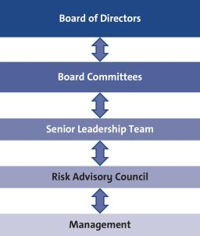

members of management, specifically the Senior Leadership Team. The Senior Leadership Team also utilizes our Risk Advisory Council, an executive-level body with delegates from each business unit and function, to discuss and monitor the most significant enterprise risks in a cross-functional setting. They are tasked with championing risk management practices and integrating them into their functional or regional business units.
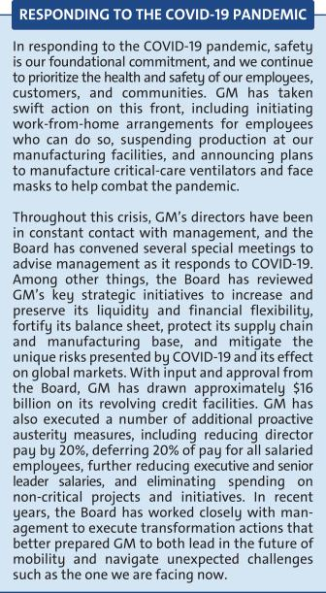

22

Table of Contents

CORPORATE GOVERNANCE

- Role of the Board Committees

Each of the Board’s Committees has a critical role to play in the overall execution of the Board’s risk oversight duties. The Board delegates oversight for certain risks to each Committee based on the risk categories relevant to the subject matter of the Committee. The Chair of the Risk and Cybersecurity Committee coordinates with the Chairs of the other Committees to support them in managing the relationship between risk management

policies and practices and their respective oversight responsibilities. The Risk and Cybersecurity Committee also assists the Board by monitoring the overall effectiveness of the Company’s risk management framework and processes. Below is a summary of the key risk oversight responsibilities that the Board has delegated to the Committees.

RISK AND

CYBERSECURITY

u Oversees risks related to the Company’s key strategic, enterprise, and cybersecurity risks, including workplace and product safety and privacy

 | AUDIT |  |  |  | FINANCE
u Oversees risks related to financial |  |  |  | u Oversees | significant | financial
reporting, | internal | controls, or |  | exposures | and | contingent
auditing matters |  |  |  | liabilities of the Company
u Oversees risk related to legal, |  |  |  | u Oversees | regulatory | compliance
regulatory, | and | compliance |  | of employee defined benefits
programs |  |  |  | plans

GOVERNANCE AND CORPORATE

RESPONSIBILITY

u Oversees risks related to
public policy and political
activities

u Oversees risks related to
director independence and
related party transactions

u Oversees risks related to the

sustainability of our operations
and products

EXECUTIVE COMPENSATION


u Oversees risks related to executive and employee compensation plans, including by designing compensation plans that promote prudent risk management

- Annual Risk Assessment

The Company’s Strategic Risk Management team conducts an annual risk assessment designed to prioritize GM’s most significant enterprise risks. The Risk and Cybersecurity Committee reviews this assessment and helps management focus on and select the key

risks that should be brought to the Board and the other Committees. Below are certain of the key enterprise risks that the Board and management have identified for 2020.

Talent |  | Customer |  | Supply Chain |  | Privacy |  | Manufacturing
Talent |  | Experience |  | Supply Chain |  | Privacy |  | Disruptions
 |  | Experience |  | Disruptions |  |  |  | Disruptions
Workplace Safety |  |  |  | Shifting Trade and |  | Economic |  | Cybersecurity
and Health |  | Vehicle Safety |  | Government |  | Economic |  | Cybersecurity
and Health |  | Vehicle Safety |  | Government |  | Fluctuations |  | Cybersecurity
 |  |  |  | Policies

23

Table of Contents

CORPORATE GOVERNANCE

SPOTLIGHT:

CYBERSECURITY AND PRIVACY

RISK OVERSIGHT


The Risk and Cybersecurity Committee works closely with management and the other Committees to manage GM’s cybersecurity and data privacy risks.

Cybersecurity

At each meeting, the Risk and Cybersecurity Committee reviews management’s Cybersecurity Risk Scorecard, which measures the maturity of GM’s domain security programs, and discusses various cybersecurity topics. The Risk and Cybersecurity Committee also receives intelligence briefings on notable cyber events impacting the industry. The briefings summarize the vulnerabilities that led to the event, provide insight into what happened, and highlight learnings that GM can leverage in the future.

GM’s Global Cybersecurity organization is a virtual alignment of cybersecurity domains across functions and business units that enables the Company to leverage both business and technical experts to accelerate the development and execution of security solutions. In recent years, GM has invested heavily in cybersecurity, including through the hiring of nearly 500 employees. These employees have diverse skillsets and include pen-testers, cryptologists, mathematicians, data analysts, program managers, and “true hackers.”

Privacy

In recent years, GM’s Strategic Risk Management team determined that privacy risks were increasing in significance due to the enactment of new and more stringent U.S. and global regulations on the use and protection of personal information. Accordingly, the Risk and Cybersecurity Committee has taken steps to continue to enhance its oversight on GM’s data privacy policies and practices. The Committee’s charter makes it clear that the Committee is responsible for overseeing GM’s privacy risks relating to the Company’s employees, customers, and stakeholders. The Committee also devotes portions of its meetings to discuss critical privacy issues with management, including GM’s processes and policies designed to ensure compliance with the California Consumer Privacy Act.

CLIMATE CHANGE

RISK OVERSIGHT


GM takes the challenge of climate change seriously and recognizes the role of the transportation sector in contributing to global greenhouse gas emissions.

Governance

The Board is committed to overseeing the Company’s integration of ESG principles throughout the enterprise. GM is fortunate that several of its Board members have extensive business experience in managing ESG- and climate-related issues, such as transitioning from high- to low-carbon-emitting technologies and managing environmental impacts within the supply chain.

The Board has been actively involved in shaping GM’s EV strategy, which has led to the development of our third-generation global EV platform powered by our proprietary Ultium battery system. This highly flexible platform will support vehicles ranging from affordable cars and crossovers to luxury SUVs and pickup trucks, effectively competing for nearly every customer in the market.

Risk Management and Scenario Planning

Climate change has been incorporated into GM’s enterprise risk management process. This designation ensures that these issues are at the forefront of daily decision making and that we manage them at the highest levels of the organization. As an example, a cross-functional climate change workshop helped us assess the risks, challenges, and opportunities associated with various two-degree warming scenarios. The workshop consisted of a three-step process including exploring uncertainties and defining success in the future world; answering questions to shape each scenario; and performing an analysis to determine what GM should be doing now to influence its future. This exercise helped clarify risks but also highlighted opportunities. Above all, it underscored the reality that the need to limit global warming is influencing consumer choices and brand perception today.

24

Table of Contents

CORPORATE GOVERNANCE

Your Board’s Governance Policies and Practices

- Code of Business Conduct and Ethics: “Winning with Integrity”

The Board is committed to the highest legal and ethical standards in fulfilling its responsibilities. We have adopted a code of business conduct and ethics, “Winning with Integrity,” that applies to our directors, officers, and employees. This Code of Conduct forms the foundation for compliance with corporate policies and procedures and creates a Company-wide focus on uncompromising integrity in every aspect of our operations. It embodies our expectations for a number of topics, including

workplace and vehicle safety, conflicts of interest, protection of confidential information, insider trading, competition and fair dealing, human rights, community involvement and corporate citizenship, political activities and lobbying, preservation and use of Company assets, and compliance with all laws and regulations applicable to the conduct of our business. Employees are expected to report any conduct that they believe in good faith to be an actual or apparent violation of our Code of Conduct.

- Corporate Governance Guidelines

Our Corporate Governance Guidelines form a transparent framework for the effective governance of the Company. The Corporate Governance Guidelines address matters such as the respective roles and responsibilities of the Board and management, the Board’s leadership structure, the responsibilities of the Independent Lead Director, director independence, the Board membership criteria, Board Committees, and Board and CEO

evaluation. The Governance Committee regularly reviews the Corporate Governance Guidelines and periodically recommends to your Board the adoption of amendments in response to changing regulations, evolving best practices, and shareholder concerns. For a summary of our corporate governance best practices, please see “Shareholder Protections and Governance Best Practices” on page 28 of this Proxy Statement.

- CEO Succession Planning

Our Independent Lead Director oversees the CEO succession planning process and leads, at least annually, the Board’s discussion of CEO succession planning. Our CEO provides the Board with recommendations for and evaluations of potential CEO successors and reviews with the Board development plans for these successors. Directors

engage with potential CEO and senior management talent at Board and Committee meetings and in less formal settings to enable directors to personally assess candidates. The Board reviews management succession in the ordinary course of business as well as contingency planning in the event of an emergency or unanticipated event.

- Board and Committee Evaluations

The Governance Committee periodically reviews the form and process for Board and Committee self-evaluations. In 2019, following extensive benchmarking, engagement with shareholders, interviewing third-party facilitators, and internal

discussion, the Board approved, based on the recommendation of the Governance Committee, changes to its self-evaluation process. Beginning in 2020, the Board and its Committees will observe the following self-evaluation process:

Throughout the process, directors have ample opportunity to provide feedback on individual director performance.

25

Table of Contents

CORPORATE GOVERNANCE

The Board is committed to incorporating feedback from its self-evaluations. Recent examples of changes to practice, include:

- Conducting bi-annual “Next Generation Lunches” with emerging leaders of the Company to assess talent and cultural change.

- Meeting with dealers to understand concerns and strategize about opportunities to create a better customer experience.

- Combining the Risk and Cybersecurity Committees to create more efficient meeting cycles and allow for broader discussions about risk management.

- Enhancing pre-read and meeting presentation materials to allow for more discussion during meetings.

- Changing the Board’s Self-Evaluation Process to make it more efficient and collaborative.

- Annual Evaluation of CEO

Each year, the Board reviews the CEO’s performance against her annual strategic goals. The non-management directors, meeting separately in executive session, annually conduct a formal evaluation of the CEO, which is communicated to the CEO by the Independent Lead Director. The evaluation is based on both objective and subjective criteria, including, but not limited to: the Company’s financial performance; accomplishment of ongoing

initiatives in furtherance of the Company’s long-term strategic objectives; and development of the Company’s top management team. The results of the evaluation are considered by the Compensation Committee in its deliberations when determining the compensation of the CEO as further described in “Executive Compensation” on page 52 of this Proxy Statement.

- Director Orientation and Continuing Education

All new directors participate in the Company’s director orientation program. The orientation enables new directors to become familiar with the Company’s business and strategic plans; significant financial matters; core values, including ethics; compliance programs; corporate governance practices; and other key policies and practices.

Continuing education opportunities are provided to keep directors updated with information about the

Company and its strategy, operations, products, and other matters relevant to Board service. Board members are encouraged to visit GM facilities and dealers and attend auto shows and other key corporate and industry events to enhance their understanding of the Company and its competitors in the auto industry. In addition, all directors are encouraged to attend, at our expense, director continuing education programs sponsored by governance organizations and other institutions.
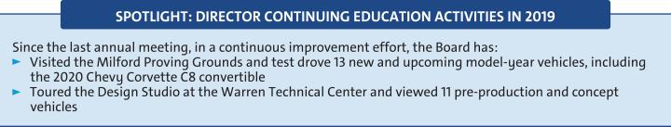

- Director Service on Other Public Company Boards

The Board recognizes that service on other public company boards provides directors valuable experience that benefits the Company. The Board also believes, however, that it is critical that directors

dedicate sufficient time to their service on the Company’s Board. Directors are expected to advise the Chairman, Independent Lead Director, or Chair of the Governance Committee in advance of accepting

26

Table of Contents

CORPORATE GOVERNANCE

an invitation to serve on another board of directors or any audit committee of another public company board. This allows the Governance Committee to assess the impact of joining another board based on various factors relevant to the specific situation, including the nature and extent of a director’s other professional obligations and the time commitment attendant to the new position. Directors who are engaged in active, full-time employment, for example, could have less time to devote to Board service than a director whose principal occupation is serving on boards. Our Corporate Governance Guidelines provide that without obtaining the approval of the Board:

- A director may not serve on the boards of more than four other public companies (excluding nonprofits and subsidiaries).

- No member of the Audit Committee may serve on more than two other public company audit committees.

In general, senior members of management may not serve on the board of more than one other public company or for-profit entity and must obtain the approval of the Governance Committee prior to accepting an invitation to serve on an outside board. All directors and senior members of management are in compliance with this policy.

- Compensation Committee Interlocks and Insider Participation

Mses. Stephenson and Russo and Messrs. Bush, Jimenez, and Mulva (until May 2019) served on the Compensation Committee in 2019. As of the date of this Proxy Statement, none of the members of the Compensation Committee was or is an officer or

employee of the Company, and no executive officer of the Company served or serves on the compensation committee or board of any company that employed or employs any member of the Company’s Compensation Committee or Board.

Shareholder Engagement

Members of the Board and senior management routinely engage with shareholders and stakeholders. These engagements help the Board and management gain feedback on a variety of topics, including strategic and financial performance, operations, products, executive compensation, and Board composition and leadership structure, as well as on important environmental and social issues. The constructive insights, experiences, and ideas exchanged during these engagements have helped your Board evaluate and assess key initiatives during the Company’s ongoing transition to an all-electric future.

In 2019, members of the Board and senior management engaged with shareholders representing approximately 50 percent of GM’s outstanding shares of common stock. Recent engagements have included:

- Presentations by two of our largest shareholders at a Board meeting;

- Capital Markets Day and EV Week; and

- Shareholder visits to our Battery Lab and EV assembly plant.

See page 40 of this Proxy Statement for feedback and actions taken related to GM’s Executive Compensation program.


27

Table of Contents

CORPORATE GOVERNANCE

Shareholder Protections and Governance Best Practices

Your Board is committed to governance structures and practices that protect shareholder value and important shareholder rights. The Governance Committee regularly reviews these structures and practices, which include the following:
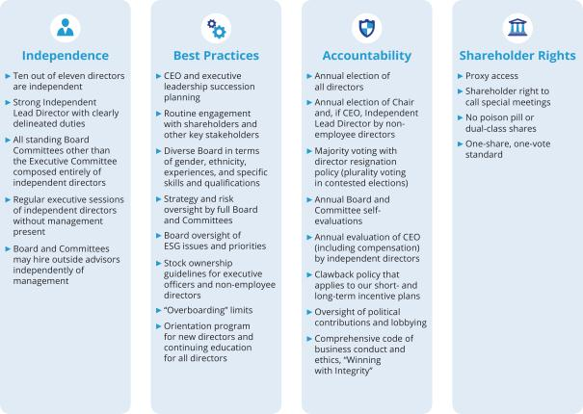

- Corporate Political Contributions and Lobbying Expenditures

We participate in the political process to help shape public policy and address legislation that impacts GM, our industry, and our shareholders and other stakeholders. GM has supported and will continue to support public policies that drive the achievement of our long-term, sustainable growth. To guide our activities, the Board has adopted a U.S. Corporate Political Contributions and Expenditures Policy (“Political Contributions Policy”).

The Governance Committee oversees the Political Contributions Policy and annually reviews the Company’s engagement in the public policy process.

The Governance Committee also annually reviews all corporate political contributions, reviews GM Political Action Committee contributions and expenditures (which are funded entirely by voluntary employee contributions) and the process by which they are made and receives multiple updates each year regarding the Company’s lobbying expenditures. The Board also receives a monthly report on the most pressing public policy issues. It uses this report to continuously assess which issues are important to the Company’s long-term interests and which organizations the Company is working with to advance those interests.

28

Table of Contents

CORPORATE GOVERNANCE
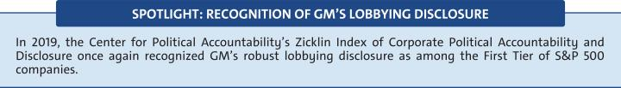

Certain Relationships and Related Party Transactions

Our Code of Conduct requires all of our employees and directors to avoid any activity that is in conflict with our business interests. In addition, your Board has adopted a written policy regarding the review and approval or ratification of “related party transactions” (the “Related Party Transactions Policy”). Under the Related Party Transactions Policy, which is administered by our Governance Committee, directors and executive officers must report any potential related party transactions (including transactions involving immediate family members of directors and executive officers) to the General Counsel or Corporate Secretary to determine whether the transaction constitutes a related party transaction. If any member of the Governance Committee has a potential interest in any related party transaction, such member will recuse himself or

herself and abstain from voting on the approval or ratification of the related party transaction.

For purposes of our Related Party Transactions Policy, a related party transaction includes transactions in which our Company (or a subsidiary), is a participant, the amount involved exceeds $ 120,000, and a “related party” has or will have a direct or an indirect material interest. Related parties of our Company consist of directors (including nominees for election as directors), executive officers, shareholders beneficially owning more than 5% of the Company’s voting securities, and the immediate family members of these individuals. Once a related party transaction has been identified, the Governance Committee will review all of the relevant facts and circumstances and approve or disapprove entry into the transaction. As required under SEC rules, we disclose all related party transactions annually in our Proxy Statement.

- Factors Used in Assessing Related Party Transactions


u Whether the terms of the related party transaction are fair to the Company and on the same basis as if the transaction had occurred on an arms-length basis;

u Whether there are any compelling business reasons for the Company to enter into the related party transaction and the nature of alternative transactions, if any;

u Whether the related party transaction would impair the independence of an otherwise independent director;

u Whether the Company was notified about the related party transaction before its commencement, and if not, why preapproval was not sought and whether subsequent ratification would be detrimental to the Company; and


u Whether the related party transaction would present an improper conflict of interest for any director or executive officer of the Company, taking into account the specific facts and circumstances of such transaction.

In 2019, the son of Craig Glidden, employed by Cruise as a Manager, Reliability and Lifecycle Planning, had a salary and bonus in excess of $120,000; and two holders of 5% or more of the Company’s common stock – BlackRock and Vanguard – provided investment management services to Company-sponsored pension plans.

29

Table of Contents

SPOTLIGHT ON KEY ESG INITIATIVES

Environmental & Sustainability Highlights
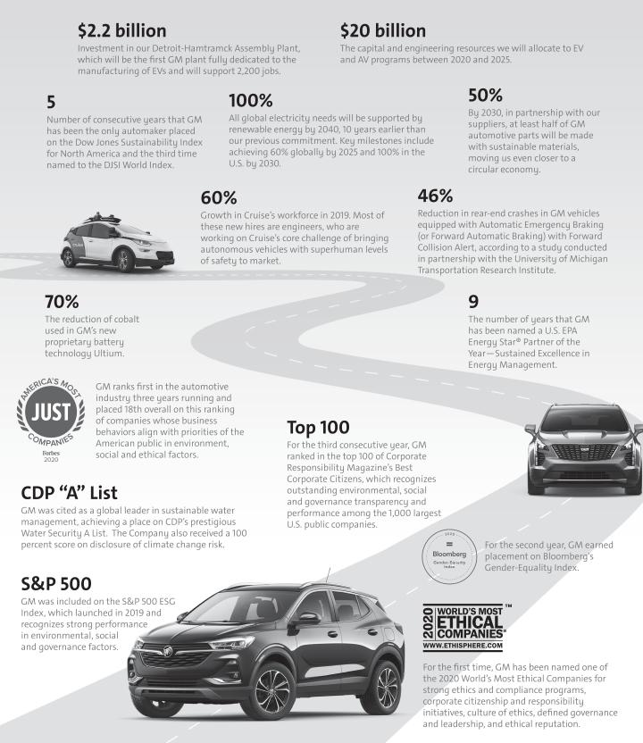

30

Table of Contents

SPOTLIGHT ON KEY ESG INITIATIVES

Creating a Workplace of Choice

Our work is personal and tied to a greater mission - and that’s to move humanity forward. We know we have the capability, talent, and the technology to realize a safer, better, more sustainable world for everyone, which starts and ends with our workforce. To remain competitive, GM must continue to attract and retain the brightest talent around the world. We are working hard to build an inclusive and unified workforce – a true Workplace of Choice. Today, we compete for talent against not just other automotive companies, but, increasingly, sophisticated technology companies. We strive to build our workforce across various key dimensions, including teamwork, fairness, trust, growth, commitment, recognition, and impact.

- Key Workforce Priorities

- Talent Acquisition: Hiring and retaining top talent.

- Talent Engagement: Creating a positive work environment and a place where employees feel inspired to do their best work and feel valued for doing it.

- Talent Development: Increasing the number and variety of career resources available to employees.

- Wellness and Benefits: Providing benefits that help employees balance their jobs with other aspects of their lives: a living wage; quality health care; 401K plans with matching programs; paid time off for vacations, illness, parental, and military leave; health and well-being programs; and a focus on accomplishing work-related tasks rather than spending a certain number of hours in the office.

- Labor Relations: Respecting our employees’ right to freedom of association in all countries and complying with our obligation to satisfy all local labor laws and regulations.

- Diversity and Inclusion

An integral part of GM’s mission to build a Workplace of Choice is creating an inclusive culture that welcomes and celebrates diversity. Our path to innovation starts and ends with our employees, who are fundamental to the vibrancy and success of our company. Everything we accomplish depends on their abilities and engagement. This is why we have established employee development programs that address both individual and business needs, as well as effective recruitment programs that reach out to diverse populations. In particular, GM has long been a global leader in advocating for women’s equality in the workplace, with women in approximately 34 percent of our top management positions. GM is currently the only company among the Fortune 20 that has both a female CEO and CFO.
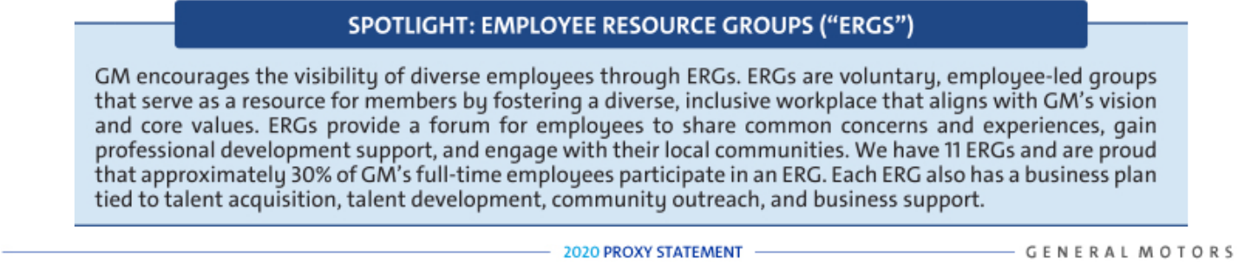

31

Table of Contents

SPOTLIGHT ON KEY ESG INITIATIVES

Responsible Sourcing

At GM, we recognize that our impact goes beyond our walls to include our entire value chain, of which suppliers make up a significant part. As a result, we seek to partner with suppliers who share our purpose and values.

- Holding Our Suppliers Accountable

Our Supplier Code of Conduct and supplier contracts set forth expectations for ethical social, business, and environmental practices; and our major suppliers must certify compliance. Beyond our Supplier Code of Conduct, we outline our expectations for supplier conduct in purchase contract terms and conditions. These clearly state our prohibition against any use of child labor or any other form of forced or involuntary labor, abusive treatment of employees, or corrupt business practices in the supplying of goods and services to us. Furthermore, our contracts lay out expectations for lawful compliance with data protection and privacy; wages; hours and conditions of employment; subcontractor selection; anti-discrimination; occupational health/safety, and motor vehicle safety. By choosing to do business with GM, our suppliers accept our terms and conditions, and for our largest suppliers we also expect that they certify compliance with laws in the provisions of our contract. Additionally, we provide our suppliers with access to the same communication tools—the AwareLine, Speak Up For Safety, Global Response Incident Reporting and others—that our own employees use to raise concerns. We also hold various webinars and provide external training to improve supplier operations, primarily in the areas of environmental management, workplace conditions, ethics, and human rights.
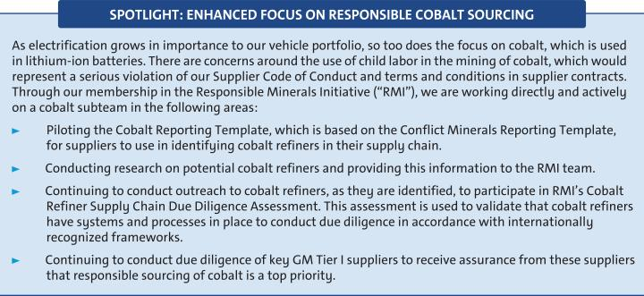

32

Table of Contents

SECURITY OWNERSHIP INFORMATION

Security Ownership of Directors, Named Executive Officers, and Certain Other Beneficial Owners

The following table and accompanying footnotes show information regarding the beneficial ownership of GM’s issued and outstanding common stock by (i) each of our directors and NEOs, and all directors and executive officers as a group, each as of April 1, 2020, and (ii) each person known by us to beneficially own more than 5% of the issued and outstanding common stock as of the dates indicated in the footnotes. All directors and executive officers have sole voting and dispositive power over the shares. The Percentage of Outstanding Shares is based on 1,432,276,664 shares issued and outstanding as of April 1, 2020.

 |  |  |  |  | Shares of Common | Percentage of
 |  |  |  |  | Stock Beneficially | Outstanding
Name |  |  |  |  | Owned | Shares
Non-Employee Directors (1)
Wesley G. Bush |  |  |  |  | 10,000(2) | *
Linda R. Gooden |  |  |  |  | 1,000(2) | *
Joseph Jimenez |  |  |  |  | 32,330(2) | *
Jane L. Mendillo |  |  |  |  | 4,560(2) | *
Judith A. Miscik |  |  |  |  | —(2) | *
Patricia F. Russo |  |  |  |  | 12,300(2) | *
Thomas M. Schoewe |  |  |  |  | 22,005(2) | *
Theodore M. Solso |  |  |  |  | 6,561(2) | *
Carol M. Stephenson |  |  |  |  | 800(2) | *
Devin N. Wenig |  |  |  |  | —(2) | *
Named Executive Officers (1)
Mary T. Barra |  |  |  |  | 4,996,409(3) | *
Dhivya Suryadevara |  |  |  |  | 305,733(3) | *
Mark L. Reuss |  |  |  |  | 792,865(3) | *
Alan S. Batey (4) |  |  |  |  | 556,701(3) | *
Barry L. Engle II |  |  |  |  | 432,218(3) | *
Craig B. Glidden |  |  |  |  | 634,134(3) | *
All Directors and Executive Officers as a Group (21 persons, including the |  |  |  |  | 9,303,394(3)
foregoing) |  |  |  |  | 9,303,394(3) | *
Certain Other Beneficial Owners (5)
The Vanguard Group (6) |  |  |  |  | 102,990,145 | 7.2%
UAW Retiree Medical Benefits Trust (7) |  |  |  |  | 100,150,000 | 7.0%
BlackRock, Inc. (8)** |  |  |  |  | 99,328,603 | 6.9%
Capital World Investors (9)** |  |  |  |  | 94,227,194 | 6.6%
Berkshire Hathaway Inc. (10) |  |  |  |  | 75,000,000 | 5.2%

- Less than 1%.

- The Vanguard Group and BlackRock, Inc., provide investment management services to Company-sponsored pension plans. The total amount of the fees will fluctuate based on allocation decisions made by the applicable fiduciary.

33

Table of Contents

SECURITY OWNERSHIP INFORMATION

- c/o General Motors Company, 300 Renaissance Center, Detroit, Michigan 48265.

- These amounts represent common stock only and do not include DSUs, which are unit equivalents of our common stock, under the Director Compensation Plan described on page 11 of this Proxy Statement. Directors hold the following number of DSUs: 7,131 DSUs for Mr. Bush; 21,510 DSUs for Ms. Gooden; 39,319 DSUs for Mr. Jimenez; 29,529 DSUs for Ms. Mendillo; 4,980 DSUs for Ms. Miscik; 42,851 DSUs for Ms. Russo; 35,147 DSUs for Mr. Schoewe; 87,951 DSUs for Mr. Solso; 67,898 DSUs for Ms. Stephenson; and 13,961 DSUs for Mr. Wenig.

- These amounts include shares that may be acquired upon exercise of stock options that are currently exercisable or will become exercisable within 60 days of April 1, 2020, as follows: 3,688,080 shares for Ms. Barra; 279,195 shares for Ms. Suryadevara; 504,113 shares for Mr. Reuss; 408,575 shares for Mr. Batey; 311,510 shares for Mr. Engle; and 442,990 shares for Mr. Glidden.

- Mr. Batey retired from the Company effective March 1, 2020.

- The Company is permitted to rely on the information reported by each beneficial owner in filings with the SEC and has no reason to believe that the information is incomplete or inaccurate or that the beneficial owner should have filed an amended report and did not.

- Based solely on information set forth in a Schedule 13G/A filed with the SEC on February 12, 2020, The Vanguard Group reported that it and its subsidiaries listed on Appendix A of Schedule 13G/A were the beneficial owners of 102,990,145 shares of GM’s outstanding common stock as of December 31, 2019. As of December 31, 2019, The Vanguard Group had the sole power to vote 1,881,783 shares; the sole power to dispose of 100,923,202 shares; the shared power to vote 356,496 shares; and the shared power to dispose of 2,066,943 shares. The address for The Vanguard Group is 100 Vanguard Boulevard, Malvern, Pennsylvania 19355.

- Based solely on information set forth in a Schedule 13G/A filed with the SEC on August 22, 2019, the UAW Retiree Medical Benefits Trust, as advised by its fiduciary and investment advisor Brock Fiduciary Services LLC, and a Schedule 13G/A filed with the SEC on August 22, 2019, by Brock Capital Group LLC and Brock Fiduciary Services LLC, as of December 31, 2018, the UAW Retiree Medical Benefits Trust had shared voting and dispositive power of 100,150,000 shares of GM’s outstanding common stock. No sole voting and dispositive powers were reported. The address for the UAW Retiree Medical Benefits Trust is 200 Walker Street, Detroit, Michigan 48207.

Pursuant to the Stockholders Agreement dated October 15, 2009, between the Company and the UAW Retiree Medical Benefits Trust, the Trust will vote its shares of our common stock on each matter presented to the shareholders at the Annual Meeting in the same proportionate manner as the holders of our common stock other than our directors and executive officers. The Trust will be subject to the terms of the Stockholders Agreement until it beneficially owns less than 2% of the shares of our common stock then issued and outstanding.

- Based solely on information set forth in a Schedule 13G/A filed with the SEC on February 5, 2020, Blackrock, Inc., reported that it and its subsidiaries listed on Exhibit A to Schedule 13G/A were the beneficial owners of 99,328,603 shares of GM’s outstanding common stock as of December 31, 2019. BlackRock reported having sole voting power for 87,229,425 shares and sole dispositive power of 99,328,603 shares. No shared voting or dispositive powers were reported. The address for BlackRock, Inc., is 55 East 52nd Street, New York, New York 10055.

- Based solely on information set forth in a Schedule 13G/A filed with the SEC on February 14, 2020, Capital World Investors reported that it is the beneficial owner of 94,227,194 shares of GM’s outstanding common stock as of December 31, 2019. Capital World Investors reported having sole voting power for 94,222,494 shares and sole dispositive power of 94,227,194 shares. No shared voting or dispositive powers were reported. Capital World Investors divisions of Capital Research and Management Company and Capital International Limited collectively provide investment management services under the name Capital World Investors. The address for Capital World Investors is 333 South Hope Street, Los Angeles, California 90071.

- Based solely on information set forth in a Schedule 13G/A filed with the SEC on February 14, 2020, Warren E. Buffett and Berkshire Hathaway Inc. and its subsidiaries listed on Exhibit A to Schedule 13G/A reported being the beneficial owners of 75,000,000 shares of GM’s outstanding common stock as of December 31, 2019, over which they had shared voting and dispositive power. No sole voting or dispositive power was reported. The address for Berkshire Hathaway Inc. is 3555 Farnam Street, Omaha, Nebraska 68131.

34

Table of Contents

AUDIT COMMITTEE REPORT

The Audit Committee (the “Committee”) of the Board of Directors of General Motors Company is a standing committee composed of five directors: Thomas M. Schoewe (Chair), Wesley G. Bush, Linda R. Gooden, Jane L. Mendillo, and Judith A. Miscik.
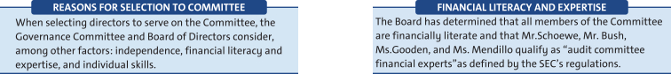

Purpose

The Committee’s core purpose is to assist the Board by providing oversight of:

- The quality and integrity of GM’s financial statements;

- GM’s compliance with legal and regulatory requirements; and

- The qualifications and independence of GM’s external auditors and the performance of GM’s internal audit staff and external auditors.

The Committee operates under a written charter adopted by the Committee and approved by the Board of Directors. The Committee’s charter is posted on our website at investor.gm.com/resources. The Committee’s charter is reviewed at least annually and updated as necessary to address changes in

regulatory requirements, authoritative guidance, evolving oversight practices, and shareholder feedback.

Management is responsible for the Company’s internal controls and the financial reporting process and has delivered its opinion on the effectiveness of the Company’s controls. EY is responsible for performing an independent audit of the Company’s consolidated financial statements and opining on the effectiveness of those controls in accordance with the standards of the Public Company Accounting Oversight Board (United States) (the “PCAOB”) and issuing its reports thereon. As provided in its charter, the Committee’s responsibilities include monitoring and overseeing these processes.

Required Disclosures

In 2019, the Committee met six times and fulfilled all of its core charter obligations. Consistent with its charter responsibilities, the Committee met and held discussions with management and EY regarding the Company’s audited financial statements and internal controls for the year ended December 31, 2019. In this context, management represented to the Committee that the Company’s consolidated financial statements were prepared in accordance with accounting principles generally accepted in the United States. The Committee reviewed and discussed the consolidated financial statements with management and EY and further discussed with EY the matters required to be discussed by the standards of the PCAOB.

EY also provided to the Committee the written disclosures and the letter required by the applicable requirements of the PCAOB concerning independence, and the Committee discussed with EY the auditor’s independence. The Committee also considered and determined that the provision of non-audit services to GM is compatible with maintaining EY’s independence. The Committee concluded that EY was independent from the Company and management.

35

Table of Contents

AUDIT COMMITTEE REPORT

Recommendation

Based upon the Committee’s discussions with management
and EY as described in this report and the Committee’s
review of the representation of management and the reports
of EY to the Committee, the Committee recommended to
the Board of Directors, and the Board of Directors approved,
the inclusion of the audited consolidated financial
statements in the Company’s Annual Report on Form 10-K
for the year ended December 31, 2019, as filed with the
U.S. Securities and Exchange Commission on February 5,
2020.

Audit Committee
Thomas M. Schoewe (Chair)
Wesley G. Bush
Linda R. Gooden
Jane L. Mendillo

Judith A. Miscik

The preceding Audit Committee Report shall not be deemed
incorporated by reference by any general statement
incorporating by reference this Proxy Statement or any
portion hereof into any filing under the Securities Act of
1933, as amended, or the Securities Exchange Act of 1934,
as amended, and shall not otherwise be deemed filed
thereunder.

36

Table of Contents

EXECUTIVE COMPENSATION

Compensation Discussion and Analysis (CD&A) |  | Executive Compensation Tables
Compensation Overview | 38 | Summary Compensation Table | 62
Compensation Principles | 45 | Grants of Plan-Based Awards | 65
Compensation Elements | 45 | Outstanding Equity Awards at Fiscal
Performance Measures | 47 | Year-End | 66
Performance Results and Compensation Decisions | 50 | Option Exercises and Stock Vested | 67
Compensation Policies and Governance Practices | 58 | Pension Benefits | 67
Compensation Committee Report | 61 | Nonqualified Deferred Compensation | 69
 |  | Plan | 69
 |  | Potential Payments Upon Termination | 70

AFCF | – Automotive Free Cash Flow |  | NEO | – | Named Executive Officer
DB | – | Defined Benefit | NQ | – | Nonqualified
DC | – | Defined Contribution | OEM | – | Original Equipment Manufacturer
DSV | – | Driving Stockholder Value | PSU | – | Performance Share Unit
EBIT | – Earnings Before Interest and Taxes |  | ROIC | – Return on Invested Capital
EPS | – | Earnings Per Share | RSA | – | Restricted Stock Award
ESG | – Environmental, Social, and Governance |  | RSU | – | Restricted Stock Unit
EV | – | Electric Vehicle | STIP | – | Short-Term Incentive Plan
GICS | – Global Industry Classification Standard |  | TSR | – | Total Shareholder Return
LTIP | – | Long-Term Incentive Plan | WACC | – Weighted Average Cost of Capital


Mary T. Barra | Chairman and Chief Executive Officer
Dhivya Suryadevara | Executive Vice President and Chief Financial Officer
Mark L. Reuss | President
Barry L. Engle II | Executive Vice President and President, North America
Craig B. Glidden | Executive Vice President and General Counsel
Alan S. Batey | Advisor and Former Executive Vice President and President, North America






Positions as of December 31, 2019.

37

Table of Contents

EXECUTIVE COMPENSATION
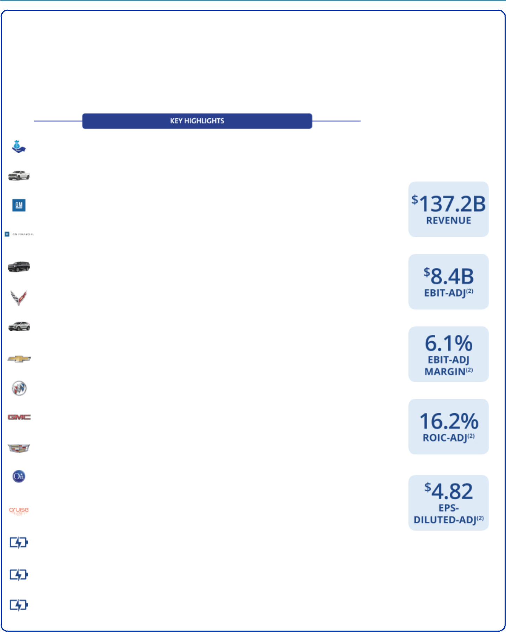

Compensation Overview

- Our Company Performance

In 2019, we continued to move towards a world with zero crashes, zero emissions, and zero congestion. The results below demonstrate how we continue to strengthen the core automotive business, invest in future products, and define the future of personal mobility.

Strong underlying business performance of $137.2 billion in revenue and $2.2 billion returned to shareholders through dividends, while launching and refreshing 27 vehicles globally

Sold more full-size and mid-size trucks combined in the U.S. than any other competitor every year for the past six years

Delivered record average transaction prices in the U.S. of $36,844 for 2019, above the industry average

GM Financial generated record-breaking earnings before tax of $2.1 billion and paid $400 million in dividends to GM

We ended 2019

with the following
key financial results(1):

Unveiled all-new full-size SUVs including the 2021 Chevrolet Tahoe and Suburban, 2021 GMC Yukon and Yukon XL, and 2021 Cadillac Escalade

Introduced the first-ever mid-engine Corvette earning 2020 North American Car of the Year and Motor Trend Car of the Year

Sold more than 1 million crossovers for the second year in a row in the U.S., a 12.7% increase from 2018

Achieved best-ever sales in 2019 for the Chevrolet Traverse, and GM’s best-selling crossover, the Chevrolet Equinox

Unveiled the 2020 Buick Encore GX, expanding the brand’s premium SUV family

Best GMC Denali year ever, with 30% penetration rate. GMC is completing its pioneering move into the premium off-road space by making AT4 available across its entire retail lineup in 2020

Achieved best-ever global sales in Cadillac’s 113-year history, led by its crossover portfolio including the XT4, XT5, and all-new XT6

Unveiled new fleet telematics solution, OnStar Vehicle Insights

Secured additional investment of $1.15 billion from a group comprised of institutional investors, including funds and accounts advised by T. Rowe Price Associates, Inc., and existing partners GM, SoftBank Vision Fund, and Honda, valuing the company at $19 billion

Enabled access to numerous charging ports through collaborations with EVgo, ChargePoint, and Greenlots, the largest collective EV charging network in the U.S.

Announced joint venture with LG Chem to build a plant to mass-produce battery cells for an all-electric future

Announced a collaboration with Bechtel to build a public facing EV fast-charging infrastructure in the U.S.

- The financial information relates to our continuing operations.
- These are non-GAAP financial measures. Refer to Appendix A for a reconciliation of EBIT-adjusted, EBIT-adjusted margin, ROIC-adjusted, and EPS-diluted-adjusted to their closest comparable GAAP measure.

38

Table of Contents

EXECUTIVE COMPENSATION


- Leadership Changes

The Company made the following leadership changes:

Mark L. Reuss – Named President on January 3, 2019. On April 1, 2019, Mr. Reuss assumed the additional responsibility of leading all global markets.

Barry L. Engle II – Named Executive Vice President and President, The Americas, on April 1, 2019, and subsequently named Executive Vice President and President, North America, on November 1, 2019, to focus solely on the North American market and key vehicle launches.

Alan S. Batey – Transitioned to an advisory role effective April 1, 2019, after serving as Executive Vice President and President, North America, since January 15, 2014; retired from the Company effective March 1, 2020.

- Compensation Governance and Best Practices

WHAT WE DO

- Provide short-term and long-term incentive plans with performance targets aligned to business goals

- Maintain a Compensation Committee composed entirely of independent directors who are advised by an independent compensation consultant

- Require stock ownership for all senior leaders

- Engage with shareholders and other stakeholders on various topics with members of management and directors, including our Compensation Committee and our Independent Lead Director

- Include non-compete and non-solicitation terms in all grant agreements with senior leaders

- Maintain an Insider Trading Policy requiring directors, executive officers, and all other senior leaders to trade only during established window periods after receiving preclearance from the GM Legal Staff

- Require equity awards to have double trigger (change in control and termination of employment) vesting provisions

- Complete an annual incentive compensation risk review

- Require short-term cash and long-term equity awards for all executive officers to be subject to clawback and cancellation provisions

- Conduct an annual audit of senior executive expenses and perquisites

WHAT WE DON’T DO

- Provide_{benefits} gross-up payments to cover personal income taxes or excise taxes pertaining to executive severance

- Pay above-market interest on deferred compensation

- Allow directors or executives to engage in hedging or pledging of GM securities

- Reward executives for excessive, imprudent, inappropriate, or unnecessary risk-taking

- Allow the repricing or backdating of equity awards

39

Table of Contents

EXECUTIVE COMPENSATION
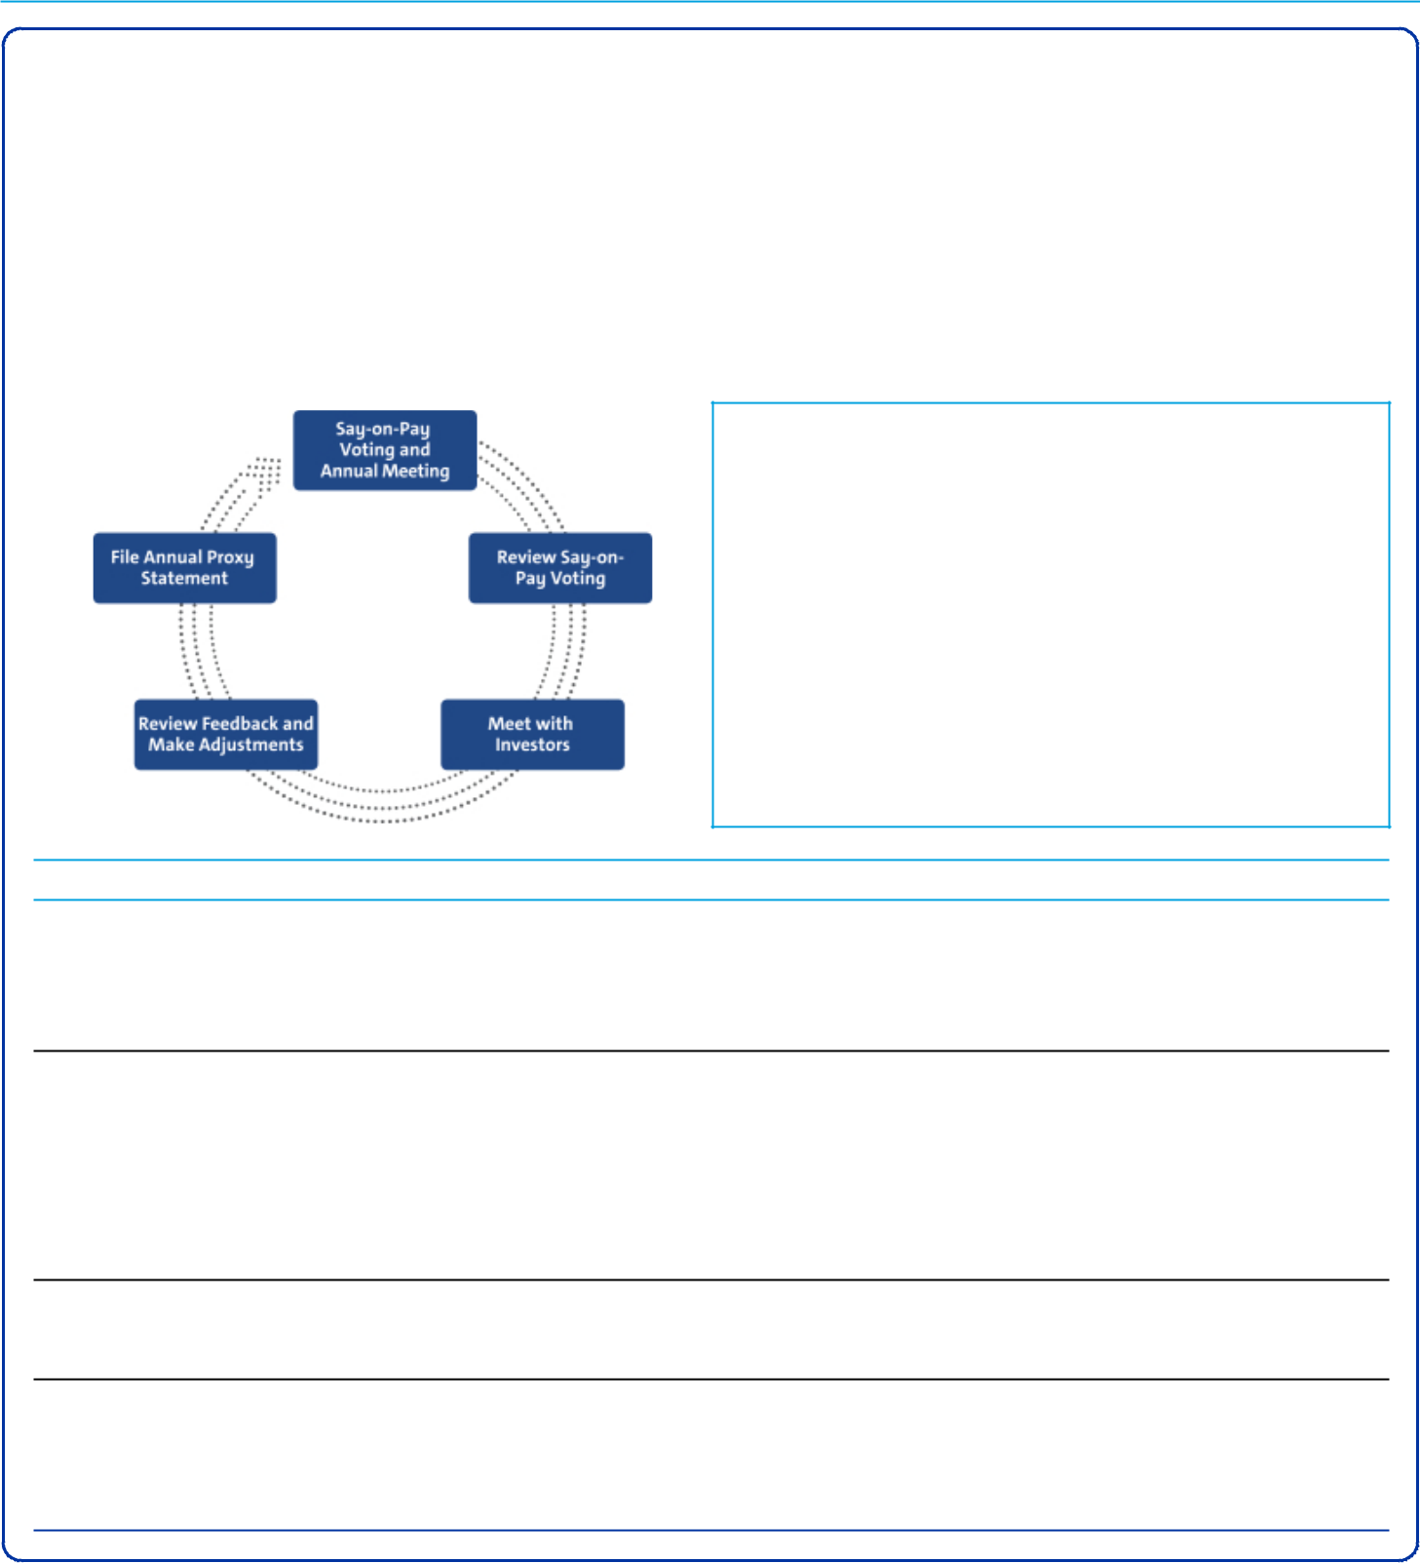

- Shareholder Engagement

The Company annually seeks feedback through engagement with shareholders and we continued this process in 2019. We view shareholder engagement as an important and continuous process. In 2019, members of the Board and senior management engaged with shareholders representing approximately 50% of GM’s outstanding shares of common stock on various topics, including executive compensation.

Through these engagements, we received feedback in support of executive compensation programs and, in particular, the Compensation Committee’s decision to further drive accountability and reinforce our safety culture and ESG results. These discussions, Say-on-Pay voting results, and alignment to the Company vision and strategic goals, are key drivers in our ongoing assessment of our current and future programs. As executive compensation programs evolve, the Board remains committed to continuing the dialogue with shareholders regarding our compensation philosophy and practices.

SHAREHOLDER SAY-ON-PAY

The Compensation Committee seeks to align the Company’s executive compensation programs with the interests of the Company’s shareholders. The Compensation Committee considers the results of the annual Say-on-Pay vote, the long-term vision and strategic goals of the Company, input from management, input from its independent compensation consultant, and investor engagement feedback when setting compensation for our executives. In 2019, 97.3% of our shareholders voted in favor of our executive compensation programs.

Investor Alignment Topics 2019 Activities

Evaluate ESG Performance ESG performance is a focus for the Company and our shareholders. The Compensation Committee factors ESG performance related to strategic goals for each NEO. We identify ESG results with a leaf in the “Our Company Performance” and “Performance Results and Compensation Decisions” sections, which reflect our ongoing commitment to ESG performance outcomes.

Balanced Approach to Long- Shareholder feedback led us to change the performance measure weights for PSUs.

Term Performance Beginning in 2020, PSUs will be equally weighted for Relative ROIC-adjusted and Relative TSR, with each representing 37.5% of total LTIP and Stock Options representing the remaining 25%. Relative ROIC-adjusted will be capped at target if GM’s ROIC-adjusted performance is less than GM’s WACC over the performance period. Relative TSR will be capped at target if GM’s TSR is negative over the performance period. We continue to evaluate the external market and hold conversations with investors to ensure the competitiveness and appropriateness of both the STIP and LTIP.

Measure Relative Performance Our PSUs measure Relative ROIC-adjusted and Relative TSR versus the OEM peer group to drive performance to be at the top of the industry, regardless of where we are in our business cycle.

Simple Compensation Plans We continue an approach of using simple and clear compensation plans that align with the interests of our shareholders. Our performance measures focus our most senior leaders on a culture of safety, key operational performance results, and strategic goals. Our executive compensation plans have continued to align the interests of our senior leadership with those of our shareholders.

40

Table of Contents

EXECUTIVE COMPENSATION
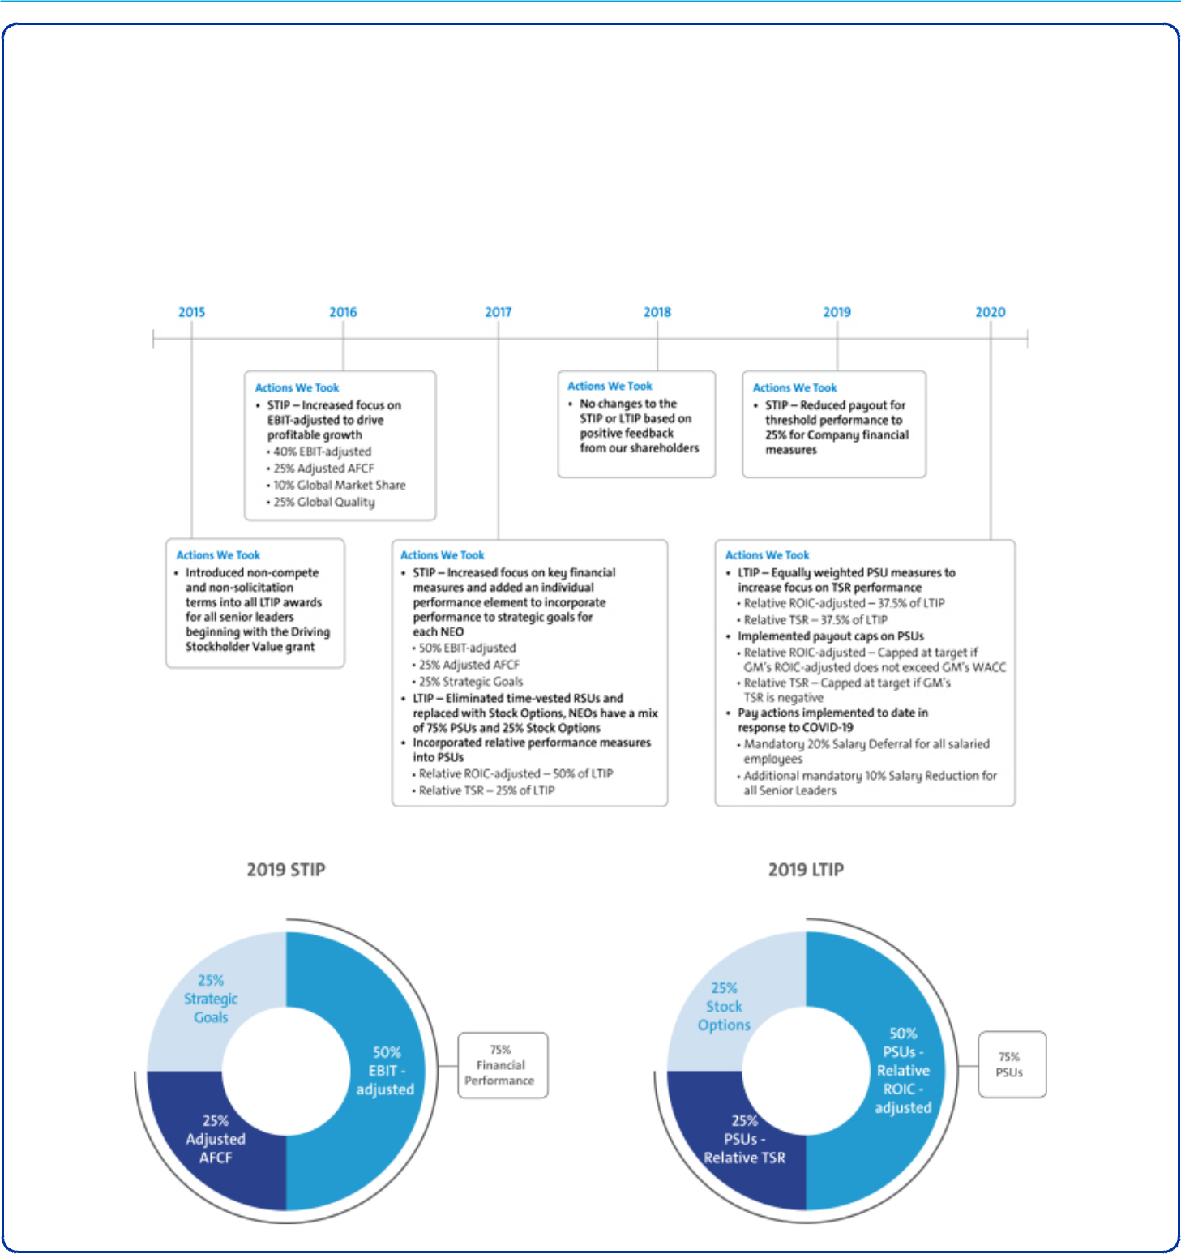

- Compensation Program Evolution

Our compensation programs focus our leadership on key areas that drive the business forward and align to the short-term and long-term interests of our shareholders. The Compensation Committee regularly reviews and discusses plan performance at each meeting. The Compensation Committee considers many factors when electing to make plan changes for future incentive plans including results, market trends, feedback from its independent compensation consultant, and shareholder feedback. The timeline below shows the actions we have taken to develop compensation programs that align the interests of our leaders with those of our shareholders, including actions taken to date in response to COVID-19.

41

Table of Contents

EXECUTIVE COMPENSATION
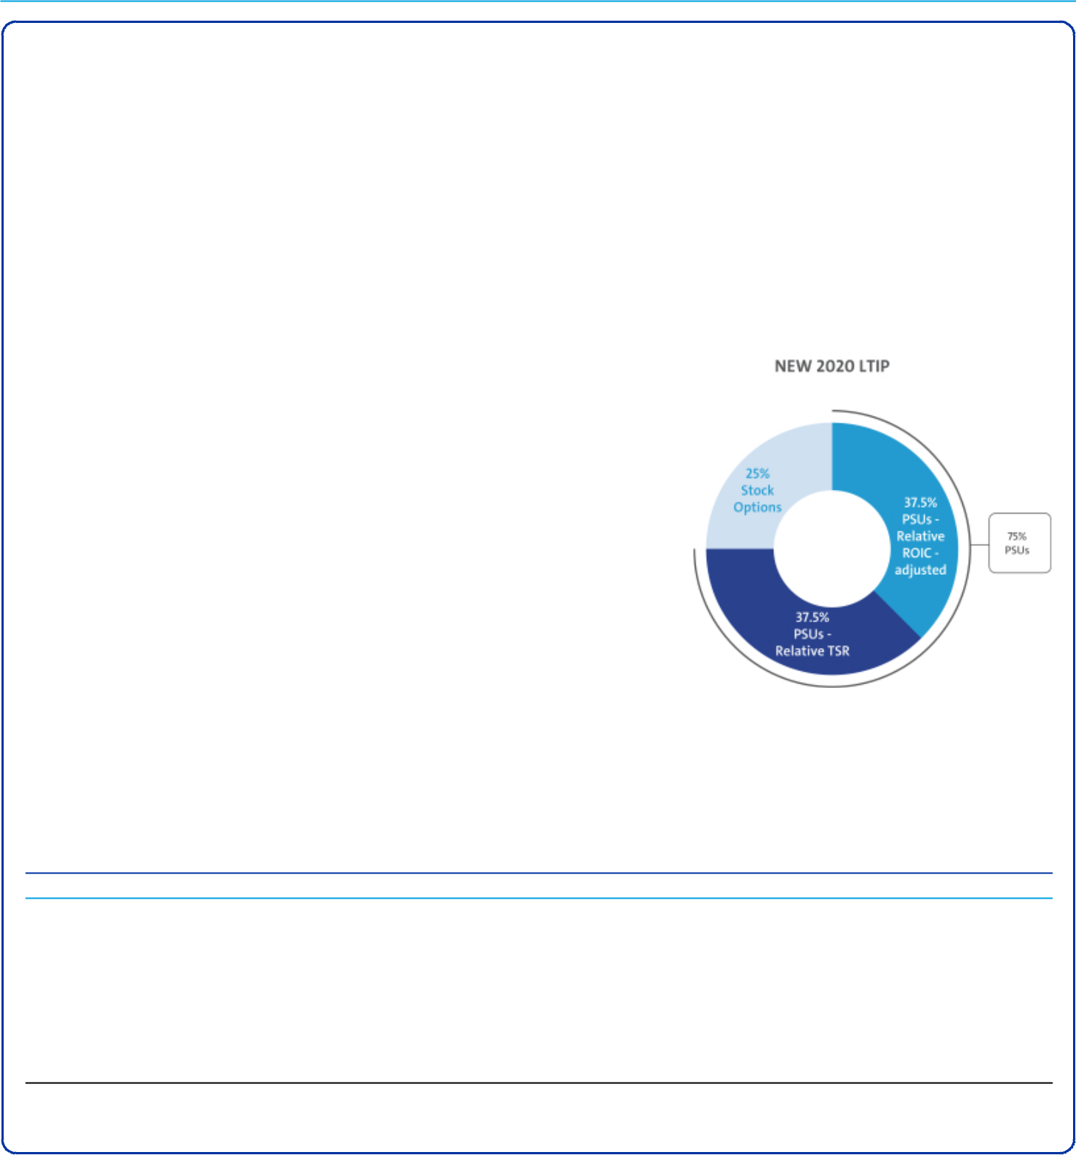

The STIP focuses leadership on key financial measures (75% of STIP) and strategic goals (25% of STIP). The total payout for the STIP ranges from 0% to 200% of target based on performance against pre-established targets. The Compensation Committee determines performance to strategic goals using a rigorous assessment process measuring performance against pre-established operational goals, safety results, and other measures. Payout for strategic goals performance will only occur if threshold performance of at least one financial measure is met.

The 2019 LTIP is the same design as in 2018 and features Stock Options (25% of total LTIP) to align our most senior leaders with our shareholders’ interest in stock price appreciation and PSUs (75% of total LTIP) with relative performance measures that drive long-term results. The PSUs measure Relative ROIC-adjusted (50% of total LTIP) and Relative TSR (25% of total LTIP).

Focusing performance on both financial measures and strategic goals in the short term, combined with measuring Relative ROIC-adjusted and Relative TSR compared to our OEM peers in the long term, provides direct alignment of our executive compensation program with the interests of our shareholders and focuses senior leaders on making the investments that will provide profitable long-term growth.

- 2020 LTIP Changes

The 2020 LTIP will continue to have a mix of 25% Stock Options and 75% PSUs. Beginning in 2020, PSUs will be equally weighted for Relative ROIC-adjusted and Relative TSR, with each representing 37.5% of total LTIP. Both PSU measures will have performance caps added, as described below.

Relative ROIC-adjusted – Capped at target if GM’s ROIC-adjusted does not exceed GM’s WACC

Relative TSR – Capped at target if GM’s TSR is negative over the performance period

- Peer Group for 2019-2021 LTIP Performance

We use the following OEMs in the Dow Jones Automobile & Parts Titans 30 Index to measure relative performance for Relative ROIC-adjusted and Relative TSR measures for the 2019-2021 PSU awards. The Compensation Committee uses this index for performance comparisons because the companies represent our global competition and are subject to similar macroeconomic challenges.

Dow Jones Automobiles & Parts Titans 30 Index – OEM Peer Group(1)

Bayerische Motoren Werke AG | Hyundai Motor Co. | Renault SA
Daimler AG | Kia Motors Corp. | Suzuki Motor Corp.
Fiat Chrysler Automobiles NV | Mazda Motor Corp. | Tesla, Inc.
Ford Motor Company | Nissan Motor Co. Ltd | Toyota Motor Company
Honda Motor Co. Ltd. | Peugeot SA | Volkswagen AG

- GM is a member of the Dow Jones Automobiles & Parts Titans 30 Index. Our performance will be determined on a continuous ranking for performance relative to OEM peers following the completion of the performance period.

42

Table of Contents

EXECUTIVE COMPENSATION
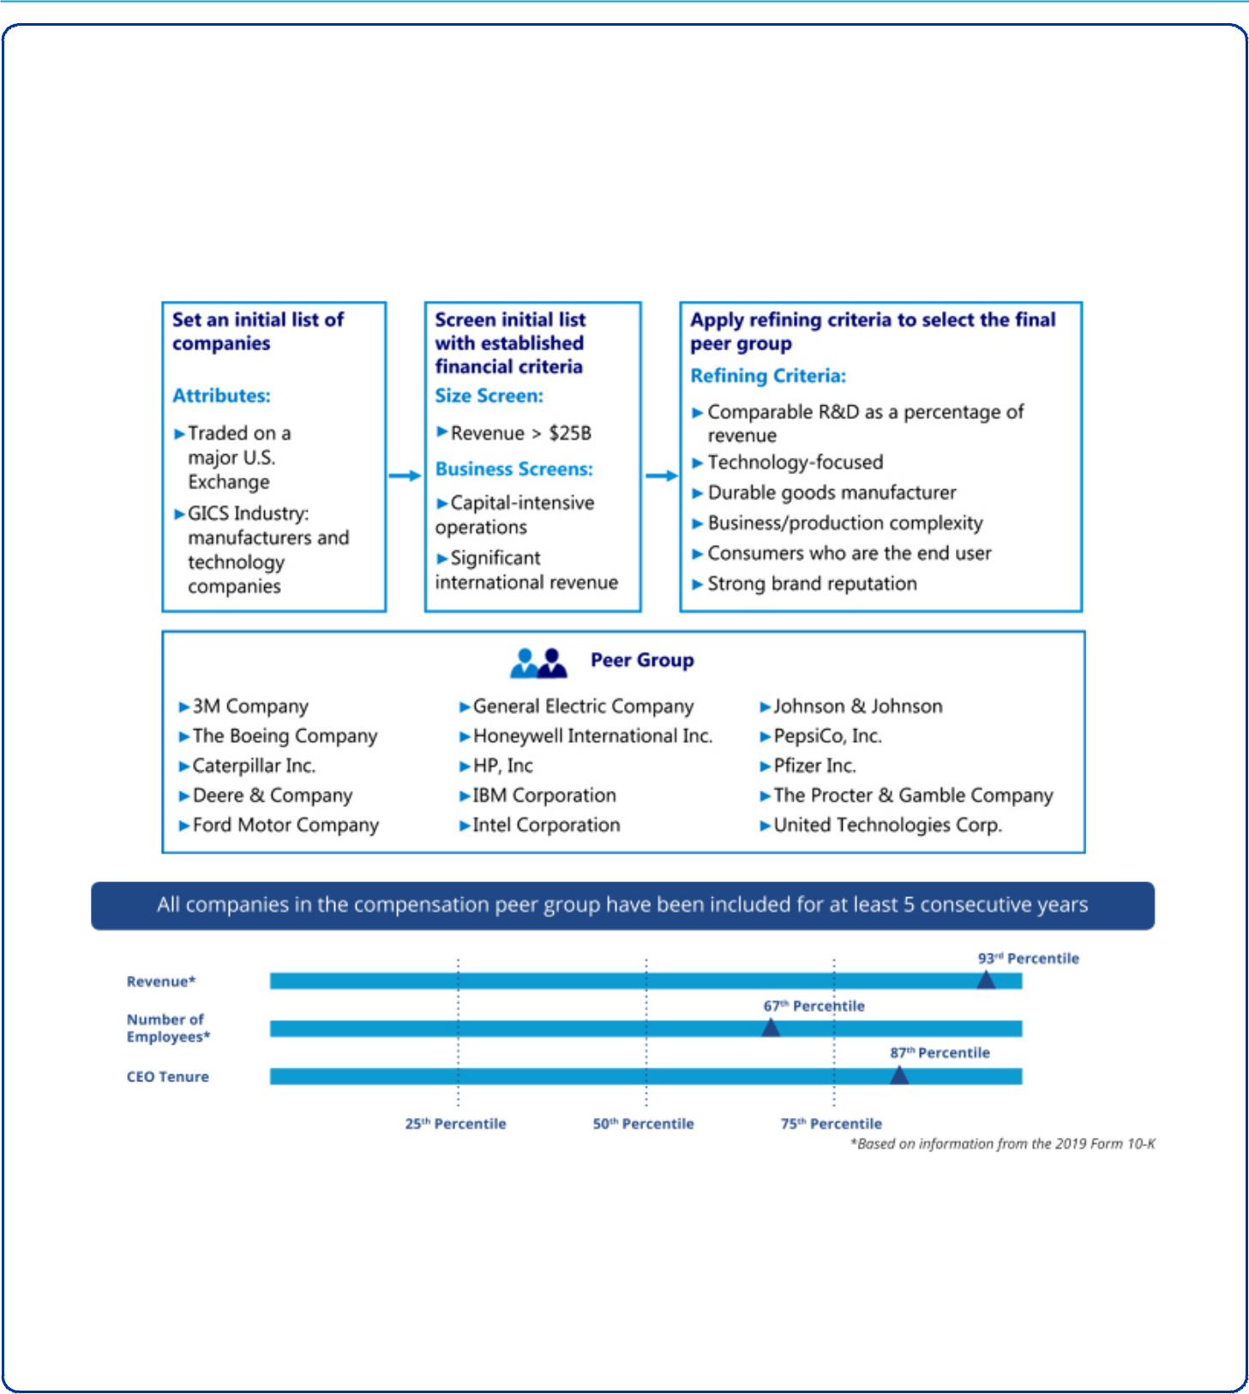

- Peer Group for Compensation Comparisons

The Compensation Committee annually reviews the peer group for compensation comparisons and makes updates as needed to align with both the established criteria and Company strategy. We do not limit the peer group to our industry alone because we believe compensation practices for NEOs at other large U.S.-based multinationals affect our ability to attract and retain diverse talent around the globe.

The Compensation Committee considered the following factors when selecting the peer group used to inform 2019 target compensation levels for our NEOs:

- How We Use Comparator Data to Assess Compensation

We benchmark pay practices and compensation levels against the proxy statement disclosures of our peer group. In addition, we use executive compensation surveys composed of a broad array of industrial companies to benchmark relevant market data for executive positions and adjust this data to reflect GM’s size and market expected compensation trends. Furthermore, the Compensation Committee reviews an analysis completed by their independent compensation consultant of the competitive position of each of our executives relative to the benchmark data.

43

Table of Contents

EXECUTIVE COMPENSATION
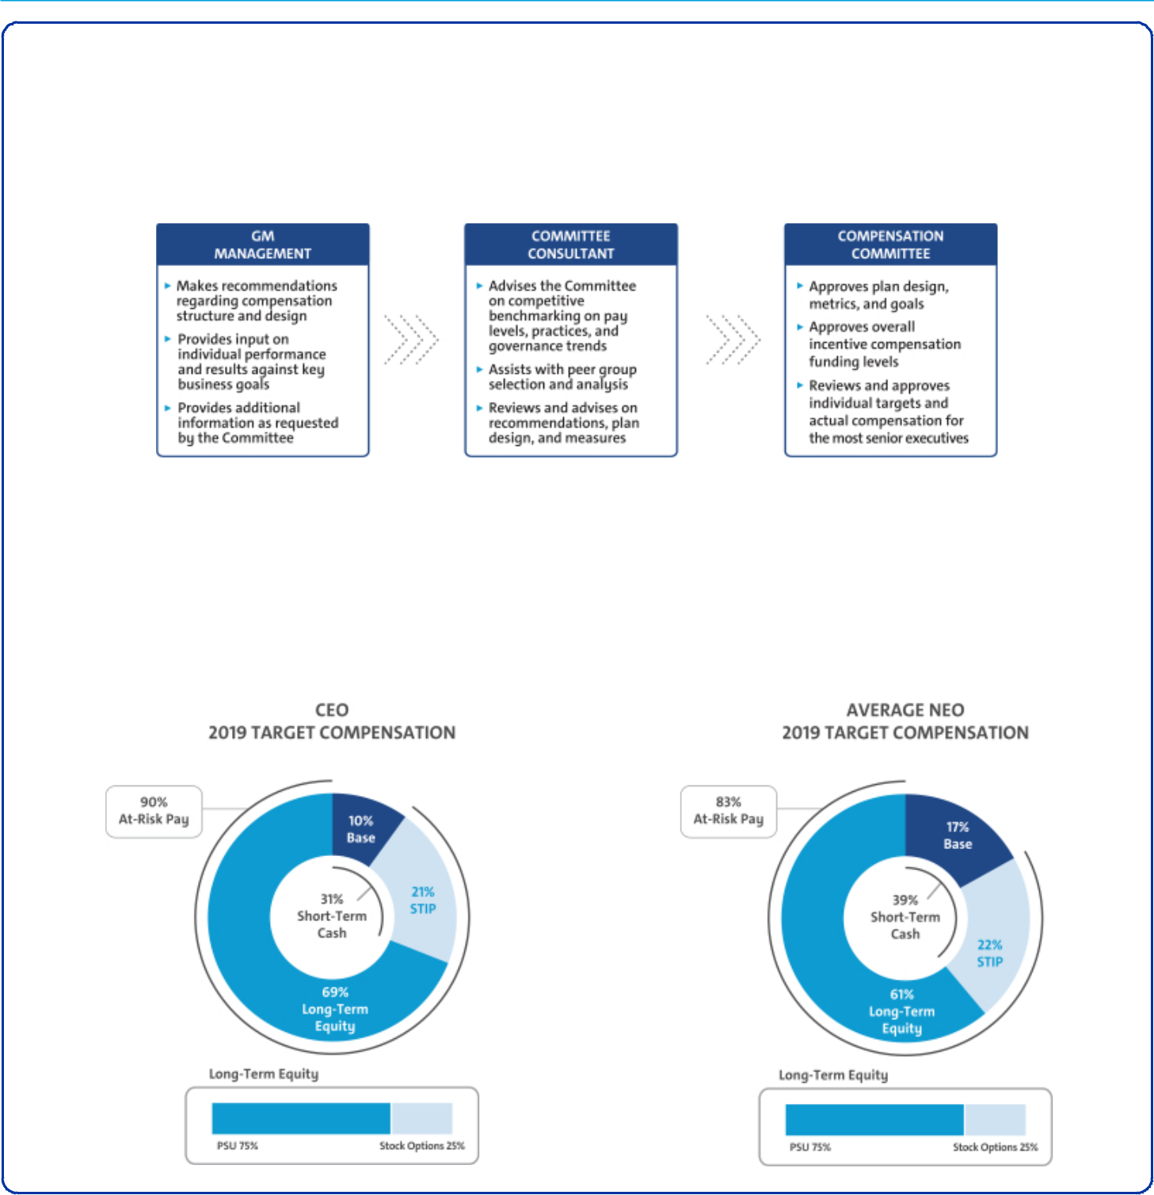

We review each element of compensation compared with the market and generally target each element of our total direct compensation (base salary, STIP, and LTIP) for the executive group on average to be at or near the market median. An individual element or an individual’s total direct compensation may be positioned above or below the market median due to considerations such as specific responsibilities, experience, and performance.

- How We Plan Compensation

- Performance-Based Compensation Structure

Our incentive plans are designed to optimize long-term financial returns for our shareholders and reward our NEOs for increased profitability, improving margins, placing our customers at the center of everything we do, growing the business, and driving innovation. The performance-based structure for 2019 incorporated short-term and long-term incentives tied to financial and operational metrics to drive Company performance for fiscal year 2019 and beyond. The Compensation Committee believes a majority of compensation opportunity should be in the form of equity to align the interests of executives with those of shareholders.

44

Table of Contents

EXECUTIVE COMPENSATION

Compensation Principles

The compensation provided to our senior leaders is guided by pay-for-performance and the following principles:

Aligned with Shareholders – Compensation paid should align directly with the long-term interests of our shareholders, and our executives should share with them in the performance and value of our common stock.

Enable Company Strategy – Compensation should be based on challenging Company performance and strategic goals, which are within our executive’s control and reward performance aligned with GM’s strategy, values, and expected behaviors.

Competitive Compensation – Target compensation should have an appropriate mix of short-term and long-term pay elements and should be competitive (market median) with that paid to individuals at peer group companies so that it attracts, motivates, and retains talent.

Avoid Excessive Risk Taking – Compensation structure should avoid incentives to take unnecessary and excessive risk.

Simple Design – Compensation plans should be easy to understand and communicate and minimize unintended consequences.

Compensation Elements

- Compensation Structure

The 2019 compensation structure is market competitive with each pay element targeted at or near the market median and included the following pay elements:
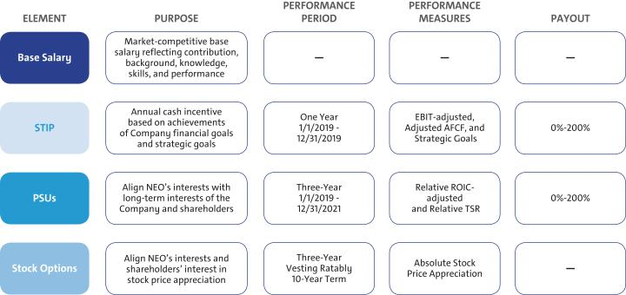

- Perquisites and Other Compensation

We provide perquisites and other compensation to our NEOs consistent with market practices. The following perquisites and other compensation were provided in 2019.

45

Table of Contents

EXECUTIVE COMPENSATION

Personal Air Travel – Ms. Barra is prohibited by Company policy from commercial air travel for both business and personal use due to security reasons identified by an independent third-party security consultant. As a result, the Company pays the costs associated with the use of aircraft for both business and personal use. In 2019, the Company entered into a time-sharing arrangement with Ms. Barra to allow her to reimburse the Company for her personal use of aircraft, subject to limits under the Federal Aviation Administration regulations. Other NEOs may travel on company aircraft in certain circumstances with prior approval from the CEO or the Senior Vice President, Global Human Resources. No NEOs, other than the CEO, had personal use of aircraft in 2019. All NEOs, including our CEO, incur imputed income when aircraft is used for personal travel and do not receive any tax gross ups.

Company Vehicle Programs – NEOs are eligible to participate in the Executive Company Vehicle Program and may use evaluation vehicles for the purpose of providing feedback on Company products. In addition, NEOs are eligible to use driver services provided by the Company and in accordance with Company policies.

Security – NEOs may receive security services, including home security systems and monitoring, for specific security-related reasons identified by independent third-party security consultants. We maintain security staff in order to provide all employees with a safe and secure environment to align with and reinforce our safety culture.

Financial Counseling – NEOs are eligible to receive financial counseling, estate planning, and tax preparation services through an approved provider. These services allow our NEOs to focus on Company business and ensure accurate personal tax reporting.

Executive Physicals – All employees are encouraged to complete an annual physical. NEOs are eligible to receive a comprehensive wellness examination with an approved provider. These wellness visits promote employee well-being and allow employees to take appropriate steps in the event of an illness or medical condition that may impact their ability to perform their duties.

- 2019 Target Compensation

Our target total direct compensation for each NEO in 2019 was as follows:

 |  |  |  |  | LTIP
 |  |  |  | Target Total Cash |  |  | Target Total
 |  |  |  | Target Total Cash |  | Stock | Target Total
 | Base Salary | STIP | STIP | Compensation | PSUs(1) | Options | Compensation
Name | ($) | (%) | ($) | ($) | ($) | ($) | ($)
Mary T. Barra | 2,100,000 | 200% | 4,200,000 | 6,300,000 | 10,575,000 | 3,525,000 | 20,400,000
Dhivya Suryadevara | 1,000,000 | 125% | 1,250,000 | 2,250,000 | 3,187,500 | 1,062,500 | 6,500,000
Mark L. Reuss | 1,200,000 | 125% | 1,500,000 | 2,700,000 | 3,600,000 | 1,200,000 | 7,500,000
Barry L. Engle II | 800,000 | 125% | 1,000,000 | 1,800,000 | 2,400,000 | 800,000 | 5,000,000
Craig B. Glidden | 775,000 | 125% | 968,800 | 1,743,800 | 1,804,650 | 601,550 | 4,150,000
Alan S. Batey | 1,025,000 | 125% | 1,281,300 | 2,306,300 | 2,020,275 | 673,425 | 5,000,000

- The number of PSUs awarded is determined by using the target PSU value divided by the closing price on the date of grant. PSUs with performance tied to Relative TSR are valued in the Summary Compensation Table using a Monte Carlo analysis resulting in amounts that may be higher or lower than target.

46

Table of Contents

EXECUTIVE COMPENSATION

Performance Measures

- How We Set Performance Targets

Annually, the Compensation Committee approves the performance measures for the STIP and LTIP. The Compensation Committee reviews recommendations from management, receives input from its independent compensation consultant, evaluates the annual budget and mid-term business plan, and reviews prior year performance to approve value-creating goals tied to long-term shareholder value.

- 2019 STIP Performance Measures

STIP performance is linked to the Company’s achievement of annual financial goals and individual performance results to strategic goals. The Compensation Committee annually reviews and approves STIP goals that align with shareholders’ interests through the achievement of the business plan and strategic goals. 2019 STIP targets were set at the beginning of the performance period based on the business plan. Strategic goals are assessed using an individual performance scorecard measuring results against pre-established goals that the Compensation Committee approves at the beginning of the year which align to the Company’s objectives. Individual performance results to strategic goals and final individual compensation decisions are discussed beginning on page 52 of this Proxy Statement.

STIP awards, if any, are determined following final Company performance and the Compensation Committee’s assessment of performance to strategic goals for each NEO. The table below describes each STIP performance measure, its weighting, its target, and the behavior each measure drives. The targets for EBIT-adjusted and Adjusted AFCF were set above prior year results.

STIP Performance
Measure | Weight | Target | Leadership Behaviors
EBIT-adjusted ($B)(1) | 50% | $13.7 | Focus on operating profit and driving strong profitability
Adjusted AFCF ($B)(2) | 25% | $5.3 | Focus on driving strong cash flow to invest in the business
Strategic Goals | 25% | 25 pts. | Focus on performance that aligns to the Company vision and drives
 |  |  | business results

- Measure adjusted for incentive purposes and excludes the impact of Cruise.

- Measure adjusted for incentive purposes and excludes payments related to certain recall-related expenses attributable to events occurring in 2014. For a description of how Adjusted AFCF is calculated, see Appendix A of this Proxy Statement.

47

Table of Contents

EXECUTIVE COMPENSATION

The potential payouts for each Company performance measure ranges from 0% to 200% of target based on actual Company performance. The payout for threshold performance is 25% for both EBIT-adjusted and Adjusted AFCF. Final STIP awards are calculated as follows:
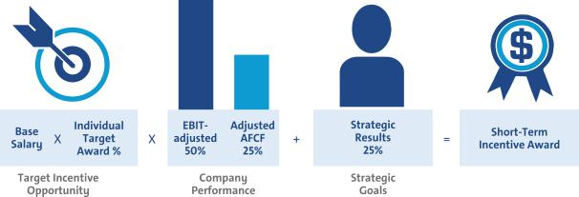

- 2019–2021 LTIP Performance Measures

Grants under the LTIP are intended to link the financial interests of NEOs with the long-term interests of shareholders. When determining grant amounts, the Compensation Committee considers factors such as individual responsibilities, experience, and performance. In addition, the Compensation Committee factors relevant market compensation comparison data and seeks input from their independent compensation consultant. The structure includes 75% PSUs and 25% Stock Options. PSUs cliff-vest following a three-year performance period and Stock Options vest ratably over three years.

2019–2021 PSUs are based on Relative ROIC-adjusted and Relative TSR performance against our OEM peers displayed on page 42 of this Proxy Statement. PSU performance measures promote the efficient use of capital for long-term growth to create value for shareholders with an increased focus on stock price appreciation. The table below describes each PSU performance measure, its weighting, its payout, and the behavior each measure drives.

Performance
Measure | Weight | Payout |  | Leadership Behaviors
Relative |  | Below Threshold (0%) – | Less than 35th Percentile | Focus on making sound investments that follow
Relative | 67% | Threshold (50%) – | 35th Percentile | the disciplined capital approach of driving 20% or
ROIC-adjusted | 67% | Target (100%) – | 60th Percentile | higher returns in world-class vehicles and leading
 |  | Maximum (200%) – | 100th Percentile | technology
 |  | Below Threshold (0%) – | Less than 25th Percentile
Relative TSR | 33% | Threshold (50%) – | 25th Percentile | Focus on delivering shareholder returns that
Relative TSR | 33% | Target (100%) – | 50th Percentile | outperform our OEM peers
 |  | Maximum (200%) – | 75th Percentile

48

Table of Contents

EXECUTIVE COMPENSATION

The 2019–2021 PSUs vest and are awarded and delivered following the completion of the three-year performance period beginning January 1, 2019, and may be earned at a level between 0% and 200% of target based on actual Company results. Final PSU awards are calculated as follows:
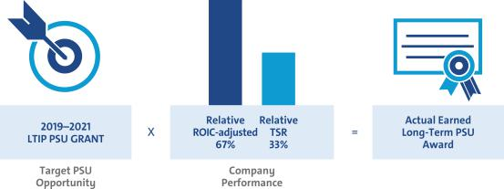

- Summary of Outstanding Performance Awards

Each PSU award features a three-year performance period and beginning with the start of each new fiscal year, resulting in overlapping awards that, in aggregate, cover a five-year period. The potential payout for each PSU award ranges from 0% to 200%. The table below illustrates the performance period for the three outstanding awards and corresponding performance measures and weights.
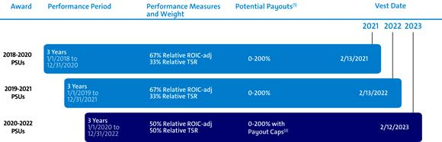

- The performance of each award will be measured and determined at the end of the performance period.

- Beginning in 2020, relative ROIC-adjusted is capped at target if GM’s ROIC-adjusted does not exceed GM’s WACC and Relative TSR is capped at target if GM’s TSR is negative over the performance period.

49

Table of Contents

EXECUTIVE COMPENSATION

Performance Results and Compensation Decisions

- 2019 STIP Results

The Company portion of the 2019 STIP award was calculated based on the Company’s achievement of EBIT-adjusted and Adjusted AFCF performance measures. In addition, each NEO has a portion of their STIP that measures performance against pre-established strategic goals. Final STIP performance approved by the Compensation Committee is displayed below.

 |  |  |  |  | Performance
STIP Measure | Weight | Threshold | Target | Maximum | Results
EBIT-adjusted ($B)(1) | 50% | $7.8 | $13.7 | $15.6 | $9.1
Adjusted AFCF ($B)(2) | 25% | $0.0 | $5.3 | $6.3 | $1.3
Strategic Goals(3) | 25% | 0 pts. | 25 pts. | 50 pts. | 25-38 pts.
Performance Payout |  |  |  | 57%–70% of Target

- Measure adjusted for incentive purposes and excludes the impact of Cruise. Final performance also reflects a downward adjustment approved by the Compensation Committee.

- Measure adjusted for incentive purposes and excludes payments related to certain recall-related expenses attributable to events occurring in 2014. For a description of how Adjusted AFCF is calculated, see Appendix A of this Proxy Statement.

- Performance results to strategic goals are discussed beginning on page 52 of this Proxy Statement.

The Company responded to the challenges faced in 2019 as a result of the work stoppage during the United Auto Workers collective bargaining negotiations. Despite the work stoppage, the Company delivered positive EBIT-adjusted and Adjusted AFCF results. The Company continues to maintain a disciplined capital approach and expects to realize cost savings from our ongoing transformation, which remains on track.

- 2017–2019 LTIP Results

The 2017–2019 PSUs vested on February 14, 2020, based on Company performance for the three-year period beginning January 1, 2017, against pre-established performance targets for Relative ROIC-adjusted and Relative TSR. Final LTIP performance approved by the Compensation Committee is displayed below.

 |  |  | Percentile
 |  |  |  |  | Performance
LTIP Measure | Weight | Threshold | Target | Maximum | Results
Relative ROIC-adjusted | 67% | 35th | 60th | 100th | 100th Percentile
Relative TSR | 33% | 25th | 50th | 75th | 57th Percentile
Performance Payout |  |  |  |  | 176% of Target

The Company continues to focus on ROIC and delivering best results among the OEMs. The Company strives to be best in class and drive performance and focus towards TSR. We continue to make the right investments in our future with a focus on the long-term interest of our shareholders.

50

Table of Contents

EXECUTIVE COMPENSATION

- One-Time 2015–2020 DSV Option Grant

The DSV option grant was a one-time grant made on July 28, 2015, to senior leaders to secure non-compete and non-solicitation terms and to drive an increased focus on stock price appreciation. The DSV option grant featured 40% time-based vesting, which vested on February 15, 2017, and 60% performance-based vesting that vested upon meeting or exceeding the median TSR relative to the OEM peer group on the date of grant. The final performance-based tranche vested on February 15, 2020. Shown below are the results of all three performance-based tranches.

DSV Measure | Performance Period | Vesting Date | Weight | Target TSR | Result | Vesting
Relative TSR | July 28, 2015–December 31, 2019 | February 15, 2020 | 20% | 50th Percentile | 89th Percentile | 100%
Relative TSR | July 28, 2015–December 31, 2018 | February 15, 2019 | 20% | 50th Percentile | 88th Percentile | 100%
Relative TSR | July 28, 2015–December 31, 2017 | February 15, 2018 | 20% | 50th Percentile | 87th Percentile | 100%

51

Table of Contents

EXECUTIVE COMPENSATION

- Compensation Decisions for Mary T. Barra

Mary T. Barra, Chairman and Chief Executive Officer


2019 performance highlights to strategic goals for Ms. Barra include:

Culture

u Continued to drive enterprise engagement towards a safety-first culture resulting in zero fatalities and reductions in permanently disabling injuries and lost workdays

u Named by Corporate Responsibility Magazine as 100 Best Corporate Citizens of 2019 for outstanding environmental, social, and governance transparency and performance

- Named to the Bloomberg Gender Equality Index for second year in a row

Core Operations

- Sold more than 1 million crossovers for the second year in a row in the U.S.

- Generated $137.2B in Revenue, $8.4B in EBIT-adjusted, 6.1% EBIT-adjusted margin, 16.2% ROIC-adjusted, and EPS-diluted-adjusted of $4.82

- GM Financial generated record-breaking earnings before tax of $2.1B

- Negotiated a new four-year labor agreement with the UAW, committing to $7.7B in future product investments along with the creation or retention of 9,000 U.S. jobs while keeping product flexibility, improving our footprint utilization, and maintaining a strong break-even point and protecting the balance sheet

- Unveiled the all new mid-engine Chevrolet Corvette earning 2020 North American Car of the Year and Motor Trend Car of the Year

Transformation

- Earned U.S. Environmental Protection Agency Green Power Leadership Award for helping to develop a diverse renewable energy supply portfolio reinforcing our vision for a zero emissions future
- Announced a joint venture with LG Chem to build a new plant to mass-produce battery cells for future EVs

- Launched the new digital vehicle platform that will enable the next generation of vehicles, EVs, active safety, and infotainment and connectivity features

- Enabled access to numerous charging ports through collaborations with EVgo, ChargePoint, and Greenlots, the largest collective EV charging network in the U.S.

The Compensation Committee made the following pay decisions considering feedback from their independent compensation consultant:

Base Salary – Held base salary at $2,100,000 based on competitive market analysis.

Annual Incentive – Awarded 33 points based on results to strategic goals, highlighted above, for the 2019 STIP performance year.

Long-Term Incentive – In February 2019, awarded an annual LTIP grant of $14.1 million, consisting of 75% PSUs and 25% Stock Options.

Total compensation for Ms. Barra in 2019, including salary, STIP, and LTIP awards, is displayed below.

Pay Element | Majority of Pay Is At-Risk | Awarded Value
Base Salary | Only Fixed Pay Element | $2,100,000
STIP | Performance to Metrics | $2,730,000
PSUs⁽¹⁾ | Performance to Metrics and Stock Price | $12,141,801
Stock Options⁽²⁾ | Performance to Stock Price | $3,525,000
TOTAL |  | $20,496,801

- PSUs are subject to performance vesting; value reflects grant date fair value at target performance for Relative ROIC-adjusted awards and reflects the accounting value based on the results from the Monte Carlo analysis for Relative TSR awards.
- Stock Options are subject to time-based vesting.

Awarded value reflects the amount included in the Summary Compensation Table, excluding change in pension value and all other compensation.
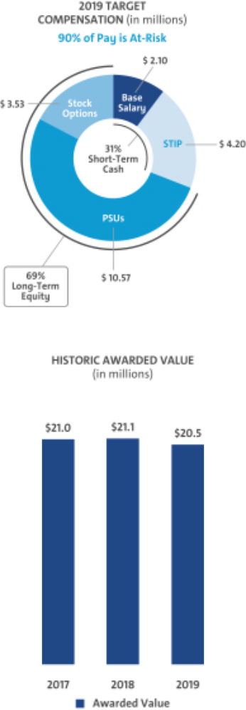

Represents ESG Results

52

Table of Contents

EXECUTIVE COMPENSATION

- Compensation Decisions for Dhivya Suryadevara

Dhivya Suryadevara, Executive Vice President and Chief Financial Officer
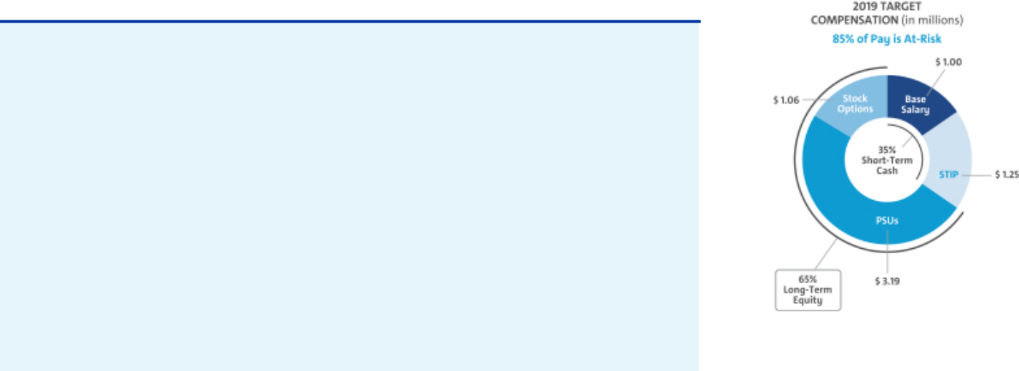

2019 performance highlights to strategic goals for Ms. Suryadevara include:

Culture

u Continued to drive enterprise engagement towards a safety-first culture resulting in zero fatalities and reductions in permanently disabling injuries and lost workdays

Core Operations

u Generated $137.2B in Revenue, $8.4B in EBIT-adjusted, 6.1% EBIT-adjusted margin, 16.2% ROIC-adjusted, and EPS-diluted-adjusted of $4.82

- Continued to enhance organizational focus on cash and quality of earnings

- Achieved record GM Financial earnings in 2019 of $2.1B and $400M in dividends paid back to GM

- Continued to execute a robust investor outreach strategy with focus on key franchises and leveraged traditional and non-traditional venues to optimize engagement

Transformation

u Announced joint venture with LG Chem to build a new plant to mass-produce battery cells for an all-electric future

- Achieved $2.8B in transformational cost savings for 2019, and $3.3B since 2018

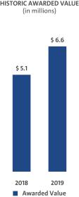

The Compensation Committee made the following pay decisions considering feedback from their independent compensation consultant and management:

Base Salary – Effective January 1, 2019, increased base salary from $900,000 to $1,000,000 based on competitive market analysis.

Annual Incentive – Awarded 38 points based on results to strategic goals, highlighted above, for the 2019 STIP performance year.

Long-Term Incentive – In February 2019, awarded an annual LTIP grant of $4.25 million, consisting of 75% PSUs and 25% Stock Options.

Total compensation for Ms. Suryadevara in 2019, including salary, STIP, and LTIP awards, is displayed below.

Pay Element | Majority of Pay Is At-Risk | Awarded Value
Base Salary | Only Fixed Pay Element | $1,000,000
STIP | Performance to Metrics | $875,000
PSUs⁽¹⁾ | Performance to Metrics and Stock Price | $3,659,772
Stock Options⁽²⁾ | Performance to Stock Price | $1,062,503
TOTAL |  | $6,597,275

- PSUs are subject to performance vesting; value reflects grant date fair value at target performance for Relative ROIC-adjusted awards and reflects the accounting value based on the results from the Monte Carlo analysis for Relative TSR awards.
- Stock Options are subject to time-based vesting.

Awarded value reflects the amount included in the Summary Compensation Table, excluding change in pension value and all other compensation.

Represents ESG Results

53

Table of Contents

EXECUTIVE COMPENSATION

- Compensation Decisions for Mark L. Reuss

Mark L. Reuss, President


2019 performance highlights to strategic goals for Mr. Reuss include:

Culture

u Continued to drive enterprise engagement towards a safety-first culture resulting in zero fatalities and reductions in permanently disabling injuries and lost workdays

u Expanded Super Cruise compatible highway network in the U.S. and Canada by 70,000 miles, introduced automatic lane change capabilities, and developed plans to expand the technology to over 20 vehicles, furthering our commitment to zero crashes

Core Operations

- Maintained U.S. retail sales leadership position and grew volume in key segments

- Attained global Cadillac sales record of 390K units in 2019

- Introduced industry-first technologies including Power Tailgate and DuraBed in the Chevrolet Silverado and MultiPro Tailgate in the GMC Sierra

- Debuted the all new mid-engine Chevrolet Corvette earning 2020 North American Car of the Year and Motor Trend Car of the Year

- Continued to position Cadillac as a racing leader, winning the Rolex 24 at Daytona for the fourth year in a row

Transformation

u Reduced complexities in 2019 by eliminating 12% of parts in plants, with a 2020 goal of eliminating 25% parts in plants

- Debuted a new digital vehicle platform on the 2020 Cadillac CT5 sedan, which can manage up to 4.5 terabytes of data processing power per hour, a fivefold increase in capabilities over current electrical architecture
- Continued to execute global electrification plan through launch of 2020 Bolt EV

- Announced GMC’s first-ever electric truck, the HUMMER EV

The Compensation Committee made the following pay decisions considering feedback from their independent compensation consultant and management:

Base Salary – Held base salary at $1,200,000 based on competitive market analysis.

Annual Incentive – Awarded 38 points based on results to strategic goals, highlighted above, for the 2019 STIP performance year.

Long-Term Incentive – In February 2019, awarded an annual LTIP grant of $4.8 million, consisting of 75% PSUs and 25% Stock Options.

Total compensation for Mr. Reuss in 2019, including salary, STIP, and LTIP awards, is displayed below.

Pay Element | Majority of Pay Is At-Risk | Awarded Value
Base Salary | Only Fixed Pay Element | $1,200,000
STIP | Performance to Metrics | $1,050,000
PSUs⁽¹⁾ | Performance to Metrics and Stock Price | $4,133,385
Stock Options⁽²⁾ | Performance to Stock Price | $1,200,000
TOTAL |  | $7,583,385

- PSUs are subject to performance vesting; value reflects grant date fair value at target performance for Relative ROIC-adjusted awards and reflects the accounting value based on the results from the Monte Carlo analysis for Relative TSR awards.
- Stock Options are subject to time-based vesting.

Awarded value reflects the amount included in the Summary Compensation Table, excluding change in pension value and all other compensation.
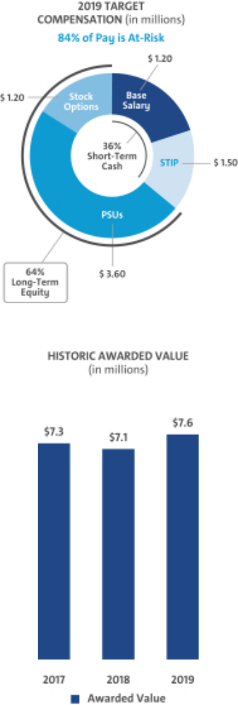

Represents ESG Results

54

Table of Contents

EXECUTIVE COMPENSATION

- Compensation Decisions for Barry L. Engle II

Barry L. Engle II, Executive Vice President and President, North America


2019 performance highlights to strategic goals for Mr. Engle include:

Culture

u Continued to drive enterprise engagement towards a safety-first culture resulting in zero fatalities and reductions in permanently disabling injuries and lost workdays

u Recognized a GM employee or team each quarter with the Mark of Customer Excellence award, reinforcing our value of putting the customer at the center of everything we do

Core Operations

- Sold more than 1 million crossovers for the second year in a row in the U.S.

- Achieved record average transaction prices of $36,844 in the U.S.

- Achieved higher average transaction prices for full-size trucks in the U.S. as compared to the industry average for 2019, through a disciplined pricing strategy

- Maintained U.S. retail sales leadership position and grew volume in key segments

- Increased heavy-duty crew cab sales year-over-year in the U.S.

- Announced availability of AT4 across the entire GMC lineup, including the first-ever 2021 Terrain AT4, Canyon AT4, and 2021 Yukon AT4

- Accomplished solid performance in GM Canada in 2019, with year-over-year sales growth in crossovers, EVs, and trucks

- Announced investment of $1.5B in U.S. manufacturing base to bring the next generation of mid-size trucks to market

Transformation

- Announced GMC’s first-ever electric truck, the HUMMER EV

- Committed to transforming the dealer experience to ensure an effective integration and partnership as we work to provide a seamless customer experience

The Compensation Committee made the following pay decisions considering feedback from their independent compensation consultant and management:

Base Salary – Effective April 1, 2019, upon Mr. Engle’s promotion, the Committee increased Mr. Engle’s base salary to $800,000 based on competitive market analysis.

Annual Incentive – Awarded 33 points based on results to strategic goals, highlighted above, for the 2019 STIP performance year.

Long-Term Incentive – In February 2019, awarded an annual LTIP grant of $2.4 million. In April 2019, following his promotion, awarded an additional LTIP grant of $0.8 million. Both grants consisted of 75% PSUs and 25% Stock Options.

Total compensation for Mr. Engle in 2019, including salary, STIP, and LTIP awards, is displayed below.

Pay Element | Majority of Pay Is At-Risk | Awarded Value
Base Salary | Only Fixed Pay Element | $800,000
STIP | Performance to Metrics | $650,000
PSUs⁽¹⁾ | Performance to Metrics and Stock Price | $2,747,276
Stock Options⁽²⁾ | Performance to Stock Price | $800,003
TOTAL |  | $4,997,279

- PSUs are subject to performance vesting; value reflects grant date fair value at target performance for Relative ROIC-adjusted awards and reflects the accounting value based on the results from the Monte Carlo analysis for Relative TSR awards.
- Stock Options are subject to time-based vesting.

Awarded value reflects the amount included in the Summary Compensation Table, excluding change in pension value and all other compensation.
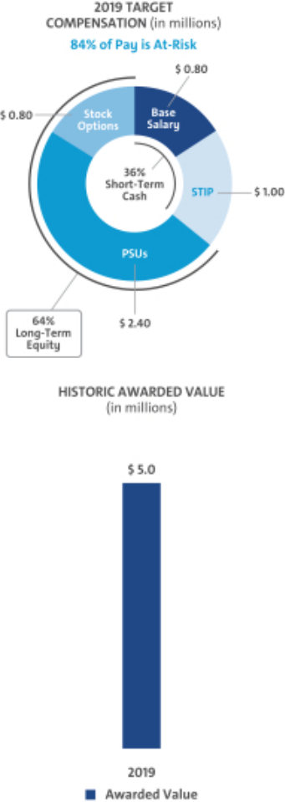

Represents ESG Results

55

Table of Contents

EXECUTIVE COMPENSATION

- Compensation Decisions for Craig B. Glidden

Craig B. Glidden, Executive Vice President and General Counsel
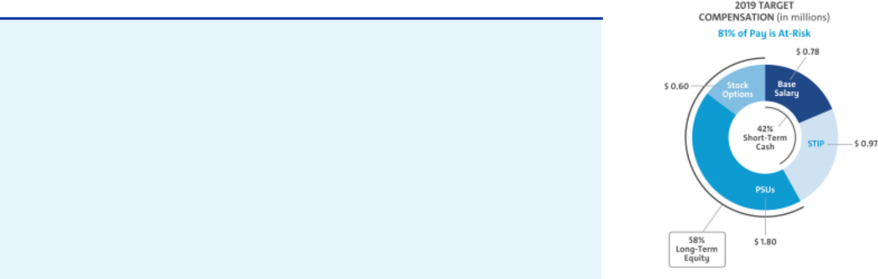

2019 performance highlights to strategic goals for Mr. Glidden include:

Culture

u Continued to drive enterprise engagement towards a safety-first culture resulting in zero fatalities and reductions in permanently disabling injuries and lost workdays

u Recognized by Financial Times as the Most Innovative In-House Legal Team in North America

Core Operations

- Resolved complex legal matters

- Oversaw legal support for all acquisition, divestiture, and transformation efforts

Transformation

u Furthered efforts in autonomous vehicle regulations to move closer to commercial deployment

u Advised the Company on legal issues related to the joint venture with LG Chem to manufacture battery cells for future EVs

The Compensation Committee made the following pay decisions considering feedback from their independent compensation consultant and management:

Base Salary – Determined a base salary of $775,000 based on competitive market analysis.

Annual Incentive – Awarded 38 points based on results to strategic goals, highlighted above, for the 2019 STIP performance year.

Long-Term Incentive – In February 2019, awarded an annual LTIP grant of $2.4 million, consisting of 75% PSUs and 25% Stock Options.

Total compensation for Mr. Glidden in 2019, including salary, STIP, and LTIP awards, is displayed below.

Pay Element | Majority of Pay Is At-Risk | Awarded Value
Base Salary | Only Fixed Pay Element | $775,000
STIP | Performance to Metrics | $678,200
PSUs⁽¹⁾ | Performance to Metrics and Stock Price | $2,072,064
Stock Options⁽²⁾ | Performance to Stock Price | $601,553
TOTAL |  | $4,126,817

- PSUs are subject to performance vesting; value reflects grant date fair value at target performance for Relative ROIC-adjusted awards and reflects the accounting value based on the results from the Monte Carlo analysis for Relative TSR awards.
- Stock Options are subject to time-based vesting.

Awarded value reflects the amount included in the Summary Compensation Table, excluding change in pension value and all other compensation.
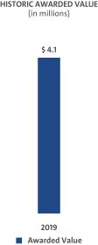

Represents ESG Results

56

Table of Contents

EXECUTIVE COMPENSATION

- Compensation Decisions for Alan S. Batey

Alan S. Batey, Advisor and Former Executive Vice President and

President, North America
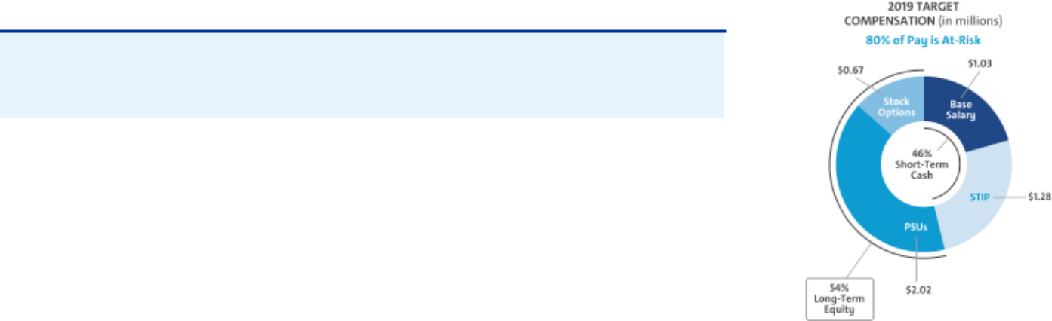

Mr. Batey retired on March 1, 2020, after 40 years with the Company. He held the position of EVP and President, North America, since 2014 and led Global Chevrolet since July 2013. Mr. Batey served as an advisor after stepping down on April 1, 2019, to assist in a smooth transition of his responsibilities to Mr. Engle.

The Compensation Committee made the following pay decisions considering feedback from their independent compensation consultant and management:

Base Salary – Held base salary at $1,025,000 based on competitive market analysis.

Annual Incentive – Awarded 25 points for the 2019 STIP performance year as Mr. Batey stepped down from his position as Executive Vice President and President, North America effective April 1, 2019, and served as an advisor through his retirement on March 1, 2020.

Long-Term Incentive – In February 2019, awarded an annual LTIP grant of $2.69 million, consisting of 75% PSUs and 25% Stock Options.
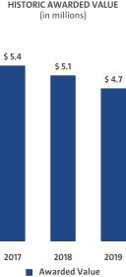

Total compensation for Mr. Batey in 2019, including salary, STIP, and LTIP awards, is displayed below.

Pay Element | Majority of Pay Is At-Risk | Awarded Value
Base Salary | Only Fixed Pay Element | $1,025,000
STIP | Performance to Metrics | $730,300
PSUs⁽¹⁾ | Performance to Metrics and Stock Price | $2,319,594
Stock Options⁽²⁾ | Performance to Stock Price | $673,425
TOTAL |  | $4,748,319

- PSUs are subject to performance vesting; value reflects grant date fair value at target performance for Relative ROIC-adjusted awards and reflects the accounting value based on the results from the Monte Carlo analysis for Relative TSR awards.
- Stock Options are subject to time-based vesting.

Awarded value reflects the amount included in the

Summary Compensation Table, excluding change in
pension value and all other compensation.

57

Table of Contents

EXECUTIVE COMPENSATION

Compensation Policies and Governance Practices

- Stock Ownership Requirements

The Company requires our senior leaders to own GM stock to align their interests with those of our shareholders. The stock ownership requirements:

- Cover all senior leaders

- Set five years as the time frame to meet ownership requirements

- Require senior leaders to hold vested shares to maintain ownership requirements

- Establish a multiple of each executive’s base salary on the date they are first covered

- Make it possible to meet ownership requirements by owning either a multiple of base salary or a required number of shares

- Count only actual share holdings and unvested RSUs

The table below shows the stock ownership requirement by level in the Company. As of December 31, 2019, all NEOs have met or are on track to meet stock ownership requirements by their respective dates.
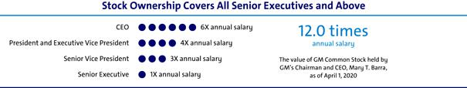

- Compensation Risk Assessment

The Compensation Committee annually reviews the potential impact of our compensation programs on organizational risk. The Compensation Committee discusses the compensation programs and risk mitigation features when evaluating whether the programs encourage or reward employees for engaging in excessive, imprudent, inappropriate, or unnecessary risk.

The annual risk review, completed on December 9, 2019, with assistance from our human resources, audit, legal, and strategic risk management organizations, involved analyzing our current compensation programs in relation to risk. Our analysis concluded that our compensation programs include the following risk mitigation features:

Mix of Pay Elements – Base salary, STIP, PSUs, and Stock Options are included in the executive compensation program.

Short-Term and Long-Term Programs – The mix of our short-term and long-term compensation programs appropriately reward employees while balancing risk through the delayed payment of long-term awards.

Adjustments to Compensation – Maximum payout caps are in place for incentive compensation and the Compensation Committee has the ability to apply negative discretion.

Compensation Committee Oversight – Our Compensation Committee reviews plan performance and approves all executive compensation programs and payouts.

Multiple Performance Measures – Multiple performance measures work together to balance risk in our incentive compensation programs.

Stock Ownership Requirements – All senior leaders are subject to stock ownership requirements of at least 1x their salary, as described above.

58

Table of Contents

EXECUTIVE COMPENSATION

Clawback and Cancellation Provisions – All awards are subject to our Policy on Recoupment of Incentive Compensation, as described below. In addition, cancellation provisions apply to all outstanding STIP and LTIP awards.

In 2019, the Compensation Committee determined that our compensation programs have sufficient risk mitigation features and do not encourage or reward employees for engaging in excessive, imprudent, inappropriate, or unnecessary risk. Based on the Compensation Committee’s review, the Committee determined our compensation programs to be low risk.

- Policy on Recoupment of Incentive Compensation

Under our Policy on Recoupment of Incentive Compensation (available on our website at investor.gm.com/resources), our Compensation Committee is empowered to recoup (“clawback”) compensation paid to Executive Officers based on a materially inaccurate misstatement of earnings, revenues, gains, performance metrics, or other criteria. Financial statements or performance metrics will be treated as materially inaccurate when an employee knowingly engaged in providing inaccurate information or knowingly failed to correct information in a timely manner. The Compensation Committee may also cancel outstanding equity-based awards granted to any covered employee if that employee engages in conduct detrimental to the Company.

 |  | Cancellation and | Cancellation of
 | Clawback Policy | Clawback due to Violation | Unvested
 | Clawback Policy | of Non-Compete and Non- | and Outstanding
 |  | Solicitation Terms | Awards
Covered | Executive Officers | Approximately 275 | All employees that
Covered | Executive Officers | Approximately 275 | receive awards through
Population | covered by the policy | Senior Leaders | receive awards through
Population | covered by the policy | Senior Leaders | the STIP or LTIP
 | Materially inaccurate | Employee violates
Event Applicable | misstatement of earnings, | Employee violates | Employee engages in conduct
Event Applicable | revenues, gains, performance | non-compete or | deemed detrimental to the
 | metrics, or other criteria | non-solicitation terms | Company
 | including reputational harm
Awards Subject
to Cancellation, | STIP, PSUs, RSUs, | PSUs, RSUs, and | STIP, PSUs, RSUs,
Forfeiture, | STIP, PSUs, RSUs, | PSUs, RSUs, and | STIP, PSUs, RSUs,
Forfeiture, | and Stock Options | Stock Options | and Stock Options
and/or | and Stock Options | Stock Options | and Stock Options
Recoupment

- Trading GM Securities

Our Insider Trading Policy prohibits our employees from buying or selling GM securities when in possession of material nonpublic information and during other closed periods. Any sale or purchase of common stock by directors, executive officers, and all other senior leaders must be made during pre-established periods after receiving preclearance by a member of the GM Legal Staff or according to a preapproved Rule 10b5-1 plan.

Trading in GM derivatives (i.e., puts or calls), engaging in short sales, or otherwise engaging in hedging activities, and pledging of GM securities is prohibited. All GM executive officers are in compliance with the Insider Trading Policy and have not hedged nor pledged any shares of GM common stock. This policy is posted on our website at investor.gm.com/resources.

59

Table of Contents

EXECUTIVE COMPENSATION

- Tax Considerations

In tax years commencing prior to January 1, 2018, Internal Revenue Code (“IRC”) Section 162(m) generally disallowed federal tax deductions for compensation in excess of $1 million paid to the CEO and the next three highest-paid officers (other than the CFO) (collectively the “Covered Executives”). The Tax Cuts and Jobs Act, enacted on December 22, 2017, substantially modified IRC Section 162(m) and, among other things, eliminated the performance-based compensation exception to the $1 million deduction limit effective as of January 1, 2018. As a result, beginning in 2018, compensation paid to Covered Executives in excess of $1 million will generally be nondeductible, whether or not it is performance-based. In addition, beginning in 2018, the Covered Executives include any individual who served as the CEO or CFO at any time during the taxable year and the next three highest paid officers (other than the CEO and CFO) for the taxable year, and once an individual becomes a Covered Executive for any taxable year beginning after December 31, 2016, that individual will remain a Covered Executive for all future years, including following any termination of employment.

The Tax Cuts and Jobs Act includes a transition relief rule pursuant to which the changes to IRC Section 162(m) described above will not apply to compensation payable pursuant to a written binding contract that was in effect on November 2, 2017, and is not materially modified after that date. To the extent it is applicable to our existing arrangements, the Compensation Committee may avail itself of this transition relief rule.

- Compensation Committee and Consultant Independence

Our Compensation Committee is composed entirely of independent directors as determined by the Board under NYSE guidelines and as defined for various regulatory purposes. The Compensation Committee was assisted in its work by Farient Advisors from January to June of 2019 and transitioned to Frederic W. Cook & Co., Inc. (“FW Cook”) in June of 2019. Both Farient Advisors and FW Cook are independent compensation consulting firms who take direction from and are solely responsible to the Compensation Committee. The Compensation Committee is also aided in its deliberations by in-house legal counsel.

Under its charter, the Compensation Committee has the authority to hire outside consultants and advisors at the Company’s expense. The Compensation Committee retains the services of an independent consultant for advice on issues related to the compensation of NEOs and other executive compensation-related matters. The independent compensation consultant attends Compensation Committee meetings, either in person or via telephone, consults with and advises the Compensation Committee members on executive compensation, including the structure and amounts of various pay elements, and develops executive benchmarking data. Neither Farient Advisors nor FW Cook provided services to the Company’s management.

The Compensation Committee annually reviews the performance of the compensation consultant and considers the following factors when assessing consultant independence in accordance with NYSE standards:

- Services provided to GM management outside the services provided to the Compensation Committee

- Fees paid as a percentage of total revenue

- Policies and procedures designed to prevent conflicts of interest

- Any business or personal relationships between members of the Compensation Committee and the independent consultant

- Stock ownership by employees of the independent consultant

- Any business or personal relationships between GM and the independent consultant

After reviewing the performance and independence of their consultant, the Compensation Committee determined both Farient Advisors and FW Cook were independent based on the standards above.

60

Table of Contents

EXECUTIVE COMPENSATION

- Employment and Termination Agreements

The Company has no employment or termination agreements with any of our 2019 NEOs. All NEOs participate in the General Motors LLC U.S. Executive Severance Program filed as an exhibit to the 2019 Form 10-K.

Compensation Committee Report

The Compensation Committee has reviewed and discussed with management the CD&A and, based on that review and discussion, has recommended to the Board of Directors that the CD&A be included in this Proxy Statement and incorporated by reference into the GM 2019 Annual Report on Form 10-K.

Compensation Committee

Carol M. Stephenson (Chair)
Wesley G. Bush
Joseph Jimenez

Patricia F. Russo

61

Table of Contents

EXECUTIVE COMPENSATION

Executive Compensation Tables

- Summary Compensation Table

 |  |  |  |  |  |  |  | Change in
 |  |  |  |  |  |  |  | Pension
 |  |  |  |  |  |  |  | Value and
 |  |  |  |  |  |  | Nonequity | NQ Deferred
Name and |  | Salary | Bonus | Stock |  | Option | Incentive Plan | Compensation |  | All Other |  | Total
Principal |  | Salary | Bonus | Awards | (2) | Awards | Compensation | Earnings | (5) | Compensation | (6) | Total
 |  |  |  |  | (2) | (3) | (4) |  | (5) |  | (6)
Position(1) | Year | ($) | ($) | ($) |  | ($) | ($) | ($) |  | ($) |  | ($)
Mary T. Barra | 2019 | 2,100,000 | — | 12,141,801 |  | 3,525,000 | 2,730,000 | 302,986 |  | 831,080 |  | 21,630,867
Chairman and Chief
Chairman and Chief | 2018 | 2,100,000 | — | 11,081,760 |  | 3,425,006 | 4,452,000 |  | — | 811,684 |  | 21,870,450
Executive Officer |  |  |  |  |  |  |  |  | — |  |  | 21,870,450
 | 2017 | 2,100,000 | — | 10,737,570 |  | 3,250,003 | 4,956,000 | 52,792 |  | 861,683 |  | 21,958,048
Dhivya Suryadevara | 2019 | 1,000,000 | — | 3,659,772 |  | 1,062,503 | 875,000 | 2,890 |  | 167,392 |  | 6,767,557
Executive Vice President
and Chief Financial Officer | 2018 | 668,100 | — | 2,446,635 |  | 796,263 | 1,192,500 |  | — | 402,592 |  | 5,506,090
Mark L. Reuss | 2019 | 1,200,000 | — | 4,133,385 |  | 1,200,000 | 1,050,000 | 250,488 |  | 348,374 |  | 8,182,247
President
President | 2018 | 1,200,000 | — | 3,276,007 |  | 1,012,504 | 1,590,000 |  | — | 277,579 |  | 7,356,090
 | 2017 | 1,200,000 | — | 3,345,168 |  | 1,012,504 | 1,770,000 | 54,390 |  | 344,446 |  | 7,726,508
Barry L. Engle II | 2019 | 800,000 | — | 2,747,276 |  | 800,003 | 650,000 |  | — | 149,005 |  | 5,146,284
Executive Vice President and
President, North America
Craig B. Glidden | 2019 | 775,000 | — | 2,072,064 |  | 601,553 | 678,200 |  | — | 156,015 |  | 4,282,832
Executive Vice President and
General Counsel
Alan S. Batey | 2019 | 1,025,000 | — | 2,319,594 |  | 673,425 | 730,300 | 353,583 |  | 216,131 |  | 5,318,033
Advisor and Former
Advisor and Former | 2018 | 1,025,000 | — | 2,178,894 |  | 673,429 | 1,230,000 |  | — | 233,197 |  | 5,340,520
Executive Vice President |  |  |  |  |  |  |  |  | — |  |  | 5,340,520
and President, North America | 2017 | 1,025,000 | — | 2,224,928 |  | 673,426 | 1,447,800 | 316,601 |  | 287,373 |  | 5,975,128

- Titles reflect position as of December 31, 2019. Mr. Engle and Mr. Glidden were not NEOs in 2017 or 2018. Mr. Batey became an Advisor on April 1, 2019, and retired on March 1, 2020.

- Stock Awards displays the grant date fair value of PSUs issued under the LTIP, computed in accordance with Financial Accounting Standards Board (“FASB”) Accounting Standards Codification (“ASC”) Topic 718. PSUs will vest based on GM’s performance against Relative ROIC-adjusted and Relative TSR. The maximum award for PSUs for the 2019–2021 performance period is 200% of PSUs granted. The assumptions used for the Monte Carlo valuation of the Relative TSR portion of the PSUs are summarized below:

 |  |  | Risk-Free |  | Valuation Price as a
Grant Date | Stock Price | Implied Volatility | Interest Rate | Valuation Price | Percent of Target
2/13/2019 | $39.00 | 28% | 2.57% | $56.51 | 144.9%
4/1/2019 | $37.76 | 26% | 2.36% | $53.13 | 140.7%

There is no dividend yield as dividends are assumed to be reinvested for the TSR calculation. The table below shows the PSUs valued based on the closing stock price on the date of grant and the maximum grant value based on maximum performance.

62

Table of Contents

 |  |  | EXECUTIVE COMPENSATION
 |  | Value of PSU Awards at Target and Maximum Performance
 |  | 2019 Target | 2019 Maximum
 |  | ($) | ($)
 | Mary T. Barra | 10,575,006 | 21,150,012
 | Dhivya Suryadevara | 3,187,509 | 6,375,018
 | Mark L. Reuss | 3,600,012 | 7,200,024
 | Barry L. Engle II | 2,400,012 | 4,800,024
 | Craig B. Glidden | 1,804,686 | 3,609,372
 | Alan S. Batey | 2,020,278 | 4,040,556

- Option Awards displays the grant date fair value of Stock Options issued under the LTIP, computed in accordance with FASB ASC Topic 718 using a Black-Scholes valuation. The assumptions used for the Black-Scholes valuation of the Stock Options are summarized below:

Grant Date | Dividend Yield | Implied Volatility | Risk-Free Interest Rate | Expected Option Life | Grant Date Fair Value
2/13/2019 | 3.90% | 28% | 2.63% | 6.00 years | $7.50
4/1/2019 | 4.03% | 26% | 2.35% | 5.87 years | $6.36

- All NEOs were eligible for a payment under the STIP for 2019 performance based on the Company’s achievement of annual performance goals and individual performance. Individual performance decisions for each NEO are determined by the Compensation Committee; results are discussed beginning on page 52 of this Proxy Statement.

- These amounts represent the actuarial change in the present value of the NEO’s accrued benefit for 2019 attributed to year-over-year variances in applicable discount rates, lump sum interest rates, mortality rates, and employer contributions to tax-qualified and non-tax-qualified plans, as described in “Pension Benefits” on page 67 of this Proxy Statement. The Company does not credit interest at above-market rates to any deferred accounts and no interest amounts are included in these totals. Mr. Engle and Mr. Glidden are not eligible for defined benefit pension plans.

- The amounts included as All Other Compensation are described in the table below.

All Other Compensation

 | M.T. Barra | D. Suryadevara | M.L. Reuss | B. L. Engle | C. B. Glidden | A.S. Batey
 | ($) | ($) | ($) | ($) | ($) | ($)
Perquisites and Other
Personal Benefits(1) | 340,225 | 37,685 | 125,263 | 37,464 | 44,150 | 33,244
Employer Contributions
to Savings Plans(2) | 477,120 | 127,700 | 215,400 | 106,400 | 103,076 | 176,300
Life and Other
Insurance Benefits(3) | 13,735 | 2,007 | 7,711 | 5,141 | 8,789 | 6,587
TOTAL | 831,080 | 167,392 | 348,374 | 149,005 | 156,015 | 216,131

- The amounts included as Perquisites and Other Personal Benefits are described in the table below.

- Includes employer contributions to tax-qualified and non-tax-qualified savings and retirement plans during 2019.

- Includes premiums paid by the Company for Group Variable Universal Life insurance for executives. Executives are responsible for any ordinary income taxes resulting from the cost of the GM-paid premiums. For Ms. Barra, amounts also include the Company’s cost of premiums for providing personal accident insurance for members of the Board.

63

Table of Contents

EXECUTIVE COMPENSATION

Perquisites and Other Personal Benefits

 | M.T. Barra | D. Suryadevara | M.L. Reuss | B. L. Engle | C. B. Glidden | A.S. Batey
 | ($) | ($) | ($) | ($) | ($) | ($)
Personal Travel(1) | 199,839 | — | — | — | — | —
Security(2) | 87,347 | — | 82,028 | — | — | —
Company Vehicle Programs(3) | 37,629 | 27,325 | 28,075 | 22,054 | 28,990 | 22,884
Executive Physical(4) | 5,050 | — | 4,800 | 5,050 | 4,800 | —
Financial Counseling(5) | 10,360 | 10,360 | 10,360 | 10,360 | 10,360 | 10,360
Other(6) | — | — | — | — | — | —
TOTAL | 340,225 | 37,685 | 125,263 | 37,464 | 44,150 | 33,244

- Personal travel, pursuant to Company policy as discussed on page 46 of this Proxy Statement, includes incremental costs (fuel, flight crew expenses, landing fees, ground transportation fees, and other miscellaneous variable expenses) associated with aircraft use. Ms. Barra serves on outside boards which we view as directly and integrally related to her role as Chairman and CEO and her professional development. The cost of travel to outside boards for 2019 was $216,607 and is excluded from the amount above.

- Amounts include the incremental cost of providing security services and residential security system monitoring for Ms. Barra and Mr. Reuss as recommended by an independent third-party security consultant. For security personnel employed by the Company, the cost is the actual incremental cost of expenses incurred by the security personnel. Total salary, wages, and benefits are not allocated as the Company already incurs these costs for business purposes.

- Includes the cost of providing cars, drivers, and the estimated annual lease value of the Company vehicles, inclusive of fuel and insurance, driven by NEOs. The annual lease value is included because it is more reflective of the value of the Company vehicle perquisite than of the Company’s incremental costs, which are generally significantly lower because the Company manufactures and ordinarily disposes of Company vehicles for a profit, resulting in minimal incremental costs, if any. Taxes related to imputed income are the responsibility of each participant.

- Costs associated with executive physicals with our approved provider.

- Costs associated with financial counseling and estate planning services with our approved provider.

- Occasionally unused tickets from sponsorship agreements are made available for personal use. Tickets are included in sponsorship agreements and typically result in no incremental costs to the Company. In 2019, there were no incremental costs associated with the personal use of tickets to GM-sponsored events. Occasionally, limited souvenirs may be included as part of a sponsorship agreement and no incremental costs are incurred by the Company.

64

Table of Contents

EXECUTIVE COMPENSATION

- Grants of Plan–Based Awards

STIP awards for the 2019 performance year were made under the terms of the 2017 STIP. PSU and Stock Option grants were made to each NEO under the terms of the 2017 LTIP. PSUs vest and deliver at the end of the performance period and will be earned at a level between 0% and 200% of target. PSUs are based on the achievement of performance conditions relating to Relative ROIC-adjusted and Relative TSR over a three-year performance period from January 1, 2019, to December 31, 2021. The Stock Options vest ratably over a three-year period.

 |  |  |  | Estimated Future Payouts |  |  | Estimated Future Payouts |  |  | All Other | All Other
 |  |  |  |  |  |  |  |  |  | Stock | Option | Exercise
 |  |  |  | Under Non-Equity Incentive |  |  | Under Equity Incentive |  |  | Stock | Option | Exercise
 |  |  |  |  |  |  |  |  |  | Awards: | Awards: | or Base | Grant Date
 |  |  |  |  | Plan Awards |  | Plan Awards
 |  |  |  |  | Plan Awards |  |  |  |  | Number of | Number of | Price of | Fair Value
 |  |  |  |  |  |  |  |  |  | Shares of | Securities | Option | of Stock
 | Award | Grant | Approval | Threshold | Target | Maximum | Threshold | Target | Maximum | Stock or | Underlying | Awards | and Option
Name | Type | Date | Date | ($) | ($) | ($) | (#) | (#) | (#) | Units (#) | Options (#) | ($/share) | Awards($)(1)
Mary T. Barra | STIP | 1/1/2019 | 1/17/2019 | 262,500 | 4,200,000 | 8,400,000
 | Options | 2/13/2019 | 1/17/2019 |  |  |  |  |  |  |  | 470,000 | 39.00 | 3,525,000
 | PSU | 2/13/2019 | 1/17/2019 |  |  |  | 44,740 | 271,154 | 542,308 |  |  |  | 12,141,801
Dhivya Suryadevara | STIP | 1/1/2019 | 1/17/2019 | 78,125 | 1,250,000 | 2,500,000
 | Options | 2/13/2019 | 1/17/2019 |  |  |  |  |  |  |  | 141,667 | 39.00 | 1,062,503
 | PSU | 2/13/2019 | 1/17/2019 |  |  |  | 13,486 | 81,731 | 163,462 |  |  |  | 3,659,772
Mark L. Reuss | STIP | 1/1/2019 | 1/17/2019 | 93,750 | 1,500,000 | 3,000,000
 | Options | 2/13/2019 | 1/17/2019 |  |  |  |  |  |  |  | 160,000 | 39.00 | 1,200,000
 | PSU | 2/13/2019 | 1/17/2019 |  |  |  | 15,231 | 92,308 | 184,616 |  |  |  | 4,133,385
Barry L. Engle II | STIP | 1/1/2019 | 1/17/2019 | 62,500 | 1,000,000 | 2,000,000
 | Options | 2/13/2019 | 1/17/2019 |  |  |  |  |  |  |  | 80,000 | 39.00 | 600,000
 | Options | 4/1/2019 | 2/25/2019 |  |  |  |  |  |  |  | 31,447 | 37.76 | 200,003
 | PSU | 2/13/2019 | 1/17/2019 |  |  |  | 7,615 | 46,154 | 92,308 |  |  |  | 2,066,684
 | PSU | 4/1/2019 | 2/25/2019 |  |  |  | 2,622 | 15,890 | 31,780 |  |  |  | 680,592
Craig B. Glidden | STIP | 1/1/2019 | 1/17/2019 | 60,550 | 968,800 | 1,937,600
 | Options | 2/13/2019 | 1/17/2019 |  |  |  |  |  |  |  | 80,207 | 39.00 | 601,553
 | PSU | 2/13/2019 | 1/17/2019 |  |  |  | 7,635 | 46,274 | 92,548 |  |  |  | 2,072,064
Alan S. Batey | STIP | 1/1/2019 | 1/17/2019 | 80,081 | 1,281,300 | 2,562,600
 | Options | 2/13/2019 | 1/17/2019 |  |  |  |  |  |  |  | 89,790 | 39.00 | 673,425
 | PSU | 2/13/2019 | 1/17/2019 |  |  |  | 8,547 | 51,802 | 103,604 |  |  |  | 2,319,594

- This column shows the aggregate grant date fair value of PSUs and Stock Options granted to the NEOs in 2019. The aggregate grant date fair value is the amount that the Company expects to expense in its financial statements over the vesting schedule. All grant date fair values have been computed in accordance with FASB ASC Topic 718.

65

Table of Contents

EXECUTIVE COMPENSATION

- Outstanding Equity Awards at Fiscal Year-End

 |  |  |  | Option Awards |  |  |  |  | Stock Awards(1)
 |  |  |  |  |  |  |  |  |  |  | Equity
 |  |  |  |  |  |  |  |  |  | Equity | Incentive
 |  |  |  |  |  |  |  |  |  | Incentive | Plan Awards:
 |  |  |  |  |  |  |  |  |  | Plan Awards: | Market or
 |  |  | Number of | Number of |  |  |  |  | Market | Number of | Payout Value
 |  |  | Securities | Securities |  |  |  | Number | Value of | Unearned | of Unearned
 |  |  | Underlying | Underlying |  |  |  | of Shares | Shares or | Shares, Units, | Shares, Units,
 |  |  | Unexercised | Unexercised |  |  |  | or Units of | Units of | or Other | or Other
 |  |  | Options | Options | Option | Option |  | Stock That | Stock That | Rights That | Rights That
 |  | Grant | Exercisable | Unexercisable | Exercise | Expiration |  | Have Not | Have Not | Have Not | Have Not
Name |  | Date | (#) | (#) | Price ($) | Date |  | Vested (#) | Vested ($) | Vested (#) | Vested ($)
Mary T. Barra | 2/13/2019 |  | — | 470,000(2) | 39.00 | 2/13/2029 |  |  |  | 271,154(7)(8) | 9,924,236(8)
 | 2/13/2018 |  | 137,883 | 275,765(3) | 41.40 | 2/11/2028 |  |  |  | 248,189(7)(8) | 9,083,717(8)
 | 6/7/2017 |  | 435,074 | 217,537(4) | 34.34 | 6/7/2027
 | 2/14/2017 |  |  |  |  |  |  | 460,797(6) | 16,865,170
 | 7/28/2015 |  | 2,082,430 | 520,607(5) | 31.32 | 7/28/2025
Dhivya Suryadevara | 2/13/2019 |  | — | 141,667(2) | 39.00 | 2/13/2029 |  |  |  | 81,731(7)(8) | 2,991,355(8)
 | 10/1/2018 |  | 33,198 | 66,396(3) | 34.20 | 2/11/2028 |  |  |  | 53,729(7)(8) | 1,966,481(8)
 | 2/13/2018 |  | 7,398 | 14,795(3) | 41.40 | 2/11/2028 |  |  |  | 13,316(7)(8) | 487,366(8)
 | 6/7/2017 |  | 24,599 | 12,299(4) | 34.34 | 6/7/2027
 | 2/14/2017 |  |  |  |  |  |  | 26,054(6) | 953,576
 | 7/28/2015 |  | 91,107 | 22,776(5) | 31.32 | 7/28/2025
Mark L. Reuss | 2/13/2019 |  | — | 160,000(2) | 39.00 | 2/13/2029 |  |  |  | 92,308(7)(8) | 3,378,473(8)
 | 2/13/2018 |  | 40,761 | 81,522(3) | 41.40 | 2/11/2028 |  |  |  | 73,370(7)(8) | 2,685,342(8)
 | 6/7/2017 |  | 135,543 | 67,771(4) | 34.34 | 6/7/2027
 | 2/14/2017 |  |  |  |  |  |  | 143,557(6) | 5,254,186
 | 7/28/2015 |  | — | 165,943(5) | 31.32 | 7/28/2025
Barry L. Engle II | 4/1/2019 |  | — | 31,447(2) | 37.76 | 2/13/2029 |  |  |  | 15,890(7)(8) | 581,574(8)
 | 2/13/2019 |  | — | 80,000(2) | 39.00 | 2/13/2029 |  |  |  | 46,154(7)(8) | 1,689,236(8)
 | 2/13/2018 |  | 22,142 | 44,284(3) | 41.40 | 2/11/2028 |  |  |  | 39,856(7)(8) | 1,458,730(8)
 | 6/7/2017 |  | 52,500 | 26,250(4) | 34.34 | 6/7/2027
 | 2/14/2017 |  |  |  |  |  |  | 55,606(6) | 2,035,180
 | 10/1/2015 |  | 100,885 | 50,442(5) | 30.67 | 7/28/2025
Craig B. Glidden | 2/13/2019 |  | — | 80,207(2) | 39.00 | 2/13/2029 |  |  |  | 46,274(7)(8) | 1,693,628(8)
 | 2/13/2018 |  | 23,714 | 47,428(3) | 41.40 | 2/11/2028 |  |  |  | 42,685(7)(8) | 1,562,271(8)
 | 6/7/2017 |  | 78,856 | 39,428(4) | 34.34 | 6/7/2027
 | 2/14/2017 |  |  |  |  |  |  | 83,520(6) | 3,056,832
 | 7/28/2015 |  | 167,028 | 83,514(5) | 31.32 | 7/28/2025
Alan S. Batey | 2/13/2019 |  | — | 89,790(2) | 39.00 | 2/13/2029 |  |  |  | 51,802(7)(8) | 1,895,953(8)
 | 2/13/2018 |  | 27,111 | 54,221(3) | 41.40 | 2/11/2028 |  |  |  | 48,799(7)(8) | 1,786,043(8)
 | 6/7/2017 |  | 45,076 | 45,075(4) | 34.34 | 6/7/2027
 | 2/14/2017 |  |  |  |  |  |  | 95,482(6) | 3,494,641
 | 7/28/2015 |  | 117,137 | 117,136(5) | 31.32 | 7/28/2025

- The awards are valued based on the closing price of common stock on the NYSE on December 31, 2019, which was $36.60.

- Option awards granted on February 13, 2019, and April 1, 2019, vest ratably each February 13 of 2020, 2021, and 2022.

- Option awards granted on February 13, 2018, and October 1, 2018, vest ratably each February 13 of 2019, 2020, and 2021.

- Option awards granted on June 7, 2017, vest ratably each February 14 of 2018, 2019, and 2020.

- Option awards granted under the DSV option grant on July 28, 2015, and October 1, 2015. This portion represents the 20% of the award that features performance-based vesting and vested on February 15, 2020, for the performance period ending December 31, 2019.

- 2017 PSU awards granted on February 14, 2017, cliff-vested on February 14, 2020, upon determination of results for the performance period January 1, 2017–December 31, 2019. The final performance for the 2017–2019 PSU was 176% and is discussed on page 50 of this Proxy Statement.

66

Table of Contents

EXECUTIVE COMPENSATION

- 2019 PSU awards granted on February 13, 2019, and April 1, 2019, cliff-vest on February 13, 2022, upon determination of results for the performance period January 1, 2019–December 31, 2021. 2018 PSU awards granted on February 13, 2018, and October 1, 2018, cliff-vest on February 13, 2021, upon determination of results for the performance period January 1, 2018–December 31, 2020.

- Assumes target-level payout of PSU awards. If maximum-level payout of PSU awards, the number of shares (and market value of such shares) with respect to unvested 2018–2020 PSUs and 2019–2021 PSUs outstanding as of December 31, 2019, was for Ms. Barra 496,378 ($18,167,435) and 542,308 ($19,848,473); for Mr. Reuss 146,740 ($5,370,684) and 184,616 ($6,756,946); for Mr. Glidden 85,370 ($3,124,542) and 92,548 ($3,387,257); and for Mr. Batey 97,598 ($3,572,087) and 103,604 ($3,791,906), respectively. For Ms. Suryadevara, the number of shares (and market value of such shares) for maximum-level payout with respect to unvested 2018–2020 PSUs granted on February 13, 2018, 2018–2020 PSUs granted on October 1, 2018, and 2019-2021 PSUs, outstanding as of December 31, 2019, was 26,632 ($974,731); 107,458 ($3,932,963); and 163,462 ($5,982,709), respectively. For Mr. Engle, the number of shares (and market value of such shares) for maximum-level payout with respect to unvested 2018–2020 PSUs, 2019–2021 PSUs granted on February 13, 2019, and 2019-2021 PSUs granted on April 1, 2019, outstanding as of December 31, 2019, was 79,712 ($2,917,459); 92,308 ($3,378,473); and 31,780 ($1,163,148), respectively.

- Option Exercises and Stock Vested

 | Option Awards(1) |  |  | Stock Awards(2)
 | Number of Shares | Value Realized on |  | Number of Shares | Value Realized on
 | Acquired on | Exercise |  | Acquired on Vesting | Vesting
Name | Exercise (#) | ($) |  | (#) | ($)
Mary T. Barra | — | — |  | 623,181 | 24,117,105
Dhivya Suryadevara | — | — |  | 35,235 | 1,363,595
Mark L. Reuss | 165,944 | 1,445,737 |  | 186,955 | 7,235,159
Barry L. Engle II | — | — |  | 68,312 | 2,643,674
Craig B. Glidden | — | — |  | 112,653 | 4,359,671
Alan S. Batey | — | — |  | 129,432 | 5,009,018

- The aggregate dollar value realized upon exercise is computed by multiplying the number of shares at exercise by the difference between the market price of common stock and the exercise price of the options.

- The aggregate dollar value realized upon vesting is computed by multiplying the number of shares vested by the closing stock price on the vesting date.

- Pension Benefits

GM Salaried Retirement Plan

Eligibility and Vesting: The GM Salaried Retirement Plan (“SRP”) is a funded, tax-qualified retirement program that covers eligible employees hired prior to January 1, 2007. Employees who commenced service on or after January 1, 2007 are eligible to participate only in defined contribution plans. Employees are vested in the SRP after five years of qualifying service. The plan permitted employee contributions, which vested immediately, until December 31, 2006. All Defined Benefit accruals were frozen on September 30, 2012 with service continuing towards eligibility to retire.

Benefit Formula:

Service Prior to January 1, 2001: The plan provided benefits on both a contributory and noncontributory formula. The contributory formula factors the contributions of the employee and earnings for each fiscal year. The formulas were frozen effective December 31, 2006, and effective January 1, 2007, employees continued to participate in the SRP under a new formula that provided a pension accrual equal to 1.25% of the employee’s eligible earnings up to the IRS-prescribed limits for tax-qualified plans. The 1.25% accruals were frozen September 30, 2012.

67

Table of Contents

EXECUTIVE COMPENSATION

Service from January 1, 2001, to December 31, 2006: The plan provided benefits under a cash balance formula with pay credits based on age through December 31, 2006, when the formula was frozen, with balances continuing to earn interest credits thereafter.

Time and Form of Payment: For employees hired prior to January 1, 2001, the accumulated benefit an employee earns over his or her career with the Company is payable starting after retirement. Normal retirement age is defined as age 65. Employees who commenced service prior to 1988 may elect early retirement after 30 years of credited service or 85 points, based on combined age and service, or age 60 and 10 or more years of service, with certain age-reduction factors applied. The plan also provides Social Security supplements for those hired prior to 1988. Additionally, for employees hired on or after January 1, 1988, and prior to December 31, 2000, Social Security supplements are not payable and age-reduction factors are greater for retirements prior to age 62. The plan provides a single-life annuity, a spousal joint and survivor annuity, contingent annuitant optional form of payment, or 100% lump sum option. For employees hired from January 1, 2001, to December 31, 2006, the plan provides a single-life annuity, contingent annuitant optional form of payment, or a 100% lump sum option.

Tax Code Limitations on Benefits: Section 415(b)(1)(A) of the IRC limits the benefits payable under the GM SRP. For 2019, the maximum single life annuity a NEO could have received under these limits was $225,000 per year. This ceiling is actuarially adjusted in accordance with IRS rules to reflect employee contributions, actual forms of distribution, and actual retirement dates.

GM Executive Retirement Plan

Eligibility and Vesting: The GM Executive Retirement Plan (“DB ERP”) is an unfunded, non-tax-qualified retirement program that covers eligible executives to provide retirement benefits above amounts available under our other pension programs.

Benefit Formula:

Service Prior to January 1, 2007: The supplemental pension will equal the greater of (a) 2% of the average monthly base salary multiplied by all years of contributory service less the sum of all benefits payable under the GM SRP plus the maximum Social Security benefit as of January 2007 multiplied by all years of contributory service or (b) 1.5% of the average monthly base salary plus annual incentive plan compensation multiplied by all years of contributory service, up to a maximum of 35 years, less the sum of all benefits payable under the GM SRP plus 100% of the maximum Social Security benefit as of January 2007. In both cases, the base salary and annual incentive plan payments are determined using the highest 60 months out of the last 120 months prior to retirement.

Service from January 1, 2007, to September 30, 2012: For employees hired prior to January 1, 2001, the supplemental pension will equal 1.25% multiplied by their annual base salary plus short-term incentive payments and is applicable to amounts in excess of the IRS-prescribed limit applicable to tax-qualified plans.

Time and Form of Payment: Normal retirement age under the plan is age 65; however, employees who commenced service prior to January 1, 2007, may retire at age 60 with 10 or more years of service without any reduction in benefits. Employees may also retire at age 55 with 10 or more years of service with benefits reduced using the same factors as are utilized for early retirement under the GM SRP. The GM DB ERP is payable as a five-year certain annuity, with payments starting upon the retirement of the executive and continuing for 60 months.

VML Pension Plan

Eligibility and Vesting: The Vauxhall Motors (“VML”) Pension Plan is a funded defined benefit plan open to all GM United Kingdom employees prior to October 2012, when it closed to new entrants.

68

Table of Contents

EXECUTIVE COMPENSATION

Benefit Formula:

Service Prior to May 31, 2009: The VML Pension Plan gave an annual pension equal to 1/55th times pensionable service times Final Pensionable Pay. Pensionable Pay is defined as basic pay less the lower earnings limit.

Service from June 1, 2009: The VML Pension plan gave an annual pension equal to 1/60th times pensionable service times Final Pensionable Pay. Increases in pensionable pay are limited to the annual rate of Retail Price Index inflation other than for one-off increases due to promotions.

Time and Form of Payment: Normal retirement age under the plan is age 65. Deferred members can take their pension from age 55 subject to a reduction, using the plans early retirement factors.

 |  | Number of Years of | Present Value of
 |  | Eligible Credited Service | Accumulated | Payments During
 |  | as of December 31, | Benefits(2) | Last Fiscal Year
Name | Plan Name | 2019(1) | ($) | ($)
Mary T. Barra | SRP | 37.3 | 1,238,420 | —
 | DB ERP | 37.3 | 1,069,427 | —
Dhivya
Suryadevara | SRP | 15.3 | 12,462 | —
Mark L. Reuss | SRP | 32.8 | 1,006,602 | —
 | DB ERP | 32.8 | 672,472 | —
Barry L. Engle II(3) | — | — | — | —
Craig B.
Glidden(3) | — | — | — | —
Alan S. Batey(4) | SRP | 40.3 | 60,132 | —
 | VML Pension Plan | 31.8 | 2,945,854 | —

- Eligible service recognizes credited service under the frozen qualified SRP in addition to future service to determine retirement eligibility.

- The present value of the SRP benefit amount shown takes into consideration the ability to elect a joint and survivor annuity form of payment as well as the ability to elect to receive the annuity as a lump sum. For SRP and DB ERP benefits, the present value represents the value of the benefit payable at age 60 (or immediately if over age 60). Present values shown here are based on the mortality and discount rate assumptions used in the December 31, 2019, FASB ASC Topic 715, “Compensation-Retirement Benefits,” except where needed to meet proxy statement requirements. The discount rates used for calculations as of December 31, 2019, for the SRP is 3.44%; for the DB ERP is 2.97%; and for the VML Pension Plan is 1.97%.

- Mr. Engle and Mr. Glidden are only eligible to participate in defined contribution plans offered by the Company.

- Mr. Batey is a participant in the VML Pension Plan from his service in the United Kingdom.

- Nonqualified Deferred Compensation Plan

We maintain certain deferred compensation programs and arrangements for executives.

The DC ERP allows for the equalization of benefits for highly compensated salaried employees under the Retirement Savings Plan when such employees’ contribution and benefit levels exceed the maximum limitations on contributions and benefits imposed by Section 2004 of Employment Retirement Income Security Act of 1974, commonly known as ERISA, as amended, and Sections 401(a)(17) and 415(c)(1)(A) of the IRC, as amended. The DC ERP is maintained as an unfunded plan and we bear all expenses for administration of the plan and payment of amounts to participants.

Aggregate account balances disclosed below include both vested and unvested contributions by the Company. Contributions made prior to 2007 were vested immediately. Contributions made between January 1, 2007, and September 30, 2012, vest when the participant attains age 55 with 10 years of service and the benefit is payable

69

Table of Contents

EXECUTIVE COMPENSATION

as a five-year certain annuity, with payments starting upon the retirement of the executive and continuing for 60 months. Contributions made on October 1, 2012, and later vest when the participant attains three years of service, regardless of age, and the benefit is payable as a 100% lump sum upon the retirement of the executive.

The table below reflects December 31, 2019, balances for the nonqualified deferred compensation plan and any contributions, earnings, or withdrawals during the year.

 |  | Executive | Registrant | Aggregate | Aggregate | Aggregate
 |  | Contributions | Contributions | Earnings | Withdrawals | Balance at 2019
 |  | in the Last | in the Last | in the Last | and | Fiscal
 |  | Fiscal Year | Fiscal Year(1) | Fiscal Year(2) | Distributions | Year End(3)
Name | Plan | ($) | ($) | ($) | ($) | ($)
Mary T. Barra | DC ERP | — | 461,981 | 485,419 | — | 3,048,647
Dhivya
Suryadevara | DC ERP | — | 117,700 | 58,224 | — | 394,471
Mark L. Reuss | DC ERP | — | 205,400 | 226,063 | — | 1,376,541
Barry L. Engle II | DC ERP | — | 98,400 | 59,019 | — | 385,734
Craig B. Glidden | DC ERP | — | 95,326 | 76,653 | — | 515,478
Alan S. Batey | DC ERP | — | 152,712 | 188,038 | — | 1,124,811

- The amounts shown are included in All Other Compensation in the Summary Compensation Table.

- The amounts shown are not reported in Change in Pension Value and Nonqualified Deferred Compensation Earnings in the Summary Compensation Table because we do not pay above-market earnings on deferred compensation.

- The following amounts have been included in the Summary Compensation Table in prior years: $1,891,074 (Ms. Barra), $66,032 (Ms. Suryadevara), $869,866 (Mr. Reuss), $25,467 (Mr. Glidden), and $541,528 (Mr. Batey).

- Potential Payments Upon Termination

The Company does not maintain individual employment agreements with any NEO that provide guaranteed payments in the event of a termination of employment or change in control. In the event that a NEO’s position with the Company is eliminated, including the elimination of the NEO’s position as a result of a change in control, the NEO would be eligible for a severance payment under the General Motors LLC U.S. Executive Severance Program (“Executive Severance Program”).

The table below shows the potential payments to each NEO assuming a termination of employment on December 31, 2019, due to the following events: voluntary separation or termination for cause, qualifying termination under the Executive Severance Program, full career status retirement, disability, death, and change in control with termination of employment. Each of the separation events is described in more detail below. These provisions are generally applicable to participants in each of the applicable plans and are not reserved only for NEOs. The payments below are in addition to the present value of the accumulated benefits from each NEO’s qualified and nonqualified pension plans shown in the Pension Benefits table on page 69 of this Proxy Statement, and the aggregate balance due to each NEO that is shown in the Nonqualified Deferred Compensation Plan table above.

For purposes of the following table, the Company describes these terminations and potential payments:

Voluntary Separation or Termination for Cause – A voluntary separation occurs when an executive voluntarily terminates employment with the Company. A full career status retirement receives different treatment, as discussed below. A termination for cause occurs when an executive is dismissed from employment by the Company for cause, which is considered to include, but is not limited to, the executive’s gross negligence, willful misconduct, or violation of state or federal securities laws. Under each of these scenarios, the executive generally forfeits all outstanding equity awards and is not eligible for any award or payment under the STIP.

70

Table of Contents

EXECUTIVE COMPENSATION

Executive Severance Program – A separation occurs when an executive’s position is eliminated or the Company and an executive agree to mutually end the employment relationship. An executive will be eligible to receive a severance payment from the Company calculated based on his or her position and reflected as a multiple of base salary, COBRA, and a STIP award at target. An executive will receive cash payments of the value of the equity awards that are scheduled to vest within the next year after separation at the time of vesting. All unvested Stock Options are usually forfeited. An executive is also eligible for outplacement assistance based on position. All the potential payments are contingent upon the executive entering into a mutual separation agreement.

Full Career Status Retirement – A full career status retirement occurs when an executive reaches the age of 55 with 10 or more years of continuous service with the Company, or age 62 or older, at which time the executive voluntarily separates from the Company. If an executive enters into a separation or severance agreement, they cannot also elect full career status retirement.

In the event of a full career status retirement, the executive is generally eligible for a prorated STIP award based on months of active service in the performance year as of their retirement date and once final performance has been determined. RSUs granted within one year prior to the date of retirement are prorated based on months of active service from the grant date to the date of retirement. RSUs granted more than one year prior to the date of retirement continue to vest in accordance with their vesting schedule. PSUs granted within one year prior to the date of retirement are prorated based on months of active service from the start of the performance period to the date of retirement and will be adjusted for final company performance against the performance measures contained in the awards; such awards will be payable following approval of such performance. PSUs granted more than one year prior to the date of retirement will remain outstanding until the end of the performance period, at which time they will be adjusted for final company performance and be settled following approval of such performance. Stock Options granted within one year prior to the date of retirement are prorated based on months of active service from the grant date to the date of retirement. Stock Options granted more than one year prior to the date of retirement will continue to vest in accordance with their vesting schedule.

Disability – Disability occurs when an executive terminates employment by reason of their inability to engage in any gainful activity due to a medically determinable physical or mental impairment that can be expected to result in death or can be expected to last for a continuous period of not less than 12 months. Executives are eligible for a full-year STIP award related to the year in which termination occurs once final company performance has been determined. RSUs continue to vest according to their vesting schedule. PSUs vest immediately upon such termination and will remain outstanding until the end of the performance period, at which time they will be adjusted for final company performance and be settled following approval of such performance. Stock Options will continue to vest in accordance with their vesting schedule.

Death – Following the death of an executive, the beneficiary of the executive will be eligible to receive the full-year STIP award subject to adjustment for final company performance. RSUs immediately vest in full and are settled within 90 days of death. PSUs vest immediately upon death and will remain outstanding until the end of the performance period, at which time they will be adjusted for final company performance and be settled following approval of such performance. Stock Options vest immediately upon death.

Change in Control (Double Trigger) – In the event of a termination of employment resulting from a change in control, an executive will be eligible for severance under the Executive Severance Program that provides a severance payment based on position and a multiple of base salary and COBRA. Executives also receive a STIP award at target and the STIP award for the prior year, if such award has been determined, but not paid. If the STIP award for the prior year has not been determined, the award shall be determined at target and paid. All RSU awards will generally vest and become payable immediately prior to the change in control. For PSUs, the performance period will end immediately prior to the change in control and awards will be determined based on actual performance and converted to a time-based award. Stock Options immediately vest and are exercisable upon termination as a result of a change in control.

71

Table of Contents

EXECUTIVE COMPENSATION

Amounts shown below are calculated by assuming that the relevant employment termination event occurred on December 31, 2019.

 |  | Voluntary
 | Compensation | Separation or | Executive |  |  |  | Change in
 | Element(1)(2) | Termination | Severance |  |  |  | Control with
Name | (3) | for Cause | Program | Retirement(4) | Disability | Death | Termination
Mary T. Barra | Cash | — | 4,239,507 | — | — | — | 4,224,507
 | STIP | — | 4,200,000 | 2,394,000 | 2,394,000 | 2,394,000 | 4,200,000
 | LTIP | — | 16,865,170 | 39,113,562 | 39,113,562 | 39,113,562 | 39,113,562
 | TOTAL | — | 25,304,677 | 41,507,562 | 41,507,562 | 41,507,562 | 47,538,069
Dhivya Suryadevara | Cash | — | 1,533,380 | — | — | — | 1,518,380
 | STIP | — | 1,250,000 | — | 712,500 | 712,500 | 1,250,000
 | LTIP | — | 953,576 | — | 6,706,181 | 6,706,181 | 6,706,181
 | TOTAL | — | 3,736,956 | — | 7,418,681 | 7,418,681 | 9,474,561
Mark L. Reuss | Cash | — | 1,854,598 | — | — | — | 1,839,598
 | STIP | — | 1,500,000 | 855,000 | 855,000 | 855,000 | 1,500,000
 | LTIP | — | 5,254,186 | 12,347,342 | 12,347,342 | 12,347,342 | 12,347,342
 | TOTAL | — | 8,608,784 | 13,202,342 | 13,202,342 | 13,202,342 | 15,686,940
Barry L. Engle | Cash | — | 1,233,380 | — | — | — | 1,218,380
 | STIP | — | 1,000,000 | — | 570,000 | 570,000 | 1,000,000
 | LTIP | — | 2,035,180 | — | 6,123,166 | 6,123,166 | 6,123,166
 | TOTAL | — | 4,268,560 | — | 6,693,166 | 6,693,166 | 8,341,546
Craig B. Glidden | Cash | — | 1,211,970 | — | — | — | 1,196,970
 | STIP | — | 968,800 | — | 552,200 | 552,200 | 968,800
 | LTIP | — | 3,056,832 | — | 6,842,792 | 6,842,792 | 6,842,792
 | TOTAL | — | 5,237,602 | — | 7,394,992 | 7,394,992 | 9,008,562
Alan S. Batey(5) | Cash | — | — | — | — | — | —
 | STIP | — | — | 730,300 | — | — | —
 | LTIP | — | — | 3,068,331 | — | — | —
 | TOTAL | — | — | 3,798,631 | — | — | —

- Cash amounts shown for Executive Severance Program and Change in Control with Termination are based on the Executive Severance Program. Payments are 2X base salary for the CEO and 1.5X base salary for all other NEOs. Under the Executive Severance Program, the CEO is eligible for a cash payment equal to 24 months of COBRA premiums and the other NEOs are eligible for a cash payment equal to 18 months of COBRA premiums. There are no cash payments due upon Voluntary Separation or Termination for Cause, Retirement, Disability, or Death.

- STIP amounts shown under Retirement, Disability, and Death are based on final company performance. STIP amounts shown for Executive Severance Program and Change in Control with Termination reflect target-level performance. Executives forfeit STIP awards for Voluntary Separation or Termination for Cause.

- LTIP amounts shown reflect the value of any unvested RSU awards, PSU awards, and Stock Options that may vest upon termination. The value of the awards is based on the closing stock price on December 31, 2019, of $36.60. Under the Executive Severance Program, structure equity awards are delivered in cash once vested; the value displayed reflects the value of awards that would be subject to payment based on awards outstanding as of December 31, 2019.

- Ms. Barra and Mr. Reuss were eligible for full career status retirement as of December 31, 2019.

- Since Mr. Batey retired on March 1, 2020, the table only reflects a termination based on his retirement on that date. The value of the LTIP awards is based on the closing stock price on February 28, 2020, of $30.50.

72

Table of Contents

EXECUTIVE COMPENSATION

CEO Pay Ratio

Our CEO, who leads our global workforce of 164,000 (96,000 are located in the United States and 68,000 are non-U.S.
employees) earned $21,630,867 in total compensation in 2019 as reported in the Summary Compensation Table.

To identify our median employee, we:

- Excluded all employees (8,045) in the following 26 countries under the SEC’s 5% de minimis exception: Australia (767), Chile (217), China (711), Colombia (1,122), Ecuador (485), Egypt (808), Germany (5), Indonesia (26), Ireland (248), Israel (313), Italy (711), Japan (36), New Zealand (33), Peru (37), Philippines (395), Romania (1), Russia (69), Singapore (8), South Africa (9), Switzerland (12), Taiwan (9), Thailand (1,798), United Arab Emirates (163), United Kingdom (43), Uruguay (11), Uzbekistan (8)

- Calculated year-to-date payroll as of November 1, 2019, for all employees, excluding the CEO

- Identified the middle 51 employees using year-to-date payroll converted to U.S. dollars as a consistently applied compensation measure

- Calculated annual total compensation for the 51 middle employees based on the same SEC requirements that apply to determine total compensation in the Summary Compensation Table

- Re-ranked all middle 51 employees and selected the median employee

At GM, we believe that fair and equitable pay is an essential element of any successful organization and we invest in our employees with market competitive pay and benefits. We compensate our employees to create alignment with the short-term and long-term goals tied to the success of the organization and align with our vision of zero crashes, zero emissions, and zero congestion.

Based on our calculation, we can reasonably estimate that our median employee earned $106,715 in 2019, including a change in pension value of $25,478. The ratio of our CEO’s compensation to that of our median employee is estimated to be 203:1.

The SEC’s rules for identifying the median employee and calculating the pay ratio based on that employee’s annual total compensation allow companies to adopt a variety of methodologies to calculate the median employee, excluding up to 5% of the workforce, and make reasonable estimates and assumptions that may impact their employee populations. As a result, the pay ratio reported by other companies may not be comparable to the pay ratio reported above. Other companies have different employee populations, compensation practices, and the ability to utilize different methodologies, exclusions, estimates, and assumptions in calculating their own pay ratios.

73

Table of Contents

EXECUTIVE COMPENSATION

Equity Compensation Plan Information

The following table provides information as of December 31, 2019, about the Company’s common stock that may be issued upon the exercise of options, warrants, and rights under all the Company’s existing equity compensation plans.

 |  |  |  | Number of Securities
 |  |  |  | Remaining Available for
 | Number of Securities to |  |  | Future Issuance Under
 | be Issued Upon Exercise |  | Weighted-Average Exercise | Equity Compensation Plan
 | of Outstanding Options, | Price of Outstanding Options, |  | (excluding securities
 | Warrants, and Rights |  | Warrants, and Rights | reflected in column (A))
Plan Category | (A) |  | (B) | (C)
Equity compensation
plans approved by | 39,005,590(1)
security holders | 39,005,590(1) | $ | 34.31 | 25,479,864
Equity compensation
plans not approved by
security holders(2) | 844,824(3) |  | — | 15,187
Total | 39,850,414(4) | $ | 34.31 | 25,495,051

- The number includes the following:

  - 25,713,261 shares represent options.

  - 11,754,178 shares represent PSU awards assuming performance is achieved at target. For performance above target, awards may be settled in common stock, cash, or a combination of both.

  - 1,538,151 shares represent RSUs.

- 2016 Equity Incentive Plan – refer to Note 21 in our 2016 Form 10-K.

- Represents RSUs, RSAs, and PSUs. PSUs may be issued upon achievement of performance conditions.

- Excludes 1,641,102 stock-based units that are required to be settled in cash pursuant to award agreements.

The following table provides information on share usage for awards granted and performance awards vested/earned during fiscal year 2019 under the Company’s equity compensation plans.

 |  | Performance
 |  | Awards
 | Granted(1) | Vested/Earned
RSUs | 800,000 | —
RSAs | — | —
PSUs | 4,100,000 | 8,500,000
Time-Based Stock Options | 3,900,000 | —
Performance-Based Stock Options | — | 4,400,000

- Excludes 100,000 stock-based units that are required to be settled in cash pursuant to award agreements.

74

Table of Contents

ITEM NO. 1 – ELECTION OF DIRECTORS

The Board has nominated the 11 incumbent directors – Ms. Barra, Mr. Solso, Mr. Bush, Ms. Gooden, Mr. Jimenez, Ms. Mendillo, Ms. Miscik, Ms. Russo, Mr. Schoewe, Ms. Stephenson, and Mr. Wenig – to be elected to serve on the Board until the next annual meeting of shareholders, or until their successors are duly elected and qualified, or until his or her earlier resignation or removal.

If any nominee becomes unable to serve, proxies will be voted for the election of such other person as the Board may designate, unless the Board chooses to reduce the number of directors. Each of the directors has consented to serving as a nominee, being named in this Proxy Statement, and serving on the Board if elected.

Your Board believes that GM has the right board at the right time, and that these directors collectively possess the right mix of skills, qualifications, and experiences to make strategic decisions that strengthen our business today and position it for long-term success.

The Board recommends a vote FOR each of the nominees.

FOR

75

Table of Contents

ITEM NO. 2 – ADVISORY APPROVAL OF NAMED EXECUTIVE OFFICER COMPENSATION

Executive compensation is an important matter for our shareholders. The Dodd-Frank Wall Street Reform and Consumer Protection Act requires that we provide you with the opportunity to vote to approve, on a non-binding advisory basis, the compensation of our NEOs, as disclosed in this Proxy Statement in accordance with the compensation disclosure rules of the SEC (sometimes referred to as “Say-on-Pay”).

The Compensation Committee has approved the compensation arrangements for our NEOs described in our Compensation Discussion and Analysis beginning on page 38 and the accompanying compensation tables beginning on page 62 of this Proxy Statement. We urge you to read the Compensation Discussion and Analysis for a more complete understanding of our executive compensation plans, including our compensation philosophy, objectives, and the 2019 compensation of our NEOs.

We are asking shareholders to vote in favor of the following resolution:

RESOLVED, that the compensation paid to the Company’s named executive officers, as disclosed pursuant to Item 402 of Regulation S-K, including the Compensation Discussion and Analysis, compensation tables, and the related narrative discussion, is hereby APPROVED.

Although the vote on this item is non-binding, the Board of Directors and the Compensation Committee value the opinions of our shareholders and will consider the outcome of the vote when making future compensation decisions for NEOs.

The Board recommends a vote FOR the advisory proposal to approve named executive officer compensation.

FOR

76

Table of Contents

ITEM NO. 3 – ADVISORY APPROVAL OF THE FREQUENCY OF FUTURE ADVISORY VOTES ON NAMED EXECUTIVE OFFICER COMPENSATION

The Dodd-Frank Wall Street Reform and Consumer Protection Act requires that shareholders be given the opportunity to vote, on a non-binding advisory basis, on the future frequency of advisory votes on the compensation of our NEOs. When voting on this proposal, shareholders may indicate their preference for conducting future advisory votes to approve the compensation of NEOs once every one, two, or three years. Shareholders also may abstain from casting a vote on this proposal.

Your Board of Directors believes that an annual advisory vote to approve the compensation of the NEOs will allow our shareholders to provide timely, direct input on the Company’s executive compensation philosophy, policies, and practices disclosed in the Proxy Statement each year. The vote is advisory, which means that the vote is not binding on the Company, our Board of Directors, or the Compensation Committee.

We are asking shareholders to vote in favor of the following resolution:

RESOLVED, that the shareholders determine, on an advisory basis, that the preferred frequency of an advisory vote on the compensation of the Company’s named executive officers as set forth in the Company’s Proxy Statement should be every year.

Shareholders will be able to specify one of four choices for this proposal on the proxy card: one year, two years, three years, or abstain. Although the vote on this item is non-binding, the Board of Directors and the Compensation Committee value the opinions of our shareholders and will consider the outcome of the vote when determining how often to submit an advisory vote on compensation for NEOs to our shareholders.


The Board recommends a vote for the option of ONE YEAR as the preferred frequency for a shareholder advisory vote on named executive officer compensation.

ONE

YEAR

77

Table of Contents

ITEM NO. 4 – RATIFICATION OF THE SELECTION OF THE INDEPENDENT REGISTERED PUBLIC ACCOUNTING FIRM FOR 2020

The Audit Committee has selected Ernst & Young LLP as the Company’s independent registered public accounting firm for the fiscal year ending December 31, 2020. The Board recommends that shareholders ratify the Audit Committee’s selection. If shareholders do not ratify the selection of EY, the Audit Committee will reconsider whether to engage EY, but may ultimately determine to engage EY or another audit firm without resubmitting the matter to shareholders.

Even if the shareholders ratify the selection of EY, the Audit Committee may, in its sole discretion, terminate the engagement of EY and direct the appointment of another independent registered public accounting firm at any time during the year, although it has no current intention to do so.

We expect that representatives of EY will be present at the Annual Meeting, and they will have an opportunity to make a statement if they so desire and are expected to be available to respond to appropriate questions from shareholders.
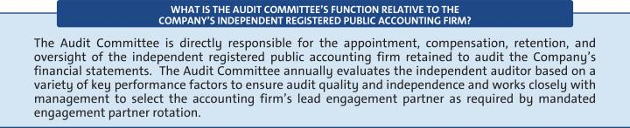


The Board recommends a vote FOR the proposal to ratify the selection of Ernst & Young LLP as the independent registered public accounting firm for 2020.

FOR

78

Table of Contents

Fees Paid to Independent Registered Public Accounting Firm

The following table summarizes the fees for professional services provided by EY for the audit of GM’s annual financial statements and internal control over financial reporting for the years ended December 31, 2019 and 2018, together with the fees billed for other services rendered by EY during these periods.

 | 2019 | 2018
Type of Fees | ($ in millions) | ($ in millions)
Audit | 22 | 23
Audit-Related | 5 | 5
Tax | 3 | 4
Subtotal | 30 | 32
All Other
Services | — | 3
TOTAL | 30 | 35

Audit-Related Fees – Includes fees for assurance and related services that are traditionally performed by the independent registered public accounting firm. More specifically, these services include employee benefit plan audits, comfort letters in connection with funding transactions, other attestation services, and consultation concerning financial accounting and reporting standards.

Tax Fees – Includes fees for tax compliance, tax planning, and tax advice. Tax compliance involves preparation of original and amended tax returns and claims for refund. Tax planning and tax advice encompass a diverse range of services, including assistance with tax audits and appeals, tax advice related to mergers and acquisitions and employee benefit plans, and requests for rulings or technical advice from taxing authorities.

All Other Fees – Includes fees for services that are not contained in the above categories and consists of permissible advisory services.

Audit Fees – Includes fees for the integrated audit of the
Company’s annual consolidated financial statements and
attestation of the effectiveness of the Company’s internal
controls over financial reporting, including reviews of the
interim financial statements contained in the Company’s
Quarterly Reports on Form 10-Q and audits of statutory

financial statements.

Policy for Approval of Audit and Permitted Non-Audit Services

The services performed by EY in 2019 were preapproved in accordance with the preapproval policy and procedures established by the Audit Committee. This policy requires that prior to the provision of services by the auditor, the Audit Committee will be presented, for consideration, with a description of the types of Audit-Related, Tax, and All Other Services expected to be performed by the auditor during the fiscal year, with amounts budgeted for each category (Audit-Related, Tax, and All Other Services). Any requests for such services for $1 million or more not contemplated and approved by the Audit Committee initially must thereafter be submitted to the Audit Committee for specific preapproval. Requests for services less than $1 million individually can be approved by management based on the amounts approved for each category.

Management must report actual spending for each category to the full Audit Committee periodically throughout the year.

These services are actively monitored (both spending and work content) by the Audit Committee to maintain the appropriate objectivity and independence in EY’s core work, which is the audit of the Company’s consolidated financial statements and internal controls. The Audit Committee determined that all services provided by EY in 2019 were compatible with maintaining the independence of EY.

79

Table of Contents

ITEM NO. 5 – APPROVAL OF THE GENERAL MOTORS COMPANY 2020 LONG-TERM INCENTIVE PLAN

The Board of Directors recommends shareholders vote FOR the approval of the 2020 Long-Term Incentive Plan (the “2020 LTIP”), which will allow for equity awards to support our performance-based compensation programs. Long-term, equity-based compensation is a critical component of our executive compensation structure that allows the Company to continue to attract, motivate, and retain the critical talent necessary to deliver long-term results to our shareholders as the industry continues to evolve. The terms of the 2020 LTIP are substantially similar to the terms of the 2017 Long-Term Incentive Plan (the “2017 LTIP”), which was approved by 96.3% of our shareholders who voted on the matter.

For the 2020 LTIP, we are seeking approval of 50,000,000 shares of common stock, par value $0.01 per share, to provide equity-based compensation as approved by the Compensation Committee, which is comprised of all independent directors. In determining the number of shares requested, the Company took several factors into consideration, such as market trends, feedback from investors, the compensation levels we anticipate in the future, the types of awards that may be granted under the 2020 LTIP, and the potential dilution. As of the record date, the closing price of our common stock on the NYSE was $22.48 per share.

Upon approval, the 2020 LTIP will apply to new awards granted after the Annual Meeting. To the extent any shares remain available for issuance under our predecessor plans (i.e., the 2014 Long-Term Incentive Plan, the 2016 Equity Incentive Plan, and/or the 2017 LTIP), such shares will only be used to settle outstanding awards that were previously granted under such plans prior to the Annual Meeting. No new awards will be granted under any predecessor plans upon approval of the 2020 LTIP. However, if the 2020 LTIP is not approved by our shareholders, the 2017 LTIP will remain in effect in accordance with its terms. We expect the requested shares under the 2020 LTIP to be sufficient for a period of two to three years, with an anticipated annual burn rate of approximately 1%, and we plan to seek shareholder approval of equity plans on a regular basis in the future to confirm shareholders continue to support the terms of our equity compensation programs. We intend to file with the SEC a registration statement on Form S-8 covering the shares issuable under the 2020 LTIP.

- 2020 LTIP – Key Facts and Features

The 2020 LTIP will allow the Compensation Committee to continue to approve equity awards to support our performance-based compensation programs and align the long-term interests of our executives and shareholders.

- We are seeking shareholder approval to authorize 50,000,000 shares for issuance under the 2020 LTIP representing 3.5% of the outstanding shares of common stock as of the record date, which may be granted in the form of stock options, SARs, restricted stock, RSUs, performance awards, or other stock-based awards.

- Under the 2020 LTIP, our annual burn rate is anticipated to be approximately 1%.

- All employees (approximately 164,000) are eligible to receive awards under the 2020 LTIP, and we intend to grant equity to approximately 1,100 employees (which includes our 10 executive officers) representing less than 1% of our global workforce.

- Ten non-employee directors are eligible to receive awards under the 2020 LTIP, subject to an annual limit of $750,000 per director for awards granted plus cash fees paid for service as a member of the Board. Currently, such awards are not contemplated under the non-employee director compensation program, but we have the flexibility to update the program as appropriate. The 2020 LTIP also allows awards to be granted to certain Company consultants and advisors, although none have been identified.

80

Table of Contents

ITEM NO. 5 – APPROVAL OF THE GENERAL MOTORS COMPANY 2020 LONG-TERM INCENTIVE PLAN

The 2020 LTIP contains key features that protect shareholders’ interests and align to our compensation principles and practices discussed in the CD&A:

- Minimum Vesting Periods – Generally, no stock options or SARs will vest prior to the first anniversary of the vesting commencement date. Restricted stock, RSUs, or performance awards will generally vest over a period of not less than three years from the vesting commencement date.

- Double-Trigger Change in Control – Awards that are continued or converted into similar awards of the successor company will not accelerate vesting based solely on a change in control, and gross-ups are not provided to cover personal income taxes or excise taxes.

- No Payment of Dividend Equivalents until Awards are Earned – Restricted stock, RSUs, performance awards, and other stock-based awards will only receive dividend equivalent payments once awards are earned and settled. Stock options and SARs are generally not eligible for dividend equivalents.

- No “Evergreen” Provisions – The 2020 LTIP does not allow for automatic increases in the number of shares available under the plan.

- No Repricing of Stock Options or SARs – The repricing of stock options or SARs, or any other action that has the effect of reducing the exercise price of stock options or SARs, including voluntary surrender and re-grant, or the exchange of underwater stock options or SARs for cash or any other security, is prohibited without shareholder approval (other than adjustments in connection with a corporate transaction or restructuring).

- No Discounted Stock Options or SARs – The 2020 LTIP prohibits granting stock options or SARs with an exercise price less than the fair market value of GM common stock on the date of grant.

- No Recycling of Shares – Shares surrendered or withheld in payment for any grant, purchase, exercise price of an award or taxes related to an award, and shares repurchased in the open market using stock option proceeds will not again become available for grant.

- Clawback/Recoupment – Any awards granted under the 2020 LTIP are subject to the Company’s clawback and cancellation policies.

81

Table of Contents

ITEM NO. 5 – APPROVAL OF THE GENERAL MOTORS COMPANY 2020 LONG-TERM INCENTIVE PLAN

- 2020 LTIP – Potential Equity Dilution and Historical Annual Share Usage

While equity-based awards are an important part of our performance-based compensation programs, we are mindful of our responsibility to our shareholders to exercise judgment in granting these awards. The table below provides a summary of the outstanding awards and shares available under all the Company’s existing equity incentive plans as of December 31, 2019, and March 31, 2020.

 | As of | As of
 | December 31, | March 31,
 | 2019 | 2020
Stock Options Outstanding under the Plans | 25,700,000 | 31,500,000
Vested and Unexercised | 13,800,000 | 22,000,000
Unvested | 11,900,000 | 9,500,000
Weighted Average Exercise Price of Stock Options Outstanding | $34.31 | $34.53
Weighted Average Remaining Term of Stock Options Outstanding | 6.78 | 7.16
Full Value Awards Outstanding under the Plans | 14,200,000 | 14,600,000
Outstanding PSUs (at target) | 12,600,000 | 13,000,000
Outstanding RSUs | 1,600,000 | 1,600,000
Outstanding RSAs | — | —
Total Awards Outstanding under the Plans | 39,900,000(1) | 46,100,000(2)
Shares Available under the Plans | 25,500,000 | 11,600,000(3)

- Excludes 1,600,000 stock-based units that are required to be settled in cash pursuant to award agreements.

- Excludes 1,400,000 stock-based units that are required to be settled in cash pursuant to award agreements.

- No new awards will be granted under our existing plans upon approval of the 2020 LTIP.

Shares Requested under the 2020 LTIP: | 50,000,000
GM Common Stock Outstanding as of the Record Date: | 1,432,378,376

Overhang – As of March 31, 2020, there were approximately 11.6 million shares authorized and available for issuance under the Company’s existing equity incentive plans and 46.1 million shares subject to awards outstanding under these plans, representing 4.0% of the common stock outstanding as of the record date on a fully diluted basis (the “Overhang Percentage”). The 50 million shares requested under the 2020 LTIP would increase the Overhang Percentage to approximately 7.5%. We believe this represents a reasonable amount of potential equity dilution that will allow us to continue granting equity awards, which is an important component of our executive compensation structure.

82

Table of Contents

ITEM NO. 5 – APPROVAL OF THE GENERAL MOTORS COMPANY 2020 LONG-TERM INCENTIVE PLAN

Share Usage – The annual share usage under the Company’s equity incentive plans for the last three fiscal years is presented below. The features of these plans are discussed further in Note 23 to the Consolidated Financial Statements, “Stock Incentive Plans” in our 2019 Form 10-K.

 |  |  |  | 3-Year
 | 2019 | 2018 | 2017 | Average
A Full Value Awards Granted During Fiscal Year | 4,900,000 | 5,300,000 | 6,200,000
PSUs Granted (at target) | 4,100,000 | 4,400,000 | 5,200,000
RSUs Granted | 800,000 | 900,000 | 1,000,000
RSAs Granted | — | — | —
B Stock Options Granted During Fiscal Year | 3,900,000 | 3,800,000 | 6,500,000
Time-Based Stock Options Granted | 3,900,000 | 3,800,000 | 6,500,000
Performance Stock Options Granted | — | — | —
C Total Awards Granted During Fiscal Year [A + B] | 8,800,000(1) | 9,100,000(2) | 12,700,000(3)
D Basic Weighted-Average GM Common Stock Outstanding | 1,424,000,000 | 1,411,000,000 | 1,465,000,000
Burn Rate Including Performance Awards Granted [C / D] | 0.6% | 0.6% | 0.9% | 0.7%
Burn Rate Including Performance Awards Vested/Earned
[C(4) / D] | 1.2% | 1.1% | 1.0% | 1.1%

- Excludes 100,000 stock-based units that are required to be settled in cash pursuant to award agreements.

- Excludes 4,600,000 stock-based units that are required to be settled in cash pursuant to award agreements.

- Excludes 4,000,000 stock-based units that are required to be settled in cash pursuant to award agreements.

- Awards with performance conditions include PSUs and performance stock options. Stock-based units that are required to be settled in cash pursuant to award agreements have been excluded. The following table details the amounts granted and vested or earned in the last three fiscal years to all eligible participants:

 |  | Number of
 | Number of | Performance
 | PSUs | Stock Options
2017
Granted | 5,200,000 | —
Vested or Earned | 6,500,000 | —
2018
Granted | 4,400,000 | —
Vested or Earned | 6,500,000 | 4,800,000
2019
Granted | 4,100,000 | —
Vested or Earned | 8,500,000 | 4,400,000

Stock Repurchase Program – Our stock repurchase program has more than offset the dilution of our equity incentive programs. We have repurchased 123 million shares since 2017. Note repurchased shares are not available for issuance under the equity incentive plans.

83

Table of Contents

ITEM NO. 5 – APPROVAL OF THE GENERAL MOTORS COMPANY 2020 LONG-TERM INCENTIVE PLAN

- Summary of the 2020 LTIP

The following summary is qualified in its entirety by reference to the complete text of the 2020 LTIP, which is attached as Appendix B to this Proxy Statement.

Key Provisions | Description
Eligible | Officers, employees, consultants, advisors, and non-employee directors who are designated by the
Participants | Compensation Committee to participate in the 2020 LTIP.
Shares Subject to | The 2020 LTIP authorizes a pool of 50 million shares of common stock from which stock options, SARs,
Shares Subject to | restricted stock, RSUs, performance awards, and other stock-based awards may be granted. No more
Plan
Plan | than 50 million shares may be issued as incentive stock options.
 | The 2020 LTIP is administered by the Compensation Committee, which has the authority to: designate
 | the eligible individuals who will receive awards; determine the type, amounts and terms and conditions of
 | awards (including vesting terms); determine amounts payable that may be deferred; interpret and
Plan | administer the 2020 LTIP; prescribe the form of award documentation under the 2020 LTIP; establish,
Plan | amend, suspend, or waive any rules and regulations under the 2020 LTIP; and make any other
Administration
Administration | determinations or take any other actions to administer the 2020 LTIP. Subject to the limits established by
 | the Compensation Committee, the Compensation Committee may delegate to one or more members of
 | the Compensation Committee or officers of the Company (including the CEO) the authority to grant
 | awards and take other actions under the 2020 LTIP.
Award Types | Stock options, SARs, restricted stock, RSUs, performance awards, other stock-based awards, and cash
Award Types | incentive awards.
 | The Compensation Committee is authorized to grant stock options to purchase shares of common stock
Stock Options | (including incentive stock options) and SARs, which provide the right to receive a payment or a number
Stock Options | of shares equal to the increase in value above the exercise price. The exercise price of stock options and
and SARs | SARs may not be lower than the fair market value of the underlying shares on the date of grant. The term
 | of any stock option will not be more than ten years and two days (or for SARs or incentive stock options,
 | ten years) from the date of grant.
Restricted Stock | The Compensation Committee is authorized to grant restricted stock and RSUs, which provide the right
and RSUs | to receive the value of the underlying shares, either in cash, shares, or a combination thereof.
Performance | The Compensation Committee is authorized to grant performance awards, which may be denominated in
Performance | cash, shares, units, or a combination thereof, to be earned upon the achievement of performance
Awards
Awards | conditions specified by the Compensation Committee.
 | A performance award may be subject to a formula established in advance based on the achievement
 | during the performance period of one or more of the following performance criteria, expressed on an
 | absolute or an adjusted basis, and which may be based on an absolute or relative measure (e.g., relative
 | to the performance of other companies or an index): Asset turnover, cash flow, contribution margin, cost
Performance | objectives, cost reduction, earnings before interest and taxes (EBIT), earnings before interest, taxes,
Performance | depreciation and amortization (EBITDA), earnings per share, economic value added, free cash flow,
Measures | increase in customer base, inventory turnover, liquidity, market share, net income, net income margin,
 | operating cash flow, operating profit, operating profit margin, pre-tax income, productivity, profit margin,
 | quality (internal or external measures), return on assets, return on net assets, return on capital, return on
 | invested capital, return on equity, revenue, revenue growth, stockholder value, stock price, total
 | shareholder return, warranty experience, and/or any other objective or subjective measure determined by
 | the Compensation Committee in its sole discretion.

84

Table of Contents

 | ITEM NO. 5 – APPROVAL OF THE GENERAL MOTORS COMPANY 2020 LONG-TERM INCENTIVE PLAN
 | With respect to the applicable performance period, if the Compensation Committee determines that a
 | change in the business, operations, corporate structure, or capital structure of the Company, or the
Adjustments | manner in which it conducts its business, or other events or circumstances render the applicable
Adjustments | performance measures unsuitable, the Compensation Committee may in its discretion modify such
 | performance objectives or the related minimum acceptable level of achievement, in whole or part, as the
 | Compensation Committee deems appropriate and equitable.
 | Restricted stock, RSUs, performance awards, and other stock-based awards will generally provide
Dividend | dividend equivalent rights, which will accrue and be paid upon vesting or settlement of awards, provided
Dividend | that no dividend payments will be made with respect to shares that are not ultimately earned and settled
Equivalent Rights
Equivalent Rights | unless otherwise determined by the Compensation Committee. Stock options and SARs will not be
 | eligible for dividend equivalent rights unless otherwise determined by the Compensation Committee.
 | Stock options and SARs: In general, no portion of an award is intended to vest prior to the first
 | anniversary of the vesting commencement date; however, the Compensation Committee may provide for
Minimum Vesting | shorter vesting if appropriate under the circumstances.
Period | Restricted Stock, RSUs, and Performance Awards: Awards will generally vest in whole or in part over a
 | period of not less than three years from the vesting commencement date; however, the Compensation
 | Committee may provide for shorter vesting if appropriate under the circumstances.
 | Except as otherwise provided for in an award agreement, or as the Compensation Committee may
 | determine in any individual case, a participant’s outstanding awards will be treated as set forth below
 | upon his or her termination of service:

Death:
- Stock options and SARs immediately vest and remain exercisable until the earlier of three years after death or the original expiration date.
- Restricted stock and RSUs vest and are settled within 90 days after death.
- Performance awards will have any service-based vesting waived, will be earned based upon the achievement of the applicable performance conditions, and will be paid or settled on the scheduled settlement date(s).

 | Disability:
 | • Stock options and SARs continue to vest and become exercisable in accordance with the vesting
Effect of | schedule and remain exercisable until the original expiration date.
Effect of | • Restricted stock and RSUs continue to vest and settle on the scheduled settlement date(s).
Termination of | • Performance awards will have any service-based vesting waived, will be earned based upon the
Service | achievement of the applicable performance conditions, and will be paid or settled on the scheduled
 | settlement date(s).

Full Career Status Termination (age 55 or older with ten or more years of continuous service or age 62 or older):
- Stock options and SARs continue to vest and become exercisable in accordance with the vesting schedule and remain exercisable until the original expiration date; provided that the amount of the award will be prorated if termination occurs prior to the one-year anniversary of the grant.
- Restricted stock and RSUs continue to vest and settle on the scheduled settlement date(s); provided that the amount of the award will be prorated if termination occurs prior to the one-year anniversary of the grant.
- Performance awards will have any service-based vesting waived, will be earned based upon the achievement of the applicable performance conditions, and will be paid or settled on the scheduled settlement date(s); provided that the award will be prorated if termination occurs within the first year of the performance period.

85

Table of Contents

ITEM NO. 5 – APPROVAL OF THE GENERAL MOTORS COMPANY 2020 LONG-TERM INCENTIVE PLAN

Other Terminations, including Termination Pursuant to an Approved Separation Agreement or Program:
- The participant will not be entitled to retain any portion of an award; provided that any vested stock options or SARs shall remain exercisable until the earlier of 90 days after termination or the original expiration date.

The 2020 LTIP generally provides for double-trigger change in control vesting provisions such that if awards are continued or converted into similar awards of the successor company, the awards will be subject to accelerated vesting in the event of a participant’s termination of service by the Company without cause or by the participant for good reason within 24 months after the change in control. If awards are not continued or converted into similar awards of the successor company, then the awards will have accelerated vesting immediately prior to the change in control.

Change in Control | With respect to any outstanding performance awards, the performance period will end immediately prior
 | to such change in control, achievement of the applicable performance criteria will be determined at such
 | time, and the number of shares deemed earned will be converted into a time vesting award that will be
 | paid or settled on the scheduled settlement date(s), provided that such awards will be subject to
 | accelerated vesting in the event of the participant’s termination of service by the Company without cause
 | or by the participant for good reason within 24 months after the change in control.
Clawback / | Any awards granted under the 2020 LTIP (including any amounts or benefits payable under such awards)
Clawback / | will be subject to the Company’s clawback or recoupment policies. The Company currently maintains the
Recoupment | General Motors Policy on Recoupment of Incentive Compensation, which is available
 | at investor.gm.com/resources.
 | The 2020 LTIP may be amended by the Board of Directors or the Compensation Committee, generally
Plan | subject to shareholder approval to the extent required by applicable law or applicable stock exchange
Plan | rules and the consent of the affected participant if the amendment would materially adversely affect the
Amendments
Amendments | rights of such participant under any outstanding award, and subject to certain other limitations included in
 | the 2020 LTIP.
 | The 2020 LTIP is effective as of June 17, 2020, subject to the approval of shareholders, and no awards
Plan Term | will be granted under the 2020 LTIP after June 17, 2030, or such earlier time as the maximum number of
Plan Term | shares available for issuance under the 2020 LTIP have been issued or the Board terminates the 2020
 | LTIP.

86

Table of Contents

ITEM NO. 5 – APPROVAL OF THE GENERAL MOTORS COMPANY 2020 LONG-TERM INCENTIVE PLAN

- New Plan Benefits

The dollar value and number of awards to be granted in the future to eligible participants under the 2020 LTIP are generally not currently determinable because the value and number of such awards are subject to the discretion of the Compensation Committee.

- Federal Income Tax Consequences for Awards

Applicable disclosure rules require us to include a brief summary of the federal income tax consequences applicable to awards that may be granted under the 2020 LTIP. This summary is not intended to be exhaustive, does not constitute tax advice and, among other things, does not describe state, local or foreign tax consequences, which may be substantially different.

Non-Qualified Stock Options – When an optionee exercises a stock option, the amount by which the fair market value of the stock underlying the stock option on the date of exercise exceeds the aggregate exercise price of the stock option is taxed as ordinary income to the optionee in the year of exercise and generally will be allowed as a deduction for federal income tax purposes to the Company in the same year. When an optionee disposes of shares acquired by the exercise of the stock option, any amount received in excess of the fair market value of the shares on the date of exercise will be treated as a long-term or short-term capital gain to the optionee, depending upon the holding period of the shares. If the amount received is less than the market value of the shares on the date of exercise, the loss will be treated as a long-term or short-term capital loss, depending upon the holding period of the shares.

Incentive Stock Options – When an optionee exercises an incentive stock option while employed by the Company or a subsidiary or within the three-month (one year for disability) period after termination of service, no ordinary income (other than alternative minimum tax) will be recognized by the optionee at that time. If the shares acquired upon exercise are not disposed of until more than two years after the stock option was granted and one year after the date of exercise, the excess of the sale proceeds over the aggregate exercise price of such shares will be treated as long-term capital gain to the optionee, and the Company will not be entitled to a tax deduction under such circumstances. However, if the shares are disposed of prior to such date (a “disqualifying disposition”), any portion of the proceeds representing the excess of the fair market value of such shares at the time of exercise over the aggregate exercise price (but generally not more than the amount of gain realized on the disposition) will generally be ordinary income to the optionee at the time of such disqualifying disposition and the Company generally will be entitled to a federal tax deduction equal to the amount of ordinary income so recognized by the optionee. If an incentive stock option is exercised more than three months (one year for disability) after termination of service, the tax consequences are the same as described above for non-qualified stock options.

Restricted Stock – A participant generally will not be taxed upon the grant of restricted stock, but rather will recognize ordinary income in an amount equal to the fair market value of the stock at the time the stock vests. The Company will be entitled to a deduction at the time when, and in the amount that, the participant recognizes ordinary income on account of such vesting. Under Section 83(b) of the IRC, a participant may elect to recognize ordinary income at the time the restricted stock is awarded in an amount equal to the fair market value of the restricted stock at that time, notwithstanding the fact that such restricted stock is unvested. If such an election is made, no additional taxable income will be recognized by such participant at the time the restricted stock vests. The Company generally will be entitled to a tax deduction at the time when, and to the extent that, ordinary income is recognized by the participant.

RSUs – A participant generally will not be taxed upon the grant of RSUs (including PSUs), but rather will recognize ordinary income in an amount equal to the fair market value of the shares received at the time of settlement of such an award in shares or the cash payment received if the award is settled in cash. The Company generally will be entitled to a tax deduction at the same time and in the same amount.

87

Table of Contents

ITEM NO. 5 – APPROVAL OF THE GENERAL MOTORS COMPANY 2020 LONG-TERM INCENTIVE PLAN

Other Awards – With respect to other awards granted under the 2020 LTIP, including other stock-based awards and cash incentive awards, a participant generally will recognize ordinary income equal to the payment received with respect to an award paid in cash and/or the fair market value of any shares or other property received. The Company generally will be entitled to a tax deduction at the same time and in the same amount.

Under Section 162(m) of the Code, the deductibility of compensation paid to certain individuals is limited to $1,000,000 per person per year. These individuals include our Chief Executive Officer, Chief Financial Officer and certain other executive officers (including, but not necessarily limited to, our next three other most highly compensated named executive officers other than the Chief Executive Officer and Chief Financial Officer and certain individuals who were subject to Section 162(m) at the Company for the 2017 calendar year or later).

The Board recommends a vote FOR the approval of the General Motors Company 2020 Long-Term Incentive Plan.

FOR

88

Table of Contents

[THIS PAGE INTENTIONALLY LEFT BLANK]

89

Table of Contents

ITEM NO. 6 – SHAREHOLDER PROPOSAL REGARDING WRITTEN CONSENT

We will provide the name, address, and share ownership of the shareholders who submitted this Rule 14a-8 shareholder proposal upon a shareholder’s request. The shareholder proponents are responsible for the content of the proposal for which we and our Board accept no responsibility.

Shareholders request that our board of directors take the steps necessary to permit written consent by shareholders entitled to cast the minimum number of votes that would be necessary to authorize the action at a meeting at which all shareholders entitled to vote thereon were present and voting. This written consent is to give shareholders the fullest power to act by written consent consistent with applicable law. This includes shareholder ability to initiate any appropriate topic for written consent.

Hundreds of major companies enable shareholder action by written consent. This proposal topic won majority shareholder support at 13 large companies in a single year. This included 67%-support at both Allstate and Sprint. This proposal topic also won 63%-support at Cigna Corp. (CI) in 2019. This proposal topic would have received higher votes than 63% to 67% at these companies if more shareholders had access to independent proxy voting advice.

Taking action by written consent is a means shareholders can use to raise important matters outside the normal annual meeting cycle like the election of a new director.

Plus GM’s higher 25%-threshold for shareholders to call a special meeting has bureaucratic pitfalls that trigger minor shareholder errors that could mean that

50% of shares would need to ask for a special meeting in order to be sure of obtaining the minimum threshold of 25% of requests without errors. One can be sure that management will have an eagle eye to spot any errors.

The right for shareholders to act by written consent is gaining acceptance as a more important right than the right to call a special meeting. The directors at Intel apparently thought they could divert shareholder attention away from written consent by making it less difficult for shareholders to call a special meeting. However Intel shareholders responded with greater support for written consent in 2019 compared to 2018.

Following a 45%-vote (less than a majority) for a written consent shareholder proposal The Bank of New York Mellon Corporation (BK) said it adopted written consent in 2019.

It is especially important to gain a shareholder right, such as written consent, to make up for our management abruptly taking away an important shareholder right – the right to an in-person annual meeting. For decades shareholders had a once-a-year opportunity to ask our $29 million paycheck CEO and directors (who earn about $30,000 a week for the time they devote to GM) questions in person.

The timing is right to improve shareholder rights at GM since the price of GM stock has been flat since 2010 in a robust market.

Please vote yes: Adopt a Mainstream Shareholder Right – Written Consent – Proposal 6

90

Table of Contents

ITEM NO. 6 – SHAREHOLDER PROPOSAL REGARDING WRITTEN CONSENT


Your Board of Directors recommends a vote AGAINST this proposal for the following reasons:

A simple majority written consent provision is not in the best interests of shareholders.

Your Board believes that all shareholders – not just a simple majority – should have an opportunity to hear about, and express their views on, important shareholder proposals. Because a written consent need not be distributed to all shareholders entitled to vote on a matter, actions permitted to be taken by the written consent of a simple majority of shareholders could deprive many shareholders of the critical opportunity to assess, discuss, deliberate, and vote on pending actions.

Further, a simple majority written consent provision caters particularly to shareholders with special and short-term interests. The proposal would permit these shareholders to bypass our existing procedural protections and marginalize smaller shareholders. Multiple shareholder groups could solicit written consents simultaneously, some of which may be duplicative or contradictory. In addition, the Board would not have the opportunity to consider the merits of the proposed action and provide its recommendation for shareholder consideration.

GM’s shareholders already have the ability to advance concerns outside of the annual meeting process through special meetings.

Shareholders that are able to demonstrate a relatively modest level of support (25% of shares that would be entitled to vote on a matter) for their concerns can call for a special meeting of shareholders. Your Board believes that this mechanism is preferable to a simple majority written consent provision because it is fairer and more transparent to all shareholders.

GM’s commitment to shareholder engagement and governance best practices provides a meaningful voice for shareholders.

The Board has adopted a variety of practices and policies that enhance Board accountability to shareholders, including the annual election of directors, proxy access rights, an active shareholder engagement program, and maintaining an established channel for shareholder communication with the Board.

GM’s 2019 Virtual Annual Meeting of Shareholders enhanced shareholder participation while maintaining transparency and access to your Board.

The proponent argues that the proposal is particularly important due to GM’s transition to a virtual annual meeting in 2019 – suggesting shareholders no longer have an opportunity to hold your Board and management accountable. In fact, the virtual meeting format resulted in attendance increasing to approximately 125 from an average of fewer than 35 over the last five years. In addition, GM’s 2019 virtual annual meeting featured a live video stream of the meeting and an opportunity for shareholders to ask live questions during the meeting (via telephone and in writing), resulting in a better and more productive experience for our shareholders. A replay of our 2019 Annual Meeting of Shareholders and a summary of all the shareholder questions we received (as well as GM’s responses) are available at investor.gm.com/ shareholder.

91

Table of Contents

ITEM NO. 7 – SHAREHOLDER PROPOSAL REGARDING PROXY ACCESS AMENDMENT: SHAREHOLDER AGGREGATION LIMIT

We will provide the name, address, and share ownership of the shareholders who submitted this Rule 14a-8 shareholder proposal upon a shareholder’s request. The shareholder proponents are responsible for the content of the proposal for which we and our Board accept no responsibility.

Shareholders request that our board of directors take the steps necessary to enable as many shareholders as may be needed to aggregate their shares to equal 3% of our stock owned continuously for 3-years in order to enable shareholder proxy access.

Currently proxy access at General Motors is limited to 20 shareholders who must together own 1.6 billion of GM stock continuously for 3-years at a time when many shares are held for less than one-year. “Continuously for 3-years” of stock ownership will exclude the vast majority of GM stockholders.

Under this proposal it is likely that the number shareholders who participate in the aggregation process would still be a modest number due to the administrative burden on shareholders to qualify as one of the aggregation participants. Plus it is easy for management to reject potential aggregating shareholders because the administrative burden on shareholders leads to a number of potential technical errors by shareholders that management can then nitpick and thus reject.

Shareholders should be able to select the ownership structure of a group that requests proxy access. Shareholders are in the best position to know whether it will be more practical to have a few big shareholders or a greater number smaller of shareholders and should not be saddled with inflexible rules.

The directors of many companies are in favor of “one sizes does not fit all” in their proxies and this principle should apply here to shareholders. Indeed the GM directors should support this proposal to be consistent with GM citing the importance of “flexibility” 10-times in the 2019 GM proxy.

This proposal can help ensure that our management will nominate directors with outstanding qualifications in order to avoid giving shareholders a reason to exercise their right to use proxy access.

This is important because there does not seem to be any GM director with automotive marketing experience. On the other hand GM has a director with 20-years CIA experience but GM provides no CIA job title for this director. This leads to the question of whether there is any adequate marketing oversight of GM management.

There are 2 directors linked to Northrop Grumman. Another director is linked to Lockheed Martin. The past failed combination of GM and Hughes Aircraft showed that there was little synergy between automotive and aerospace. Another director is a former dean who has been retired for 7-years.

Please vote yes: Improve Shareholder Proxy Access – Proposal 7

92

Table of Contents

ITEM NO. 7 – SHAREHOLDER PROPOSAL REGARDING PROXY ACCESS AMENDMENT: SHAREHOLDER AGGREGATION LIMIT


Your Board of Directors recommends a vote AGAINST this proposal for the following reasons:

GM’s proxy access bylaw provides a meaningful and appropriate mechanism for shareholders to nominate individuals for your Board.

GM’s proxy access bylaw was adopted in March 2016 following considerable discussion and consideration by your Board and engagement with many of GM’s largest shareholders. It allows an eligible shareholder (or group of up to 20 eligible shareholders), owning at least 3% of GM’s outstanding voting shares continuously for at least three years, to nominate and include in GM’s proxy materials director nominees constituting up to the greater of two individuals or 20% of the Board, provided that the shareholder(s) and the nominee(s) satisfy the requirements specified in our bylaws.

GM’s 20-shareholder aggregation limit is critical to appropriately balance the benefits and risks to shareholders of proxy access.

When a shareholder group submits a nominee under our proxy access bylaw, GM must confirm that the eligibility and procedural requirements have been satisfied (and remain satisfied through the annual meeting date) by each member of the group. The 20-shareholder aggregation limit ensures that GM is not forced to make burdensome and time-consuming inquiries into the nature and duration of the share ownership of a large number of individuals. This administrative burden could distract our employees and cause GM to incur excessive costs. Further, this reasonable limit on the number of shareholders permitted to act as a group helps to ensure that the interests of the group are aligned with the interests of our long-term shareholders generally by ensuring that the members of the group have a meaningful financial interest in our Company.

GM’s proxy access bylaw is consistent with current market standards and best practices.

A 20-shareholder aggregation limit has been widely adopted by companies that have adopted proxy access, including Citigroup Inc., The Boeing Company, and Lockheed Martin Corporation, and is

widely endorsed among institutional investors. According to Shearman & Sterling’s 2019 Corporate Governance & Executive Compensation Survey, approximately 92% of public companies that have adopted or modified proxy access have a 20-shareholder aggregation limit.

The shareholder’s proposal would not significantly enhance proxy access at GM because the current aggregation limit is not prohibitive.

GM’s 30 largest institutional shareholders hold approximately 59% of our outstanding shares, including 7 who individually own more than 3% and approximately 80 who owned more than 0.15% (which is the average ownership needed for 20 shareholders to aggregate to 3%). Accordingly, the 20-shareholder aggregation limit does not unduly restrict any shareholder from forming a group to submit a proxy access nomination, and provides ample opportunities for all shareholders to combine with other shareholders to reach the 3% threshold. In fact, any shareholder, regardless of the size of its holdings, could achieve the 3% minimum by combining with as little as just one other shareholder.

GM has the right Board at the right time.

GM has added three new directors in the last two years – bolstering your Board’s expertise by adding accomplished leaders with critical technology, manufacturing, and geopolitical risk management experience. Your Board has the right directors to ensure the Company wins in this period of industry transformation. Your Board is also committed to regular director refreshment and succession planning to ensure it remains a strategic asset for the Company. This proposal is not necessary to ensure your Board possesses the appropriate mix of skills, expertise, and diverse viewpoints.

93

Table of Contents

ITEM NO. 8 – SHAREHOLDER PROPOSAL REGARDING REPORT ON HUMAN RIGHTS POLICY IMPLEMENTATION

We will provide the name, address, and share ownership of the shareholders who submitted this Rule 14a-8 shareholder proposal upon a shareholder’s request. The shareholder proponents are responsible for the content of the proposal for which we and our Board accept no responsibility.

Whereas: According to the UN Guiding Principles on Business and Human Rights (UNGPs), companies have a responsibility to respect human rights throughout their operations and value chains by conducting due diligence to assess, identify, prevent, mitigate, and remediate adverse human rights impacts.

As the largest automaker in the United States, General Motors Company (GM) “produces more than 10 million vehicles a year, sources more than 100,000 unique parts from 5,500 supplier sites worldwide, and sells its cars in more than 100 countries.”1 The scale of GM’s global business exposes the company to significant human rights risks in its operations and supply chain.

GM relies on complex extended supply chains to source the numerous raw materials used to manufacture cars. GM risks contributing to or being linked to forced labor, child labor, hazardous working conditions, or other adverse human rights impacts, when sourcing from regions with weak rule of law, corruption, conflict, or poor worker protections. For example, GM suppliers may source cobalt mined under conditions of child labor in the Democratic Republic of Congo, where 60% of cobalt is produced and child labor is pervasive.2 Reports by Amnesty International and the 2019 Mining the Disclosures benchmark found GM’s cobalt due diligence practices to be inadequate given its awareness of the risk.3 Sourcing of conflict minerals, steel, rubber, mica, electronics, and leather also present human rights risks for GM.4

In its operations, nearly 50,000 members of the GM United Auto Workers union went on strike for six weeks to collectively bargain for higher wages, job security for temporary workers, and better healthcare.5 The strike cost GM up to $4 billion in

earnings.6 GM faces multiple lawsuits alleging harassment and discrimination at its Toledo plant from employees who experienced intimidation, threats, and racism in the workplace.7

While GM has policies in place, it does not demonstrate how its Human Rights Policy, Code of Conduct, and Supplier Code are operationalized to ensure human rights are respected. GM does not provide evidence of suppliers’ compliance with labor laws and its Code, or how GM assures suppliers cascade expectations through their own supply chains. Investors are unable to assess the effectiveness of GM’s Awareline or other grievance mechanisms to provide legitimate, accessible, transparent and meaningful remedy to impacted stakeholders.8

GM may face legal, reputational, financial, and business continuity risks if the company fails to address its human rights risks.

Resolved: Shareholders request the Board of Directors prepare a report, at reasonable cost and omitting proprietary information, on GM’s systems to ensure effective implementation of its Human Rights Policy.

Supporting Statement: The report might address:

- Human rights due diligence processes to embed respect for human rights into operations and the value chain, and provide access to remedy for human rights impacts connected to the business; and

- Indicators used to assess effectiveness.

- https://www.esri.com/about/newsroom/publications/wherenext/gm-maps-supply-chain-risk/

- https://www.theguardian.com/news/2019/jan/14/on-the-charge-why-batteries-are-the-future-of-clean-energy

- https://www.amnestyusa.org/reports/time-to-recharge/; https://www.sourcingnetwork.org/mining-the- disclosures
- https://www.thedragonflyinitiative.com/material-change-report/
- https://www.cnn.com/2019/10/25/business/gm-strike-uaw-vote/index.html
- https://www.cnbc.com/2019/10/29/uaw-strike-cost-gm-about-3point8-billion-for-
2019-substantially-higher-than-estimated.html
- https://www.cnn.com/2019/01/16/us/gm-toledo-racism lawsuit/index.html
⁸ UNGP Principle 31.

94

Table of Contents

ITEM NO. 8 – SHAREHOLDER PROPOSAL REGARDING REPORT ON HUMAN RIGHTS POLICY IMPLEMENTATION
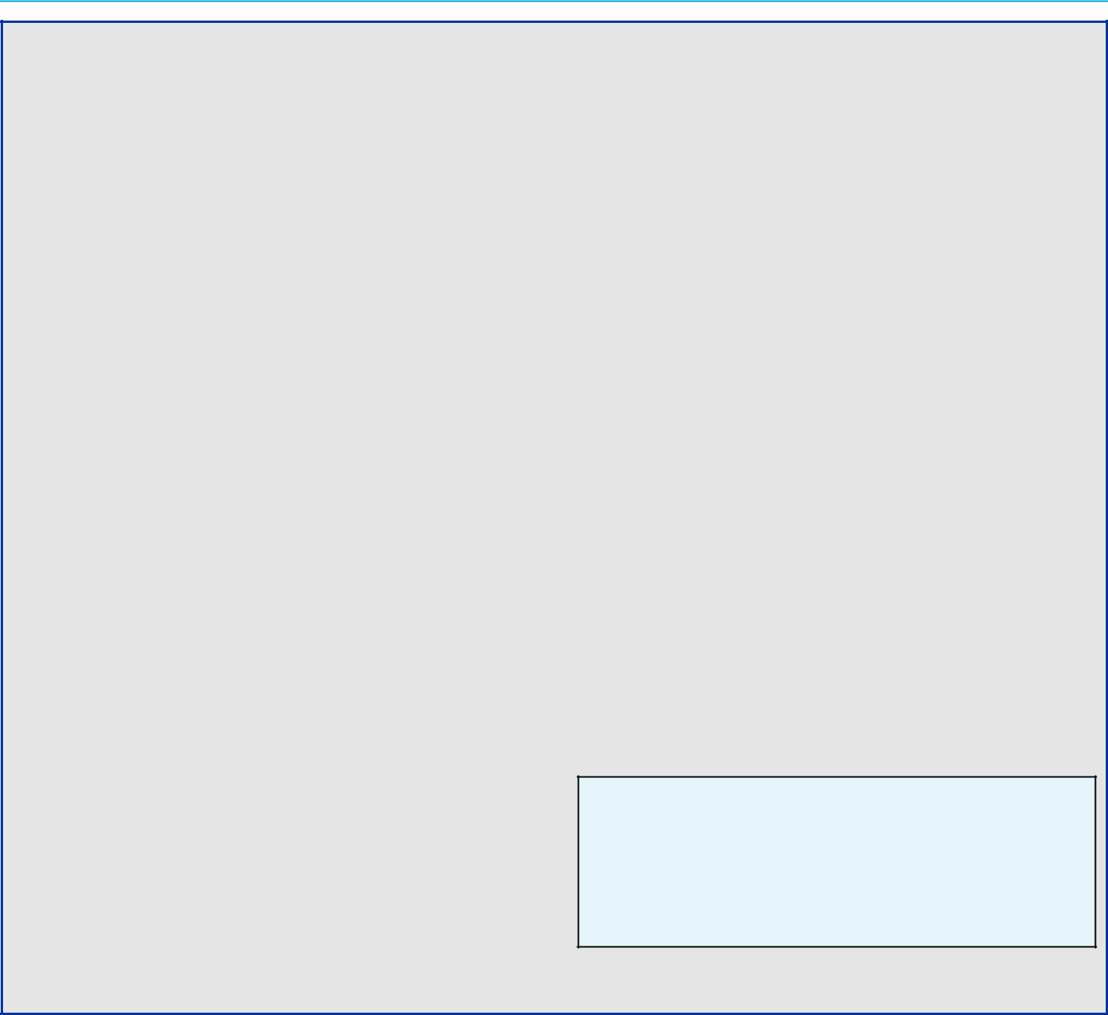

Your Board of Directors recommends a vote AGAINST this shareholder proposal for the following reasons:

GM’s Human Rights Policy reflects GM’s strong focus on human rights, diversity, and inclusion.

GM is committed to the highest standards of ethical conduct and respect for human rights. This commitment is cascaded throughout our global operations, global supply chain, and all of the businesses and entities that provide materials, parts, and services to GM. GM is building an inclusive and unified workforce – a true Workplace of Choice – where everyone understands our vision, believes in their role in securing GM’s future, and shares in our success.

In 2016, GM adopted its Human Rights Policy, which underscores our commitment to maintaining a workplace where employees are treated with dignity and respect. GM has also adopted a standalone Supplier Code of Conduct to ensure that our suppliers and other business partners share our values through compliance with several GM policies, including our Human Rights Policy; Code of Conduct, Winning with Integrity; Conflict Minerals Policy; and Speak Up For Safety. Our Supplier Code of Conduct articulates GM’s expectations that, among other things, its suppliers and business partners will:

- comply with laws that promote safe working conditions and individual security; prohibit slavery, forced labor, child labor, human trafficking, harassment, and unlawful discrimination; and ensure the right to engage in collective bargaining;

- maintain a reporting mechanism for their employees to raise integrity concerns, safety issues, and misconduct without fear of retaliation as well as appropriately investigate reports and take corrective action;

- cascade policies and expectations that align with those of GM throughout their own supply chains; and

u be able to demonstrate compliance with GM’s Supplier Code of Conduct upon request.

Your Board holds management accountable for protecting and enhancing our culture.

GM has several reporting mechanisms and strong anti-retaliation policies in place. Management monitors GM’s operations, partners, and suppliers for potential violations and takes action if violations occur, up to and including terminating employees and canceling supplier contracts. In addition, our employees, suppliers, contractors, and others can report any incidents or concerns (on an anonymous basis, if desired) using GM’s Awareline 24 hours per day, seven days per week by phone, web, email, mail, or fax. Your Board actively oversees management’s adherence to these mechanisms and policies.

The requested report is unnecessary because GM already follows robust and transparent reporting practices.

The Company’s approach to supply chain governance, compliance, and policy implementation is addressed in its annual sustainability report. Furthermore, GM engages regularly with shareholders and other stakeholders on these and other critical ESG issues. GM will continue to provide robust public disclosure on its actions and engagement on human rights matters.

Learn More

For a discussion of our ongoing efforts to protect the rights of everyone working for and with GM, see “Spotlight on Key ESG Initiatives—Responsible Sourcing” on page 32 of this Proxy Statement.

95

Table of Contents

ITEM NO. 9 – SHAREHOLDER PROPOSAL REGARDING REPORT ON LOBBYING COMMUNICATIONS AND ACTIVITIES

We will provide the name, address, and share ownership of the shareholders who submitted this Rule 14a-8 shareholder proposal upon a shareholder’s request. The shareholder proponents are responsible for the content of the proposal for which we and our Board accept no responsibility.

Whereas, we believe in full disclosure of General Motors’ (“GM”) direct and indirect lobbying activities and expenditures to assess whether GM’s lobbying is consistent with its express goals and in the shareholders’ best interest.

Resolved, the shareholders of General Motors Company (“GM”) request the preparation of a report, updated annually, disclosing:

- Company policy and procedures governing lobbying, both direct and indirect, and grassroots lobbying communications.

- Payments by GM used for (a) direct or indirect lobbying or (b) grassroots lobbying communications, in each case including the amount of the payment and the recipient.

- Description of management’s decision-making process and the Board’s oversight for making payments described above.

For purposes of this proposal, a “grassroots lobbying communication” is a communication directed to the general public that (a) refers to specific legislation or regulation,
- reflects a view on the legislation or regulation and
- encourages the recipient of the communication to take action with respect to the legislation or regulation. “Indirect lobbying” is lobbying engaged in by a trade association or other organization of which GM is a member.

Both “direct and indirect lobbying” and “grassroots lobbying communications” include efforts at the local, state and federal levels.

The report shall be presented to the Governance and Corporate Responsibility Committee and posted on GM’s website.

Supporting Statement

We encourage transparency in the use of GM’s corporate funds to influence legislation and regulation. GM spent $79,265,000 from 2010 – 2018 on federal lobbying. This does not include state lobbying expenditures in the 49 states where GM lobbies, but disclosure is uneven or absent.1 For example, GM spent $2,992,235 on lobbying in California from 2010 – 2018.

GM belongs to the Business Roundtable, which is lobbying against the right of shareholders to file resolutions, and is a member of the Alliance of Automobile Manufacturers, which spent $16,320,000 on lobbying for 2017 and 2018. GM does not disclose its memberships in, or payments to, trade associations, or the amounts used for lobbying. GM discloses trade association payments used for political contributions, but not payments used for lobbying. This leaves a serious disclosure gap, as trade associations generally spend far more on lobbying than on political contributions.

We are concerned that GM’s lack of lobbying disclosure presents significant reputational risk when it contradicts the company’s public positions. For example, GM claims it supports the Paris climate agreement, yet a 2019 InfluenceMap report found GM among the strongest opponents lobbying to undermine it.2 As shareholders, we believe that companies should ensure there is alignment between their own positions and their lobbying, including through trade associations.

Investors participating in Climate Action 100+ representing $34 trillion in assets are asking companies to align their lobbying with the goals of the Paris Agreement. GM uses the Global Reporting Initiative (GRI) for sustainability reporting, yet fails to report “any differences between its lobbying positions and any stated policies, goals, or other public positions” under GRI Standard 415.

- https://publicintegrity.org/state-politics/amid-federal-gridlock-lobbying-rises-in-the-states/

- https://www.theguardian.com/environment/2019/oct/10/exclusive-carmakers-opponents-climate-action-us-europe-emissions

96

Table of Contents

ITEM NO. 9 – SHAREHOLDER PROPOSAL REGARDING REPORT ON LOBBYING COMMUNICATIONS AND ACTIVITIES


Your Board of Directors recommends a vote AGAINST this shareholder proposal for the following reasons:

GM already provides comprehensive political and lobbying disclosure.

As part of our overall effort to promote political transparency and accountability, GM publishes an annual voluntary report of political contributions (available for each of the past five years at investor.gm.com/resources). Included in this report are (i) contributions to section 527 organizations; (ii) contributions to individual candidates for state and local office; (iii) portions of dues or similar payments to 501(c)(6) trade associations and section 501(c)(4) organizations to the extent the dues or other payments equal or exceed $50,000 and are attributable to political purposes; and (iv) a link to all contributions by GM.

In addition, GM files publicly available federal Lobbying Disclosure Act Reports each quarter, which disclose GM’s lobbying expenditures, describe legislation and general issues that were the topic of communication, and identify the individual who lobbied on behalf of GM. GM also files similar periodic reports with state agencies.

The 2019 CPA-Zicklin Index of Corporate Political Disclosure and Accountability ranked GM’s lobbying disclosure in the First Tier.

In 2019, the Center for Political Accountability’s Zicklin Index of Corporate Political Accountability and Disclosure, which benchmarks the political disclosure and accountability policies and practices of leading U.S. public companies, has again recognized the quality of our disclosure and ranked GM among the First Tier of S&P 500 companies.

GM protects and promotes shareholder value by participating in the political process.

Public policy decisions can significantly affect GM’s strategies, operations, and, ultimately, shareholder value. To protect shareholder value, GM exercises its fundamental right and responsibility to participate in the legislative, regulatory, and political processes to ensure decision makers are informed by our expertise and insights when considering policies that impact GM. GM does this by making political contributions to candidates and entities that

support our industry and our vision for the future of mobility, by engaging in direct and indirect lobbying, and by participating in various business and policy organizations that advocate positions designed to support GM’s business and enhance long-term shareholder value.

GM’s political activities are subject to thorough review and independent oversight.

GM participation in the political process is subject to best-in-class corporate governance practices. All corporate political contributions are centrally controlled, budgeted, and reviewed for compliance with the law and consistency with GM’s policies and strategic goals. At least annually, management reviews with the Governance and Corporate Responsibility Committee all political contributions, including those made by GM PAC and various GM state political action committees.

GM believes that climate change is real and advocates for climate action.

GM believes the best way to remove automobile emissions from the environmental equation is an all-electric, zero emissions future on a national and global level. That is why GM has proposed a National Zero Emissions Vehicle program that will help accelerate our transition to EVs. If we want true electrification across the country – which we do – we need the infrastructure, education, and incentive programs all working together.

Additional lobbying disclosure is unnecessary.

Your Board believes GM’s lobbying activities are transparent and the adoption of this proposal is unnecessary given the information that is already publicly available.

Learn More

See “Corporate Political Contributions and Lobbying Expenditures” on page 28 of this Proxy Statement for more on the Board’s oversight of GM’s lobbying activities and “Climate Change Risk Oversight” on page 24 of this Proxy Statement for a discussion of GM’s work to manage the impacts of climate change.

97

Table of Contents

GENERAL INFORMATION ABOUT THE ANNUAL MEETING

Voting and Meeting Information

- Board Recommendations and Vote Requirements*

 |  |  |  |  | Effect of
Agenda |  | Board |  | Effect of | Broker
Item | Description | Recommendation | Vote Requirement for Approval | Abstentions | Non-Votes
1 | Board Proposal Regarding Election of | FOR | Majority of votes cast | No effect | No effect
1 | Directors
 | Board Proposal to Approve, on an |  |  | Counted as
2 | Advisory Basis, Named Executive Officer | FOR |  | Counted as | No effect
2 | Advisory Basis, Named Executive Officer | FOR |  | “AGAINST” | No effect
 | Compensation |  |  | “AGAINST”
 | Board Proposal to Approve, on an
3 | Advisory Basis, the Frequency of Future | 1 YEAR |  | Counted as | No effect
3 | Advisory Votes on Named Executive | 1 YEAR |  | “AGAINST” | No effect
 | Officer Compensation
 | Board Proposal to Ratify the Selection of
4 | Ernst & Young LLP as the Company’s | FOR |  | Counted as | Discretionary
4 | Independent Registered Public | FOR |  | “AGAINST” | vote
 | Accounting Firm for 2020
 |  |  | Majority of shares present
 | Board Proposal to Approve the General |  | Majority of shares present | Counted as
 | Board Proposal to Approve the General |  | (in person or by proxy) | Counted as
5 | Motors Company 2020 Long-Term | FOR | (in person or by proxy) | Counted as | No effect
5 | Motors Company 2020 Long-Term | FOR | and entitled to vote | “AGAINST” | No effect
 | Incentive Plan |  | and entitled to vote | “AGAINST”
6 | Shareholder Proposal Regarding | AGAINST |  | Counted as | No effect
6 | Shareholder Written Consent | AGAINST |  | “AGAINST” | No effect
 | Shareholder Proposal Regarding Proxy |  |  | Counted as
7 | Access Amendment: Shareholder | AGAINST |  | Counted as | No effect
7 | Access Amendment: Shareholder | AGAINST |  | “AGAINST” | No effect
 | Aggregation Limit |  |  | “AGAINST”
8 | Shareholder Proposal Regarding Report | AGAINST |  | Counted as | No effect
8 | on Human Rights Policy Implementation | AGAINST |  | “AGAINST” | No effect
 | Shareholder Proposal Regarding Report |  |  | Counted as
9 | on Lobbying Activities and | AGAINST |  | Counted as | No effect
9 | on Lobbying Activities and | AGAINST |  | “AGAINST” | No effect
 | Communications |  |  | “AGAINST”

- See sections 1.7 and 2.2(c) of the General Motors Company Amended and Restated Bylaws as of August 14, 2018, for a description of the vote requirements and the impact of abstentions and broker non-votes on the meeting agenda items listed above.

- Other Matters to Be Presented at the Annual Meeting

We do not know of any matters to be voted on by shareholders at the Annual Meeting other than those included in this Proxy Statement. If any matter, other than the election of the Board’s nominees for director or Items two to nine in this Proxy Statement, is properly presented at the meeting, your executed proxy gives the Proxies (as defined below) discretionary authority to vote your shares in accordance with their best judgment with respect to the matter presented.

98

Table of Contents

GENERAL INFORMATION ABOUT THE ANNUAL MEETING

- Attending the Virtual Annual Meeting

GM currently expects that its Annual Meeting will be held via a live video webcast; however, as of the date of this mailing, COVID-19 continues to spread around the world and throughout the United States, including Michigan. If it becomes necessary due to public health considerations and the need to comply with federal, state, and local restrictions on gatherings and movement, we may need to conduct the Annual Meeting in an audio-only format. If this occurs, the Board of Directors and certain members of management will dial in to the webinar from remote locations and will not be present in person.

How to participate in |  |  |  | 1. Visit virtualshareholdermeeting.com/GM2020; and
the | Annual |  | Meeting | 2. Enter the 16-digit control number included on your Notice Regarding the Availability of Proxy
online |  |  |  | Materials (“Notice”), on your proxy card (if you received a printed copy of the proxy materials),
 |  |  |  | or on the instructions that accompanied your proxy materials.
 |  |  |  | You may begin to log into the meeting platform beginning at 7:45 a.m. Eastern Time on June 16,
 |  |  |  | 2020. The meeting will begin promptly at 8:00 a.m. Eastern Time.
How to participate in |  |  |  | Call (877) 328-2502 (toll free) or (412) 317-5419 (international) to listen to the meeting
the | Annual |  | Meeting | proceedings. You will not be able to vote your shares or submit questions during the meeting.
without |  | Internet
access
How to participate in |  |  |  | Visit virtualshareholdermeeting.com/GM2020 and register as a guest. You will not be able to
the | Annual |  | Meeting | vote your shares or ask questions during the meeting.
without a 16-digit
control number
For | Help |  | With | Call (800) 586-1548 (U.S.) or (303) 562-9288 (international) for assistance. If you need
Technical Difficulties |  |  |  | additional shareholder support, please e-mail shareholder.relations@gm.com or call (313) 667-
 |  |  |  | 1432 for assistance.
Additional Questions |  |  |  | Email GM Shareholder Relations at shareholder.relations@gm.com or call
 |  |  |  | (313) 667-1432.

- Submitting Questions for Our Online Meeting

Submitting Questions | 1. Log in to proxyvote.com;
Submitting Questions | 2. Enter your 16-digit control number; and
Before the Meeting | 3. Once past the login screen, click on “Questions for Management,” type in your question and
 | click “Submit.”
Submitting Questions | 1. Log into the online meeting platform at virtualshareholdermeeting.com/GM2020, type your
Submitting Questions | question into the “Ask a Question” field, and click “Submit”; or
During the Meeting
During the Meeting | 2. Call (877) 328-2502 (toll free) or (412) 317-5419 (international)

Only shareholders with a valid control number will be allowed to ask questions.

Questions pertinent to meeting matters will be answered during the meeting, subject to time constraints. If there are questions pertinent to meeting matters that cannot be answered during the meeting due to time constraints, management will post answers to a representative set of such questions at investor.gm.com/shareholder. The questions and answers will be available as soon as practicable after the meeting and will remain available until GM’s 2021 Proxy Statement is filed.

99

Table of Contents

GENERAL INFORMATION ABOUT THE ANNUAL MEETING

- Voting at the Annual Meeting

Shareholders of record and beneficial owners will be able to vote their shares electronically during the Annual Meeting. However, even if you plan to participate in the Annual Meeting online, we recommend that you also vote by proxy so that your votes will be counted if you later decide not to participate in the Annual Meeting.

- Quorum

The presence of the holders of a majority of the outstanding shares of our common stock, in person or by proxy, will constitute a quorum for transacting business at the Annual Meeting. Abstentions and broker non-votes are counted as present for purposes of establishing a quorum at the meeting.

- Proxies

The Board appointed the following officers to act as proxies: Mary T. Barra, Craig B. Glidden, and Rick E. Hansen (collectively, the “Proxies”). If you sign and return your proxy card or voting instruction form with voting instructions, one or more of the Proxies will vote your shares as you direct on the matters described in this Proxy Statement. If you sign and return your proxy card or voting instruction form without voting instructions, one or more of the Proxies will vote your shares as recommended by the Board.

- Who Can Vote

If you are a holder of the Company’s common stock as of the close of business on April 17, 2020, or you hold a valid proxy, you are entitled to vote at the Annual Meeting. On that date, the Company had 1,432,378,376 shares of common stock outstanding and entitled to vote. Each share of our common stock entitles the holder to one vote.

- Voting Without Attending the Annual Meeting

To vote your shares without attending the meeting, please follow the instructions for voting on the Notice, on your proxy card, or on the voting instructions form. When you timely submit your proxy or voting instructions in the proper form, your shares will be voted according to your instructions. If you sign, date, and return the proxy card or voting instruction form without specifying how you wish to cast your vote, your shares will be voted by the Proxies according to the recommendations of the Board of Directors, as indicated above. Internet and telephone voting is available 24 hours a day, through 11:59 p.m. Eastern Time on Monday, June 15, 2020.

- Revoking Your Proxy

After you have submitted your proxy or voting instructions by Internet, telephone, or mail, you may revoke it at any time until it is voted at the Annual Meeting. Participation in the Annual Meeting will not cause your previously granted proxy to be revoked unless you specifically make that request.

To revoke your proxy, follow the instructions below.

Shareholders of Record | Street Name Shareholders
• Grant a new proxy bearing a later date (which | • Notify your broker, bank, or nominee in accordance with
automatically revokes the earlier proxy); | that entity’s procedures for revoking your voting
• Send a written notice of revocation to the General | instructions; or
Motors Company Corporate Secretary at Mail Code | • Participate in the meeting and electronically vote your
482-C24-A68, 300 Renaissance Center, Detroit, | shares during the meeting.
Michigan 48265;
• E-mail the General Motors Company Corporate
Secretary at shareholder.relations@gm.com; or
• Participate in the Annual Meeting and vote your shares
electronically during the meeting.

100

Table of Contents

GENERAL INFORMATION ABOUT THE ANNUAL MEETING

- Annual Meeting Voting Results

Our independent inspector of elections, Broadridge Financial Services, Inc., will tabulate the vote at the Annual Meeting. We will provide voting results on our website and in a Current Report on Form 8-K filed with the SEC.

- “Shareholder of Record” and “Beneficial Shareholder”

If your shares are owned directly in your name in an account with GM’s stock transfer agent, Computershare Trust Company, N.A., you are considered the “shareholder of record” of those shares in your account. If your shares are held in an account with a broker, bank, or other nominee as custodian on your behalf, you are considered a “beneficial shareholder” of those shares, which are held in street name. The broker, bank, or other nominee is considered the shareholder of record for those shares. As the beneficial owner, you have the right to instruct the broker, bank, or other nominee on how to vote the shares in your account. In order for your shares to be voted in the way you would like, you must provide voting instructions to your broker, bank, or other nominee by the deadline provided in the proxy materials you receive from your broker, bank, or other nominee. If you do not provide voting instructions to your broker, bank, or other nominee, whether your shares can be voted on your behalf depends on the type of item being considered for vote. Under NYSE rules, brokers are permitted to exercise discretionary voting authority only on “routine” matters. Therefore, your broker may vote on Item No. 4 (“Ratification of the Selection of the Independent Registered Public Accounting Firm for 2020”) even if you do not provide voting instructions because it is considered a routine matter. Your broker is not permitted to vote on the other agenda Items if you do not provide voting instructions because those items involve matters that are considered nonroutine.

- Householding

SEC rules permit companies to send a single Proxy Statement and Annual Report or Notice to two or more shareholders that share the same address, subject to certain conditions. Each shareholder will continue to receive a separate proxy card, voting instruction form, or Notice, and it will include the unique 16-digit control number that is needed to vote those shares and to access and vote during the Annual Meeting. This “householding” rule will benefit both the shareholders and GM by reducing the volume of duplicate information shareholders receive and reducing GM’s printing and mailing costs.

If one set of these documents was sent to your household for the use of all GM shareholders in your household and one or more of you would prefer to receive additional sets or if multiple copies of these documents were sent to your household and you want to receive one set, please contact Broadridge Financial Solutions, Inc., by calling toll-free at 866-540-7095 or by writing to Broadridge Financial Solutions, Inc., Householding Department, 51 Mercedes Way, Edgewood, New York 11717.

If a broker, bank, or other nominee holds your shares, please contact your broker, bank, or other nominee directly if you have questions about delivery of materials, require additional copies of the Proxy Statement or Annual Report, or wish to receive multiple copies of proxy materials, which would require you to state that you do not consent to householding.

101

Table of Contents

GENERAL INFORMATION ABOUT THE ANNUAL MEETING

- Shareholder Proposals and Director Nominations for the 2021 Annual Meeting

Type of Proposal | Rule 14a-8 Proposals by |  |  |  |  |  | Director Nominees for |  |  |  |  |  |  | Other Proposals or
 |  | Shareholders |  |  |  |  | Inclusion in Next Year’s |  |  |  |  |  |  | Nominees for
 | for Inclusion in Next |  |  |  |  |  | Proxy Statement |  |  |  |  |  |  | Representation at Next
 | Year’s Proxy Statement |  |  |  |  |  | (Proxy Access) |  |  |  |  |  |  | Year’s Annual Meeting
Rules/Provisions | SEC rules and our Bylaws |  |  |  |  |  | Our | Bylaws |  |  | permit |  | a | Our Bylaws require that any
 | permit shareholders to submit |  |  |  |  |  | shareholder |  | or |  | group |  | of | shareholder |  | proposal,
 | proposals for inclusion in our |  |  |  |  |  | shareholders (up to 20) who |  |  |  |  |  |  | including |  | a | director
 | Proxy | Statement |  |  | if | the | have | owned |  | a | significant |  |  | nomination, |  | that | is | not
 | shareholder |  | and | the | proposal |  | amount of common stock (at |  |  |  |  |  |  | submitted | for | inclusion |  | in
 | meet | the |  | requirements |  |  | least 3%) for a significant |  |  |  |  |  |  | next | year’s |  | Proxy
 | specified in SEC Rule 14a-8. |  |  |  |  |  | amount of time (at least three |  |  |  |  |  |  | Statement | (either |  | under
 |  |  |  |  |  |  | years) | to | submit |  |  | director |  | SEC Rule 14a-8 or our
 |  |  |  |  |  |  | nominees (up to 20% of the |  |  |  |  |  |  | proxy access bylaw), but is
 |  |  |  |  |  |  | Board | or | two |  | directors, |  |  | instead | sought |  | to | be
 |  |  |  |  |  |  | whichever |  | is | greater) |  |  | for | presented | directly |  | at | the
 |  |  |  |  |  |  | inclusion |  | in | our |  | Proxy |  | next year’s annual meeting
 |  |  |  |  |  |  | Statement |  |  |  | if |  | the | must be received at our
 |  |  |  |  |  |  | shareholder(s) |  |  |  | and |  | the | principal | executive |  | offices
 |  |  |  |  |  |  | nominee(s) |  |  | satisfy |  |  | the | no earlier than 180 days
 |  |  |  |  |  |  | requirements specified in our |  |  |  |  |  |  | and no later than 120 days
 |  |  |  |  |  |  | Bylaws. |  |  |  |  |  |  | before the first anniversary
 |  |  |  |  |  |  |  |  |  |  |  |  |  | of this | year’s |  | Annual
 |  |  |  |  |  |  |  |  |  |  |  |  |  | Meeting.
Deadline for | Proposals must be received at |  |  |  |  |  | Proposals must be sent no earlier than December 18, 2020,
Submitting These | our principal |  | executive |  |  | offices | and no later than 11:59 p.m. Eastern Time on February 16,
Proposals | no later than 11:59 p.m. |  |  |  |  |  | 2021.
 | Eastern |  | Time |  |  | on
 | December 28, 2020.
Where to Send These | Mail proposals to our Corporate Secretary at Mail Code 482-C24-A68, 300 Renaissance Center,
Proposals | Detroit, Michigan 48265, or send proposals by e-mail to shareholder.relations@gm.com.
What to Include | Proposals must conform to and |  |  |  |  |  | Proposals must include information required by our Bylaws,
 | include | the |  | information
 | include |  |  |  |  |  | which are available on our website at
 | required by SEC Rule 14a-8.
 |  |  |  |  |  |  | investor.gm.com/resources.

102

Table of Contents

GENERAL INFORMATION ABOUT THE ANNUAL MEETING

- Annual Report and Other Investor Materials

You may download a copy of our 2019 Annual Report and Proxy Statement at investor.gm.com/shareholder. Our other SEC filings are available at investor.gm.com/sec-filings. Alternatively, you may request a printed copy of these publications by writing to Shareholder Relations at General Motors Company, Mail Code: 482-C23-A68, 300 Renaissance Center, Detroit, Michigan 48265 or by e-mail to shareholder.relations@gm.com.

- Cost of Proxy Solicitation

We will pay our cost for soliciting proxies for the Annual Meeting. The Company will distribute proxy materials and follow-up reminders, if any, by mail and electronic means. We have engaged Alliance Advisors, LLC (“Alliance”), a professional proxy solicitation firm, located at 200 Broadacres Drive, Bloomfield, New Jersey 07003 to assist with the solicitation of proxies and to provide related advice and informational support for a service fee, plus customary disbursements. We expect to pay Alliance an aggregate fee, including reasonable out-of-pocket expenses, of up to $20,000, depending on the level of services actually provided. GM directors, officers, and employees may also solicit proxies by mail, telephone, or personal visits. They will not receive any additional compensation for their services.

GM will provide copies of these proxy materials to banks, brokerage houses, fiduciaries, and custodians holding in their names shares of our common stock beneficially owned by others so that they may forward these proxy materials to the beneficial owners. As usual, we will reimburse brokers, banks, and other nominees for their reasonable expenses in forwarding proxy materials to beneficial owners.

103

Table of Contents

[THIS PAGE INTENTIONALLY LEFT BLANK]

104

Table of Contents

APPENDIX A: NON-GAAP FINANCIAL MEASURES

Non-GAAP Reconciliations

Our Company reports its financial results in accordance with generally accepted accounting principles in the United States (“GAAP”). However, management believes that certain non-GAAP financial measures provide users with additional meaningful financial information.

Our non-GAAP measures presented in this Proxy Statement include: (i) earnings before interest and taxes (“EBIT”)– adjusted, presented net of noncontrolling interests,
- earnings per share (“EPS”)–diluted–adjusted, and
- ROIC-adjusted. These measures relate to our continuing operations and not our discontinued operations. Our calculation

of these non-GAAP measures may not be comparable with similarly titled measures of other companies due to potential differences between companies in the method of calculation. As a result, the use of these non-GAAP measures has limitations and should not be considered superior to, in isolation from, or as a substitute for, related GAAP measures. See our Annual Report on Form 10-K for the fiscal year ended December 31, 2019, and our subsequent filings with the SEC for additional information about the non-GAAP measures presented herein, including a description of the use of such measures. The numbers in the tables below may not sum due to rounding.

($B) |  | 2019 |  | 2018
Net Income Attributable to Stockholders | $ | 6.7 | $ | 8.0
Loss from Discontinued Operations, Net of Tax |  | – |  | 0.1
Income tax expense |  | 0.8 |  | 0.5
Automotive interest expense |  | 0.8 |  | 0.7
Automotive interest income |  | (0.4) |  | (0.3)
Add Back Special Items:
Transformation activities⁽¹⁾ |  | 1.7 |  | 1.3
GM Brazil indirect tax recoveries⁽²⁾ |  | (1.4) |  | –
FAW-GM divestiture⁽³⁾ |  | 0.2 |  | –
GM International (“GMI”) restructuring⁽⁴⁾ |  | – |  | 1.1
Ignition switch recall and related legal matters⁽⁵⁾ |  | – |  | 0.4
Total Special items |  | 0.5 |  | 2.9
EBIT-adjusted | $ | 8.4 | $ | 11.8
Net Sales and Revenue | $ | 137.2 | $ | 147.0
EBIT-adjusted Margin |  | 6.1% |  | 8.0%

- These adjustments were excluded because of a strategic decision to accelerate our transformation for the future to strengthen our core business, capitalize on the future of personal mobility, and drive significant cost efficiencies. The adjustments primarily consist of accelerated depreciation, supplier-related charges, pension and other curtailment charges and employee-related separation charges in the year ended December 31, 2019, and primarily employee separation charges and accelerated depreciation in the year ended December 31, 2018.

- This adjustment was excluded because of the unique events associated with decisions rendered by the Superior Judicial Court of Brazil resulting in retrospective recoveries of indirect taxes.

- This adjustment was excluded because we divested our joint venture FAW-GM Light Duty Commercial Vehicle Co., Ltd. (“FAW-GM”), as a result of a strategic decision by both shareholders, allowing us to focus our resources on opportunities expected to deliver higher returns.

- This adjustment was excluded because of a strategic decision to rationalize our core operations by exiting or significantly reducing our presence in various international markets to focus resources on opportunities expected to deliver higher returns. The adjustments primarily consist of employee separation charges, asset impairments and supplier claims, all in Korea.

A-1

Table of Contents

APPENDIX A: NON-GAAP FINANCIAL MEASURES

- This adjustment was excluded because of the unique events associated with the ignition switch recall, which included various investigations, inquiries and complaints from constituents.

$ per Share | 2019 | 2018
Diluted Earnings (Loss) per Common Share | $ 4.57 | $ 5.53
Diluted loss per common share – discontinued operations | – | 0.05
Adjustments⁽¹⁾ | 0.38 | 2.03
Tax effect of adjustments⁽²⁾ | (0.13) | (0.29)
Tax adjustments⁽³⁾ | – | (0.78)
EPS-diluted-adjusted | $ 4.82 | $ 6.54

- Refer to the reconciliation of EBIT-adjusted on a continuing operations basis on page A-1 of this Proxy Statement for adjustment details.

- The tax effect of each adjustment is determined based on the tax laws and valuation allowance status of the jurisdiction to which the adjustment relates.

- This adjustment consists of: (1) a non-recurring tax benefit related to foreign earnings and (2) tax effects related to U.S. tax reform legislation. This adjustment was excluded because impacts of tax legislation and valuation allowances are not considered part of our core operations.

($B) | 2019
EBIT-adjusted⁽¹⁾ | $ 8.4
Average equity⁽²⁾ | 43.7
Add: Average automotive debt and interest liabilities (excluding capital leases) | 14.9
Add: Average automotive net pension & OPEB liability | 16.7
Less: Average automotive net income tax asset | (23.5)
ROIC-adjusted average net assets | 51.8
ROIC-adjusted | 16.2%

- Refer to the reconciliation of EBIT-adjusted on a continuing operations basis on page A-1 of this Proxy Statement.

- Includes equity of noncontrolling interests where the corresponding earnings are included in EBIT-adjusted.

A-2

Table of Contents

APPENDIX A: NON-GAAP FINANCIAL MEASURES

Adjusted Automotive Free Cash Flow

In the section titled “Executive Compensation,” we present one of our incentive compensation measures, adjusted automotive free cash flow, which is not prepared in accordance with GAAP. Below is a reconciliation of adjusted automotive free cash flow (as calculated for incentive compensation purposes) to net automotive cash provided by operating activities, its nearest GAAP measure.

($B) | 2019
Net automotive cash provided by operating activities – continuing operations | $ 7.4
Less: capital expenditures – continuing operations | (7.5)
Adjustments
Transformation activities | 1.1
GM Brazil indirect tax recoveries | (0.1)
FAW-GM divestiture | 0.2
GMI Restructuring | 0.0
Incentive compensation adjustments⁽¹⁾ | 0.2
Total adjustments | 1.4
Adjusted automotive free cash flow (for incentive compensation purposes) | $ 1.3

- Reflects certain recall-related expenses attributable to events occurring in 2014. Note: Amounts may not sum due to rounding.

A-3

Table of Contents

APPENDIX B: GENERAL MOTORS COMPANY 2020 LONG-TERM INCENTIVE PLAN

Section 1. Purpose. The purpose of the General Motors Company 2020 Long-Term Incentive Plan (as amended from time to time, the “Plan”) is to incentivize selected employees, consultants, advisors and non-employee directors of General Motors Company (the “Company”) and its Subsidiaries and to align their interests with those of the Company’s stockholders. However, nothing in this Plan or any Award granted pursuant to this Plan shall be interpreted to create or establish an employment relationship between the Company and any Participant.

Section 2. Definitions. As used in the Plan, and unless otherwise specified in an applicable Award Document, the following terms shall have the meanings set forth below:

- “Award” means any Option, SAR, Restricted Stock, RSU, Performance Award, Other Stock-Based Award or cash incentive award granted under the Plan.

- “Award Document” means any appropriately authorized agreement, contract or other instrument or document evidencing any Award granted under the Plan, whether in electronic form or otherwise, which must be duly executed or acknowledged by a Participant (unless otherwise specifically provided by the Company).

- “Beneficiary” means a person designated by a Participant to receive payments or other benefits or exercise rights that are available under the Plan in the event of the Participant’s death pursuant to Section 14(f).

- “Board” means the Board of Directors of the Company.

- “Cause” means, with respect to any Participant, any of the following unless explicitly excluded by such Participant’s applicable Award Document, and any additional grounds as may be set forth in such Award Document:

  - the Participant’s commission of, or plea of guilty or no contest to, a felony or comparable local charge in non-U.S. jurisdictions;

  - the Participant’s gross negligence or willful misconduct that is materially injurious to the Company or any of its Subsidiaries; or

  - the Participant’s material violation of state or federal securities laws.

- “Change in Control” means the occurrence of any one or more of the following events:

  - any Person other than an Excluded Person, directly or indirectly, becomes the “beneficial owner” (within the meaning of Rule 13d-3 under the Exchange Act) of securities of the Company constituting more than 40 percent of the total combined voting power of the Company’s Voting Securities outstanding; provided that if such Person becomes the beneficial owner of 40 percent of the total combined voting power of the Company’s outstanding Voting Securities as a result of a sale of such securities to such Person by the Company or a repurchase of securities by the Company, such sale or purchase by the Company shall not result in a Change in Control; provided further, that if such Person subsequently acquires beneficial ownership of additional Voting Securities of the Company (other than from the Company), such subsequent acquisition shall result in a Change in Control if such Person’s beneficial ownership of the Company’s Voting Securities immediately following such acquisition exceeds 40 percent of the total combined voting power of the Company’s outstanding Voting Securities;

  - at any time during a period of 24 consecutive months, individuals who at the beginning of such period constituted the Board and any new member of the Board whose election or nomination for election was approved by a vote of at least a majority of the directors then still in office who either were directors at the beginning of such period or whose election or nomination for election was so approved (the “Incumbent Board”), cease for any reason to constitute a majority of members of the Board; provided that no individual

B-1

Table of Contents

APPENDIX B: GENERAL MOTORS COMPANY 2020 LONG TERM INCENTIVE PLAN

initially elected or nominated as a director as a result of an actual or threatened election contest, as such terms are used in Rule 14a-12 of Regulation 14A promulgated under the Exchange Act, with respect to directors or as a result of any other actual or threatened solicitation of proxies or consents by or on behalf of any Person other than the Board shall be deemed to be an Incumbent Director;

- the consummation of a reorganization, merger or consolidation of the Company or any of its Subsidiaries with any other corporation or entity, in each case, unless, immediately following such reorganization, merger or consolidation, more than 60 percent of the combined voting power and total fair market value of the then outstanding Voting Securities of the resulting corporation from such reorganization, merger or consolidation is then beneficially owned, directly or indirectly, by all or substantially all of the individuals and entities who were the beneficial owners of the outstanding Voting Securities of the Company immediately prior to such reorganization, merger or consolidation in substantially the same proportion as their beneficial ownership of the Voting Securities of the Company immediately prior to such reorganization, merger or consolidation; or

- the consummation of any sale, lease, exchange or other transfer to any Person (other than a Subsidiary or affiliate of the Company) of assets of the Company and/or any of its Subsidiaries, in one transaction or a series of related transactions within a 12-month period, having an aggregate fair market value of more than 50 percent of the fair market value of the Company and its Subsidiaries immediately prior to such transaction(s).

Notwithstanding the foregoing, in no event shall a “Change in Control” be deemed to have occurred (A) as a result of the formation of a Holding Company, (B) with respect to any Participant, if the Participant is part of a “group” within the meaning of Section 13(d)(3) of the Exchange Act as in effect on the date hereof, which consummates the Change in Control transaction or (C) if the transaction does not constitute a “change in ownership,” “change in effective control,” or “change in the ownership of a substantial portion of the assets” of the Company within the meaning of Section 409A of the Code.

- “Code” means the Internal Revenue Code of 1986, as amended from time to time, and the rules, regulations and guidance thereunder. Any reference to a provision in the Code shall include any successor provision thereto.

- “Committee” means the Executive Compensation Committee of the Board or such other independent committee as may be designated by the Board to perform any functions of the Executive Compensation Committee with respect to this Plan.

- “Disability” means, with respect to any Participant, such Participant’s inability upon a Termination of Service to engage in any gainful activity by reason of any medically determinable physical or mental impairment that can be expected to result in death or can be expected to last for a continuous period of not less than 12 months.

- “Effective Date” means June 17, 2020.

- “Exchange Act” means the Securities Exchange Act of 1934, as amended from time to time, and the rules, regulations and guidance thereunder. Any reference to a provision in the Exchange Act shall include any successor provision thereto.

- “Excluded Person” means (i) the Company, (ii) any of the Company’s Subsidiaries, (iii) any Holding Company, (iv) any employee benefit plan of the Company, any of its Subsidiaries or a Holding Company, or (v) any Person organized, appointed or established by the Company, any of its Subsidiaries or a Holding Company for or pursuant to the terms of any employee benefit plan described in clause (iv).

- “Fair Market Value” means with respect to Shares, the closing price of a Share on the date in question (or, if there is no reported sale on such date, on the last preceding date on which any reported sale occurred) on the principal stock market or exchange on which the Shares are quoted or traded, or if Shares are not so quoted or

B-2

Table of Contents

APPENDIX B: GENERAL MOTORS COMPANY 2020 LONG TERM INCENTIVE PLAN

traded, fair market value as determined by the Committee, and with respect to any property other than Shares, the fair market value of such property determined by such methods or procedures as shall be established from time to time by the Committee.

- Achievement of “Full Career Status” means a Participant’s voluntary Termination of Service (i) at the age of 55 or older with ten or more years of continuous service or (ii) at the age of 62 or older. The chief human resources officer of the Company (or such individual holding a comparable role in the event of a restructuring of positions or re-designation of titles) shall have the binding authority to determine how many years of continuous service a Participant has at any given time.

- “Good Reason” means, with respect to any Participant, the occurrence of any of the following acts by the Company, or failure by the Company to act, following or in connection with the occurrence of a Change in Control, unless explicitly excluded in such Participant’s applicable Award Document and any additional grounds, as may be set forth in such Award Document:

  - a material reduction of such Participant’s base salary or target incentive compensation;

  - an involuntary relocation of the geographic location of such Participant’s principal place of employment (or for consultants or advisors, service) by more than 50 miles; or

  - only for Participants who are executive officers of the Company covered by Section 16 of the Exchange Act, a material diminution of the Participant’s authority, duties, or responsibilities.

In each case, if such Participant desires to terminate his or her employment or service with the Company or Subsidiary, as applicable, for Good Reason, he or she must first give written notice within 90 days of the initial existence of the facts and circumstances providing the basis for Good Reason to the Company or Subsidiary, as applicable, and allow the Company or Subsidiary, as applicable, 60 days from the date of such notice to rectify the situation giving rise to Good Reason, and in the absence of any such rectification, such Participant must terminate his or her employment or service for such Good Reason within 120 days after delivery of such written notice.

- “Holding Company” means an entity that becomes a holding company for the Company or its businesses as part of any reorganization, merger, consolidation or other transaction, provided that the outstanding shares of common stock of such entity and the combined voting power of the then outstanding Voting Securities of such entity are, immediately after such reorganization, merger, consolidation or other transaction, beneficially owned, directly or indirectly, by all or substantially all of the individuals and entities who were the beneficial owners, respectively, of the Voting Securities of the Company outstanding immediately prior to such reorganization, merger, consolidation or other transaction in substantially the same proportions as their ownership, immediately prior to such reorganization, merger, consolidation or other transaction, of such outstanding Voting Securities of the Company.

- “Incentive Stock Option” means an option representing the right to purchase Shares from the Company, granted pursuant to Section 6, that meets the requirements of Section 422 of the Code.

- “Incumbent Board” has the meaning assigned to it in Section 2(f).

- “Non-Qualified Stock Option” means an option representing the right to purchase Shares from the Company, granted pursuant to Section 6, that is not an Incentive Stock Option.

- “Option” means an Incentive Stock Option or a Non-Qualified Stock Option granted pursuant to Section 6.

- “Other Stock-Based Award” means an Award granted pursuant to Section 10.

- “Participant” means the recipient of an Award granted under the Plan.

B-3

Table of Contents

APPENDIX B: GENERAL MOTORS COMPANY 2020 LONG TERM INCENTIVE PLAN

- “Performance Award” means an Award granted pursuant to Section 9.

- “Performance Period” means a period of one year (or such longer or shorter period established by the Committee from time to time) during which any performance goals specified by the Committee with respect to a Performance Award are measured.

- “Person” means any individual or entity, including any two or more Persons deemed to be one “person” as used in Sections 13(d)(3) and 14(d)(2) of the Exchange Act.

- “Restricted Stock” means any Share granted pursuant to Section 8.

- “Restricted Stock Unit” or “RSU” means a contractual right granted pursuant to Section 8 that is denominated in Shares. Each RSU represents a right to receive the value of one Share (or a percentage of such value) in cash, Shares or a combination thereof.

- “Shares” means shares of the Company’s common stock, $0.01 par value.

- “Stock Appreciation Right” or “SAR” means a right granted pursuant to Section 7, denominated in Shares, that entitles the Participant within the exercise period to receive a payment (or a number of Shares with a value) equal to the increase in value between the exercise price and the Fair Market Value of the underlying Shares at the date of exercise.

- “Subsidiary” means an entity of which the Company directly or indirectly holds all or a majority of the value of the outstanding equity interests of such entity or a majority of the voting power with respect to the Voting Securities of such entity. Whether employment by or service with a Subsidiary is included within the scope of this Plan shall be determined by the Committee.

- “Termination of Service” means, subject to Section 19, the cessation of a Participant’s employment or service relationship with the Company or a Subsidiary such that the Participant is determined by the Company to no longer be an employee, consultant or non-employee director of the Company or such Subsidiary, as applicable; provided, however, that, unless the Company determines otherwise, such cessation of the Participant’s employment or service relationship with the Company or a Subsidiary, where the Participant’s employment or services for the Company continues at another Subsidiary, or as a member of the Board, shall not be deemed a cessation of employment or service that would constitute a Termination of Service; provided, further, that a Termination of Service shall be deemed to occur for a Participant employed by or providing services to a Subsidiary when the Subsidiary ceases to be a Subsidiary unless such Participant’s employment or service continues with the Company or another Subsidiary. The chief human resources officer of the Company (or such individual holding comparable roles in the event of a restructuring of positions or re-designation of titles) shall have the binding authority to determine whether a Participant has had a cessation of his or her employment or service relationship with the Company or a Subsidiary.

- “Voting Securities” means securities of a Person entitling the holder thereof to vote in the election of the members of the board of directors of such Person or such governing body of such Person performing a similar principal governing function with respect to such Person.

Section 3. Eligibility. The following individuals may be designated by the Committee as a Participant from time to time: (a) a person who serves or is employed as an officer or other employee of the Company or any Subsidiary; (b) a consultant or advisor who provides services to the Company or a Subsidiary; and (c) a non-employee director of the Company. To participate in the Plan, consultants and advisors must meet the definition of employee under Form S-8.

B-4

Table of Contents

APPENDIX B: GENERAL MOTORS COMPANY 2020 LONG TERM INCENTIVE PLAN

Section 4. Administration.

- The Plan shall be administered by the Committee. All decisions of the Committee shall be final, conclusive and binding upon all parties, including the Company, its stockholders and Participants and any Beneficiaries thereof. To the extent permitted by applicable law, the Committee may delegate to one or more members of the Committee or officers of the Company authority to administer the Plan, such as the authority to grant Awards or take any other actions permitted under the Plan, within any limits established by the Committee. Subject to the immediately preceding sentence, the Committee may directly or through its delegate issue rules and regulations for administration of the Plan.

- To the extent necessary or desirable to comply with applicable regulatory regimes, any action by the Committee shall require the approval of Committee members who are (i) independent, within the meaning of and to the extent required by applicable rulings and interpretations of the applicable stock market or exchange on which the Shares are quoted or traded; and (ii) non-employee directors within the meaning of Rule 16b-3 under the Exchange Act.

- Subject to applicable law, the terms of the Plan, including but not limited to Section 4(a), and such orders or resolutions not inconsistent with the terms of the Plan as may from time to time be adopted by the Board, the Committee or its delegate shall have full power, discretion and authority to: (i) subject to Section 3, designate eligible individuals who will be Participants;
- determine the type or types of Awards to be granted to each Participant under the Plan; (iii) determine the number of Shares to be covered by (or with respect to which payments, rights or other matters are to be calculated in connection with) Awards; (iv) determine the terms and conditions of any Award; (v) determine whether, to what extent and under what circumstances Awards may be settled or exercised in cash, Shares, other Awards, other property, net settlement, or any combination thereof, or cancelled, forfeited or suspended, and the method or methods by which Awards may be settled, exercised, cancelled, forfeited or suspended; (vi) determine whether, to what extent and under what circumstances cash, Shares, other Awards, other property and other amounts payable with respect to an Award under the Plan shall be deferred either automatically or at the election of the holder thereof or of the Committee; (vii) determine under what circumstances the vesting of an Award shall occur; (viii) interpret and administer the Plan and any instrument or agreement relating to, or Award made under, the Plan; (ix) prescribe the form of each Award Document, which need not be identical for each Participant;
- establish, amend, suspend or waive such rules and regulations and appoint such agents, trustees, brokers, depositories and advisors and determine such terms of their engagement as it shall deem appropriate for the proper administration of the Plan and due compliance with applicable law, stock market or exchange rules and regulations or accounting or tax rules and regulations; (xi) make any other determination and take any other action that the Committee in its sole discretion deems necessary or desirable for the administration of the Plan and due compliance with applicable law, stock market or exchange rules and regulations or accounting or tax rules and regulations; and (xii) to construe, interpret and apply the provisions of this Plan.

- In addition to the conditions imposed by Section 11, the Committee or its delegate may impose restrictions on any Award at the time of grant in the applicable Award Document or by other action with respect to non-competition, confidentiality and other restrictive covenants as it deems necessary or appropriate.

- Notwithstanding any other provision in the Plan to the contrary, in any instance where a determination is to be made under the Plan at the discretion of the Company’s Chief Executive Officer or chief human resources officer (or such individuals holding a comparable role in the event of a restructuring of positions or re-designation of titles), the Company’s Chief Executive Officer shall make such determination in respect of the Company’s chief human resources officer, and the Committee shall make such determination in respect of the Company’s Chief Executive Officer (or, in each case, such individuals holding the comparable roles in the event of a restructuring of positions or re-designation of titles).

B-5

Table of Contents

APPENDIX B: GENERAL MOTORS COMPANY 2020 LONG TERM INCENTIVE PLAN

Section 5. Shares Available for Awards.

- Subject to adjustment as provided in Section 5(c), the maximum number of Shares available for issuance under the Plan shall not exceed 50,000,000 Shares, with each Share subject to (or deliverable with respect to) an Option, SAR, RSU or any other Award reducing the number of Shares available for issuance under the Plan by one Share. The maximum number of Shares available for issuance under Incentive Stock Options shall be 50,000,000.

- Any Shares subject to an Award that expires, is cancelled, forfeited or otherwise terminates without the delivery of such Shares, including any Shares subject to an Award to the extent that Award is settled without the issuance of Shares, shall again be, or shall become, available for issuance under the Plan; provided, however, that (i) any Shares surrendered or withheld in payment of any grant, purchase, exercise price of an Award or taxes related to an Award, (ii) any Shares covered by a SAR that is exercised and settled in Shares and (iii) any Shares repurchased in the open market using stock option proceeds, shall not again be available for issuance under the Plan.

- In the event that the Committee determines that, as a result of any dividend or other distribution (whether in the form of cash, Shares or other securities), recapitalization, stock split, reverse stock split, reorganization, merger, consolidation, split-up, spin-off, combination, repurchase or exchange of Shares or other securities of the Company, issuance of warrants or other rights to purchase Shares or other securities of the Company, issuance of Shares pursuant to the anti-dilution provisions of securities of the Company, or other similar corporate transaction or event affecting the Shares, or of changes in applicable laws, regulations or accounting principles, an adjustment is appropriate in order to prevent dilution or enlargement of the benefits or potential benefits intended to be made available under the Plan, then the Committee shall adjust equitably any or all of:

  - the number and type of Shares (or other securities) which thereafter may be made the subject of Awards, including the aggregate and individual limits specified in Section 5(a);

  - the number and type of Shares (or other securities) subject to outstanding Awards; and

  - the grant, purchase or exercise price with respect to any Award or, if deemed appropriate, make provision for a cash payment to the holder of an outstanding Award; provided, however, that the number of Shares subject to any Award denominated in Shares shall always be a whole number.

- Any Shares delivered pursuant to an Award may consist, in whole or in part, of authorized and newly issued Shares or Shares acquired by the Company.

- The maximum number of Shares subject to Awards granted during a single fiscal year to any non-employee Director, taken together with any cash fees paid during the fiscal year to the non-employee Director, in respect of the Director’s service as a member of the Board during such year (including service as a member or chair of any committees of the Board), shall not exceed $750,000 in total value (calculating the value of any such Awards based on the grant date fair value of such Awards for financial reporting purposes). The independent members of the Board may make exceptions to this limit for a non-executive chair of the Board or a non-executive lead Director, provided that the non-employee Director receiving such additional compensation may not participate in the decision to award such compensation.

Section 6. Options. The Committee is authorized to grant Options to Participants with the following terms and conditions and with such additional terms and conditions, in either case not inconsistent with the provisions of the Plan, as the Committee shall determine.

- The exercise price per Share under an Option shall be determined by the Committee; provided, however, that such exercise price shall not be less than the Fair Market Value of a Share on the date of grant of such Option. Notwithstanding the foregoing, an Option may be granted with an exercise price lower than that set forth in the preceding sentence if such Option is granted pursuant to an assumption or substitution for another Option in a manner consistent with the provisions of Sections 409A and 424(a) of the Code.

B-6

Table of Contents

APPENDIX B: GENERAL MOTORS COMPANY 2020 LONG TERM INCENTIVE PLAN

- The term of each Option shall be fixed by the Committee but shall not exceed 10 years from the date of grant of such Option in the form of an Incentive Stock Option and 10 years plus two days from the date of grant of such Option in the form of a Non-Qualified Stock Option.

- The Committee shall determine the time or times at which an Option may be exercised in whole or in part.

- The Committee shall determine the method or methods by which, and the form or forms, including cash, Shares, other Awards, other property, net settlement, broker assisted cashless exercise or any combination thereof, having a Fair Market Value on the exercise date equal to the relevant exercise price, in which payment of the exercise price with respect thereto may be made or deemed to have been made.

- Any Option intended to be treated as an Incentive Stock Option shall be designated as such under the terms of the applicable Award Document. The terms of any such Incentive Stock Option shall comply in all respects with the provisions of Section 422 of the Code.

- Subject to Section 12 and Section 13, in general, no portion of an Award of Options is intended to vest prior to the first anniversary of the vesting commencement date set forth in the Award Document; however, the Committee may provide for shorter vesting if appropriate under the circumstances as determined by the Committee. Unless otherwise determined by the Committee, no dividends or dividend equivalents will be earned or paid on the Shares underlying any Options granted and outstanding under the Plan.

Section 7. Stock Appreciation Rights. The Committee is authorized to grant SARs to Participants with the following terms and conditions and with such additional terms and conditions, in either case not inconsistent with the provisions of the Plan, as the Committee shall determine.

- SARs may be granted under the Plan to Participants either alone (“freestanding”) or in addition to other Awards granted under the Plan (“tandem”) and may, but need not, relate to a specific Option granted under Section 6.

- The exercise price per Share under a SAR shall be determined by the Committee; provided, however, that such exercise price shall not be less than the Fair Market Value of a Share on the date of grant of such SAR. Notwithstanding the foregoing, a SAR may be granted with an exercise price lower than that set forth in the preceding sentence if such SAR is granted pursuant to an assumption or substitution for another SAR in a manner consistent with the provisions of Sections 409A and 424(a) of the Code.

- The term of each SAR shall be fixed by the Committee but shall not exceed 10 years from the date of grant of such SAR.

- The Committee shall determine the time or times at which a SAR may be exercised or settled in whole or in part.

- Subject to Section 12 and Section 13, in general, no portion of an Award of SARs is intended to vest prior to the first anniversary of the vesting commencement date set forth in the Award Document; however, the Committee may provide for shorter vesting if appropriate under the circumstances as determined by the Committee. Unless otherwise determined by the Committee, no dividends or dividend equivalents will be earned or paid on the Shares underlying any SARs granted and outstanding under the Plan.

Section 8. Restricted Stock and RSUs. The Committee is authorized to grant Awards of Restricted Stock and RSUs to Participants with the following terms and conditions and with such additional terms and conditions, in either case not inconsistent with the provisions of the Plan, as the Committee shall determine.

- Shares of Restricted Stock and RSUs shall be subject to such restrictions as the Committee may impose (including any limitation on the right to receive any dividend, dividend equivalent or other right), which

B-7

Table of Contents

APPENDIX B: GENERAL MOTORS COMPANY 2020 LONG TERM INCENTIVE PLAN

restrictions may lapse separately or in combination at such time or times, in such installments or otherwise, as the Committee may deem appropriate; provided that, subject to Section 12 and Section 13, in general, each Award of Restricted Stock and RSUs (other than Performance Awards) is intended to vest in whole or in part (including in installments) over a period of not less than three years from the vesting commencement date set forth in the Award Document; however, the Committee may provide for shorter vesting if appropriate under the circumstances as determined by the Committee.

- With respect to Shares of Restricted Stock, a Participant generally shall have the rights and privileges of a stockholder with respect thereto, including the right to vote such Shares of Restricted Stock and the right to receive dividends or dividend equivalents. Without limiting the generality of the foregoing, if the Award relates to Shares on which dividends are declared during the period that the Award is outstanding, such dividends or dividend equivalents shall be paid in cash on the vesting date of the Restricted Stock Award, subject to satisfaction of the vesting and other conditions of the underlying Award of Restricted Stock, unless otherwise determined by the Committee. Any share of Restricted Stock may be evidenced in such manner as the Committee may deem appropriate, including book-entry registration. For the avoidance of doubt, unless otherwise determined by the Committee, no dividends or dividend equivalent rights shall be provided with respect to any Shares of Restricted Stock that do not vest pursuant to their terms.

- With respect to an RSU Award, each RSU covered by such Award shall represent a right to receive the value of one Share in cash, Shares or a combination thereof. An RSU shall not convey to the Participant the rights and privileges of a stockholder with respect to the Share subject to the RSU, such as the right to vote or the right to receive dividends, unless and until a Share is issued to the Participant to settle the RSU. Notwithstanding the foregoing, unless otherwise determined by the Committee in its sole discretion, RSU Awards shall convey the right to receive dividend equivalents on the Shares underlying the RSU Award with respect to any dividends declared during the period that the RSU Award is outstanding. Such dividend equivalent rights shall accumulate and shall be paid in cash on the settlement date of the underlying RSU Award, subject to the satisfaction of the vesting and other conditions of the underlying RSU Award, unless otherwise determined by the Committee. Shares delivered upon the vesting and settlement of an RSU Award may be evidenced in such manner as the Committee may deem appropriate, including book-entry registration. For the avoidance of doubt, unless otherwise determined by the Committee, no dividend equivalent rights shall be provided with respect to any Shares subject to RSUs that do not vest or settle pursuant to their terms.

Section 9. Performance Awards. The Committee is authorized to grant Performance Awards with the following terms and conditions and with such additional terms and conditions, in either case not inconsistent with the provisions of the Plan, as the Committee shall determine:

- Performance Awards may be denominated as a cash amount, number of Shares or units or a combination thereof and are Awards which may be earned upon achievement or satisfaction of performance conditions specified by the Committee. In addition, the Committee may specify that any other Award shall constitute a Performance Award by conditioning the grant or the right to exercise the Award or have it settled, and the timing thereof, upon achievement or satisfaction of such performance conditions as may be specified by the Committee. The Committee may use such business criteria and other measures of performance as it may deem appropriate in establishing any performance conditions. Subject to the terms of the Plan, the performance goals to be achieved during any Performance Period, the length of any Performance Period, the amount of any Performance Award granted and the amount of any payment or transfer to be made pursuant to any Performance Award shall be determined by the Committee; provided that, subject to Section 12 and Section 13, in general, each Performance Award is intended to vest in whole or in part (including in installments) over a period of not less than three years from the vesting commencement date set forth in the Award Document; however, the Committee may provide for shorter vesting if appropriate under the circumstances as determined by the Committee.

B-8

Table of Contents

APPENDIX B: GENERAL MOTORS COMPANY 2020 LONG TERM INCENTIVE PLAN

- A Performance Award may be subject to a pre-established formula, such that payment, retention or vesting of the Award is subject to the achievement during a Performance Period or Performance Periods, as determined by the Committee, of a level or levels of, or increases in, in each case as determined by the Committee, one or more performance measures expressed on an absolute or adjusted basis with respect to the Company, including without limitation: asset turnover, cash flow, contribution margin, cost objectives, cost reduction, earnings before interest and taxes (EBIT), earnings before interest, taxes, depreciation and amortization (EBITDA), earnings per share, economic value added, free cash flow, increase in customer base, inventory turnover, liquidity, market share, net income, net income margin, operating cash flow, operating profit, operating profit margin, pre-tax income, productivity, profit margin, quality (internal or external measures), return on assets, return on net assets, return on capital, return on invested capital, return on equity, revenue, revenue growth, stockholder value, stock price, total shareholder return, warranty experience, and/or any other objective or subjective measures determined by the Committee in its sole discretion.

- Each performance criterion may be measured on an absolute (e.g., plan or budget) or relative basis. Relative performance may be measured against a group of peer companies, a financial market index or other acceptable objective and quantifiable indices which the Committee selects. With respect to the applicable Performance Period, if the Committee determines that a change in the business, operations, corporate structure or capital structure of the Company, or the manner in which it conducts its business, or other events or circumstances render the applicable performance measures unsuitable, the Committee may in its discretion modify such performance objectives or the related minimum acceptable level of achievement, in whole or part, as the Committee deems appropriate and equitable. Performance measures may vary from Performance Award to Performance Award, respectively, and from Participant to Participant, and may be established on a stand-alone basis, in tandem or in the alternative.

- Settlement of Performance Awards shall be in cash, Shares, other Awards, or any combination thereof, in the sole discretion of the Committee. The Committee may increase or reduce the amount of a settlement otherwise to be made in connection with a Performance Award.

- A Performance Award shall not convey to the Participant the rights and privileges of a stockholder with respect to the Shares subject to the Performance Award, such as the right to vote (except as relates to Restricted Stock) or the right to receive dividends, unless and until Shares are earned pursuant to the Performance Award and are issued to the Participant. Notwithstanding the foregoing, unless otherwise determined by the Committee in its sole discretion, each Performance Award shall convey the right to receive dividend equivalents with respect to any dividends declared during the period that the Performance Award is outstanding, but solely with respect to those Shares underlying the Performance Awards that are earned. Such dividend equivalents rights shall accumulate and shall be paid in cash on the settlement date of the underlying Performance Award, subject to the satisfaction of the performance, vesting and other conditions of the underlying Performance Award, unless otherwise determined by the Committee. For the avoidance of doubt, unless otherwise determined by the Committee, no dividend equivalent rights shall be provided with respect to any Shares subject to a Performance Award that are not earned or do not vest pursuant to the terms of the Performance Award.

Section 10. Other Stock-Based Awards. The Committee is authorized, subject to limitations under applicable law, to grant to Participants such other Awards that may be denominated or payable in, valued in whole or in part by reference to, or otherwise based on, or related to, Shares or factors that may influence the value of Shares, including convertible or exchangeable debt securities, other rights convertible or exchangeable into Shares, purchase rights for Shares, Awards with value and payment contingent upon performance of the Company or business units thereof or any other factors designated by the Committee. For the avoidance of doubt, unless otherwise determined by the Committee, no dividend equivalent rights shall be provided with respect to any Shares subject to an Award that are not earned or do not vest pursuant to the terms of the Award.

B-9

Table of Contents

APPENDIX B: GENERAL MOTORS COMPANY 2020 LONG TERM INCENTIVE PLAN

Section 11. Conditions Precedent to Awards. As a condition precedent to the vesting, exercise, payment or settlement of any portion of any Award at any time prior to a Change in Control, each Participant shall: (a) refrain from engaging in any activity which will cause damage to the Company or is in any manner inimical or in any way contrary to the best interests of the Company, as determined in the sole discretion of the Company’s Chief Executive Officer or chief human resources officer (or such individuals holding a comparable role in the event of a restructuring of positions or re-designation of titles), (b) not for a period of 12 months following any voluntary termination of employment or service, directly or indirectly, knowingly induce any employee of the Company or any Subsidiary to leave his or her employment for participation, directly or indirectly, with any existing or future employer or business venture associated with such Participant, and (c) furnish to the Company such information with respect to the satisfaction of the foregoing conditions precedent as the Committee may reasonably request. In addition, the Committee may require a Participant to enter into such agreements as the Committee considers appropriate. The failure by any Participant to satisfy any of the foregoing conditions precedent shall result in the immediate cancellation of the unvested portion of any Award and any portion of any vested Award that has not yet been exercised, paid or settled and such Participant will not be entitled to receive any consideration with respect to such cancellation.

Section 12. Effect of Termination of Service on Awards. Subject to Sections 11 and 13, and unless otherwise provided by the Committee in any Award Document, or as the Committee may determine in any individual case, the following shall apply with respect to a Participant’s outstanding Awards upon such Participant’s Termination of Service.

- Death. In the event of a Participant’s Termination of Service due to death:

  - Each Option and SAR held by the Participant shall immediately vest (to the extent not vested) and become exercisable and shall remain exercisable until the third anniversary of the date of death or, if earlier, the expiration date of such Option or SAR.

  - Each Restricted Stock and RSU Award held by the Participant shall immediately vest. Any RSU that vests pursuant to the preceding sentence shall be settled within 90 days following the Participant’s death.

  - Each outstanding Performance Award held by the Participant (A) shall have any service-based vesting requirements waived, (B) shall be earned based upon the achievement of the performance conditions applicable to such Award, and (C) shall be paid or settled on the scheduled settlement date or dates as provided under the terms of the applicable Award Document.

- Disability. In the event of a Participant’s Termination of Service due to Disability:

  - Each Option and SAR held by the Participant shall continue to vest and become exercisable in accordance with its existing vesting schedule and shall remain exercisable until the expiration date of such Option or SAR.

  - Each Restricted Stock and RSU Award held by the Participant shall continue to vest in accordance with its existing vesting schedule. Each RSU that vests pursuant to the preceding sentence shall be settled on the scheduled settlement date or dates as provided under the terms of the applicable Award Document.

  - Each outstanding Performance Award held by the Participant (A) shall have any service-based vesting requirements waived, (B) shall be earned based upon the achievement of the performance conditions applicable to such Award and (C) shall be paid or settled on the scheduled settlement date or dates as provided under the terms of the applicable Award Document.

- Full Career Status Termination. In the event of a Participant’s Termination of Service after achieving Full Career Status:

  - With respect to each outstanding Option and SAR held by the Participant:

B-10

Table of Contents

APPENDIX B: GENERAL MOTORS COMPANY 2020 LONG TERM INCENTIVE PLAN

    - If such Termination of Service occurs on or prior to the one-year anniversary of the grant date of the Award (or if earlier, the one-year anniversary of the vesting commencement date as set forth in the Award Document), such Award shall be prorated (as set forth in the Award Document) and the pro-rata portion of the Award that is retained shall continue to vest in accordance with its existing vesting schedule, with the remaining portion of the Award being forfeited. Options and SARs that vest pursuant to this Section 12(c)(i)
    - shall become exercisable and remain exercisable until the expiration date of such Option or SAR as provided under the terms of the applicable Award Document.

    - If such Termination of Service occurs after the one-year anniversary of the grant date of such Award (or if earlier, the one-year anniversary of the vesting commencement date as set forth in the Award Document), such Award shall continue to vest in accordance with its existing vesting schedule. Options and SARs that vest pursuant to this Section 12(c)(i)(B) shall become exercisable and remain exercisable until the expiration date of such Option or SAR as provided under the terms of the applicable Award Document.

  - With respect to each outstanding Restricted Stock or RSU Award held by the Participant:

    - If such Termination of Service occurs on or prior to the one-year anniversary of the grant date of the Award (or if earlier, the one-year anniversary of the vesting commencement date as set forth in the Award Document), such Award shall be prorated (as set forth in the Award Document) and the pro-rata portion of the Award that is retained shall continue to vest in accordance with its existing vesting schedule, with the remaining portion of the Award being forfeited. RSUs that vest pursuant to this Section 12(c)(ii)(A) shall be settled on the scheduled settlement date or dates as provided under the terms of the applicable Award Document.

    - If such Termination of Service occurs after the one-year anniversary of the grant date of such Award (or if earlier, the one-year anniversary of the vesting commencement date as set forth in the Award Document), such Award shall continue to vest in accordance with its existing vesting schedule. RSUs that vest pursuant to this Section 12(c)(ii)(B) shall be settled on the scheduled settlement date or dates as provided under the terms of the applicable Award Document.

  - With respect to each outstanding Performance Award held by the Participant:

    - If such Termination of Service occurs within the first year of the Performance Period, (x) the Performance Award shall be prorated (as set forth in the Award Document) and the pro-rata portion of the Performance Award that is retained shall have any service-based vesting requirements waived, (y) the pro-rata portion of the Performance Award that is retained shall be earned based upon the achievement of the performance conditions applicable to such Award, and (z) the Performance Award shall be paid or settled on the scheduled settlement date or dates as provided under the terms of the applicable Award Document.

    - If such Termination of Service occurs after the first year of the Performance Period, the Performance Award (x) shall have any service-based vesting requirements waived, (y) shall be earned based upon the achievement of the performance conditions applicable to such Award, and (z) shall be paid or settled on the scheduled settlement date or dates as provided under the terms of the applicable Award Document.

- Other Terminations. In the event of a Participant’s Termination of Service for any reason not specified in this Section 12, the Participant shall not be entitled to retain any portion of an Award; provided that any Option or SAR that is vested on the date of the Termination of Service shall remain outstanding and exercisable until the earlier of (i) the applicable expiration date of such Option or SAR or (ii) 90 days after the Termination of Service.

B-11

Table of Contents

APPENDIX B: GENERAL MOTORS COMPANY 2020 LONG TERM INCENTIVE PLAN

- Termination Pursuant to Approved Separation Agreement or Program. Notwithstanding the above provisions, in the event of a Participant’s Termination of Service pursuant to an approved separation agreement or program, such Participant will not be entitled to retain any portion of an Award; provided that any Option or SAR that is vested on the date of the Termination of Service shall remain outstanding and exercisable until the earlier of (i) the applicable expiration date of such Option or SAR or

- 90 days after the Termination of Service.

- Alternative Treatment. Notwithstanding the foregoing, the Committee may provide for any alternative treatment of outstanding Awards, and the circumstances in which, and the extent to which, any such Awards may be exercised, settled, vested, paid or forfeited in the event of a Participant’s Termination of Service prior to the end of a Performance Period or the exercise, vesting or settlement of such Award, either in an Award Document or, subject to Section 15, by Committee action after the grant of an Award. Unless otherwise provided in an Award Document or otherwise determined by the Committee, a qualifying leave of absence shall not constitute a Termination of Service. A Participant’s absence or leave shall be deemed to be a qualifying leave of absence if so provided under the Company’s employee policies or if approved by the Company’s chief human resources officer (or such individual holding a comparable role in the event of a restructuring of positions or redesignation of titles).

Section 13. Effect of a Change in Control on Awards.

- In the event of a Change in Control, unless otherwise provided in an Award Document, outstanding Options and SARs shall be treated as described in subsection (i) below, outstanding Restricted Stock and RSUs shall be treated as described in subsection (ii) below and outstanding Performance Awards shall be treated as described in subsection (iii) below.

  - (A) If in connection with the Change in Control, any outstanding Option or SAR is continued in effect or converted into an option to purchase or right with respect to stock of the successor or surviving corporation (or a parent or subsidiary thereof) which conversion shall comply with Sections 424 (to the extent applicable) and 409A of the Code, then upon the occurrence of a Termination of Service of a Participant by the Company without Cause or a Termination of Service by such Participant for Good Reason within 24 months following the Change in Control, such Option(s) or SAR(s) held by such Participant shall vest and become exercisable and shall remain exercisable until the earlier of the expiration of its full specified term or the first anniversary of such Termination of Service.

    - If outstanding Options or SARs are not continued or converted as described in subsection (i)(A) above, such Options or SARs shall vest and become fully exercisable effective immediately prior to the Change in Control (in a manner facilitating full exercise, including cashless exercise by Participants subject to the Change in Control) and any Options or SARs not exercised prior to the Change in Control shall be cancelled without consideration effective as of the Change in Control.

  - (A) If in connection with the Change in Control, any outstanding Restricted Stock or RSU is continued in effect or converted into a restricted stock or unit representing an interest in stock of the successor or surviving corporation (or a parent or subsidiary thereof) on a basis substantially equivalent to the consideration received by stockholders of the Company in connection with the Change in Control, then upon the occurrence of a Termination of Service of a Participant by the Company without Cause or a Termination of Service by such Participant for Good Reason within 24 months following the Change in Control, such restricted stock or unit(s) held by such Participant shall vest and, in the case of units, be immediately due and payable.

- If outstanding Restricted Stock or RSUs are not continued or converted as described in subsection (ii)(A) above, such Restricted Stock or RSUs shall vest and, in the case of RSUs, be due and payable effective immediately prior to the Change in Control.

B-12

Table of Contents

APPENDIX B: GENERAL MOTORS COMPANY 2020 LONG TERM INCENTIVE PLAN

- With respect to each outstanding Performance Award, (A) the Performance Period shall end as of the date immediately prior to such Change in Control and the Committee shall determine the extent to which the performance criteria applicable to such Performance Award have been satisfied at such time, (B) the portion of such Performance Award that is deemed to have been earned pursuant to clause (A) above shall be converted into a time-vesting Award of equivalent value to which any service vesting requirements applicable to the predecessor Performance Award shall continue to apply and (C) the converted time-vesting Award shall be paid or settled on the settlement date or dates as provided under the terms of the predecessor Performance Award that would have applied had a Change in Control not occurred; provided that upon the occurrence of a Termination of Service of a Participant by the Company without Cause or a Termination of Service by such Participant for Good Reason within 24 months following the Change in Control, any service vesting requirements applicable to any such converted Award shall be deemed to have been met and such converted Award shall be immediately paid or settled upon such Termination of Service.

For purposes of subsections (i) and (ii) above, no Option, SAR, Restricted Stock or RSU (including Performance Awards denominated in any of the foregoing forms) shall be treated as “continued or converted” on a basis consistent with the requirements of subsection (i)(A) or (ii)(A), as applicable, unless the stock underlying such award after such continuation or conversion consists of securities of a class that is widely held and publicly traded on a U.S. national securities exchange.

- In addition, in the event of a Change in Control and to the extent not less favorable to a Participant than the provisions of Section 13(a) above or the applicable Award Document, the Committee, and on such terms and conditions as it deems appropriate, either by the terms of the Award or by action taken prior to the occurrence of such Change in Control, may take any one or more of the following actions whenever the Committee determines that such action is appropriate or desirable in order to prevent the dilution or enlargement of the benefits intended to be made available under the Plan or to facilitate the Change in Control transaction:

  - to terminate or cancel any outstanding Award in exchange for a cash payment (and, for the avoidance of doubt, if as of the date of the Change in Control, the Committee determines that no amount would have been realized upon the exercise of the Award or other realization of the Participant’s rights, then the Award may be cancelled by the Company without payment of consideration);

  - to provide for the assumption, substitution, replacement or continuation of any Award by the successor or surviving corporation (or a parent or subsidiary thereof) with cash, securities, rights or other property to be paid or issued, as the case may be, by the successor or surviving corporation (or a parent or subsidiary thereof), and to provide for appropriate adjustments with respect to the number and type of securities (or other consideration) of the successor or surviving corporation (or a parent or subsidiary thereof), subject to any replacement awards, the terms and conditions of the replacement awards (including, without limitation, any applicable performance targets or criteria with respect thereto) and the grant, exercise or purchase price per share for the replacement awards;

  - to make any other adjustments in the number and type of securities (or other consideration) subject to outstanding Awards and in the terms and conditions of outstanding Awards (including the grant or exercise price and performance criteria with respect thereto) and Awards that may be granted in the future; and

  - to provide that any Award shall be accelerated and become exercisable, payable and/or fully vested with respect to all Shares covered thereby, notwithstanding anything to the contrary in the Plan or the applicable Award Document.

Section 14. General Provisions Applicable to Awards.

- Awards shall be granted for no cash consideration or for such minimal cash consideration as may be required by applicable law.

B-13

Table of Contents

APPENDIX B: GENERAL MOTORS COMPANY 2020 LONG TERM INCENTIVE PLAN

- Awards may, in the discretion of the Committee, be granted either alone or in addition to or in tandem with any other Award or any award granted under any other plan of the Company. Awards granted in addition to or in tandem with other Awards, or in addition to or in tandem with awards granted under any other plan of the Company, may be granted either at the same time as or at a different time from the grant of such other Awards or awards.

- Subject to the terms of the Plan, payments or transfers to be made by the Company upon the grant, exercise or settlement of an Award may be made in the form of cash, Shares, other Awards, other property, net settlement, or any combination thereof, as determined by the Committee in its discretion, and may be made in a single payment or transfer, in installments or on a deferred basis, in each case in accordance with rules and procedures established by the Committee. Such rules and procedures may include provisions for the payment or crediting of reasonable interest on installment or deferred payments or the grant or crediting of dividend equivalents in respect of installment or deferred payments.

- Except pursuant to Section 14(f) or the laws of descent, no Award and no right under any Award may be voluntarily or involuntarily assigned, alienated, sold or transferred, including as between spouses or pursuant to a domestic relations order in connection with dissolution of marriage, or by operation of law. An Award, and any rights under an Award, shall be exercisable only by the Participant during the Participant’s lifetime unless a court of competent jurisdiction determines that the Participant lacks the capacity to handle his or her own affairs, in which case an Award or any rights under an Award may be exercised by the person to whom such court has expressly granted authority to exercise such Award or the rights under such Award on the Participant’s behalf. After the Participant’s lifetime, an Award and any rights under an Award shall be exercisable only by the designated Beneficiary, by the person who obtains an interest pursuant to laws of descent or by the Participant’s estate. In the event a person who so obtains an interest in an Award is determined by a court of competent jurisdiction to lack the capacity to handle his or her own affairs, an Award or any rights under an Award may be exercised by the person to whom such court has expressly granted authority to exercise such Award or the rights under such Award on the person’s behalf. The Plan shall not recognize any grant of authority to exercise an Award or any rights under an Award except as set forth in this Section 14(d). The provisions of this Section 14(d) shall not apply to any Award that has been fully exercised or settled, as the case may be, and shall not preclude forfeiture of an Award in accordance with the terms thereof or of the Plan.

- Notwithstanding any other provision of the Plan, the Committee may determine at any time and in its sole discretion to delay any amounts payable with respect to any Award, provided that such Award is payable no later than December 31 of the year following the end of the applicable Performance Period.

- A Participant may designate a Beneficiary or change a previous Beneficiary designation at such times prescribed by the Committee by using forms and following procedures approved or accepted by the Committee for that purpose.

- Any Awards granted under the Plan (including any amounts or benefits arising from such Awards) shall be subject to any clawback or recoupment policies the Company has in place from time to time.

- Subject to the requirements of Section 409A of the Code, if the Company or any Subsidiary has any unpaid claim against a Participant arising out of or in connection with the Participant’s employment or service with the Company or any Subsidiary, prior to settlement of an Award, such claim may be offset against Awards under this Plan (up to $5,000 per year) and at the time of vesting or settlement of any Award, such claim may be offset in total. Such claims may include, but are not limited to, unpaid taxes or corporate business credit card charges.

Section 15. Amendments and Termination.

- Except to the extent prohibited by applicable law and unless otherwise expressly provided in an Award Document or in the Plan, the Board may amend, alter, suspend, discontinue or terminate the Plan or any portion

B-14

Table of Contents

APPENDIX B: GENERAL MOTORS COMPANY 2020 LONG TERM INCENTIVE PLAN

thereof at any time; provided, however, that no such amendment, alteration, suspension, discontinuation or termination shall be made without (i) stockholder approval if such approval is required by applicable law or the rules of the stock market or exchange, if any, on which the Shares are principally quoted or traded, or (ii) the consent of the affected Participant, if such action would materially adversely affect the rights of such Participant under any outstanding Award, except (A) to the extent any such amendment, alteration, suspension, discontinuance or termination is made to cause the Plan to comply with applicable law, stock market or exchange rules and regulations or accounting or tax rules and regulations, (B) to impose any clawback or recoupment provisions with respect to any Awards (including any amounts or benefits arising from such Awards) adopted by the Company from time to time, or (C) as the Board determines in good faith to be in the best interests of the Participants affected thereby. Notwithstanding anything to the contrary in the Plan, the Committee may amend the Plan, or create sub-plans, in such manner as may be necessary to enable the Plan to achieve its stated purposes in any jurisdiction in a tax-efficient manner and in compliance with local rules and regulations to the extent that such action would not require shareholder approval. The Committee may correct any defect, supply any omission or reconcile any inconsistency in the Plan or any Award in the manner and to the extent it shall deem desirable to carry the Plan into effect.

- The Committee may waive any conditions or rights under, amend any terms of, or amend, alter, suspend, discontinue or terminate any provision of the Plan or any Award theretofore granted, prospectively or retroactively, without the consent of any relevant Participant or holder or Beneficiary of an Award; provided, however, that no such action shall materially adversely affect the rights of any affected Participant or holder or Beneficiary under any Award theretofore granted under the Plan, except (i) to the extent any such action is made to cause the Plan to comply with applicable law, stock market or exchange rules and regulations or accounting or tax rules and regulations, (ii) to impose any clawback or recoupment provisions with respect to any Awards (including any amounts or benefits arising from such Awards) adopted by the Company from time to time, or (iii) as the Committee determines in good faith to be in the best interests of the Participants affected thereby.

- The Committee may specify in an Award Document that the Participant’s rights, payments and benefits with respect to an Award shall be subject to reduction, cancellation, forfeiture or recoupment upon the occurrence of certain specified events, in addition to the conditions set forth in Section 11 and any otherwise applicable vesting or performance conditions of an Award. Such events may include (without limitation) a Termination of Service with or without Cause (and, in the case of any Cause that is resulting from an indictment or other non-final determination, the Committee may provide for such Award to be held in escrow or abeyance until a final resolution of the matters related to such event occurs, at which time the Award shall either be reduced, cancelled or forfeited (as provided in such Award Document) or remain in effect, depending on the outcome), violation of material policies, breach of noncompetition, confidentiality or other restrictive covenants that may apply to the Participant, or other conduct by the Participant that is determined in the sole discretion of the Committee to be detrimental to the business or reputation of the Company and/or its Subsidiaries.

- Notwithstanding the foregoing, except as provided in Section 5(c) or in connection with a Change in Control, without approval of the Company’s stockholders, (i) no action shall directly or indirectly, through cancellation and regrant, through voluntary surrender and regrant, or any other method, reduce, or have the effect of reducing, the exercise price of any Option or SAR established at the time of grant thereof, and (ii) no Option or SAR may be cancelled in exchange for cash or other securities at any time when the exercise price for such Option or SAR is greater than the Fair Market Value of the Shares underlying such Option or SAR.

Section 16. Miscellaneous.

- No employee, consultant, advisor, Participant or other person shall have any claim to be granted any Award under the Plan, and there is no obligation for uniformity of treatment of employees, consultants, advisors, Participants or holders or Beneficiaries of Awards under the Plan. The terms and conditions of Awards need not

B-15

Table of Contents

APPENDIX B: GENERAL MOTORS COMPANY 2020 LONG TERM INCENTIVE PLAN

be the same with respect to each recipient. Any Award granted under the Plan shall be a one-time Award that does not constitute a promise of future grants. The Committee maintains the right to make available future grants under the Plan.

- The grant of an Award shall not be construed as giving a Participant the right to be retained in the employ of, or to continue to provide services to, the Company or any Subsidiary. Further, the Company or the applicable Subsidiary may at any time dismiss a Participant free from any liability or any claim under the Plan, unless otherwise expressly provided in the Plan or in any Award Document or in any other agreement binding the parties. The receipt of any Award under the Plan is not intended to confer any rights on the receiving Participant except as set forth in the applicable Award Document.

- Nothing contained in the Plan shall prevent the Committee or the Company from adopting or continuing in effect other or additional compensation arrangements (including Share-based arrangements), and such arrangements may be either generally applicable or applicable only in specific cases.

- The Company (or any Subsidiary) shall be authorized to withhold from any Award granted or any payment due or transfer made under any Award or under the Plan or from any compensation or other amount owing to a Participant the amount (in cash, Shares, other Awards, other property, net settlement, or any combination thereof) of applicable withholding taxes due in respect of an Award, its exercise or settlement or any payment or transfer under such Award or under the Plan and to take such other action (including providing for elective payment of such amounts in cash or Shares by the Participant) as may be necessary in the opinion of the Company (or the Subsidiary) to satisfy all obligations for the payment of such taxes.

- If any provision of the Plan or any Award Document is or becomes or is deemed to be invalid, illegal or unenforceable in any jurisdiction, or as to any person or Award, or would disqualify the Plan or any Award under any law deemed applicable by the Committee, such provision shall be construed or deemed amended to conform to applicable laws, or if it cannot be so construed or deemed amended without, in the sole determination of the Committee, materially altering the intent of the Plan or the Award Document, such provision shall be stricken as to such jurisdiction, person or Award, and the remainder of the Plan and any such Award Document shall remain in full force and effect.

- Neither the Plan nor any Award shall create or be construed to create a trust or separate fund of any kind or a fiduciary relationship between the Company and a Participant or any other person. To the extent that any person acquires a right to receive payments from the Company pursuant to an Award, such right shall be no greater than the right of any unsecured general creditor of the Company.

- No fractional Shares shall be issued or delivered pursuant to the Plan or any Award, and the Committee shall determine whether cash or other securities shall be paid or transferred in lieu of any fractional Shares, or whether such fractional Shares or any rights thereto shall be cancelled, terminated or otherwise eliminated.

- Awards may be granted to Participants who are non-United States nationals or employed or providing services outside the United States, or both, on such terms and conditions different from those applicable to Awards to Participants who are employed or providing services in the United States as may, in the judgment of the Committee, be necessary or desirable to recognize differences in local law, tax policy or custom. The Committee also may impose conditions on the exercise or vesting of Awards in order to minimize the Company’s obligation with respect to tax equalization for Participants on assignments outside their home country.

- Neither the establishment of the Plan, nor any Award under the Plan, nor an individual’s participation in the Plan, is intended to form part of a Participant’s remuneration for the purposes of determining payments in lieu of notice of termination of employment, severance payments, leave entitlements, or any other compensation payable to a Participant, and no Award, payment, or other right or benefit, under the Plan will be taken into account in determining any benefits under any pension, retirement, savings, profit-sharing, group insurance, welfare or benefit plan of the Company or any Subsidiary.

B-16

Table of Contents

APPENDIX B: GENERAL MOTORS COMPANY 2020 LONG TERM INCENTIVE PLAN

Section 17. Effective Date of the Plan. The Plan shall be effective as of the Effective Date, subject to stockholder approval.

Section 18. Term of the Plan. No Award shall be granted under the Plan after the earliest to occur of (a) the tenth anniversary of the Effective Date, (b) the maximum number of Shares available for issuance under the Plan have been issued, or (c) the Board terminates the Plan in accordance with Section 15(a). However, unless otherwise expressly provided in the Plan or in an applicable Award Document, any Award theretofore granted may extend beyond such date, and the authority of the Committee to amend, alter, adjust, suspend, discontinue or terminate any such Award, or to waive any conditions or rights under any such Award, and the authority of the Board to amend the Plan, shall extend beyond such date.

Section 19. Section 409A of the Code. With respect to Awards subject to Section 409A of the Code, the Plan is intended to comply with the requirements of Section 409A of the Code, and the provisions of the Plan and any Award Document shall be interpreted in a manner that satisfies the requirements of Section 409A of the Code, and the Plan shall be operated accordingly. If any provision of the Plan or any term or condition of any Award would otherwise frustrate or conflict with this intent, the provision, term or condition will be interpreted and, to the extent necessary, deemed amended so as to avoid this conflict. If an amount payable under an Award as a result of the Participant’s Termination of Service (other than due to death) occurring while the Participant is a “specified employee” under Section 409A of the Code constitutes a deferral of compensation subject to Section 409A of the Code, then payment of such amount shall not occur until six months and one day after the date of the Participant’s Termination of Service, except as permitted under Section 409A of the Code. To the extent any amount that is “nonqualified deferred compensation” for purposes of Section 409A of the Code becomes payable upon a Termination of Service, such Termination of Service shall not be deemed to have occurred any earlier than a “separation from service” would occur under Section 409A of the Code, and related regulations and guidance thereunder. Notwithstanding any of the foregoing, the Company makes no representations or warranty and shall have no liability to the Participant or any other person if any provisions or payments, compensation or other benefits under the Plan are determined to constitute nonqualified deferred compensation subject to Section 409A of the Code but do not satisfy the provisions thereof.

Section 20. Data Protection. By participating in the Plan, the Participant consents to the holding and processing of personal information provided by the Participant to the Company or any Subsidiary, trustee or third party service provider, for all purposes relating to the operation of the Plan. These include, but are not limited to:

- administering and maintaining Participant records;

- providing information to the Company, Subsidiaries, trustees of any employee benefit trust, registrars, brokers or third party administrators of the Plan;

- providing information to future purchasers or merger partners of the Company or any Subsidiary, or the business in which the Participant works; and

- transferring information about the Participant to any country or territory that may not provide the same protection for the information as the Participant’s home country.

Section 21. Governing Law and Consent to Jurisdiction/Venue. The Plan and the Award Documents shall be exclusively construed and interpreted according to the laws of the State of Delaware, without application of its conflict of law provisions. The Company and each Participant also irrevocably consent to the exclusive personal jurisdiction and venue of the Chancery Court of the State of Delaware and the United States District Court for the District of Delaware for any action, claim or dispute arising out of or relating to the Plan and Award Documents.

B-17

Table of Contents
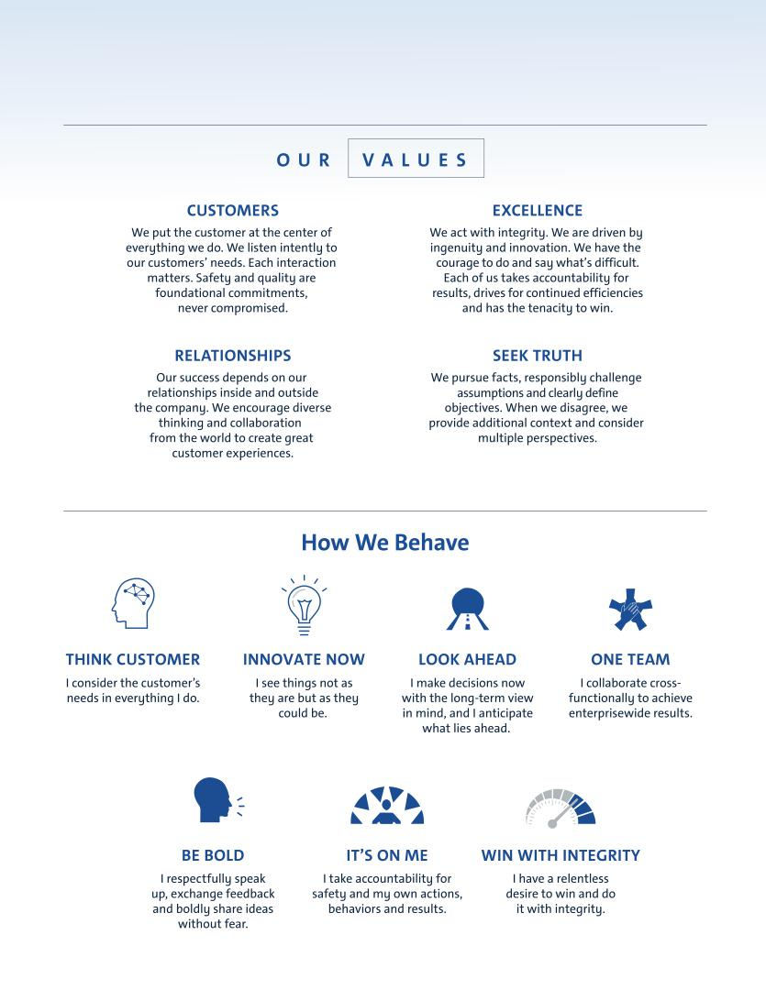

Table of Contents
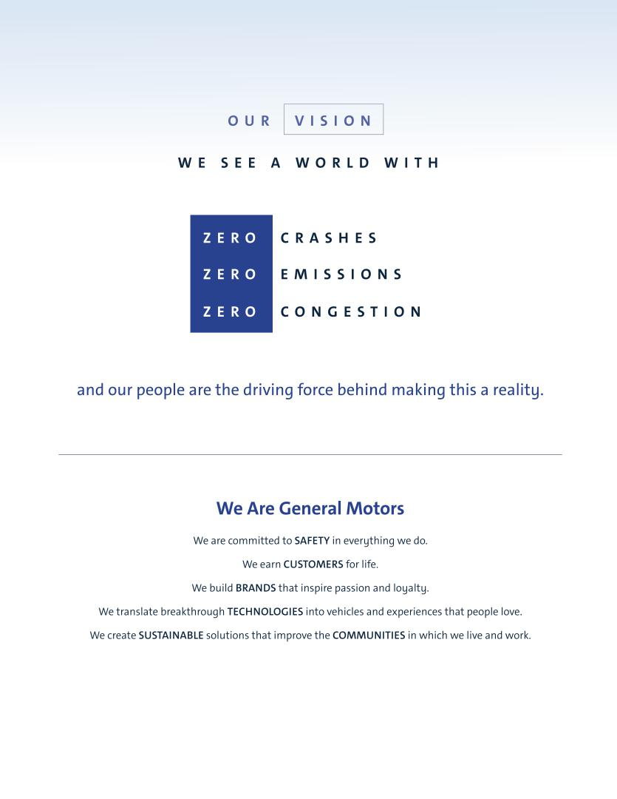

Table of Contents
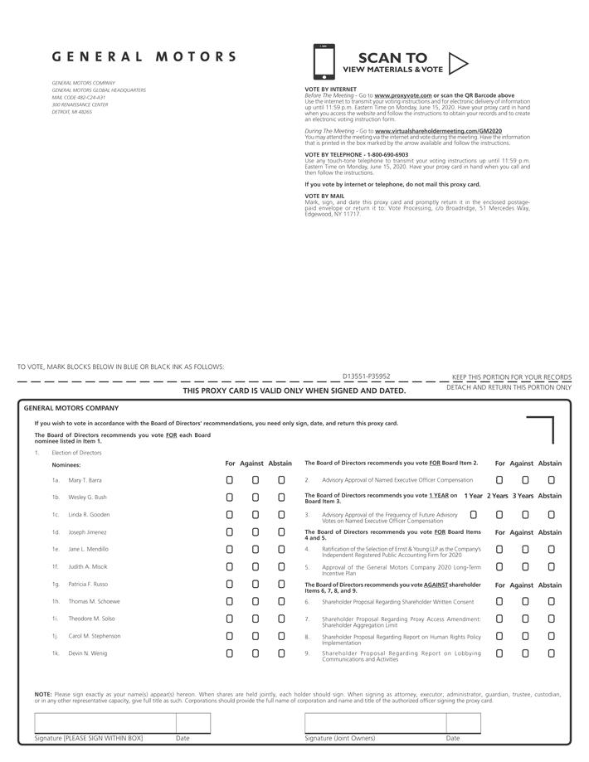

Table of Contents


